Refrigeration Cycles

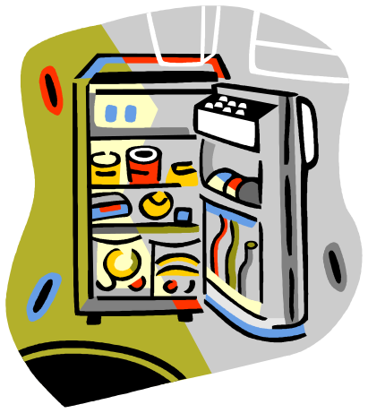

The objective of refrigeration cycles is to transfer the heat from a low temperature region to a high temperature region.

- if the objective of the cycle is to decrease the lowest temperature, we call it: a Refrigeration cycle.
- if the objective of the cycle is to increase the highest temperature, we call it: a heat pump.

Carnot cycle

As the Carnot cycle is the ideal cycle, let us first try to convert it to a refrigeration cycle, and then we will discuss practical limitations.

Figure (10.1) shows a reversed Carnot cycle, the efficiency of this cycle will be:

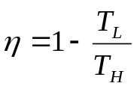

However, if we try to apply the Carnot cycle, we will face some technical difficulties:

1-2: It is not advisable to compress a mixture of vapor and gas, since the liquid droplets would cause excessive wear.

→ shift point 1 to the right (saturated vapor).

3-4: It would be quite expensive to construct a device to be used in the expansion process that would be nearly isentropic (no losses allowed). It is much simpler to reduce the pressure irreversibly by using an expansion valve (isenthalpic process).

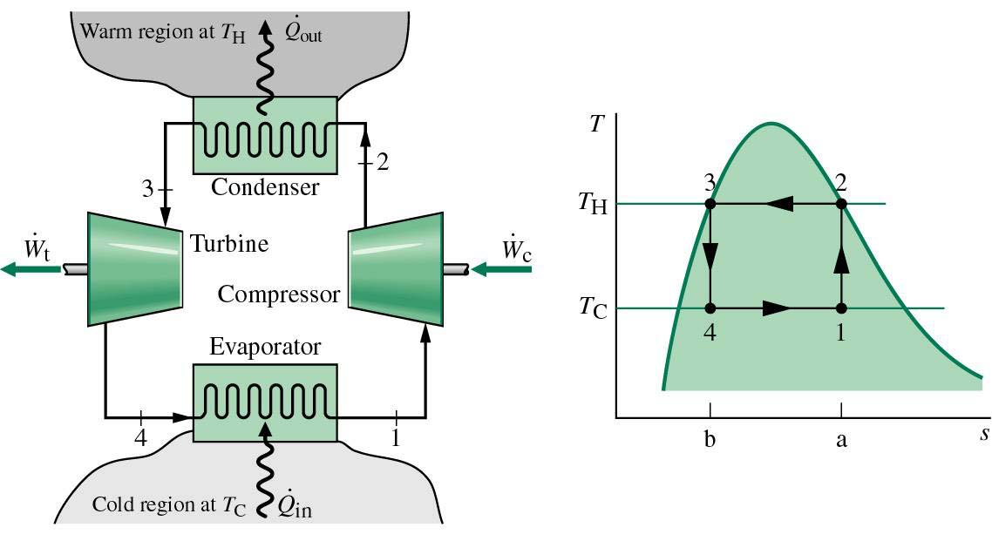

Figure.10.1. Reversed Carnot cycle.

The Ideal vapor-compression refrigeration cycle

1-2: isentropic compression in a compressor.
2-3: isobaric heat rejection in a condenser.
3-4: throttling in an expansion device.
4-1: isobaric heat absorption in an evaporator.
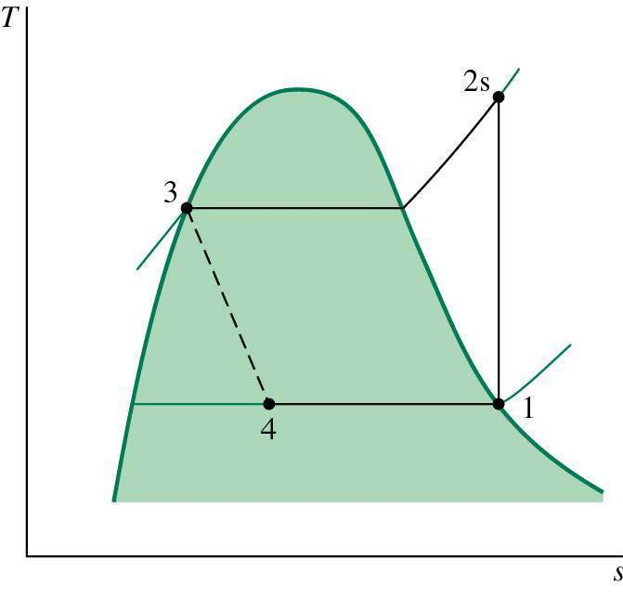
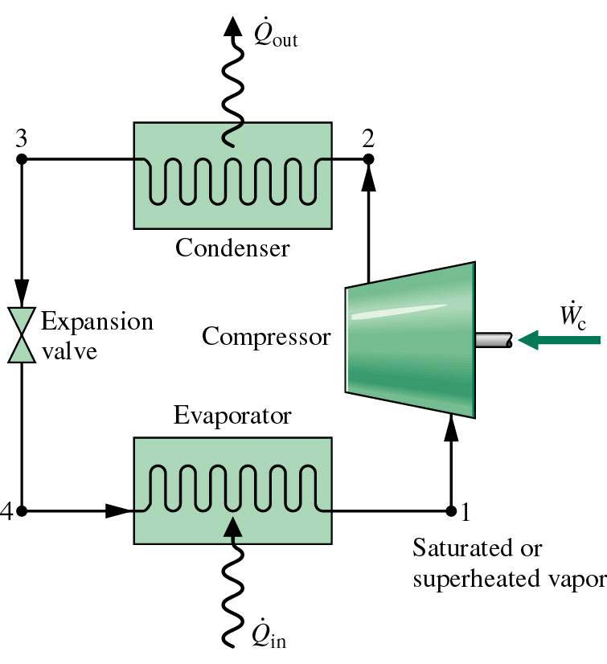

Figure.10.2. Ideal vapor-refrigeration cycle.

The coefficient of performance (COP) of a refrigeration cycle is:

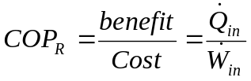

The coefficient of performance (COP) of a heat pump is:

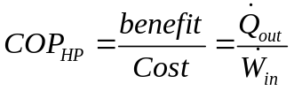

COP can attain 4 for refrigerators and perhaps 5 for heat pumps.

Actual vapor-compression refrigeration cycle

The actual cycle differs from the ideal one due to irreversibilities, such as:

- Pressure drops due to friction in connecting pipes
- Heat transfer occurs from or to the refrigerant through the pipes connecting the components.
- Pressure drops occur through the condenser and evaporator tubes.
- Heat transfer occurs from the compressor.

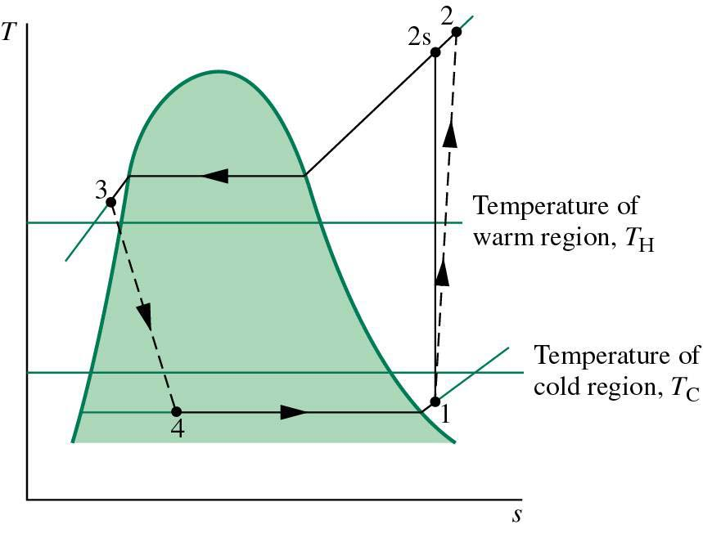

Figure.10.3.

Selecting a refrigerant

The evaporation temperature of the refrigerant must be quite low, in the neighborhood of -25°C (so usually forget water …)
The most common refrigerants used are: ChloroFluoroCarbons (CFC), ammonia , hydrocarbons (propane, ethane, ethylene, …), Carbon Dioxide, air, …

Usually R-11, R-12, R-22, R134a and R-502 where used (the trade name is Freon) before 1987, now isobutane (although it is a very dangerous gas …).

For industry, they usually use ammonia since it is cheaper, doesn’t damage the Ozone layer, has a high COP and greater delectability is case of a leak.
The major drawback is the toxicity, which makes it unsuitable for domestic use.

Important points for the design of a refrigeration cycle

- the temperature of the refrigerant within the condenser must be 5°C to 15°C higher than the exterior temperature, to allow efficient heat transfer.
- the temperature of the refrigerant within the evaporator must be 5°C to 15°C lower than the cooled space temperature, to allow efficient heat transfer.
- The equipments working at low pressure (evaporator) must be sufficiently large to account for a higher specific volume.
- The equipments working at high pressure (Condenser) must be designed to support the high pressure.

Multistage vapor refrigeration cycle
The simple vapor-compression refrigeration cycle is the most widely refrigeration cycle used. However, if we are looking for a further decrease in the temperature, we have to use a cascade refrigeration cycle.
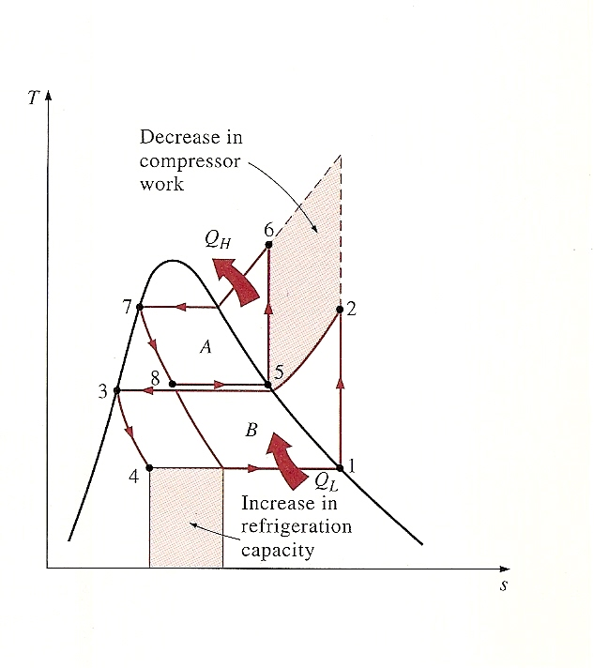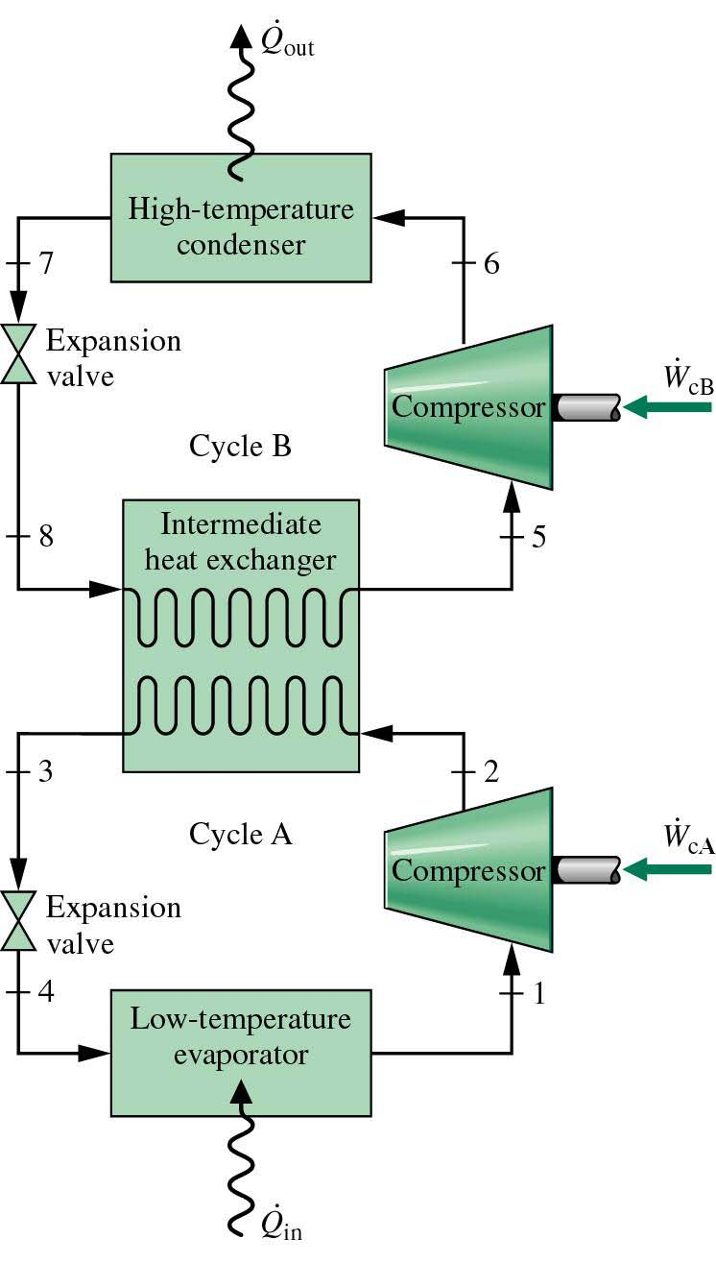
Figure.10.4. Two-stage refrigeration cycle.
Indeed, this cycle will leads to a decrease in the temperature of the point 3, therefore increasing the refrigeration. The configuration will minimize the compressor work. Note that we need for that, 2 compressors, a heat exchanger and 2 expansion valves. So the additional costs for this must be justified by improved performance. For extremely low refrigeration temperatures, several stages may be used.
The optimal intermediate pressure is:
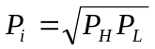
P_{H} the high pressure
P_{L} the low pressure
With this cycle, it is not an obligation to use the same refrigerant. It the refrigerants are different, the appropriate T-s diagram must be used.

Example

R134a is used in an ideal vapor refrigeration cycle operating between saturation temperatures of -20°C in the evaporator and 39.39 °C at the condenser outlet. The mass flow rate is 0.6 kg/s. Calculate the rate of refrigeration and the coefficient of performance.

Now consider a two-stage cycle replacing the simple cycle for the same conditions. Determine the rate of refrigeration and the coefficient of performance.

Absorption refrigeration cycle

In conventional refrigeration cycles, the power input needed to operate the compressor is relatively large, since the fluid compressed is in the vapor state and has a very large specific volume (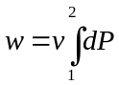, with v high) .
The objective of an absorption refrigeration cylce is to reduce the power needed for the compression by “converting” the vapor into a liquid which will be pumped by a pump (liquid → lower v ⇒ lower w for the same pressure difference).

To do so, several equipments are added to the conventional cycle. These equipments are:
the absorber; the pump; the heat exchanger; the generator and a regulating valve.

The most widly used absorption cycle is the ammonia-water system (Fig.10.5). It was patented by Ferdinand Carre (France) in 1859.

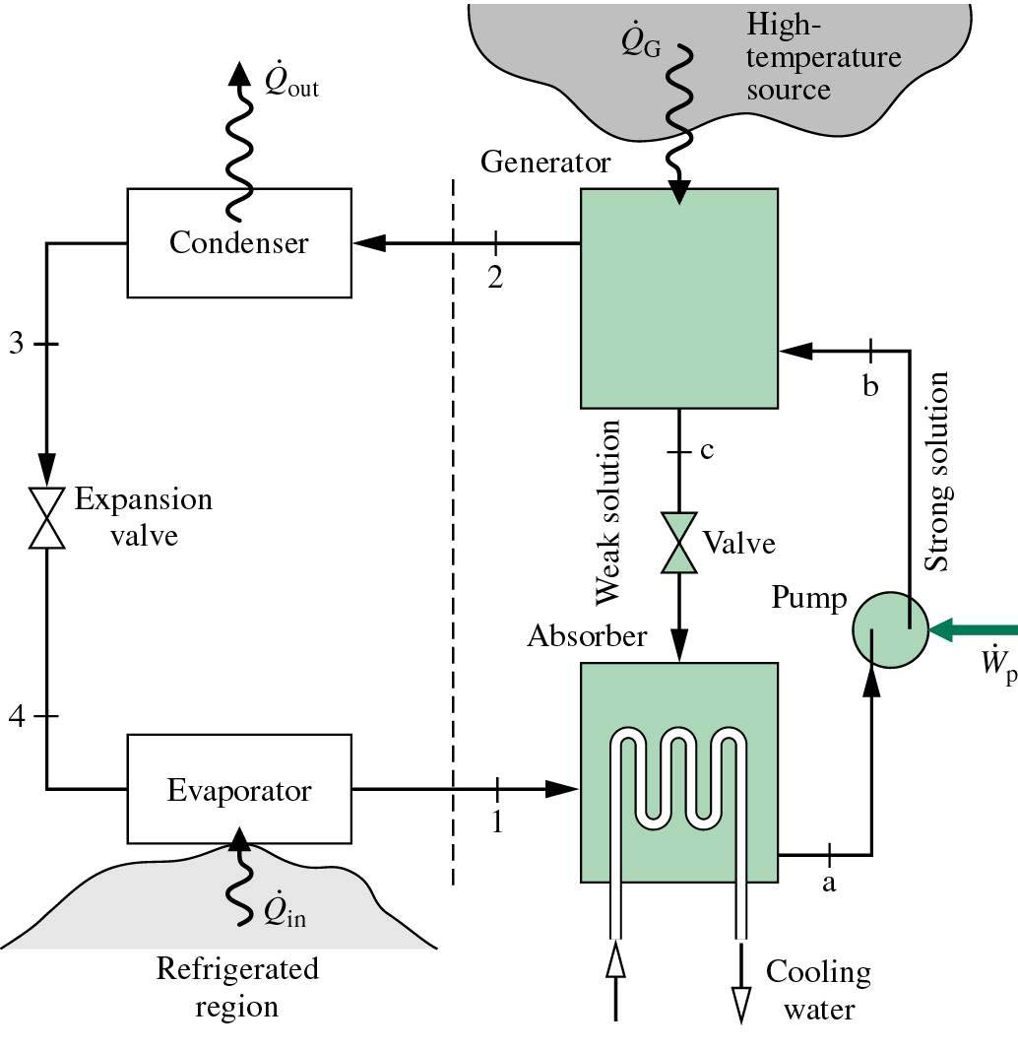

Figure.10.5. Ammonia-water system.

On the left side of the figure, it is exactly the same processes as for a conventional refrigeration cycle: condensation, throttling and evaporation. But on the right side, the compressor is replaced by the following process:

The pure ammonia NH₃ in the vapor state enters the absorber where it dissolves and reacts with water. The absorber contains therefore a mixture of NH₃+H₂O.
As the amount of NH₃ that can be dissolved in H₂O is inversely proportional to the temperature. The absorber is cooled to maintain its temperature as low as possible.
The liquid solution NH₃+H₂O, which is rich in NH₃, is then pumped to the generator. Sometimes a heat exchanger is used between the pump and the generator to pre-vaporize the mixture NH₃+H₂O. In the generator, an external source vaporize the mixture. The liquid is tranferred to the absorber through an expansion valve to reduce its pressure. The pure NH₃ vapor leaving the generator enters the condenser and follows the rest of the refrigeration cycle processes.

Note: to analyze the absorption cycle, we must know the amount of refrigerant contained in a mixture (NH₃+H₂O here), both in liquid form and vapor form. This can be found with the aid of an equilibrium diagram.

The gas refrigeration cycle

If the flow of gas is reverted in the Brayton cycle, the gas undergoes an isentropic expansion process as it flows through the turbine, resulting in a substantional reduction in temperature.

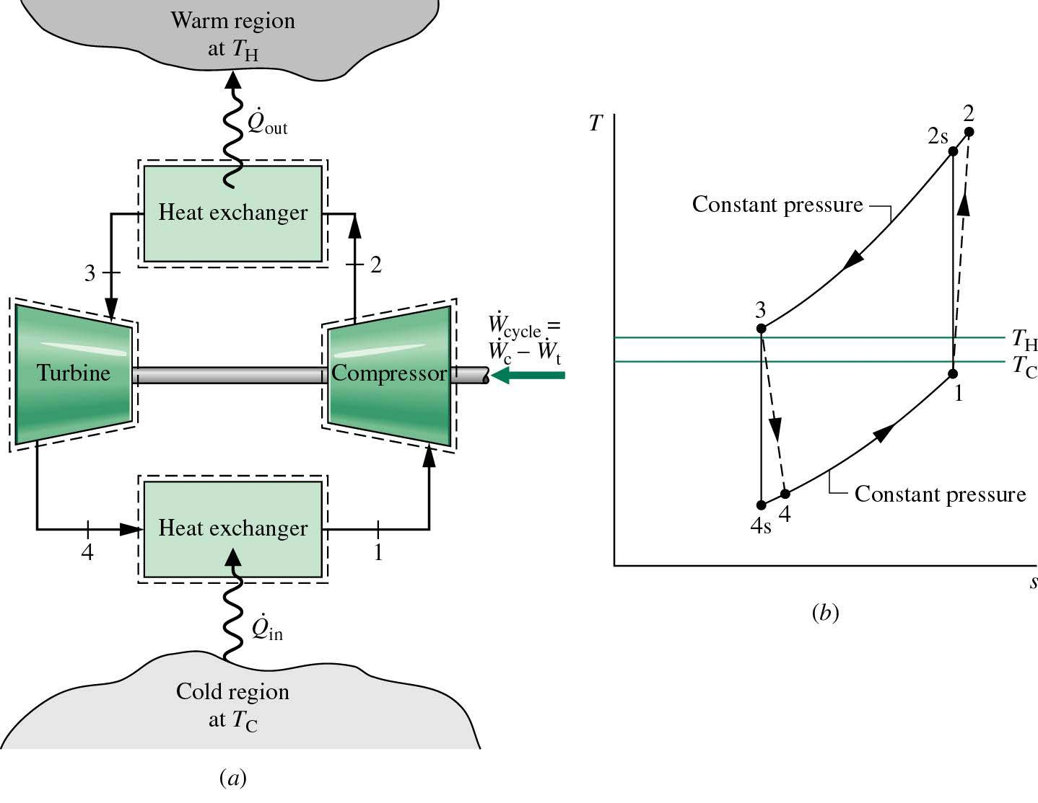

Figure.10.6. Reversed Brayton cycle.

An open cycle is used in aircraft ; air is extracted from the atmosphere at state 1 and inserted into the passenger compartment at state 4, this provides both fresh air and cooling.
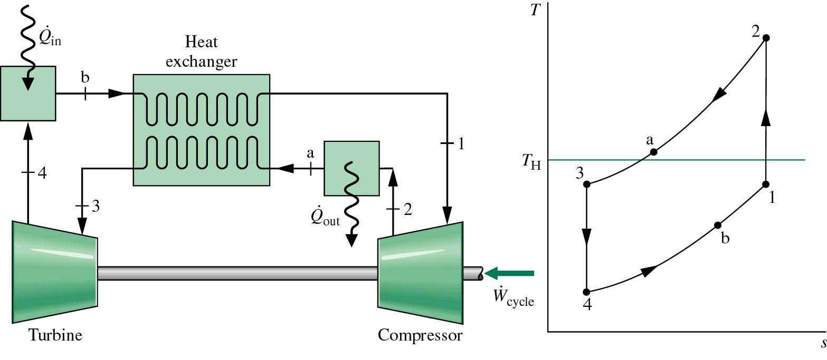
Like for the regenerative Brayton cycle, the reversed Brayton cycle can be used with a regenerator to lower the temperature of the turbine inlet.

Figure.10.6. Reversed regenerative Brayton cycle.

Heat pump

A heat pump utilizes the vapor refrigeration cycle, but to increase the temperature of the external medium, like a house (Figure).
Although using a heat pump for heating is more expensive than other conventional systems, it saves money in the long run.
The major problem with heat pumps occurs in humid regions where the temperature falls below 2 to 5°C. This may cause frosting. The accumulation of frost is highly undesirable, since it seriously disturpt heat transfer. This problem can be solved by runing the system as an air conditionner.
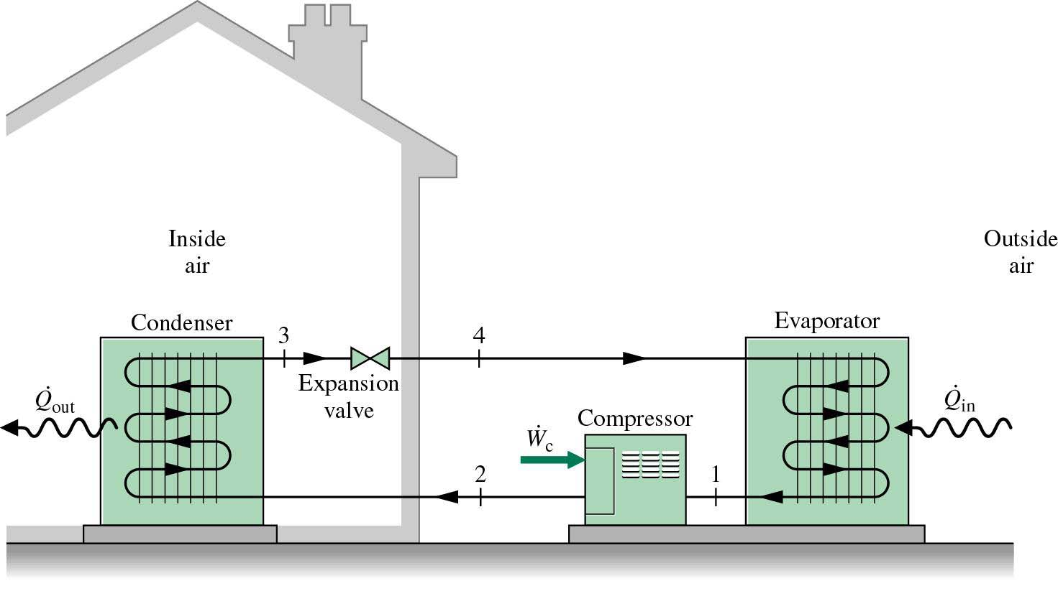

Figure.10.8. Heat pump.

Additional information

BTU: the BTU is a common unit used in refrigeration industry. A BTU (British Thermal Unit ) is the amount of heat energy needed to rise the temperature of one pound of pure water by one degree F.

Gaz liquefaction

One of the “hottest” application of refrigeration cycles is gas liquefaction. In fact, several engineering processes require very low temperatures.
To liquefy a gas such as helium, hydrogen or nitrogen, the temperature must be lower than their critical temperature: -268°C, -240°C and -147°C respectively.

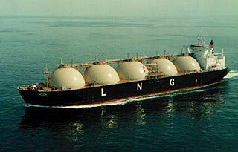 Figure.10.9. Transport of natural gas.

To reach so low temperatures several cycles may be used, usually using multistage compressors.
The man who contributed the most significantly to gas liquefaction is Carl Von Linde [if you remember well, he was Diesel’s professor at Munich Polytechnics].

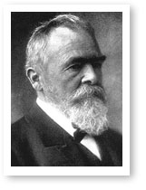

Although discovering oxygen and investigating its role in chemical reactions proved to be of crucial importance in changing the science of chemistry, initially oxygen could be produced only in the laboratory and in limited quantities, by chemical or electrolytic means: it had little importance outside the laboratory. It was the achievement of Carl von Linde (1842–1934) in 1902 to take oxygen from the air itself—and he was soon extracting it in quantities approaching one thousand cubic feet per hour. Oxygen became a common commodity that was supplied to hospitals and industries and was later used in rocket fuel, but this was not the German engineer's first important contribution.
Linde, the son of a Lutheran minister, was educated in science and engineering at the Federal Polytechnic in Zurich, Switzerland. After working for locomotive manufacturers in Berlin and Munich, he became a faculty member at the Polytechnic in Munich. His research there on heat theory, from 1873 to 1877, led to his invention of the first reliable and efficient compressed-ammonia refrigerator. The company he established to promote this invention was an international success: refrigeration rapidly displaced ice in food handling and was introduced into many industrial processes.
After a decade Linde withdrew from managerial activities to refocus on research, and in 1895 he succeeded in liquefying air by first compressing it and then letting it expand rapidly, thereby cooling it. He then obtained oxygen and nitrogen from the liquid air by slow warming. In the early days of oxygen production the biggest use by far for the gas was the oxyacetylene torch, invented in France in 1904, which revolutionized metal cutting and welding in the construction of ships, skyscrapers, and other iron and steel structures.
One company formed to use Linde's later patents was the Linde Air Products Company, founded in Cleveland in 1907. In 1917 Linde Air Products joined with four other companies that produced acetylene, among other products, to form Union Carbide and Carbon Corporation. Recently, Linde Air again became an independent company—Praxair.

