DIGITAL DESIGN COEN 312 Instructor: Asim J. Al-Khalili
Time Allowed 3:00 hrs. All questions carry equal marks Final Summer, 2010
No materials are allowed 2 Pages

Question 1
- Design a network that adds either 1 or 2 to a 3-bit binary number N (n2, n1, n0). The network output is M (m3, m2, m1, m0). K is a control signal.
When K = 0, M = N + 1
K =1, M = N + 2
b) Implement m₃ using a 4-to-1 multiplexer with minimum external logic.

N

Adder to be designed
M

K

Fig 1 Adder to be designed of Question 1

Question 2

Design a 4-bit binary number to 7 segment decoder. The decoder should show if the number is a multiple of 2 or 3 as shown ( use 2 when the number can be divided by 2 and 3) . Please refer to Fig. 2 below for the segment’s destination. Assume that all other numbers will be displayed as E.
Give circuit Implementation.
c
b
d
a
g
b
e
d
a
g
a
f
g

e
d

Fig. 2. 7-Segment Display of Question 2

Question 3

Using K-Map minimize the following function F
- F (A,B,C,D) = m(0,2,5,7,12,14) + d (8,10, 13, 15) Give results in SOP form.
- Implement in NAND-NAND from
- Implement in NOR_NOR form
- Implement in AND_OR_NOT from

Question 4
- Represent the following by a Boolean equation.
The outdoor light “L” should be turned on if there is nobody at home ”N” , the time is between 8 p.m. and 5 a.m “T”. and it is not a holiday “H”.
- Using Boolean Algebra, show that the two functions f₁ and f₂ are equal:
f₁(a,b,c) = a’c + b’c’ + ab
f₂(a,b,c) = a’b’ + bc + ac’
- Using Boolean Algebra, minimize the following function:
f(a,b,c,d) = ac’ + ab’d + a’b’c + a’cd’ + b’c’d’
- Give the maxterm list equivalent of the following function:
f(a,b,c) = ab

Question 5
Design a clocked sequential circuit with 4 outputs. The outputs are to drive colored lights: Red, R, Yellow, Y, Blue, B and Green, G consecutively and repeatedly in the same order ie: R→Y→B→G→R → Y→………… Start the design with the state diagram and follow standard design procedure. What is the frequency of operation if each light is to stay ON for 1 second. Neglect all logic and FlipFlop delays.

Question 6

Analyze the circuit given below fully. Determine Excitation equations, Transition table and the State diagram. Explain what function the circuit performs.

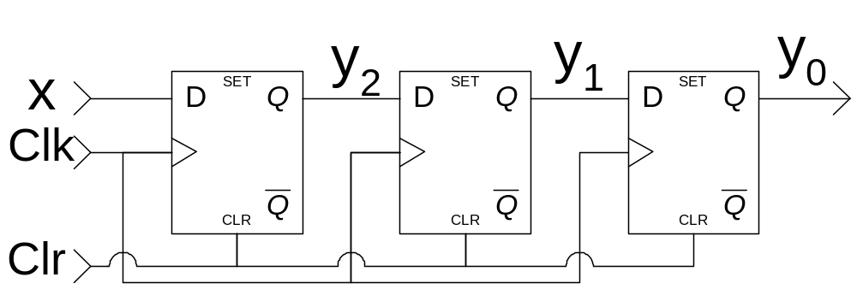

Solution:
Q1
#1 a)
 | h | n₂ | n₁ | n₀ | m₃ | m₂ | m₁ | m₀
0 | 0 | 0 | 0 | 0 | 0 | 0 | 0 | 1
1 | 0 | 0 | 0 | 1 | 0 | 0 | 1 | 0
2 | 0 | 0 | 1 | 0 | 0 | 0 | 1 | 1
3 | 0 | 0 | 1 | 1 | 0 | 1 | 0 | 0
4 | 0 | 1 | 0 | 0 | 0 | 1 | 0 | 1
5 | 0 | 1 | 0 | 1 | 0 | 1 | 1 | 0
6 | 0 | 1 | 1 | 0 | 0 | 1 | 1 | 1
7 | 0 | 1 | 1 | 1 | 1 | 0 | 0 | 0
8 | 1 | 0 | 0 | 0 | 0 | 0 | 1 | 0
9 | 1 | 0 | 0 | 1 | 0 | 0 | 1 | 1
10 | 1 | 0 | 1 | 0 | 0 | 1 | 0 | 0
11 | 1 | 0 | 1 | 1 | 0 | 1 | 0 | 1
12 | 1 | 1 | 0 | 0 | 0 | 1 | 1 | 0
13 | 1 | 1 | 0 | 1 | 0 | 1 | 1 | 1
14 | 1 | 1 | 1 | 0 | 1 | 0 | 0 | 0
15 | 1 | 1 | 1 | 1 | 1 | 0 | 0 | 1

h n₂ n₁ n₀
 |  | 00 | 01 | 11 | 10
 | 00
 | 01
 | 11 |  | 1 | 1
 | 10 |  |  | 1

m₃=∑_{m}(7,14,15)
m₃=n₂n₁n₀ + hn₂n₁

h n₂ n₁ n₀
 |  | 00 | 01 | 11 | 10
 | 00 |  | 1 | 1
 | 01 |  | 1 | 1
 | 11 | 1 |  |  | 1
 | 10 |  | 1 |  | 1

m₂=∑_{m}(3,4,5,6,10,11,12,13)
m₂=n₂n₁’ + hn₂’n₁ + n₂’n₁n₀ + h’n₂n₁’

h n₂ n₁ n₀
 |  | 00 | 01 | 11 | 10
 | 00 |  |  | 1 | 1
 | 01 | 1 | 1 | 1 | 1
 | 11
 | 10 | 1 | 1

m₁=∑_{m}(1,2,5,6,8,9,12,13)
m₁=hn₁’ + n₁’n₀ + h’n₁n₀’

h n₂ n₁ n₀
 |  | 00 | 01 | 11 | 10
 | 00 | 1 | 1
 | 01 |  |  | 1 | 1
 | 11 |  |  | 1 | 1
 | 10 | 1 | 1
m₀= ∑_{m}(0,2,4,6,9,11,13,15)
m₀= hn₀ + h’n₀’

m₃= n₂n₁n₀ + hn₂n₁
m₂=n₂n₁’ + hn₂’n₁ + n₂’n₁n₀ + h’n₂n₁’
m₁=hn₁’ + n₁’n₀ + h’n₁n₀’
m₀= (h⊕n₀)’
Assuming double rail

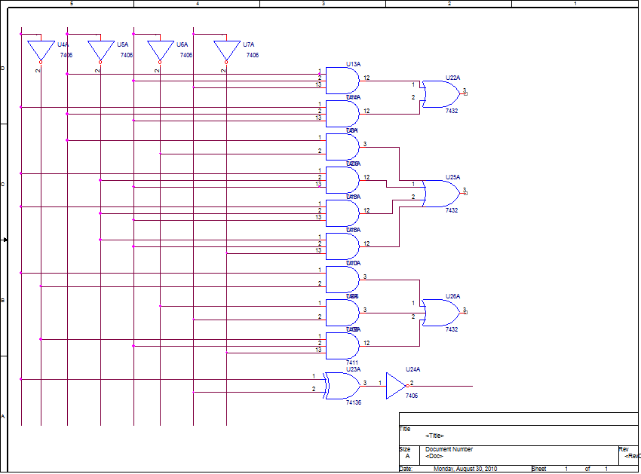

b)
m₃= n₂n₁n₀ + hn₂n₁₌ n₂n₁(n₀ + h)

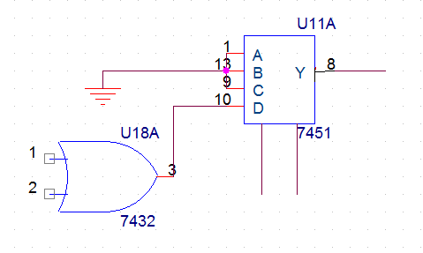

OR

m₃= h’n₂n₁n₀ + hn₂n₁n₀ + hn₂n₁n₀’ = n₂n₁(h’n₀ + hn₀ + hn₀’)

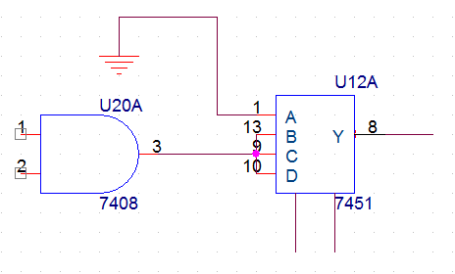

Q2
 | A3 | A2 | A1 | A0 | 7 Segment | a | b | c | d | e | f | g
0 | 0 | 0 | 0 | 0 | E | 1 | 0 | 0 | 1 | 1 | 1 | 1
1 | 0 | 0 | 0 | 1 | E | 1 | 0 | 0 | 1 | 1 | 1 | 1
2 | 0 | 0 | 1 | 0 | 2 | 1 | 1 | 0 | 1 | 1 | 0 | 1
3 | 0 | 0 | 1 | 1 | 3 | 1 | 1 | 1 | 1 | 0 | 0 | 1
4 | 0 | 1 | 0 | 0 | 2 | 1 | 1 | 0 | 1 | 1 | 0 | 1
5 | 0 | 1 | 0 | 1 | E | 1 | 0 | 0 | 1 | 1 | 1 | 1
6 | 0 | 1 | 1 | 0 | 2 | 1 | 1 | 0 | 1 | 1 | 0 | 1
7 | 0 | 1 | 1 | 1 | E | 1 | 0 | 0 | 1 | 1 | 1 | 1
8 | 1 | 0 | 0 | 0 | 2 | 1 | 1 | 0 | 1 | 1 | 0 | 1
9 | 1 | 0 | 0 | 1 | 3 | 1 | 1 | 1 | 1 | 0 | 0 | 1
10 | 1 | 0 | 1 | 0 | 2 | 1 | 1 | 0 | 1 | 1 | 0 | 1
11 | 1 | 0 | 1 | 1 | E | 1 | 0 | 0 | 1 | 1 | 1 | 1
12 | 1 | 1 | 0 | 0 | 2 | 1 | 1 | 0 | 1 | 1 | 0 | 1
13 | 1 | 1 | 0 | 1 | E | 1 | 0 | 0 | 1 | 1 | 1 | 1
14 | 1 | 1 | 1 | 0 | 2 | 1 | 1 | 0 | 1 | 1 | 0 | 1
15 | 1 | 1 | 1 | 1 | 3 | 1 | 1 | 1 | 1 | 0 | 0 | 1

a=d=g= “1” and b=f’ and c=e’
A3 A2 A1 A0
 |  | 00 | 01 | 11 | 10
 | 00 |  | 1 | 1 | 1
 | 01 |  |  | 1
 | 11 | 1 |  |  | 1
 | 10 | 1 | 1 | 1 | 1

b=A₂’A₁+A₀’A₂+A₀’A₃+A₃A₂A₁’
A3 A2 A1 A0
 |  | 00 | 01 | 11 | 10
 | 00
 | 01 |  |  |  | 1
 | 11 | 1 |  | 1
 | 10

c=A₃’A₂’A₁A₀+A₃A₂’A₁’A₀+A₃A₂A₁A₀

a=d=g=∑_{m}(0,1,2,3,4,5,6,7,8,9,10,11,12,13,14,15)
b=∑_{m}(2,3,4,6,8,9,10,12,14,15)
c=∑_{m}(3,9,15)
e=∑_{m}(0,1,2,4,5,6,7,8,10,11,12,13,14)
f=∑_{m}(0,1,5,7,11,13)

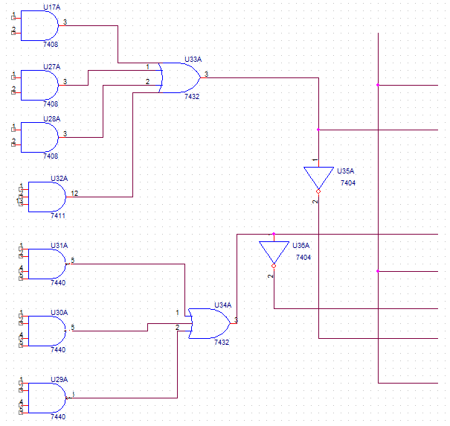

Q3
a)
A B C D
 |  | 00 | 01 | 11 | 10
 | 00 | 1 |  | 1 | X
 | 01 |  | 1 | X
 | 11 |  | 1 | X
 | 10 | 1 |  | 1 | X

F=BD + AD’+B’D’

b) F= (BD + AD’+B’D’)” = ((BD )’(AD’)’(B’D’)’)’
Assuming double rail
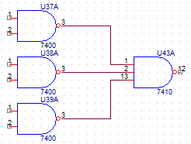

c)
A B C D
 |  | 00 | 01 | 11 | 10
 | 00 |  | 0 |  | X
 | 01 | 0 |  | X | 0
 | 11 | 0 |  | X | 0
 | 10 |  | 0 |  | X

F=(B+D’)(A+B’+D)
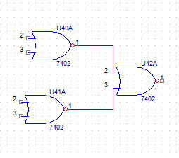

d)
A B C D
 |  | 00 | 01 | 11 | 10
 | 00 |  | 1 |  | X
 | 01 | 1 |  | X | 1
 | 11 | 1 |  | X | 1
 | 10 |  | 1 |  | X

F’=B’D+A’BD’
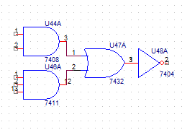

Q4
- L=> output
N=> someone is home
T=> Time is between 8 PM & 5 AM
H=> is a holiday
L= N’+H’
- Many ways of doing this problem. This is the simplest:
a’c+b’c’+ab=a’b’+bc+ac’ expand both sides
a’c(b+b’)+b’c’(a+a’)+ab(c+c’)=a’b’(c+c’)+bc(a+a’)+ac’(b+b’)
a’bc+a’b’c+ab’c’+a’b’c’+abc+abc’= a’bc+a’b’c+ab’c’+a’b’c’+abc+abc’
∑_{m}(0,1,3,5,6,7) = ∑_{m}(0,1,3,5,6,7)
- ac’+ab’d+a’b’c+a’cd’+b’c’d’
ab’d+a’b’c=ab’d+a’b’c+b’cd (eg ab+a’c+bc=ab+a’c)
ac’+ab’d+a’b’c+b’cd+a’cd’+b’c’d’
ac’+ab’d+a’cd=ac’+b’cd
ac’+b’cd+a’b’c+a’cd’+b’c’d’
b’cd+a’b’c+a’cd’=b’cd+a’cd’
f=ac’+b’cd+a’cd’+b’c’d’

ab c
ab c | 00 | 01 | 11 | 10
0 |  |  | 1
1 | 1 |  | 1

F=∏_{M}(0,1,2,3,4,5)

Q5
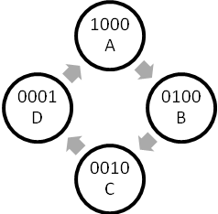
 | present | next | R | Y | B | G
00 | A | B | 1 | 0 | 0 | 0
01 | B | C | 0 | 1 | 0 | 0
10 | C | D | 0 | 0 | 1 | 0
11 | D | A | 0 | 0 | 0 | 1

Y1 Y0 |  | 0 | 1
 | 0 |  | 1
 | 1 | 1
Y₁⁺=Y₁⊕Y₀

Y1 Y0 |  | 0 | 1
 | 0 | 1 | 1
 | 1
Y₀⁺=Y₀’

present |  | next |  | output
Y1 | Y0 | Y1 | Y0 | R | Y | B | G
0 | 0 | 0 | 1 | 1 | 0 | 0 | 0
0 | 1 | 1 | 0 | 0 | 1 | 0 | 0
1 | 0 | 1 | 1 | 0 | 0 | 1 | 0
1 | 1 | 0 | 0 | 0 | 0 | 0 | 1

B=01 C=10 D=11

Using D-FF
Y⁺=D
Y₁⁺=Y₁⊕Y₀
Y₀⁺=Y₀’
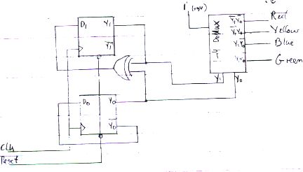

Frequency of operation: 1sec * 4 = 4sec=.25 Hz

Q6
Y⁺=D
Y₂⁺=X
Y₁⁺=Y₂ Excitation Equations
Y₀⁺=Y₁
Z=Y₀

 |  |  |  |  | X=0 |  |  | X=1 |  |  | output
Transition Table |  | Y2 | Y1 | Y0 | Y2+ | Y1+ | Y0+ | Y2+ | Y1+ | Y0+ | Z
Transition Table | A | 0 | 0 | 0 | 0 | 0 | 0 | 1 | 0 | 0 | 0
Transition Table | B | 0 | 0 | 1 | 0 | 0 | 0 | 1 | 0 | 0 | 1
Transition Table | C | 0 | 1 | 0 | 0 | 0 | 1 | 1 | 0 | 1 | 0
Transition Table | D | 0 | 1 | 1 | 0 | 0 | 1 | 1 | 0 | 1 | 1
Transition Table | E | 1 | 0 | 0 | 0 | 1 | 0 | 1 | 1 | 0 | 0
Transition Table | F | 1 | 0 | 1 | 0 | 1 | 0 | 1 | 1 | 0 | 1
Transition Table | G | 1 | 1 | 0 | 0 | 1 | 1 | 1 | 1 | 1 | 0
Transition Table | H | 1 | 1 | 1 | 0 | 1 | 1 | 1 | 1 | 1 | 1

 |  | Next |  | output
 | present | X=0 | X=1 | z
State Table | A | A | E | 0
State Table | B | A | E | 1
State Table | C | B | F | 0
State Table | D | B | F | 1
State Table | E | C | G | 0
State Table | F | C | G | 1
State Table | G | D | H | 0
State Table | H | D | H | 1

The function of this circuit is a 3-bit right shift register.

State Diagram:


