

Laboratory ManuaL

MECH 351

Thermodynamics II

Written by:

P. Sakaris

Fall 2009 Edition

September 2009

|  |  |  |  |  |  |  |
| --- | --- | --- | --- | --- | --- | --- |
| Sunday | Monday | Tuesday | Wednesday | Thursday | Friday | Saturday |
|  |  | 1 | 2 | 3 | 4 | 5 |
| 6  **NO LABS**  **Week 0 >>>** | 7 | 8 | 9 | 10 | 11 | 12  **NO LABS**  **<<< Week 0** |
| 13  **Lab #1**  **Week 1 >>>**  Grandparents Day  **Week 0>>>** | 14  Lab MK  15:45 – 17:35  Room H-027 | 15 | 16  Lab MI  14:45 – 16:35  Room H-027 | 17  Lab MP  10:45 – 12:35  Room H-027 | 18  Lab MN  15:15 – 17:05  Room H-027 | 19  **Lab#1**  **<<< Week 1**  Rosh Hashanah |
| 20  **Lab #1**  **Week 2 >>>** | 21  Lab ML  15:45 – 17:35  Room H-027 | 22 | 23  Lab MJ  14:45 – 16:35  Room H-027 | 24 | 25  Lab MO  15:15 – 17:05  Room H-027 | 26  **Lab #1**  **<<< Week 2** |
| 27  **Lab #2**  **Week 1 >>>** | 28  Lab MK  15:45 – 17:35  Room ??? | 29 | 30  Lab MI  14:45 – 16:35  Room ??? |  |  | **Lab #2**  **<<< Week 1** |

October 2009

|  |  |  |  |  |  |  |
| --- | --- | --- | --- | --- | --- | --- |
| Sunday | Monday | Tuesday | Wednesday | Thursday | Friday | Saturday |
| **Lab #1**  **Week 1 >>>** |  |  |  | 1  Lab MP  10:45 – 12:35  Room ??? | 2  Lab MN  15:15 – 17:05  Room ??? | 3  **Lab #1**  **<<< Week 1** |
| 4  **Lab #2**  **Week 2 >>>** | 5  Lab ML  15:45 – 17:35  Room ??? | 6 | 7  Lab MJ  14:45 – 16:35  Room ??? | 8 | 9  Lab MO  15:15 – 17:05  Room ??? | 10  **Lab #2**  **<<< Week 2** |
| 11  **Lab #3**  **Week 1 >>>** | 12  **NO LAB MK**  **Makeup on 12/07/2009** | 13 | 14  Lab MI  14:45 – 16:35  Room H-027 | 15  Lab MP  10:45 – 12:35  Room H-027 | 16  Lab MN  15:15 – 17:05  Room H-027 | 17  **Lab #3**  **<<< Week 1** |
| 18  **Lab #3**  **Week 2 >>>** | 19  Lab ML  15:45 – 17:35  Room H-027 | 20 | 21  Lab MJ  14:45 – 16:35  Room H-027 | 22 | 23  Lab MO  15:15 – 17:05  Room H-027 | 24  **Lab #3**  **<<< Week 2** |
| 25  **Lab #4**  **Week 1 >>>** | 26  Lab MK  15:45 – 17:35  Room H-027 | 27 | 28  Lab MI  14:45 – 16:35  Room H-027 | 29  Lab MP  10:45 – 12:35  Room H-027 | 30  Lab MN  15:15 – 17:05  Room H-027 | 31  **Lab #4**  **<<< Week 1** |

November 2009

|  |  |  |  |  |  |  |
| --- | --- | --- | --- | --- | --- | --- |
| Sunday | Monday | Tuesday | Wednesday | Thursday | Friday | Saturday |
| 1  **Lab #4**  **Week 2 >>>** | 2  Lab ML  15:45 – 17:35  Room H-027 | 3 | 4  Lab MJ  14:45 – 16:35  Room H-027 | 5 | 6  Lab MO  15:15 – 17:05  Room H-027 | 7  **Lab #4**  **<<< Week 2** |
| 8  **Lab #5**  **Week 1 >>>** | 9  Lab MK  15:45 – 17:35  Room H-027 | 10 | 11  Lab MI  14:45 – 16:35  Room H-027 | 12  Lab MP  10:45 – 12:35  Room H-027 | 13  Lab MN  15:15 – 17:05  Room H-027 | 14  **Lab #5**  **<<< Week 1** |
| 15  **Lab #5**  **Week 2 >>>** | 16  Lab ML  15:45 – 17:35  Room H-027 | 17 | 18  Lab MJ  14:45 – 16:35  Room H-027 | 19 | 20  Lab MO  15:15 – 17:05  Room H-027 | 21  **Lab #5**  **<<< Week 2** |
| 22  **Lab #6**  **Week 1 >>>** | 23  Lab MK  15:45 – 17:35  Room ??? | 24 | 25  Lab MI  14:45 – 16:35  Room ??? | 26  Lab MP  10:45 – 12:35  Room ??? | 27  Lab MN  15:15 – 17:05  Room ??? | 28  **Lab #6**  **<<< Week 1** |
| 29  **Lab #6**  **Week 2 >>>** | 30  Lab ML  15:45 – 17:35  Room ??? |  |  |  |  | **Lab #6**  **<<< Week 2** |

December 2009

|  |  |  |  |  |  |  |
| --- | --- | --- | --- | --- | --- | --- |
| Sunday | Monday | Tuesday | Wednesday | Thursday | Friday | Saturday |
| **Lab #6**  **Week 2 >>>** |  | 1 | 2  Lab MJ  14:45 – 16:35  Room ??? | 3 | 4  Lab MO  15:15 – 17:05  Room ??? | 5  **Lab #6**  **<<< Week 2** |
| 6 | 7  **Makeup Lab Lab MK**  **15:45 – 17:35**  **Room ???** | 8 | 9 | 10 | 11 | 12 |
| 13 | 14 | 15 | 16 | 17 | 18 | 19 |
| 20 | 21 | 22 | 23 | 24 | 25 | 26 |
| 27 | 28 | 29 | 30 | 31 |  |  |

# General Laboratory Safety Rules

## Follow Relevant Instructions

* Before attempting to install, commission or operate equipment, all relevant suppliers’/manufacturers’ instructions and local regulations should be understood and implemented.
* It is irresponsible and dangerous to misuse equipment or ignore instructions, regulations or warnings.
* Do not exceed specified maximum operating conditions (e.g. temperature, pressure, speed etc.).

## Installation/Commissioning

* Use lifting table where possible to install heavy equipment. Where manual lifting is necessary beware of strained backs and crushed toes. Get help from an assistant if necessary. Wear safety shoes appropriate.
* Extreme care should be exercised to avoid damage to the equipment during handling and unpacking. When using slings to lift equipment, ensure that the slings are attached to structural framework and do not foul adjacent pipe work, glassware etc.
* Locate heavy equipment at low level.
* Equipment involving inflammable or corrosive liquids should be sited in a containment area or bund with a capacity 50% greater that the maximum equipment contents.
* Ensure that all services are compatible with equipment and that independent isolators are always provided and labeled. Use reliable connections in all instances, do not improvise.
* Ensure that all equipment is reliably grounded and connected to an electrical supply at the correct voltage.
* Potential hazards should always be the first consideration when deciding on a suitable location for equipment. Leave sufficient space between equipment and between walls and equipment.
* Ensure that equipment is commissioned and checked by a competent member of staff permitting students to operate it.

## Operation

* Ensure the students are fully aware of the potential hazards when operating equipment.
* Students should be supervised by a competent member of staff at all times when in the laboratory. No one should operate equipment alone. Do not leave equipment running unattended.
* Do not allow students to derive their own experimental procedures unless they are competent to do so.

## Maintenance

* Badly maintained equipment is a potential hazard. Ensure that a competent member of staff is responsible for organizing maintenance and repairs on a planned basis.
* Do not permit faulty equipment to be operated. Ensure that repairs are carried out competently and checked before students are permitted to operate the equipment.

## Electricity

* Electricity is the most common cause of accidents in the laboratory. Ensure that all members of staff and students respect it.
* Ensure that the electrical supply has been disconnected from the equipment before attempting repairs or adjustments.
* Water and electricity are not compatible and can cause serious injury if they come into contact. Never operate portable electric appliances adjacent to equipment involving water unless some form of constraint or barrier is incorporated to prevent accidental contact.
* Always disconnect equipment from the electrical supply when not in use.

## Avoiding Fires or Explosion

* Ensure that the laboratory is provided with adequate fire extinguishers appropriate to the potential hazards.
* Smoking must be forbidden. Notices should be displayed to enforce this.
* Beware since fine powders or dust can spontaneously ignite under certain conditions. Empty vessels having contained inflammable liquid can contain vapor and explode if ignited.
* Bulk quantities of inflammable liquids should be stored outside the laboratory in accordance with local regulations.
* Storage tanks on equipment should not be overfilled. All spillages should be immediately cleaned up, carefully disposing of any contaminated cloths etc. Beware of slippery floors.
* When liquids giving off inflammable vapors are handled in the laboratory, the area should be properly ventilated.
* Students should not be allowed to prepare mixtures for analysis or other purposes without competent supervision.

## Handling Poisons, Corrosive or Toxic Materials

* Certain liquids essential to the operation of equipment, for example, mercury, are poisonous or can give off poisonous vapors. Wear appropriate protective clothing when handling such substances.
* Do not allow food to be brought into or consumed in the laboratory. Never use chemical beakers as drinking vessels
* Smoking must be forbidden. Notices should be displayed to enforce this.
* Poisons and very toxic materials must be kept in a locked cupboard or store and checked regularly. Use of such substances should be supervised.

## Avoid Cuts and Burns

* Take care when handling sharp edged components. Do not exert undue force on glass or fragile items.
* Hot surfaces cannot, in most cases, be totally shielded and can produce severe burns even when not visibly hot. Use common sense and think which parts of the equipment are likely to be hot.

## Eye/Ear Protection

* Goggles must be worn whenever there is risk to the eyes. Risk may arise from powders, liquid splashes, vapors or splinters. Beware of debris from fast moving air streams.
* Never look directly at a strong source of light such as a laser or Xenon arc lamp. Ensure the equipment using such a source is positioned so that passers-by cannot accidentally view the source or reflected ray.
* Facilities for eye irrigation should always be available.
* Ear protectors must be worn when operating noisy equipment.

## Clothing

* Suitable clothing should be worn in the laboratory. Loose garments can cause serious injury if caught in rotating machinery. Ties, rings on fingers etc. should be removed in these situations.
* Additional protective clothing should be available for all members of staff and students as appropriate.

## Guards and Safety Devices

* Guards and safety devices are installed on equipment to protect the operator. The equipment must not be operated with such devices removed.
* Safety valves, cut-outs or other safety devices will have been set to protect the equipment. Interference with these devices may create a potential hazard.
* It is not possible to guard the operator against all contingencies. Use commons sense at all times when in the laboratory.
* Before staring a rotating machine, make sure staff are aware how to stop it in an emergency.
* Ensure that speed control devices are always set to zero before starting equipment.

## First Aid

* If an accident does occur in the laboratory it is essential that first aid equipment is available and that the supervisor knows how to use it.
* A notice giving details of a proficient first-aider should be prominently displayed.
* A short list of the antidotes for the chemicals used in the particular laboratory should be prominently displayed.

Execution of the Experiments

Each experiment presented in this manual is performed on a bi-weekly basis. The order of performance of each experiment is followed unless specified otherwise by the laboratory instructor. In order that the laboratory session is conducted in the most meaningful manner possible, it is imperative that each student read, study, and understand the experiment to be conducted prior to coming to the class. The student should also read and understand the laboratory safety guidelines for undergraduate laboratories. Failure to follow safety guidelines will result in expulsion from the lab.

**Students are divided into groups of four to perform the experiment.** **Each group is required to work together throughout the semester. In other words, no switching groups in mid-stream. Students must come to the laboratory at their registered section. Consult the calendar at the beginning of this manual. Since the laboratory represents a significant portion of the student's practical training, it is imperative that the students perform all the experiments.**

**An attendance sheet is circulated and it is the responsibility of the student to sign it at each lab session. The lab instructor is not expected to remember if the student attended and later forgot to sign the attendance sheet. After missing an experiment for any reason, students should report to their lab instructor as soon as possible (not waiting until the next regular meeting of the class) and arrange to make up the work with another laboratory section if possible provided an authenticated valid note is given, otherwise a zero grade will be assessed. If it is not possible to make up the lab due to schedule issues, the students will receive a final lab grade based on the labs performed only. Any student who arrives late (at the discretion of the instructor) to the laboratory will be deducted 25% on the laboratory report. Students arriving 30 minutes after the start of the experiment is considered as a missed lab and not a valid reason to repeat at a later date.**

At the end of each lab, the laboratory instructor must sign the completed data sheet provided in this manual. This signed sheet must be incorporated at the end of the laboratory report to be submitted by the group. Students should always have on hand paper, pencil, eraser, calculator and a 3½″ floppy disk or USB flash drive to copy data files if needed.

Office hours are given at the discretion of the laboratory instructor and are announced in the first lab session.

Laboratory Report

## General

Each group will submit a complete written report covering each experiment performed. The report is to be the groups own work. The report will be written in the third person, past tense (for procedures executed, data taken, and results obtained), and should be self-sufficient. In other words, the reader should not need to consult the references in order to understand the report. Correct English and spelling should be used. The reports are practice for writing technical reports similar to those, which are required by engineers engaged in industry and engineering practice.

The report must be typed using a word processor and stapled only (i.e. no paper clips). All pages, equations, figures, graphs and tables must be numbered. Figures, tables, graphs, etc., must have titles and be introduced in a sentence in the text of the report. Figures must have axis labels that name the variable as well as giving its symbol and units if appropriate.

Figures, graphs, and tables must be neat and clear. Figures and graphs should be generated on the computer through drawing and plotting software (SigmaPlot or Excel are examples). Choose scales that are appropriate to the range of data and that can be easily read. Leave room on the paper for scales, labels, and titles.

## Specifications

In order to observe the accepted rules of good writing form, the following specifications for the general makeup of the report are suggested:

1. Use 8 ½ x 11 inch white paper.
2. Write the report with a word processor.
3. Consistent fonts and presentation for every section of the report.
4. Use one side of the paper only.
5. Create all drawings and figures using computer drawing and plotting programs. Scanned images are allowed where appropriate.
6. Use the same font style on drawings and graphs as used in the text. Graphs axes should be clearly labeled, including units where appropriate.
7. Discrete experimental data that are plotted on appropriate graphs should be designated with small symbols, such as circles, to distinguish these data from those represented by curves fitted through them either intuitively or statistically or by mathematical model. If more that one dependent variable (ordinate) is presented on a graph, each variable should have a different symbol.
8. When mathematically fitting curves to experimental data, use appropriate judgment. Just because a 6th order polynomial can fit exactly to 7 points does not mean that it is the appropriate curve for this experimental data (i.e. the distribution may actually be linear or quadratic). Instead look at the trend of the data and avoid the pitfall of many students in letting the computer chose the best curve fit. As a general rule, the lower the complexity of the curve fit that represents the data trends, the better.

## Report Outline

The following report outline is required for content and order of presentation:

1. **Title Page**: - Must include lab title, date performed, student names with corresponding identification numbers and lab section.
2. **Originality Form**: Each student from the group must print their name, sign and date. **Students who do not fully print, sign and date will be assessed a zero grade for the lab** **report.** Forms are available at http://www.encs.concordia.ca/scs/forms/labform3.pdf
3. **Objective**: State the objective clearly in a concise manner in your own words.
4. **Introduction**: Background information preparing the reader as to what is done during the experiment. Do not copy what is written in the manual. Any theory mentioned or relevant information must be referenced.
5. **Procedure**: A general description of the procedure should be given. This description should be comprehensive, but brief. It should include a generic list of equipment used and a sketch to show how the equipment items are related. The enumeration and detailed description of multitudinous mechanical operations or sequence of such operations such as closing switches, reading instruments, turning knobs and so forth, should in general be avoided. However, when a specific method of mechanical operation or sequence of such operations is necessary in order to insure the validity or accuracy of the test data, it is important that the essential details be included in the description. **Note that it is unacceptable to simply use or copy the procedural instructions from the manual.**
6. **Results**: Answer all the questions posed in the laboratory manual. All observed and calculated data should be tabulated when possible. Headings and subheadings (titles) identifying items of data or sets of data should be used.
   1. **Sample Calculations**: Show a sample of a complete calculation of each type involved in the determination of calculated data and the solution of problems. These sample calculations should be first shown in symbolic form with all symbols properly defined. Then numerical data should be used with units shown in the actual calculations.
   2. **Curves**: All curves sheets should conform to the following specifications. A sample curve is shown in Figure 1.
      * Use a good quality plotting program like Excel or SigmaPlot. The graph should be plotted on 8 ½ x 11 inch paper.
      * Include scales, axis labels and figure titles on the graph.
      * Choose scales that are easy to use and that do not allow points to be plotted to a greater accuracy than justified by the accuracy of the data.
      * Indicate the points plotted from data by small circles or other symbols.
      * Draw, plot or calculate a smooth average curve through the plotted points, except in cases in which discontinuities are known to exist. The average curve does not necessarily pass through every datum. If during the performance of the experiment, there was strong evidence that an equipment malfunction or a procedural error affected a datum, it is appropriate to disregard that point when drawing the curve. Such appoint should be consistently disregarded in all results affected by it.
      * Place a title containing all pertinent information on each curve sheet.
      * Draw or plot only related curves on the same sheet. Keep in mind that when curves truly are related it is frequently helpful to interpretation to present them on the same sheet. For example, for a gasoline engine torque, power, and specific fuel consumption are all functions of speed; and the engine performance is more easily interpreted if they are all on the same graph with separate ordinate scales for each variable.

**Sample Graph**



This illustrates an acceptable method of showing two curves on one graph. Note that these curves are closely related in theory. Note that the figure has a title in words. The axes are plainly marked. The scales chosen are easy to use. Each axis has a label, in words, and units given. Symbols and line codes are defined. Symbols are used around discrete data points and the curves pass smoothly near, but not necessarily through, the data points. To achieve this smoothness a mathematical curve fit procedure was used (quadratic curve).

1. **Discussion**: Most important section of the entire report. It should be a complete discussion of the results obtained. Part of this discussion should deal with the accuracy or reliability of the results. It is suggested that this section consist, when applicable, of a careful treatment of the effect upon the results of the following:
   1. Errors resulting from the necessity of neglecting certain factors because of physical limitations in the performance of the test
   2. Errors in manipulation
   3. Errors in observation
   4. Errors in instruments
   5. Comparison of the results obtained with those that would reasonably have been expected from a consideration of the theory involved in the problem. Whenever the theory is apparently contradicted, the probable reasons should be discussed.

When results are given in graphical form as curves, the shape of each curve should be carefully explained. Such an explanation should state the causes or the particular shape the curve may have. It is not sufficient simply to state that a particular curve has positive slope, the reason for such a slope should be given. If the slope is not constant, that is, if the curve is not a straight line, its nonlinearity should also be explained.

Any original conclusions drawn as a consequence of the laboratory procedure and a study of the results obtained should be given in this section and should be justified by the discussion.

Constructive criticism of any phase of the experiment that may seem pertinent may also be included here.

1. **Conclusions**: In this section the conclusions which were supported and drawn in the Discussion are succinctly restated, usually as a numbered list. No new information should appear in this section. All justification of conclusions should have occurred in prior sections.
2. **References**: Publication or other authorities which help explain the experiment, calculate results, explain errors, draw conclusions etc., should be acknowledged. References to original sources for cited material should be listed together at the end of the paper; footnotes should not be used for this purpose. References should be arranged in alphabetical order according to the last name of the author, or the last name of the first-named author for papers with more than one author. Each reference should include the last name of each author followed by his initials.
   1. *Reference to journal articles, papers in conference proceedings or any other collection of works by numerous authors should include:*
      * Year of publication
      * Full title of cited article
      * Full name of the publication in which it appeared
      * Volume number (if any)
      * Inclusive page numbers of the cited article
   2. *Reference to textbooks, monographs, theses and technical reports should include:*
      * Year of publication
      * Full title of the publication
      * Publisher
      * City of publication
      * Inclusive page numbers of the work being cited
   3. *Reference to web sites should include:*
      * Complete web site address including subdirectories
      * Date when accessed

In all cases, titles of books, periodicals and conference proceedings should be in italics.

1. **Appendices**: Materials that support the report but are not essential to the reader’s understanding of it are included here. The laboratory data sheet should be an appendix.

## Submission

**Students must submit their report to the laboratory instructor at the following laboratory session (i.e. exactly 2 weeks from the performance date of the experiment). Students submitting late reports are not accepted resulting in a zero grade for the experiment.**

The corrected reports will be returned to the students in the next laboratory session or can be picked up at the laboratory instructor’s office at least 2 weeks after submission. Each laboratory report will be graded out of ten.

Table of Contents

Lab #1 - STEAM TURBINE MODULE

Introduction 1

Apparatus 2

Theory 9

Experimental Capabilities and Procedure 12

Results 15

Data 17

Lab #2 – CYCLEPAD

Introduction 21

Analyzing Our Design 22

Problems 26

LAB #3 – jet engine – brayton cycle

Theory 27

Apparatus 33

Procedure 35

Results 36

Data 36

lab #4 - water chiller

Introduction 37

Apparatus 40

Theory 42

Procedure 49

Results 51

Nomenclature 52

Data 53

LAB #5 - stirling engine

Introduction 54

Apparatus 58

Procedure 60

Results 62

Data 63

LAB #6- spark-ignition engine performance tesT

Introduction 64

Theory 76

Engine 92

Procedure 95

Results 95

Data 97

references 98

Lab #

1

Steam Turbine Module

Introduction

Turbines are machines which develop torque and shaft power as a result of momentum changes in the fluid which flows through them. The fluid may be a vapour, gas or liquid. For the fluid to achieve the high velocity required to provide worthwhile momentum changes, there must be a significant pressure difference between the inlet and exhaust of the turbine.

Sources of pressurized gas include previously compressed (and possibly heated) gas as in a gas turbine or in the turbo-charger for an internal combustion engine. Steam generated in high pressure nuclear of fossil fueled boilers is extensively used in turbine driven alternators for the electrical power industry. Steam may also be generated from the waste heat from industrial processes of an internal combustion engine exhaust and in a few cases geothermal steam is employed.

There are several types of turbine from the elementary dental drill to the large multistage turbines used in generating stations which may develop as much as 100 MW. The turbine used in this experiment is classified as a simple, single stage, axial flow, impulse turbine and is known as a De Laval turbine after its inventor. Simple indicates an elementary turbine without complications such as velocity compounding. Single stage means that the expansion of the fluid from the turbine inlet pressure to the exhaust pressure takes place within one stator and its corresponding rotor. Axial flow indicates that the fluid enters and leaves the rotor at the same radius and without significant radial components in its velocity. Finally impulse means that the fluid pressure drop (and consequent increase of velocity) takes place in the stator, i.e. in the nozzle. The fluid therefore passes through the rotor at an almost constant pressure having only its velocity changed. The nozzle discharge velocity, theoretical vector diagrams and calculations of the theoretical power and theoretical efficiency of a simple impulse turbine are fully described in most standard thermodynamic text books and will not be described here.

Apparatus

Description

Steam from Concordia University’s boiler located on the top floor of the Hall Building enters the Hilton™ S210 Steam Turbine Module through the left hand end face and passes through a solenoid valve and throttle valve before entering the turbine nozzle as shown in Figure 1.1.

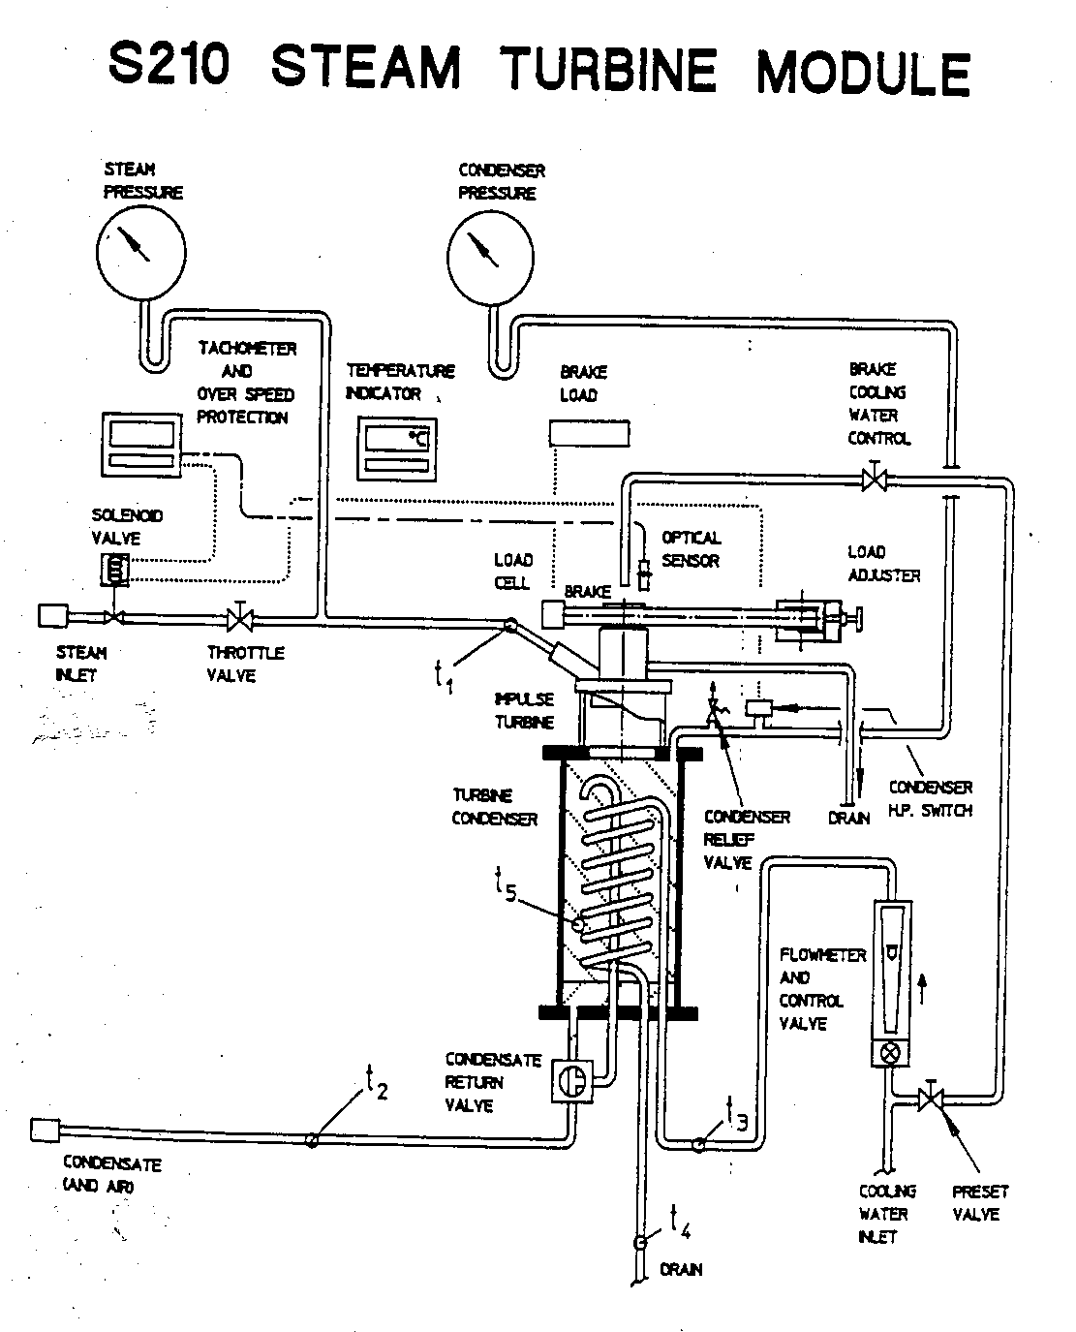

*Figure 1.1: Schematic of Hilton™ S210 Steam Module*

The turbine shaft is mounted vertically and runs in sealed ball bearings. It is fitted with a gland to reduce the ingress of air when the turbine is exhausting below atmospheric pressure. The turbine rotor is positioned at the lower end of the shaft and the brake is at the upper end. The turbine is of the single stage, axial flow impulse (De Laval) type and has a single convergent divergent nozzle to expand the steam (see Figure 1.2). After passing through the rotor blades the steam flows directly into a glass wall water cooled condenser.

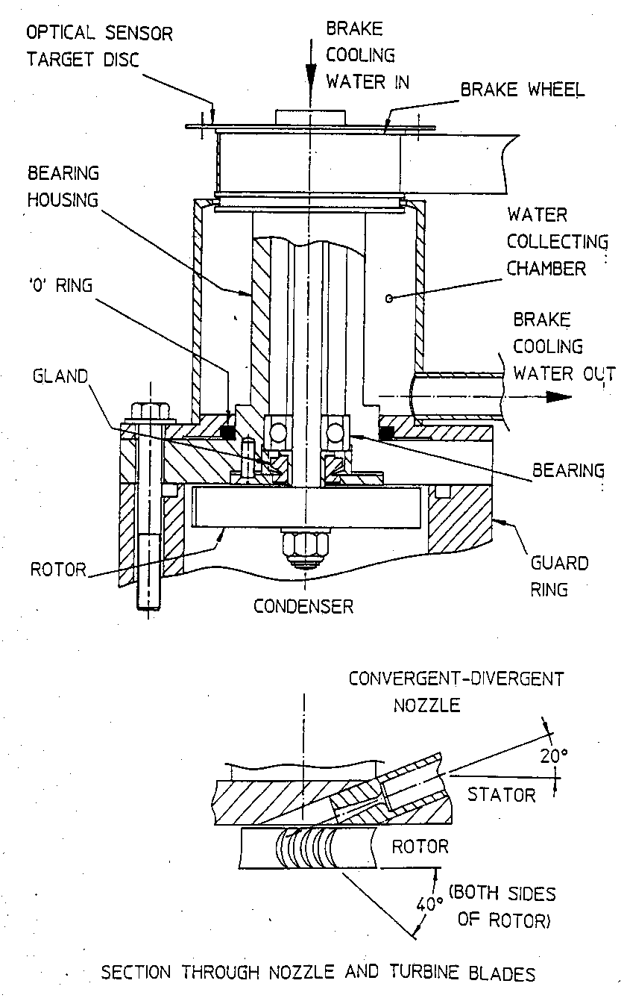

*Figure 1.2: Detail Drawing of Turbine and Convergent-Divergent Nozzle in Hilton™ S210 Steam Module*

At the bottom of the condenser is a diverter valve which has two positions. In one position, both air and condensate from the turbine condenser are dumped to drain. In the other position, air only is extracted and the condensate is retained in the turbine condenser. In this way the steam consumption of the turbine may be measured directly by volume.

The brake drum at the upper end of the shaft runs against a belt which is tensioned by a pulley moved by the load adjuster to vary the frictional resistance. The frictional force is measured by a load cell and is displayed by a digital meter on the panel. Water for cooling the brake drum is supplied to a fitting at the top of the shaft and is later collected and drained away as it leaves the periphery of the drum. An optical sensor senses the rotational speed of the turbine and this is displayed by a digital tachometer on the panel.

Safety Devices

Turbine Overspeed Protection

This turbine is not fitted with a governor and at certain operating conditions with a small load the turbine may reach an unacceptable rotational speed. To prevent this, an overspeed trip or protector is fitted. The tachometer which displays the rotational speed of the turbine is programmed to operate a main relay when the displayed speed exceeds 40,000 RPM. This de-energizes and closes the solenoid valve in the steam main, shutting off the supply of the steam to the turbine. When the speed has fallen, the solenoid valve may reopened by pressing the reset button which is located below the mains switch on the panel. It should be noted that the overspeed protection will be inoperative if the tachometer is not functioning correctly or the program has been interfered with.

Turbine Guard Ring

The turbine rotor revolves in a thick walled chamber designed to contain fragments in the unlikely event of failure.

Brake Shield

A transparent polycarbonate screen covers the brake to prevent access to the brake drum when the turbine is running. If the screen is removed the solenoid valve will close stopping the supply of steam. The screen must be replaced before the valve will reopen.

Condenser Overpressure Switch

If the condenser pressure exceeds a preset value (for example, due to the failure of cooling water), the solenoid valve will close, stopping the supply of steam. The solenoid valve must be manually reset.

Condenser Relief Valve

This is a spring loaded valve to relieve pressure in the condenser in the event of failure of the overpressure switch

Miniature Circuit Breaker (MCB)

The On/Off Switch on the front of the panel is an MCB and will cut out in the event of an overload caused by a short circuit. If this should cut out, the unit should be disconnected from the supply and the cause of the overload determined.

Residual Circuit Breaker (RCCB)

This is situated inside the panel and will isolate the unit when the incoming and outgoing currents differ by more than 30 mA as in a leakage to earth situation.

Specifications

Turbine

* Nozzle: Throat diameter 1.38 mm (nominal)

Exit Diameter 3 mm

Discharge Angle 20°

* Rotor: Blade Pitch Circle Diameter 45 mm

Number of Blades 45

Blade Inlet Angle 40°

Blade Outlet Angle 40°

* Brake: Pulley Diameter 40 mm

Effective Radius (to centerline of belt) 23 mm

Turbine may be used for any inlet condition up to 8 bar, 220°C and exhaust to vacuum. Maximum speed 40,000 RPM. Power 100 W approx. (according to conditions). Brake is water cooled mounted at upper end of turbine shaft with brake band tensioned by manually adjusted pulley. Friction force is measured by load cell

Condenser

* Heat Transfer Area 0.132 m2
* Specific Heat Capacity (*Cp*) of Water 4.18 kJ/kg-K

Condenser is made of strong glass walled chamber with water cooling coil. Fitted with two-way diverter valve and calibrated for condensate measurement.

Rotating Parts

* Moment of Inertia (*I*) 49.7 (10-6) kg-m3

Heat Loss from Turbine and Condenser to Surroundings

* Heat Transfer to Surroundings () = 3.2(*t5 – ta*) [W]



Where *t5* = temperature in condenser [°C]

*ta* = temperature of surroundings [°C]

Instruments

* Two pressure gauges for the steam pressure at nozzle inlet ranging from 0 to 8 bar g and condenser pressure ranging from -1 to +1 bar g.
* Multi-point digital temperature indicator with five Type K thermocouples. Resolution is 0.1 K.
* Digital tachometer for turbine rotational speed. Range is 0 to 99,999 RPM (high speed cut out set to 40,000 RPM)
* Digital brake load indicator to indicate brake frictional force. Range is 0 to 10 N.
* One flow meter for condenser cooling water. Range is 4 to 50 g/s

Services Required

* Electrical supply of 200W, 110/120V, single phase, 60 Hz
* Sediment free water at 3 litre/min at 15 m head

Control of Parameters

Turbine Inlet Pressure

The supply pressure from the Cleaver Brooks boiler (Concordia University - Hall Building) should be at least 90 psig or 6 bar g before opening the turbine throttle valve. The maximum turbine inlet pressure with the throttle valve fully open is determined by the quantity of steam available which is about 5 bar g.

Steam Condition

Steam leaving the boiler may be up to about 220°C but due to heat losses, it will normally have lost its superheat and become slightly wet by the time it reaches the turbine. The quality of the steam supplied to the turbine is most easily determined by an energy balance on the turbine and condenser.

Exhaust Pressure

The pressure of the steam leaving the turbine rotor is equal to the pressure in the condenser. However, the pressure in the condenser is equal to pressure of the steam plus the pressure of the air present. It follows that pressure of the steam within the condenser is less than the pressure of the steam leaving the rotor where there is no air present. This accounts for the discrepancy between the temperature in the condenser (*t5*) and the saturation temperature at exhaust pressure. The quantity of air present in the condenser is determined by the air leakage rate principally through the turbine shaft seal and the rate at which air is extracted by the Water Jet Air Ejector. Thus, the exhaust pressure is determined by the operation of the Air Ejector coupled with the flow rate and temperature of the condenser cooling water. Air may be admitted to the condenser by pulling on the ring on the condenser relief valve spindle.

Condensate Measurement

The diverter at the bottom of the condenser has two effective positions:

Handle horizontally forward (away from the panel): This allows condensate and air to leave the bottom of the condenser and flow to drain.

Handle horizontally backward (towards the panel): This allows air only to pass, the condensate being retained in the turbine condenser. Since the condenser has a volume calibration, the steam consumption rate can be measured with the aid of a stopwatch.

Brake Torque

The load on the turbine is set by the rotation of the load adjusting screw. This sets the tension of the belt loop between the turbine brake wheel and the temporary pulley. The torque developed by the turbine is converted into a tension force on the free end of the belt and this is recorded by a load cell. Due to the torque and speed characteristics of the turbine there may be a tendency for the speed to increase or decrease at a given setting of the load adjusting screw. Provided that the change of speed is gradual there will be no significant error when readings are taken.

Brake Load

The digital display shows the tension force or brake load developed by the turbine torque acting upon the brake belt. The display indicates directly in Newtons.

Zeroing the Brake Load Indicator

The indicator has five function keys used during the manufacture to configure the instrument. The two outer keys have been programmed to perform an auto zero function to remove any load cell offset error. The offset will appear as a small + or – indicated load even though no physical load is being applied to the load cell. Note that pressing any of the other keys will disturb the displayed value. However, the display will revert to normal after a 60 second delay.

To perform the auto zero function turn on the main switch to the unit. Detach the brake belt then press either of the outer keys on the brake load indicator. The display will show the word “ZERO” in upper and lower case letters. Press the same button again within 5 seconds and the display will indicate “0.00”. The display is now zeroed for the particular load cell offset error. Note that if the load is applied to the load cell during the auto zeroing procedure, a false zero will result that will be apparent when the load is removed. If this occurs, repeat the auto zero procedure with the load removed.

Rotational Speed

A disc having two diametrically opposed holes rotates within the turbine and is viewed by an optical sensor mounted on the turbine casing. The sensor thus receives two signals per shaft revolution and supplies these to the programmable tachometer. The tachometer counts pulses per second and multiplies this by some scale factor to give a display in RPM. The tachometer has facilities for operating a high speed and a low speed relay. These are used to operate to overspeed trip at 40,000 RPM and to cut off the brake cooling water below 6,000 RPM, respectively.

Brake Cooling Water

At maximum power, over 100 W is dissipated at the surface of the brake pulley. To prevent overheating, the pulley is water cooled, the flow being controlled by a small needle valve. There is a further coarse valve behind the panel which may be used to limit the flow. To prevent water overflowing at low speeds, a solenoid valve controlled by the tachometer cuts off the cooling water at speeds below 6,000 RPM. The cooling water should be set to maximum flow possible without overflowing at 6,000 to 8,000 RPM.

Temperature Indicator

The digital temperature indicator has five function keys on its front fascia. These are used only during the manufacture to configure the instrument. Pressing the keys may disturb the displayed value. The display will revert to normal after a 60 second delay. The individual temperature points referred to in Figure 3.1 are selected and displayed on the indicator by switching to the corresponding number on the selector switch below the digital temperature indicator.

Theory

Isentropic Efficiency

An ideal turbine would be one in which there is no wastage of available energy. Available energy is wasted by:

* Heat Losses
* Mechanical Friction
* Fluid Friction
* Shock losses associated with very high fluid velocities

Expansion of the fluid in a turbine in the absence of these losses would be adiabatic (i.e. no heat transfer) and reversible (i.e. no friction losses, etc.). An adiabatic and reversible process takes place at constant entropy and is said to be isentropic. An isentropic process is a thermodynamic ideal and cannot be achieved in practice. However, the performance of a real turbine may be set against the performance of an isentropic turbine in order to measure the effectiveness of design known as the isentropic efficiency (*ηs*):



both having the same inlet and exhaust conditions and the same flow rate.

The property charts usually used for steam are as shown in Figure 1.3. The coordinate axes are specific enthalpy (*h*) and specific entropy (*s*) and the chart has lines of constant pressure (*p*), constant temperature (*t*) and constant dryness fraction or quality (*x*). A process represented by a vertical line on this chart will have no change of entropy and represents an isentropic process.

The isentropic efficiency may be determined at any running condition. It is advisable to use conditions where it is known that the turbine will be developing close to its maximum power.

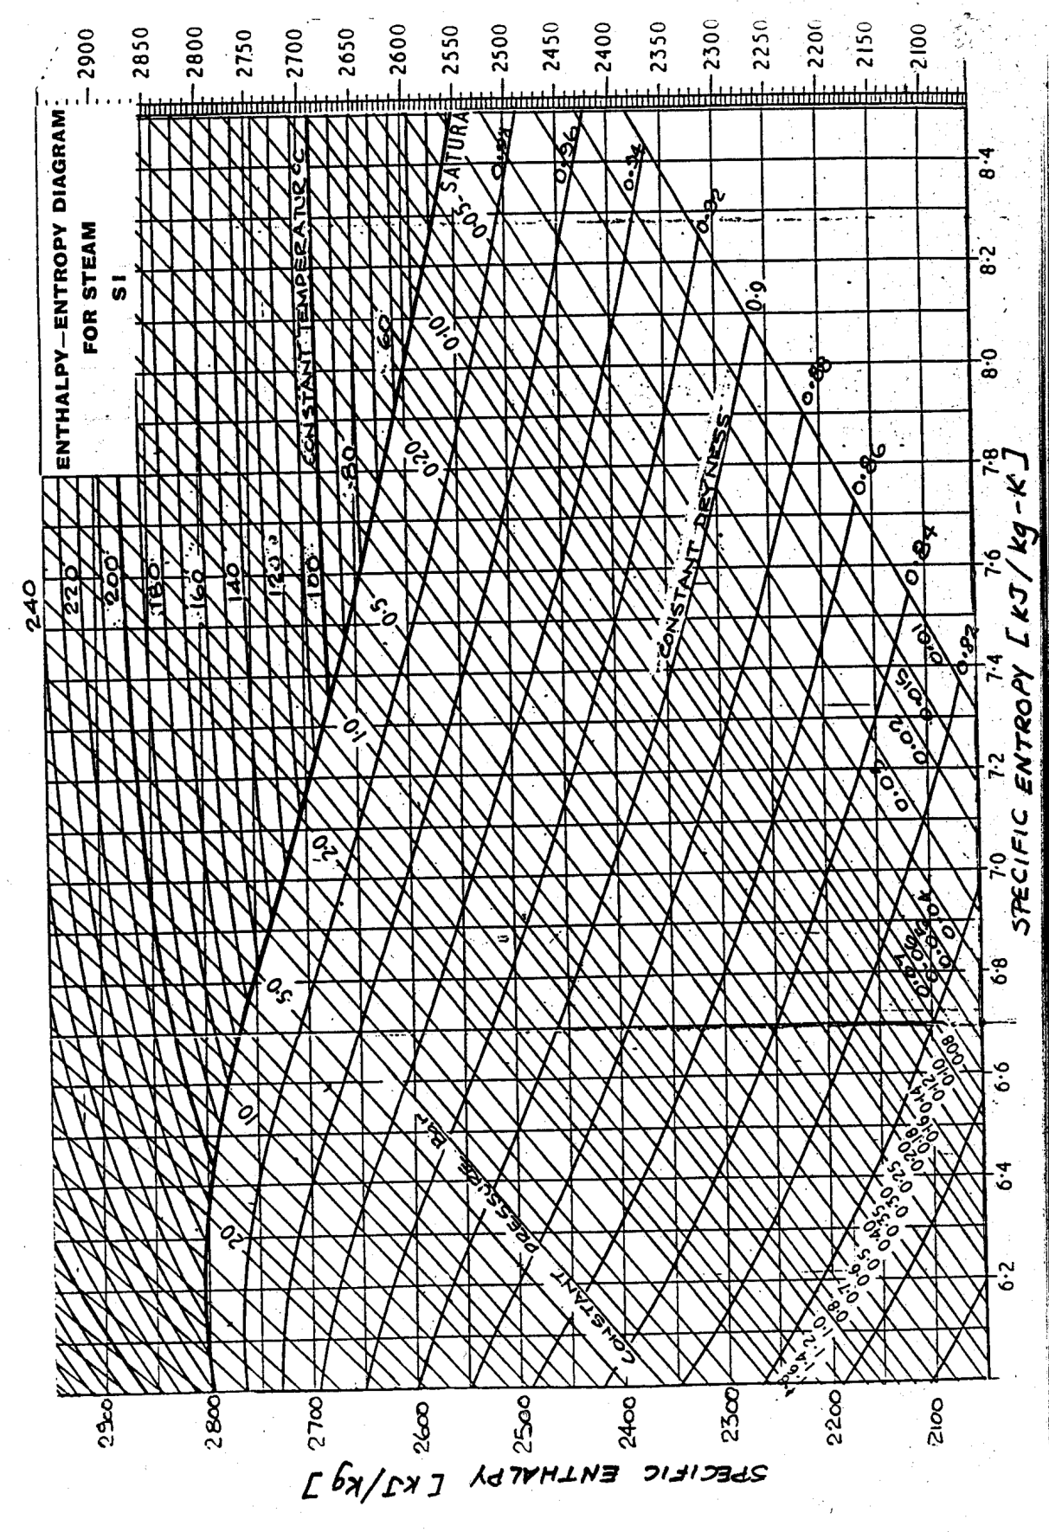

*Figure 1.3: Enthalpy-Entropy Diagram for Steam*

Thermal Efficiency

The thermal efficiency of a power plant is the ratio:



However, the ways in which the useful work output and the heat input are measured is important and thermal efficiency can be misleading if the bases used are not clearly defined. For example, in a generating station the useful work output is electrical energy but in other applications the mechanical shaft power is the useful output. Similarly, the heat input may be taken as the quantity of fuel consumed multiplied by its lower heating value89 or it may be taken as the actual heat transferred from the combustion products to the working fluid.

The thermal efficiency may be determined at any running condition but it is normal to use full load conditions, i.e. at maximum inlet pressure, minimum exhaust pressure and with the turbine load and speed for maximum power output.

The useful work output from a steam plant usually does not take into account the work input to feed pump because this value is small in comparison to turbine work.

Heat to Power Ratio

Condensing Turbine

For a given steam inlet condition, a turbine has its greatest power output when the exhaust pressure is at a minimum. A very low exhaust pressure (about 0.1 bar) can be obtained when a steam turbine discharges into a condenser cooled by water from the sea, a river or a cooling tower. Where the production of shaft power is only the consideration (as in most electricity generating stations) this is the normal exhaust arrangement.

Assuming this exhaust pressure, the steam will condense at about 40°C and if the condenser heat transfer surface is to be compact as possible, the cooling water temperature must not exceed 35°C. Water leaving a condenser at this temperature is not generally regarded as useful and is usually rejected to the environment.

Back Pressure Turbine

Most energy consumers have a demand for both electrical power (for motors, lighting, consumer goods, etc.) and heat (for space heating, process heating, hot water, etc.). The ratio of heat to power varies considerably from one consumer to another, from one climate to another and according to the time of day and year. Where suitable conditions exist a back pressure turbine may be employed to efficiently provide both types of energy from the one fuel (frequently low grade).

A back pressure turbine is smaller and produces less power than its condensing turbine counterpart but the heat available from the exhaust steam is valuable. For example, if the exhaust steam pressure is 1.0 bar, this can be used for heating duties to temperatures approaching 100°C. The pressures involved in industrial back pressure turbines vary considerably and a variety of more complex configurations are possible. However, in all cases, under suitable conditions the ratio (useful energy output/fuel heat input) is significantly greater than in a condensing turbine where the heat available from the exhaust steam is wasted. The heat/power ratio of a back pressure turbine is usually quite high (5 to 15 according to the size of the unit and pressures). Such an installation is therefore suited to process industries, for example, oil refining or sugar refining rather than for a manufacturing industry where the energy need is mainly electrical.

Internal Combustion Engines

The larger diesel and gas engines used for power generation convert between 25% and 40% of the fuel heat into electrical energy. A portion of the remaining energy which passes into the engine cooling system and exhaust gases may be recovered for space or process heating. It will be seen that the heat power ratio for an inernal combustion engine is between 1 and 2.

Gas Turbines

Industrial gas turbines convert from about 15% to 25% of the fuel heat into electricity, most of the remainder passes into the exhaust gases. In some industries the hot exhaust gases may be used directly for drying but frequently a waste gas boiler is used to generate steam or hot water. Exhaust gases from a gas turbine contain much of the oxygen from the air and it is possible to burn more fuel in this to boost the heat output. Thus the heat/power ratio when a gas turbine is used is usually greater than about 3.

Experimental Capabilities and Procedure

The experimental capabilities of this steam turbine unit are to determine:

1. Frictional losses at various exhaust pressures
2. Torque, power and specific steam consumption when operating
   1. At constant inlet pressure but with varying exhaust pressure
   2. At constant exhaust pressure but with varying inlet pressure
3. Isentropic and thermal efficiency (Efficiencies)
4. Heat to Power ratio at various exhaust pressures

Below is the procedure to be performed for each experimental capability.

Frictional Losses at Various Exhaust Pressures

1. Before starting the turbine, remove the polycarbonate shield.
2. Slacken the load adjuster screw and remove the belt from contact with the pulley.
3. Replace the shield.
4. Prepare, start and warm the turbine as instructed.
5. With a stopwatch, note the time taken for say 50 updates of the tachometer display. Then calculate the time interval between display changes (usually about 1 sec).
6. Practice noting down the first three digits of alternate tachometer displays as the turbine speed is changing fairly rapidly. Two persons are required, one to call out the readings and the other to take notes.
7. Set the exhaust pressure to -0.50 bar g then gradually open the throttle valve until the turbines runs close to 40,000 RPM.
8. Shut off the steam supply by allowing the overspeed trip to operate.
9. Note the first three or four digits of alternate tachometer displays as the turbine speed falls to 10,000 RPM.
10. Bring the turbine up to 40,000 RPM and repeat until satisfied with the observations.

Torque, Power and Specific Steam Consumption

At Constant Inlet Pressure But With Varying Exhaust Pressure

1. Make sure the brake belt is properly installed or ask the technician on site.
2. Prepare, start and warm up the turbine.
3. Using the air ejector, set the turbine condenser pressure to -0.50 bar g.
4. Fully open the throttle valve and at the same time set the load adjuster so that the turbine run at about 15,000 RPM
5. When conditions have settled note the turbine inlet pressure – this will be the constant inlet pressure (about 4.5 bar g) to be used throughout the test (small adjustments of the throttle may be necessary to maintain this).
6. Set the load adjuster until the turbine runs about 38,000 RPM then note the brake load and approximate speed display. Allow about 1 minute for the readings to stabilize.
7. Repeat at approximately 30000, 22000, 14000 and 8000 RPM by increasing the brake load.
8. Using the condensate return valve at the bottom of the condenser, note the time to collect 200 cm3 of condensate (this can be done at any speed since the steam flow rate is a function of the inlet and exhaust conditions only).
9. Immediately after noting the steam flow rate, return the valve lever to the forward position so the condensate can go to drain.
10. Turn off the air ejector and adjust the turbine condenser pressure to -0.25 bar g by venting through the relief valve then repeat steps 5 through 9.
11. Repeat at turbine condenser pressure of 0 bar g.

At Constant Exhaust Pressure But With Varying Inlet Pressure

1. Make sure the brake belt is properly installed or ask the technician on site.
2. Prepare, start and warm up the turbine.
3. By using the air ejector, set and maintain a turbine condenser pressure of -0.5 bar g (this will be the constant exhaust pressure to be used throughout the test).
4. Fully open the throttle valve and at the same time set the load adjuster so that the turbine can run at about 15,000 RPM.
5. When conditions have settled set the turbine inlet pressure to about 4.0 bar g. This is to be kept constant for steps 6 to 9 below.
6. Set the load adjuster until the turbine runs about 38,000 RPM then note the brake load.
7. Repeat at approximately 30000, 22000, 14000 and 8000 RPM by increasing the brake load.
8. Using the condensate return valve at the bottom of the condenser, note the time to collect 200 cm3 of condensate (this can be done at any speed since the steam flow rate is a function of the inlet and exhaust conditions only).
9. Immediately after noting the steam flow rate, return the valve lever to the forward position so the condensate can go to drain.
10. Using the throttle valve, reduce the turbine inlet pressure to about 1.0 bar less than initially (without changing the exhaust pressure) and repeat actions in steps 5 to 9 above.
11. Repeat in similar decrements of inlet pressure until the inlet pressure is about 2.0 bar g. Note at lower inlet pressures it may be not possible to reach higher speeds.

Efficiencies

1. Prepare, start and warm up the turbine.
2. Set the turbine inlet pressure, turbine exhaust pressure and speed to the selected values as indicated on the corresponding data sheet for Test No. C1.
3. When conditions have stabilized make the observations set out on the corresponding data sheet.

Results

Frictional Losses at Various Exhaust Pressures

1. Plot a graph of rotational speed versus time (Retardation Curve)l. Use a best fit curve technique (i.e. third order polynomial) to get a smooth curve.
2. Calculate the gradient (angular retardation due to frictional resistance or *αf*) of the speed/time curve at 35000, 30000, 25000, 20000 and 15000 RPM in [rad/s2].
3. Plot angular retardation versus rotational speed.
4. Calculate the frictional torque (*Tf*) in [N-m] and power (*Pf*) in [W] using the angular retardation at 35000, 30000, 25000, 20000 and 15000 RPM and moment of inertia. Tabulate the results.
5. Plot frictional torque and power versus rotational speed.

Torque, Power and Specific Steam Consumption

At Constant Inlet Pressure But With Varying Exhaust Pressure (A1-A5, B1-B5 and C1-C5)

1. Calculate and tabulate the following parameters:

* Brake Torque (*T*) in [N-m]
* Shaft Power (*P*) in [kW]
* Steam Consumption () in [kg/s]



* Specific Steam Consumption in [kg/kW-h]

1. Plot brake torque versus rotational speed for different turbine exhaust pressures at the constant inlet pressure.
2. Plot shaft power versus rotational speed for different turbine exhaust pressures at the constant inlet pressure.
3. Plot specific steam consumption versus rotational speed for different turbine exhaust pressures at the constant inlet pressure.

At Constant Exhaust Pressure But With Varying Inlet Pressure (D1-D5, E1-E5 and G1-G5)

1. Calculate and tabulate the following parameters:

* Brake Torque (*T*) in [N-m]
* Shaft Power (*P*) in [W]
* Steam Consumption () in [kg/s]



* Specific Steam Consumption in [kg/kW-h]

1. Plot brake torque versus rotational speed for different turbine inlet pressures at the constant exhaust pressure.
2. Plot shaft power versus rotational speed for different turbine inlet pressures at the constant exhaust pressure.
3. Plot specific steam consumption versus rotational speed for different turbine inlet pressures at the constant exhaust pressure.

Efficiencies (A1, B1 and C1 only)

1. Calculate and tabulate the following parameters:

* Heat Transfer to Cooling Water () in [W]



* Heat Transfer to Surroundings () in [W]



* Condensate Leaving Enthalpy (*ho*) in [kJ/kg]

1. Apply First Law of Thermodynamics using the Steady-State, Steady-Flow Equation to the turbine and condenser to determine the turbine inlet enthalpy (*hi*) in [kJ/kg]. Make a sketch of the control volume indicating inlet and outlet properties.
2. With the aid of Figure 2.3, determine the possible steam inlet quality (*x*) and isentropic turbine power (*Pi*) in [W].
3. Calculate the isentropic efficiency (*ηit*) and thermal efficiency (*ηth*).

Data

Frictional Losses at Various Exhaust Pressures

|  |  |  |  |  |  |  |  |  |  |  |
| --- | --- | --- | --- | --- | --- | --- | --- | --- | --- | --- |
| Interval | 1 | 2 | 3 | 4 | 5 | 6 | 7 | 8 | 9 | 10 |
| Speed [RPM (10-2)] |  |  |  |  |  |  |  |  |  |  |
| Interval | 11 | 12 | 13 | 14 | 15 | 16 | 17 | 18 | 19 | 20 |
| Speed [RPM (10-2)] |  |  |  |  |  |  |  |  |  |  |
| Interval | 21 | 22 | 23 | 24 | 25 | 26 | 27 | 28 | 29 | 30 |
| Speed [RPM (10-2)] |  |  |  |  |  |  |  |  |  |  |
| Interval | 31 | 32 | 33 | 34 | 35 | 36 | 37 | 38 | 39 | 40 |
| Speed [RPM (10-2)] |  |  |  |  |  |  |  |  |  |  |

Total Time [s]: _______________

Ambient Temperature [°F]: _______________

Atmospheric Pressure [in Hg]: _______________

Exhaust Pressure [bar g]: _______________

Torque, Power and Specific Steam Consumption

At Constant Inlet Pressure But With Varying Exhaust Pressure

|  |  |  |  |  |  |
| --- | --- | --- | --- | --- | --- |
| Test No. | Turbine Inlet Pressure | Turbine Exhaust Pressure | Rotational Speed | Brake Load | Time for 200 cm3 Condensate |
|  | [ bar g] | [ bar g] | [RPM] | [N] | [s] |
| **A1\*** | **4.5** | **-0.5** | **38,000** |  |  |
| A2 | 30,000 |  |
| A3 | 22,000 |  |
| A4 | 14,000 |  |
| A5 | 8,000 |  |
| **B1\*** | **4.5** | **-0.25** | **38,000** |  |  |
| B2 | 30,000 |  |
| B3 | 22,000 |  |
| B4 | 14,000 |  |
| B5 | 8,000 |  |
| **C1\*** | **4.5** | **0** | **38,000** |  |  |
| C2 | 30,000 |  |
| C3 | 22,000 |  |
| C4 | 14,000 |  |
| C5 | 8,000 |  |

* Record all temperatures in the “Efficiencies” Data section.

At Constant Exhaust Pressure But With Varying Inlet Pressure

|  |  |  |  |  |  |
| --- | --- | --- | --- | --- | --- |
| Test No. | Turbine Inlet Pressure | Turbine Exhaust Pressure | Rotational Speed | Brake Load | Time for 200 cm3 Condensate |
|  | [ bar g] | [ bar g] | [RPM] | [N] | [s] |
| D1 | 4.0 | -0.5 | 38,000 |  |  |
| D2 | 30,000 |  |
| D3 | 22,000 |  |
| D4 | 14,000 |  |
| D5 | 8,000 |  |
| E1 | 3.0 | -0.5 | 38,000 |  |  |
| E2 | 30,000 |  |
| E3 | 22,000 |  |
| E4 | 14,000 |  |
| E5 | 8,000 |  |
| F1 | 2.0 | -0.5 | 38,000 |  |  |
| F2 | 30,000 |  |
| F3 | 22,000 |  |
| F4 | 14,000 |  |
| F5 | 8,000 |  |

Efficiencies

|  |  |  |  |
| --- | --- | --- | --- |
| Test No.: | **A1** | **B1** | **C1** |
| Turbine Inlet Pressure [bar g]: | **4.5** | **4.5** | **4.5** |
| Turbine Exhaust Pressure [bar g]: | **-0.5** | **-0.25** | **0** |
| Rotational Speed [RPM]: | **38,000** | **38,000** | **38,000** |
| Condenser Cooling Water Flow Rate () [g/s]: | **50** | **50** | **50** |
| Inlet Steam Temperature (*t1*) [°C]: |  |  |  |
| Condensate Temperature (*t2*) [°C]: |  |  |  |
| Cooling Water Inlet Temperature (*t3*) [°C]: |  |  |  |
| Cooling Water Outlet Temperature (*t4*) [°C]: |  |  |  |
| Chamber Temperature (*t5*) [°C]: |  |  |  |

Boiler (Concordia University – Hall Building – 14th Floor)

Maximum Heat Input [W]: 1,226,000 (approx.)

Date: ______________________________

Section: _____________

Signature: ______________________________

Lab #

2

CyclePad

# Introduction

CyclePad is the first open source simulation software allowing the simulation of complex thermodynamic cycles. It is user-friendly and allows the determination of the characteristics of several simple to complex cycles (net work, heat input, thermal efficiency, Carnot efficiency etc…).

## Getting started

We would like to outline the steps involved in setting up a typical Rankine cycle, which is a very common ideal steam power cycle (see Figure 2.1). Using CyclePad, setting up such a cycle is actually very simple, but it requires that we know some of the basic facts and typical assumptions that apply to the cycle. We will examine a typical Rankine cycle problem and note the assumptions necessary to find the problem's solution, many of which will not be stated explicitly in the problem.

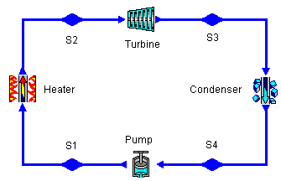

*Figure 2.1: Ideal Rankine Cycle Using Cyclepad*

## Typical Problem

Let's say we want to set up a typical Rankine Cycle. A typical problem statement is:

Consider an ideal steam cycle in which steam enters the turbine at 5 MPa, 400ºC, and exits at 10 kPa. Calculate the thermal efficiency and the net work per kilogram of steam.

This may not sound like a very complete problem description, since we are given only three numbers. However, it is sufficiently described that we can solve it. Here we will detail the other properties of a Rankine cycle which allow us to complete its design.

## What It Looks Like

First, an "ideal steam cycle" where we are only told of one turbine is probably a Rankine cycle. This cycle consists of a heater, a turbine, a cooler (or "condenser"), and a pump, in that order. We will talk about the properties of each component and the state points between them later. Right now we have enough to set up the cycle's basic layout.

# Analyzing Our Design

With the design layout complete, we turn to adding the assumptions which allow CyclePad to solve the cycle. For this example, we will go around the design and add what information we know as we go, clicking on each device or state point to get its meter window to show up. It is particularly during this stage that our own knowledge of thermodynamics is critical to making assumptions CyclePad will use in design solution. We start at the heater.

## The Heater (HTR1)

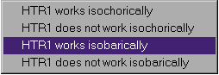

We aren't explicitly told anything about the heater, but we know that a Rankine cycle has ideal components. Heaters are usually a long series of tubes through which the working fluid is forced. As it moves through the tubes, heat (from a combustion process, for instance) is applied to the outside of the tubes and the working fluid gains enthalpy. In real heaters, it takes energy to push the fluid through all of these tubes and there is a pressure loss for the process. In an ideal heater, we assume that this pressure loss is negligible and the heater is isobaric.

(When we consider non-ideal components, we are often given a pressure loss (or a relation that allows us to compute a pressure loss) for the heater. In that case, we could enter the pressure loss as delta-P for the heater.)

We also notice that we might assume the heater to be isochoric (no change in specific volume or density). Since we will have liquid water entering the heater but steam (which is far less dense) leaving it, we know this is not the likely assumption for an ideal heater.

## The Turbine Inlet (S2)

Looking now at the state point after the heater, we know both the pressure and temperature of the fluid at this state point from the problem statement. In addition, we are dealing with a steam cycle, so our working fluid is made of water.

We are also given the temperature and pressure at this state point. Entering their values, this state point's intensive values are completely determined.

When T and P have been entered, CyclePad pauses for a second and figures out the other intensive properties at this state point, like specific volume, specific internal energy, etc (see Figure 2.2). If we were doing this problem by hand, these are all values we would have to look up in tables.

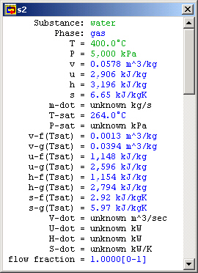

*Figure 2.2: Turbine Inlet (S2) properties*

## The Turbine (TUR1)

The next component is the turbine. While we aren't told anything explicitly about this turbine, it is ideal. In general, this means it is isentropic (zero change in entropy) and adiabatic (no heat transfer). Even if we did not know that it was ideal, we would probably assume it to be adiabatic because we have not been told how much heat transfer takes place and we have no way to figure it out.

## The Turbine Outlet (S3)

At the outlet of the turbine, we notice that the specific entropy is already known. (It is the same as that for the state point before the turbine because the turbine is isentropic.) We are told in the problem that steam exits at 10 kPa, so we assume the pressure at this state point to have that value. Since we now know both the pressure and the entropy at this state point, we know all of the intensive property values here. (Once again, CyclePad has saved us much time in table lookup, especially since this state point would require interpolation to find.)

## Other Turbine Outlet Assumptions

We are told the turbine outlet pressure in this problem, and that is the most common case, but there are other possibilities as well. We might instead know:

* The turbine pressure ratio (PR). In this case, there would be nothing to enter at S3, and we would assume a value for PR in the turbine's meter window.
* The turbine outlet quality. Turbines can typically only handle fluid down to a certain quality; lower qualities can damage them. But we want the quality to be as low as the turbine can handle in order to extract the most energy from the working fluid. In such cases, we often assume a quality at the turbine outlet and let the state be determined by that and the outlet entropy.

Note that the turbine outlet quality of 80% is dangerously low for practical use. We might wish to address this problem by adding a reheat stage.

## The Cooler (CLR1)

Similar to an ideal heater (and for the same reasons), an ideal cooler has no pressure drop, so we make the isobaric assumption here as we did with HTR1.

## The Pump Inlet (S4)

This is a state point when our own knowledge and reasoning about cycles is key to making assumptions. The only reason we have a cooler before the pump at all is because we know pumps can be damaged by non-liquids. To avoid this, the cooler must condense all of the steam leaving the turbine into a liquid before we send it to the pump. So we at least want to cool our saturated working fluid to 0% quality before sending it to the pump. Figure 2.3 shows the region to which we must cool the working fluid before safely using a pump.

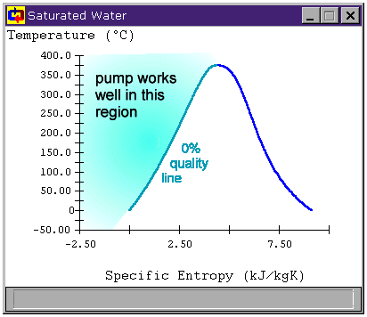

*Figure 2.3: T-s diagram for water*

Of course, pumps can work with compressed liquids as well, so we could cool the fluid even past saturated fluid down into the compressed liquid region. We do not do this for several reasons related to cycle efficiency.

For CyclePad, we can specify that a fluid be saturated by selecting a phase and choosing it to be saturated. Once we have told CyclePad that the phase is saturated, it adds another property to the meter window, allowing us to specify a quality. In this case, we want to assume that quality is zero, since we are forcing the fluid at S4 to be a saturated liquid.

## Other Pump Inlet Assumptions

Sometimes we can't cool the working fluid just until it is a saturated liquid. Most often this is because our cooling source is at a specified temperature and we cannot remove the working fluid from the cooler early enough. In these cases, we are usually given a temperature for this state.

## The Pump (PMP1)

We are given no explicit information about the pump, but, like the turbines, ideal pumps are adiabatic and isentropic. We assume both of those things here. Note, CyclePad uses the equation *wpump* = -*vΔP* to calculate reversible pump work because the fluid (liquid water) is very close to incompressible. Sometimes CyclePad finds a small heat transfer for the pump and, because this heat transfer isn't quite zero, CyclePad asserts that the pump is not adiabatic or causes a contradiction when we assert that the pump is adiabatic.

Why does this happen? The reason lays in the approximation that the water in the pump is incompressible, which is *very* close to accurate, but the slight variation in *v* between the saturated liquid at the inlet and the compressed liquid at the outlet causes this small heat transfer to show up, confusing CyclePad. This is more likely at low pump inlet pressures (under one atmosphere) than at higher ones.

For our purposes, this heat transfer is not important (it is typically on the order of 0.1% of the work done by the pump), so we can just not worry about whether the pump is adiabatic if some heat transfer has already been found or the adiabatic assumption causes a contradiction.

In general, we might try to change the order in which we make assumptions, just to be certain no contradictions occur later on. We could, for instance, always choose adiabatic before isentropic, or make the pump assumptions before those for the pump inlet. In these instances CyclePad will note the small heat transfer and assume that it is due to round-off accumulation.

## The Pump Outlet (S1)

Typically, this state is already known because we know the pressure (the same as for the turbine inlet for an isobaric heater) and the entropy (the same as for the pump inlet for an isentropic pump). In cases where this state is not known, it is because we have a non-ideal component in our system (such as a non-isobaric heater). In those cases the problem statement will typically include information about the pump outlet pressure or the pump's pressure ratio.

## Finishing The Problem

Our original problem was to find the thermal efficiency of this cycle. Go to the "Cycle" menu and choose "Cycle Properties". This meter window is mostly empty because CyclePad doesn't know which definitions for efficiencies to use and they are different for a heat engine (like our Rankine cycle) than they would be for a refrigeration cycle, for instance. Here we need to tell CyclePad that we are modeling a heat engine. We see that the Carnot efficiency is just over 52.6% (see Figure 2.4).

However, we notice that CyclePad still does not know the many of the values in this cycle. Among the unknown values is the net work per kg of steam and the thermal efficiency, which we are asked to find in the problem statement. The reason is that CyclePad finds some whole cycle properties based on extensive values, which are not known until we assume a mass flow rate (m-dot). (In other words, CyclePad needs the whole heat transfer *Q*, not the specific heat transfer *q*).

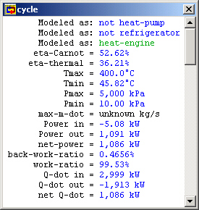

*Figure 2.4: Cycle Properties*

# Problems

Solve the following problems using CyclePad

1. Consider an ideal Rankine cycle in which steam enters the turbine at pressure of 3 MPa and a temperature of 450°C. The pressure within the condenser is 50 kPa.
2. Compute the actual Carnot and thermal efficiencies.
3. Plot the T-s diagram for the actual Rankine cycle.
4. Plot and comment the variations in (i) Carnot and thermal efficiencies (ii) steam quality at turbine outlet; for inlet turbine temperatures of [450 500 550 600] °C.
5. Plot and comment the variations in (i) Carnot and thermal efficiencies (ii) steam quality at turbine outlet; for condenser pressures of [50 40 30 20 10] kPa.
6. Consider now an ideal regeneration Rankine cycle working under the same conditions as above.
7. Represent using CyclePad the ideal regenerative Rankine cycle.
8. Plot and comment the variations in thermal efficiency for feedwater heater pressures of [200 400 600 800 1000] kPa.

Lab #

3

Jet Engine – Brayton Cycle

Theory

The Brayton cycle depicts the air-standard model of a gas turbine power cycle. A simple gas turbine is comprised of three main components: a compressor, a combustor, and a turbine. According to the principle of the Brayton cycle, air is compressed in the compressor. The air is then mixed with fuel, and burned under constant pressure conditions in the combustor. The resulting hot gas is allowed to expand through a turbine to perform work. Most of the work produced in the turbine is used to run the compressor and the rest is available to run auxiliary equipment and produce power. The gas turbine is used in a wide range of applications. Common uses include stationary power generation plants (electric utilities) and mobile power generation engines (ships and aircraft). In power plant applications, the power output of the turbine is used to provide shaft power to drive a generator, a helicopter rotor, etc. A jet engine powered aircraft is propelled by the reaction thrust of the exiting gas stream. The turbine provides just enough power to drive the compressor and produce the auxiliary power. The gas stream acquires more energy in the cycle than is needed to drive the compressor. The remaining available energy in the working fluid (the air passing through the engine) is used to propel the aircraft forward by being converted from high potential energy (enthalpy) into high kinetic energy (jet velocity) in the nozzle at the exhaust end of the engine.

A schematic of the Brayton (jet propulsion) cycle is given in Figure 3.1. Low-pressure air is drawn into a compressor (state 1) where it is compressed to a higher pressure (state 2). Fuel is added to the compressed air and the mixture is burnt in a combustion chamber. The resulting hot gases enter the turbine (state 3) and expand to state 4. The Brayton cycle consists of four basic processes:

* 1 → 2 Isentropic Compression
* 2 → 3 Reversible Constant Pressure Heat Addition
* 3 → 4 Isentropic Expansion
* 4 → 1 Reversible Constant Pressure Heat Rejection (Exhaust and Intake in the open cycle)



*Figure 3.1: Basic Brayton Cycle*

In addition to the processes described above for a simple Brayton cycle, the jet propulsion cycle includes a diffuser at the inlet of the compressor to slow down incoming air, and a nozzle at the exit of the turbine to produce a high velocity exhaust jet for propulsive thrust. When jet engines are tested at static conditions (i.e., no forward velocity) then the inlet diffuser is normally replaced with a bell shaped inlet to assure smooth flow into the compressor.

CYCLE ANALYSIS

Thermodynamics and the First Law of Thermodynamics determine the overall energy transfer. To analyze the cycle, we need to evaluate all the states as completely as possible. Air standard models are very useful for this purpose and provide acceptable quantitative results for gas turbine cycles. In these models the following assumptions are made.

* The working fluid is air and treated as an ideal gas throughout the cycle;
* The combustion process is modeled as a constant-pressure heat addition;
* The exhaust is modeled as a constant-pressure heat rejection process.

In cold air standard (CAS) models, the specific heat of air is assumed constant (perfect gas model) at the lowest temperature in the cycle. The effect of temperature on the specific heat can be included in the analysis at a modest increase in effort. However, closed form solutions would no longer be possible.

To perform the thermodynamic analysis on the cycle, we consider a control volume containing each component of the cycle shown in Figure 3.1. This step is summarized below.

Compressor

Consider the following control volume for the compressor,

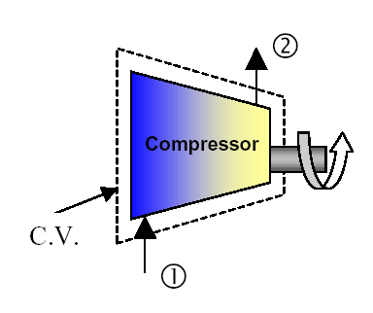

*Figure 3.2: Compressor Control Volume Model*

Note that ideally there is no heat transfer from the control volume (C.V.) to the surroundings (see Figure 3.2). Under steady-state conditions, and neglecting the kinetic and potential energy effects, the first law for this control volume is then written as:

 (3.1)

Considering that we have one flow into the control volume and one flow out of the control volume, we may write a more specific form of the first law as:

 (3.2)

Or, rearranging by grouping the terms associated with each stream,

 (3.3)

This is the general form of the First Law for a compressor. However, if the fluid stream is assumed to ideal gases we may represent the enthalpies in terms of temperature (a much more measurable quantity) by using the appropriate equation of state (dh = cpΔT), which will introduce the specific heat. Assuming constant specific heats, enthalpy differences are readily expressed as temperature differences as:

 (3.4)

To be more accurate, the specific heat of each fluid should be evaluated at the linear average between its inlet and outlet temperature,

 (3.5)

.

The irreversibilities present in the real process can be modeled by introducing the compressor efficiency,

 (3.6)

where the subscript s refers to the ideal (isentropic) process and the subscript a refers to the actual process. For a perfect gas the above equation is reduced to

 (3.7)

Combustor

Note that ideally there is work transfer from the control volume (C.V.) to the surroundings (see Figure 3.3). Under steady-state conditions, and neglecting the kinetic and potential energy effects, the first law for this control volume is then written as

 (3.8)

Considering that we have one flow into the control volume and one flow out of the control volume, we may write a more specific form of the first law as

 (3.9)

Or, rearranging by grouping the terms associated with each stream,

 (3.10)

Assuming ideal gases with constant specific heats, enthalpy differences are readily expressed as

temperature differences as

 (3.11)

Again, to be more accurate, the specific heat of each fluid should be evaluated at the linear average between its inlet and outlet temperature.

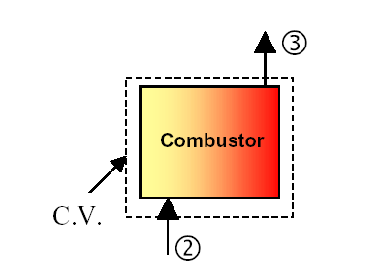

*Figure 3.3: Combustor Control Volume Model*

Turbine

Consider the following control volume for the turbine,

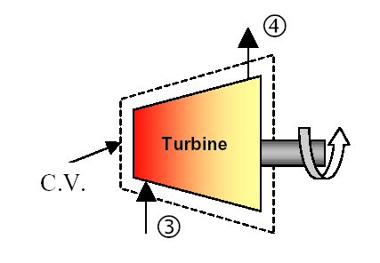

*Figure 3.4: Turbine Control Volume Model*

Note that ideally there is no heat transfer from the control volume (C.V.) to the surroundings. Under steady-state conditions, and neglecting the kinetic and potential energy effects, the first law for this control volume is then written as

 (3.12)

Considering that we have one flow into the control volume and one flow out of the control volume, we may write a more specific form of the first law as

 (3.13)

Or, rearranging by grouping the terms associated with each stream,

 (3.14)

Assuming ideal gases with constant specific heats, enthalpy differences are readily expressed as

temperature differences as

 (3.15)

As before, the specific heat of each fluid should be evaluated at the linear average between its inlet and outlet temperature for more accurate results.

The irreversibilities present in the real process can be modeled by introducing the turbine isentropic efficiency,

 (3.16)

where the subscript s refers to the ideal (isentropic) process and the subscript a refers to the actual process. For a perfect gas the above equation is reduced to

 (3.17)

## Nozzle

Consider the following control volume for the nozzle,

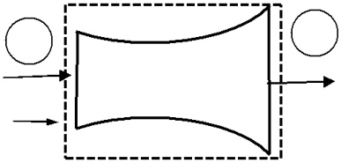

|  |  |  |  |
| --- | --- | --- | --- |
| **4** |  | **5** |  |
| Nozzle |  |  |
|  | Ve |  |
|  |  |  |

C.V.

*Figure 3.5: Nozzle Control Volume Model*

Note that ideally there is no heat transfer from the control volume (C.V.) to the surroundings and there is no work done on or by the nozzle. Under steady-state conditions, and neglecting potential energy effects, and assuming only one input and output stream, the first law for this control volume is then written as

 (3.18)

Assuming that the velocity entering the nozzle is negligible compared to the exhaust velocity, this can be written as

 (3.19)

Assuming ideal gases with constant specific heats,

 (3.20)

## Thermal Efficiency

The thermal efficiency is defined differently for a Brayton jet engine cycle than for a Brayton cycle for power production. For the jet engine case, the thermal efficiency is defined as the ratio of the rate of addition of kinetic energy to the air to the rate of energy input to the combustor. For the case when the engine is at static conditions, the efficiency becomes

 (3.21)

Apparatus

The apparatus is a self-contained, turnkey and portable propulsion laboratory manufactured by Turbine Technologies Ltd. called TTL Mini-Lab. The Mini-Lab consists of a real jet engine (see Figure 3.5). Therefore, the same safety concerns of running a jet engine are present. Care must be taken to follow all the safety procedures precisely as outlined in the laboratory and stated by your lab instructors. The following description of the setup is provided by the manufacturer.

*“A Turbine Technologies Model SR-30 turbojet engine is the systems primary component. Operational sound and smell are hard to distinguish from any idling, small business jet. The engine’s axial turbine wheel and vane guide ring are vacuum investment castings. They are produced from modern, high cobalt and nickel content super alloys (MAR-M-247 and Inconnel 718). The combustion chamber consists of an annular, counterflow system, including internal film cooling strips. Fuel and oil tanks, filters, oil cooler, all necessary plumbing and wiring is located in the lower part of the Mini-Lab structure. A throttle lever is located on the right side of the operator and above the slanted instrument panel. The throttle enables the operator to perform smooth power changes between idle and maximum N1. Digital engine RPM and E.G.T. gauges, mechanical E.P.R., Oil, Fuel, Air start pressure gauges are also part of the standard panel. Annunciator lights indicate low oil pressure, ignitor on, and air-start status. A key operated master switch controls the main electric power bus. Other panel-mounted switches control igniter, air start, and activate fuel flow. The SR-30 engine’s fuel system is very similar to large-scale engines—fuel atomization via 6 return flow high-pressure nozzles that allow operation with a wide variety of kerosene based liquid fuels (e.g. diesel, Jet A, JP-4 through 8).”*

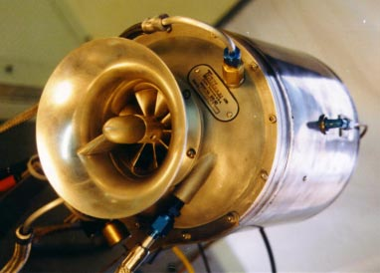

*Figure 3.5: Turbine Technologies’s “MiniLab” Engine*

ENGINE COMPONENTS

The engine consists of a single stage radial compressor, a counterflow annular combustor and a single stage axial turbine which directs the combustion products into a converging nozzle for further expansion. Details of the engine may be viewed from the ‘cutaway’ provided in Figure 3.6.

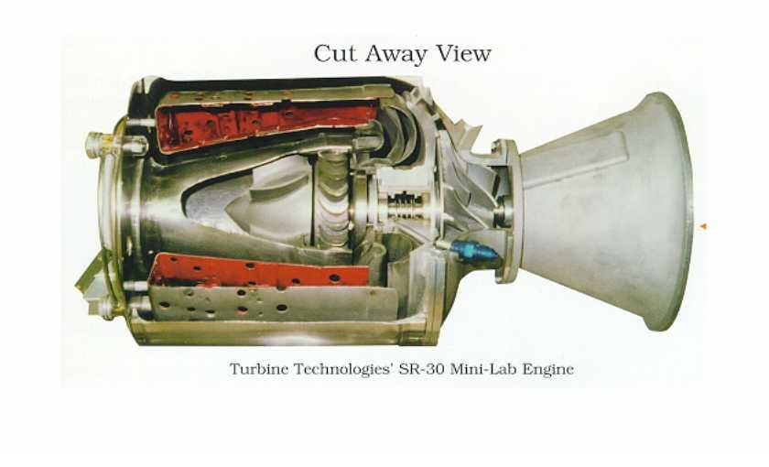.

*Figure 1..6: Turbine Technologies’ SR-30 Engine*

INSTRUMENTATION

The sensors are routed to a central access panel and interfaced with data acquisition hardware and software from National Instruments. The manufacturer provides the following description of the sensors and their location. The integrated sensor system (Mini-Lab) option includes the following probes:

* Compressor inlet static pressure (P1)
* Compressor stage exit stagnation pressure (P02)
* Combustion chamber static pressure (P3)
* Turbine exit stagnation pressure (P04)
* Thrust nozzle exit stagnation pressure (P05)
* Compressor inlet static temperature (T1)
* Compressor stage exit stagnation temperature (T02)
* Turbine stage inlet stagnation temperature (T03)
* Turbine stage exit stagnation temperature (T04)
* Thrust nozzle exit stagnation temperature (T05)

Additionally, the system includes a fuel flow sensor and a digital thrust readout measuring real time thrust force based upon a strain gage thrust yoke system.

Procedure

SAFETY NOTES

1. Make sure you are wearing ear protection. If you are not sure how the earplugs are properly used, ask you lab instructor for a demonstration. Never stay in the laboratory without ear protection while the engine is in operation.
2. The SR-30 engine operates at high rotational speeds. Although there is a protective pane that separates the engine from the operator, make certain that you do not lean too close to this pane.
3. Make sure the low-oil-pressure light goes off immediately after an engine start. If it stays on or comes on **at any time** during the engine operation cut off the fuel flow **immediately**.
4. There is a vibration sensor whose indicator is to the far right of the operator’s panel. If this indicator shows any activity (increase in voltage) shut-off the engine **immediately**.
5. If at any time you suspect something is wrong shut off the fuel immediately and notify the lab instructor.
6. If the engine is hung (starts but does not speed up to idle speed of about 40,000 rpm) turn the air-start back on for a short while until the engine speeds up to about 30,000 rpm. Then turn off the air-start switch.
7. **MAKE SURE NEITHER YOU NOR ANY OF YOUR BELONGINGS ARE PLACED IN FRONT OF THE INTAKE TO OR EXHAUST FROM THE ENGINE WHEN THE ENGINE IS RUNNING.**

EXPERIMENT

1. Ask your lab instructor to load the data acquisition program and run the pre-programmed LabView VI for this lab. The screen should display readings from all sensors. Review the readouts to make sure they are working properly.
2. Make sure that the air pressure in the compressed-air-start line is at least 100 psia (not exceeding 120 psia). Ask your lab instructor to check the oil level.
3. Ask the help of your lab instructor turn on the system and start the engine. After the engine is successfully started, you must first allow the engine to achieve the idle speed before making any measurements. Make sure the throttle is at its lowest point. The idle position is nearly vertical, and is close to the operator (away from the engine).
4. Slowly open the throttle. Start taking data at about 60,000 rpm. Make sure that you allow the engine time to reach steady state by monitoring the digital engine rpm indicator on panel. The reading fluctuates somewhat so use your judgment.
5. Take data at three different engine speeds. You will use the data to study how cycle and component efficiencies change with speed.

Results

1. Using the collected data determine the turbine isentropic efficiency, compressor isentropic efficiency, the thermal efficiency of the cycle and the corresponding Carnot efficiency at 3 different average speeds. Take average values of the data.
2. Plot the T-s diagram for the cycle for the maximum speed case. Also plot the ideal cycle case on the same plot. Give T and s values on the axes corresponding to the principal states you used in your analyses (measured and calculated for isentropic processes).
3. Determine the performance of the ideal cycle operating with the same maximum cycle temperature and compression ratio. Compare the performance of the ideal cycle with measured performance. Discuss the differences.
4. How does the cycle efficiency compare with the ideal Brayton and Carnot cycle?
5. How do the component efficiencies you calculated based on your test data compare with those of typical of those gas turbine engines?

Data

* Data is saved on 3.5” diskette or USB flash drive (provided by students).

Lab #

4

**Water Chiller**

Introduction

As summer sets in and the temperature outside begins to climb, many people seek the cool comfort of indoor air conditioning. Like water towers and power lines, air conditioners are one of those things that we see every day but never really pay much attention to. Air conditioners come in various sizes, cooling capacities and prices. One type that we see all the time is the window air conditioner. Most businesses and office buildings have condensing units on their roofs, and as you fly into any airport you notice that warehouses and malls may have 10 or 20 condensing units hidden on their roofs. And then if you go around back at many hospitals, universities and office complexes, you find large cooling towers that are connected to the air conditioning system:

Window Air Conditioner

This unit implements a complete air conditioner in a small space (see Figure 4.1). The units are made small enough to fit into a standard window frame. You close the window down on the unit, plug the unit in and turn it on to get cool air. If you take the cover off of an unplugged window unit, you will find that it contains the following:

* Compressor
* Expansion Valve
* Hot Coil (on the outside)
* Chilled Coil (on the inside)
* 2 Fans
* Control Unit

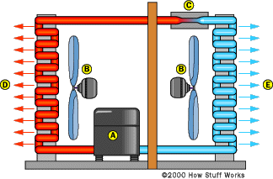

ac-indoor-labels

*Figure 4.1: Window Air Conditioner Unit*

The fans blow air over the coils to improve their ability to dissipate heat (to the outside air) and cold (to the room being cooled).

Split-System Air Conditioner

This unitsplits the hot side from the cold side of the system as shown in Figure 4.2:

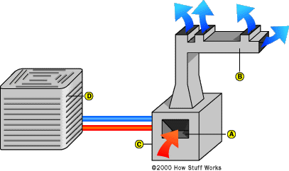

ac-home-labels

*Figure 4.2: Spilt-System Air Conditioner Unit*

The cold side, consisting of the expansion valve and the cold coil, is generally placed into a furnace or some other air handler. The air handler blows air through the coil and routes the air throughout the building using a series of ducts. The hot side, known as the condensing unit, lives outside the building. In most home installations the unit looks like a wide cylinder or box. The unit consists on a long, spiral coil shaped like a cylinder. Inside the coil is a fan to blow air through the coil along with a weather-resistant compressor and some control logic. This approach has evolved over the years because it is low cost, and also because it normally results in reduced noise inside the house (at the expense of increased noise outside the house). Besides the fact that the hot and cold sides are split apart and the capacity is higher (making the coils and compressor larger), there is no difference between a split-system and a window air conditioner. In warehouses, businesses, malls, large department stores, etc., the condensing unit normally lives on the roof and can be quite massive. Alternatively, many smaller units are found on the roof, each attached inside to a small air handler that cools a specific zone in the building.

Chilled-Water System

In larger buildings and particularly in multi-story buildings, the split-system approach begins to run into problems. Either running the pipe between the condenser and the air handler exceeds distance limitations (runs that are too long start to cause lubrication difficulties in the compressor), or the amount of duct work and the length of ducts becomes unmanageable. At this point, it is time to think about a chilled-water system as illustrated in Figure 4.3.

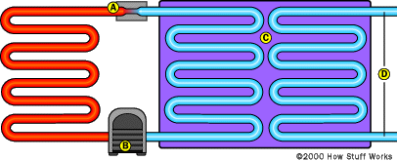

ac-water-labels

*Figure 4.3: Chilled-Water System*

In a chilled-water system, the entire air conditioner lives on the roof or behind the building. It cools water to between 4°C and 7°C. This chilled water is then piped throughout the building and connected to air handlers as needed. There is no practical limit to the length of a chilled-water pipe if it is well-insulated.

As shown in Figure 4.3 the air conditioner (on the left) is completely standard. The heat exchanger lets the cold refrigerant chill the water that runs throughout the building.

Cooling Tower

In all of the systems described above, air is used to dissipate the heat from the outside coil. In large systems, the efficiency can be improved significantly by using a cooling tower. The cooling tower creates a stream of lower-temperature water. This water runs through a heat exchanger and cools the hot coils of the air-conditioner unit. It costs more to buy the system initially, but the energy savings can be significant over time (especially in areas with low humidity), so the system pays for itself fairly quickly.

Cooling towers come in all shapes and sizes, however, they all work on the same principle:

* A cooling tower blows air through a stream of water so that some of the water evaporates.
* Generally the water trickles through a thick sheet of an open plastic mesh.
* Air blows through the mesh at right angles to the water flow.
* The evaporation cools the stream of water.

Because some of the water is lost to evaporation, the cooling tower constantly adds water to the system to make up the difference. The amount of cooling that you get from a cooling tower depends on the relative humidity of the air and the barometric pressure.

Apparatus

The laboratory water chiller system is representative of a conventional water chiller operating on a vapour compression refrigeration cycle. The theory of vapour compression refrigeration cycles (water chillers and heat pumps) presented in basic thermodynamics textbooks focuses on the properties and flow rate of the refrigerant. The properties and flow rate of the refrigerant depend on the following:

* Source Temperature and Heat Capacity Rate
* Sink Temperature and Heat Capacity Rate
* Component Capacities and Performance Characteristics

An experimental investigation of the performance of a chiller system should therefore include the source, the sink and the components.

The chiller considered consists of four basic major components - an evaporator, a condenser, a compressor, and a thermostatic expansion valve - and three fluids - a source, a sink, and a working fluid. The source is the hot water. The sink is the cold water. The working fluid is Refrigerant 134a. The water chiller also contains a receiver (to store excess refrigerant), a condenser water valve (to maintain constant condensation pressure by modulating the sink flow rate), an oil separator (to bypass the lubricant around the refrigerant flow meter), as well as components for on/off control. The system is shown schematically in Figure 4.4.



*Figure 4.4: Water chiller schematic diagram*

Starting at the compressor, the refrigerant is compressed and sent out of the compressor as a high temperature, high pressure, superheated gas. The refrigerant travels to the condenser (which is water cooled by city water). Before the refrigerant reaches the condenser, there is a slight drop in temperature better known as de-superheat gas. The condenser changes the refrigerant from a high temperature gas to a warm temperature liquid. It then travels into a receiver (optional component). It continues to the thermal expansion valve. The thermal expansion valve meters the proper amount of refrigerant into the evaporator. The thermal expansion valve takes the high pressure liquid and changes it to a low pressure cold saturated gas. This saturated gas enters the evaporator where it is changed to a cool dry gas (no liquid present). The cool "dry" gas then re-enters the compressor to be pressurized again.....The hot gas by pass (unloader assembly) is used to stabilize the cooling output of the refrigeration system by allowing hot gas to warm up the cool evaporator. This causes a reduction in to cooling efficiency and a stabilizing of the chilled water temperatures. There are a few other unloader concepts that are used in the refrigeration systems, but ideally accomplish the same outcome. There are also other specialized components such as solenoid valves, a liquid site glass, accumulators or subcoolers.

Theory

The theory present is intended to supplement, not replace, the theory presented in the textbook. The analysis considers only 4 key points. Heat losses and pressure losses are not considered. These key points must be related to the points monitored in the actual system as shown in Figure 4.4.

Components

The component models presented are the simplest ones available. The sign convention used is as follows: power output is positive, and heat transfer to a fluid is positive.

Evaporator

The rate of enthalpy loss by the source is the water chiller capacity:

 (4.1)

The rate of enthalpy gain by the refrigerant is:

 (4.2)

The performance of the evaporator is represented using the concept of exchanger heat transfer effectiveness. The energy balance for the evaporator is:

 (4.3)

For a heat exchanger in which one fluid is evaporating, the heat transfer rate is limited by the heat capacity rate of the source fluid, therefore the evaporator heat exchanger effectiveness is:

 (4.4)

The evaporation temperature is the saturation temperature corresponding to the evaporation pressure. The evaporation pressure is the low side pressure, i.e.:

 (4.5)

Condenser

The rate of enthalpy gain by the sink is:

 (4.6)

The rate of enthalpy loss by the refrigerant is:

 (4.7)

The performance of the condenser is represented by the following series of equations using the concept of exchanger heat transfer effectiveness. The energy balance for the condenser is:

 (4.8)

For a heat exchanger in which one fluid is condensing, the heat transfer rate is limited by the sink fluid, therefore the condenser heat transfer effectiveness is:

 (4.9)

The heat transfer rates related to superheated vapour and to subcooled liquid are relatively low compared to the heat transfer rate due to condensation. The condensation temperature is the saturation temperature corresponding to the condensation pressure. The condensation pressure is the high side pressure, i.e.:

 (4.10)

Condenser Water Valve

The condenser water valve maintains the condensation pressure constant at a preset valve by modulating the sink flow rate. The condenser water valve is essentially a globe valve. The position of the valve is determined by a balance of the condensation pressure (taken at point R,2) and a spring force. System performance is directly dependent on the condensation pressure setting, and indirectly dependent on the sink temperature and flow rate.

Compressor

The compressor is assumed to be adiabatic non-isentropic having an efficiency of:

 (4.11)

The isentropic compressor outlet state (R,2i) is defined by its entropy being equal to the inlet entropy (R*,*1) and its pressure being equal to the outlet pressure (R*,*2). The thermodynamic compressor power is

 (4.12)

The net system power output is:

 (4.13)

The mass flow rate of refrigerant is:

 (4.14)

The volumetric efficiency is:

 (4.15)

The rate of volumetric displacement of the compressor is = 640 ft3/hr. Its clearance volume ratio is c = 0.03.

Thermostatic Expansion Valve (TEV)

The thermostatic expansion valve provides an excellent solution to regulating refrigerant flow into a direct expansion type evaporator. The TEV regulates refrigerant flow by maintaining a nearly constant superheat at the evaporator outlet. As superheat at the evaporator outlet rises due to increased heat load on the evaporator, the TEV increases refrigerant flow until superheat returns to the valve’s setting. Conversely, the TEV will decrease refrigerant flow when superheat lowers as a result of a decreased heat load on the evaporator. The effect of this type of regulation is it allows the evaporator to remain as nearly fully active as possible under all load conditions.

In order to understand the principles of thermostatic expansion valve operation, a review of its major components is necessary. A sensing bulb is connected to the TEV by a length of capillary tubing which transmits bulb pressure to the top of the valve’s diaphragm. The sensing bulb, capillary tubing, and diaphragm assembly is referred to as the thermostatic element. The diaphragm is the actuating member of the valve. Its motion is transmitted to the pin and pin carrier assembly by means of one or two pushrods, allowing the pin to move in and out of the valve port. The superheat spring is located under the pin carrier, and a spring guide sets it in place. On externally adjustable valves, an external valve adjustment permits the spring pressure to be altered.

There are three fundamental pressures acting on the valve’s diaphragm which affect its operation: sensing bulb pressure P1, equalizer pressure P2, and equivalent spring pressure P3 (see Figure 5.5). The sensing bulb pressure is a function of the temperature of the thermostatic charge, i.e., the substance within the bulb. This pressure acts on the top of the valve diaphragm causing the valve to move to a more open position. The equalizer and spring pressures act together underneath the diaphragm causing the valve to move to a more closed position. During normal valve operation, the sensing bulb pressure must equal the equalizer pressure plus the spring pressure, i.e.:

P1 = P2 + P3 (4.16)

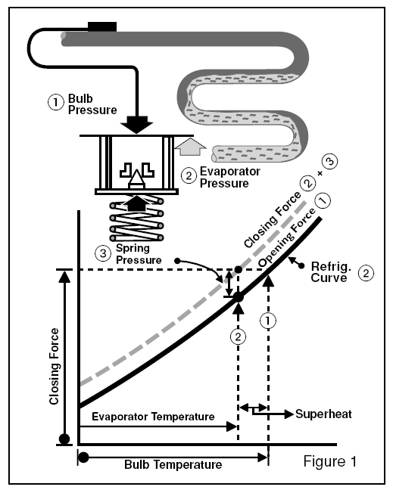

*Figure 4.5: Operation of Thermostatic Expansion Valve*

Equivalent spring pressure is defined as the spring force divided by the effective area of the diaphragm. The effective area of the diaphragm is simply the portion of the total diaphragm area which is effectively used by the bulb and equalizer pressures to provide their respective opening and closing forces. Equivalent spring pressure is essentially constant once the valve has been adjusted to the desired superheat. As a result, the TEV functions by controlling the difference between bulb and equalizer pressures by the amount of the spring pressure.

The function of the sensing bulb is to sense the temperature of the refrigerant vapor as it leaves the evaporator. Ideally, the bulb temperature will exactly match the refrigerant vapor temperature. As the bulb temperature increases, bulb pressure also increases causing the valve pin to move away from the valve port, allowing more refrigerant to flow into the evaporator. The valve continues in this opening direction until the equalizer pressure increases sufficiently such that the sum of the equalizer and spring pressures balance with the bulb pressure. Conversely, as the bulb temperature decreases, the bulb pressure decreases causing the valve pin to move toward the valve port, allowing less refrigerant to flow into the evaporator. The valve continues to close until the equalizer pressure decreases sufficiently such that the sum of the equalizer and spring pressures balance with the bulb pressure.

A change in refrigerant vapor temperature at the outlet of the evaporator is caused by one of two events: (1) the spring pressure is altered by means of the valve adjustment, and (2) the heat load on the evaporator changes. When spring pressure is increased by turning the valve adjustment clockwise, refrigerant flow into the evaporator is decreased. Vapor temperature at the evaporator outlet increases since the point where the refrigerant completely vaporizes moves further back within the evaporator, leaving more evaporator surface area to heat the refrigerant in its vapor form. The actual refrigerant vapor and bulb temperature will be controlled at the point where bulb pressure balances with the sum of the equalizer and spring pressures. Conversely, decreasing spring pressure by turning the valve adjustment counterclockwise increases refrigerant flow into the evaporator and decreases refrigerant vapor and bulb temperature. Spring pressure determines the superheat at which the valve controls. Increasing spring pressure increases superheat, decreasing spring pressure decreases superheat.

An increase in the heat load on the evaporator causes refrigerant to evaporate at a faster rate. As a result, the point of complete vaporization of the refrigerant flow is moved further back within the evaporator. Refrigerant vapor and bulb temperature increase, causing bulb pressure to rise and the valve to move in the opening direction until the three pressures are in balance. Conversely, a reduction in the heat load on the evaporator will cause the vapor and bulb temperature to fall and the valve to move in a closed direction until the three pressures are in balance. Unlike a change in the spring pressure due to valve adjustment, a change in the heat load on the evaporator does not appreciably affect the superheat at which the thermostatic expansion valve controls. This is due to the fact that the TEV is designed to maintain an essentially constant difference between bulb and equalizer pressures, thus controlling superheat regardless of the heat load.

The following equation represents the expansion valve:

 (4.17)

The valve should yield 10°F to 15°F degrees superheat at point 1. If the amount of superheat is higher, the valve may be wide open. An expansion valve may be 'under-sized' to limit the load on the compressor. If the cooling capacity is low and the superheat is high, the system may be short of refrigerant. The expansion valve in the current system is sized for 2 tons (24000 Btu/hr cooling capacity).

Receiver

Whereas the refrigerant flow rate varies over the operating range of the water chiller, excess refrigerant is stored in the receiver.

Oil Separator

The oil separator is used to return oil directly to the compressor thereby bypassing the refrigerant flow meter. The oil separator insures that measured refrigerant flow rate is that of pure refrigerant. It should be noted that oil separators are not 100% effective. Small refrigeration systems usually do not require oil separators.

It is known that dissolving oil in a refrigerant changes the properties of the mixture from those of pure refrigerant. If a state appears slightly superheated, the purity of the fluid should be verified. The state of the refrigerant leaving the evaporator may be affected by the solution of oil despite the fact that an oil separator is used.

Controls

The water chiller operates with a pump-down control strategy. The "thermostat" switch opens the liquid solenoid valve if cooling is required and closes the liquid solenoid valve if cooling is not required. In the laboratory system a manual "thermostat" switch is used to avoid the water chiller cycling during testing. The compressor is switched on and of by a magnetic starter. A magnetic starter is essentially a relay consisting of a coil and contactors. A high/low pressure switch is wired in series with the relay coil. When the liquid solenoid valve is open, refrigerant flow into the evaporator, evaporates, and causes the evaporation pressure to rise. When the evaporation pressure rises above a preset value, the compressor is switched on. If the solenoid valve is closed, or if the load on the evaporator is low, the evaporation pressure will decrease. When the evaporation pressure fall below a preset value (generally atmospheric pressure), the compressor is switched off. If the compressor discharge pressure exceeds a preset high pressure limit, the compressor is switched off. A serious malfunction is indicated if the compressor discharge pressure exceeds the preset high pressure limit.

Experimental Determination of Enthalpy

The enthalpy of a multiphase fluid is determined from the measurement of its temperature and pressure. Using the pressure-enthalpy chart as shown in Figure 4.6, the experimental enthalpy is easily determined. The determination of enthalpy at or near saturated states should consider two possible sources of error - measurement and fluid purity.

Measurements are not exact, but have a degree of uncertainty. The interpretation of the measurements, and the calculation of the enthalpy, must be made in light of the location of the measurement point in the cycle, e.g., evaporator outlet, condenser outlet, etc. It should be noted that barometric pressure should be measured to obtain accurate absolute pressures from gauges and most transducers.

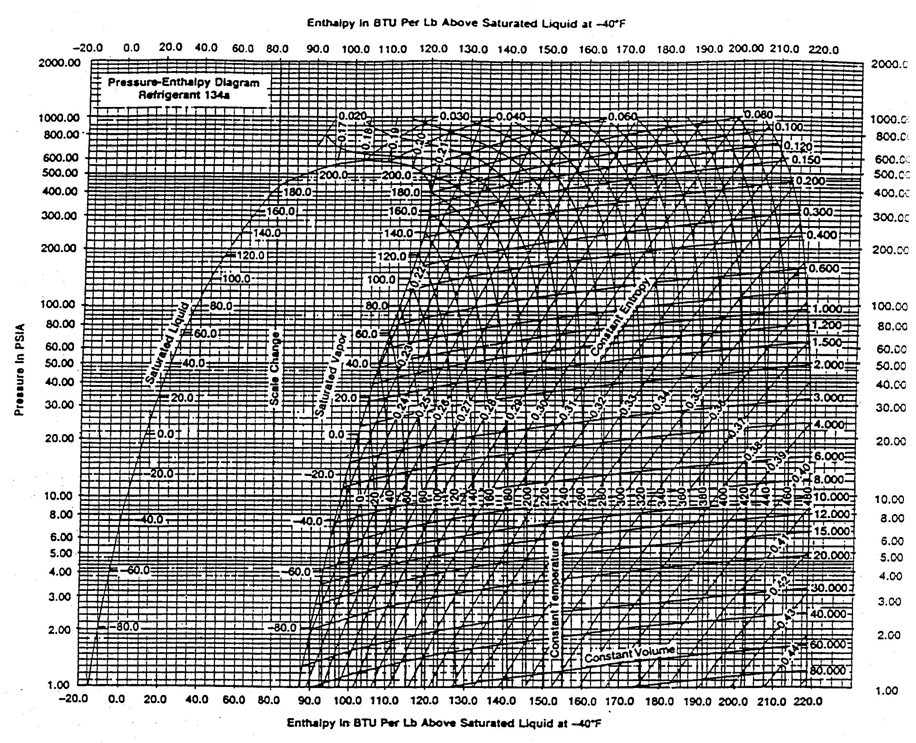

*Figure 4.6: Pressure-Enthalpy Diagram for R-134a - British Units*

Procedure

**Note: The refrigerant flow meter is currently inoperative. The refrigerant flow rate is to be calculated from energy balances on the condenser and evaporator.**

Start-Up

1. Switch on power supplies (1 DC, 1 AC) to instrumentation
2. Switch on data logger
3. Switch on computer
4. Open (source and sink) water supply valve.
5. Open condenser water bypass solenoid valve.
6. Adjust sink temperature to 77F using mixing valve.
7. Adjust source temperature to 55F using mixing valve (flow rate must be at its maximum value).
8. Switch on "thermostat" switch. (Compressor should start)
9. After 10 minutes, close condenser water bypass solenoid valve.
10. Wait for system to stabilize (No bubbles in sight glasses)
11. Wait for the average values on the data logger to reset. Record start time.

Shutdown

1. Exit the data logging program and copy the data file to a diskette for processing. The data file will be named Txxyyyzz.DAT where xx is the day, yyy is the month, and zz is the year (e.g., T07OCT99.DAT)
2. Switch off data logger and computer.
3. Switch off power supplies (1 DC, 1 AC) to instrumentation.
4. Switch off "thermostat" switch and wait for system to pump down.
5. Close (source and sink) water supply valve.

Testing

The data logger is programmed to record averaged data set every 10 minutes. Allow 2 data sets to be recorded for each test. Discard the first data set for each test because the system requires time to stabilize. The remaining data set represent steady-state operating conditions. Table 4.1 describes each channel or test parameter measured.

*Table 4.1: Data Logger Nomenclature*

|  |  |  |
| --- | --- | --- |
| Channel | Label | Description |
| 0 | EVAPH2O | Source - Water Flow Through Evaporator |
| 1 | CONDH2O | Sink - Water Flow Through Condenser |
| 3 | PLO | Evaporator Outlet / Compressor Inlet (R,2) |
| 4 | PHI | Compressor Outlet / Condenser Inlet (R,1) |
| 5 | TH2OEVP1 | Source, Inlet (SRC,1) |
| 6 | TH2OEVP2 | Source, Outlet (SRC,2) |
| 7 | TH2OCDN1 | Sink, Inlet (SNK,1) |
| 8 | TH20CDN2 | Sink, Outlet (SNK,2) |
| 9 | TRFRG1 | Refrigerant, Outlet from Evaporator / Inlet to Compressor (R,1) |
| 10 | TRFRG2A | Refrigerant, Outlet from Compressor (R,2a) |
| 11 | TRFRG2B | Refrigerant, Inlet to Condenser (R,2b) |
| 12 | TRFRG3A | Refrigerant, Outlet from Condenser / Inlet to Receiver (R,3a) |
| 13 | TRFRG3B | Refrigerant, Outlet from Receiver / Inlet to Refrigerant Flow Meter (R,3b) |
| 14 | TRFRG3C | Refrigerant, Outlet From Liquid Solenoid Valve / Inlet to Expansion Valve (R,3c) |
| 15 | TRFRG4 | Refrigerant, Outlet from Expansion Valve / Inlet to Evaporator (R,4) |

Channel 2 is inoperative

The following 4 tests are to be performed consecutively as shown in Table 4.2.

*Table 4.2: Variation of Test Parameters*

|  |  |  |
| --- | --- | --- |
| Test # | Source Temperature | Source Flow Rate |
| 1 | 70°F | 100% (Maximum) |
| 2 | 65°F | 100% |
| 3 | 60°F | 100% |
| 4 | 60°F | 85% |

The minimum source temperature (leaving the evaporator) MUST EXCEED the freezing temperature (32F).

The maximum condensation pressure MUST NOT EXCEED 165 psig (laboratory instructor shall adjust the condenser water valve if required).

Some key point temperatures shown in Figure 4.4 are monitored at several locations (e.g., 3a, 3b, and 3c) in a line between major components because variations are expected due to pressure and heat losses/gains. The location closest to the components should be used in determining component performance.

It should be noted that data is recorded in British units and that pressures are gauge pressures. All pressures should be converted to absolute before calculations are performed.

Results

1. Determine the refrigerant flow rate by performing an energy balance for the condenser and the evaporator (refrigerant flow meter is currently inoperative). Which one is more accurate?
2. Calculate and tabulate the pressure, temperature, specific volume, enthalpy, entropy and quality of the refrigerant at all key points for each test. Show a sample calculation and state all assumptions.
3. Draw the cycle on the provided *P-h* diagram (Figure 4.6) or other published pressure-enthalpy diagram for R-134a labelled with the key points for one test only.
4. Determine the following properties for each test: (i) Evaporator Heat Exchanger Effectiveness; (ii) Condenser Heat Exchanger Effectiveness; (iii) Coefficient of Performance (COP) for Cooling; (iv) Compressor Isentropic Efficiency and (v) Volumetric Efficiency.

Nomenclature

* c= Clearance Volume Ratio
* C= Heat Capacity Rate
* COP = Coefficient of Performance
* e= Heat Exchanger Effectiveness
* h= Enthalpy/Unit Mass
* = Rate of Enthalpy Flow
* i= isentropic
* = Mass Flow Rate
* P= Pressure
* T= Temperature
* v= Specific Volume
* = Rate of Volumetric Displacement
* = Power
* ε= Isentropic Efficiency
* ηv= Volumetric Efficiency

Subscripts

* 1 – 4 = Key Point in a System Fluid (Source, Sink or Refrigerant)
* CND = Condenser
* cnd= Condensation (Saturation)
* EVP= Evaporator
* evp= Evaporation (Saturation)
* R = Refrigerant
* SNK= Sink ; SRC= Source

Data

**Transfer computer printout data onto this sheet. Attach on the last page of your lab report with data printout.**

REFRIGERANT PROPERTIES (R-134a)

|  |  |  |  |  |  |  |  |  |  |
| --- | --- | --- | --- | --- | --- | --- | --- | --- | --- |
| Test  # | TRFRG1  [°F] | TRFRG2A  [°F] | TRFRG2B  [°F] | TRFRG3A  [°F] | TRFRG3B  [°F] | TRFRG3C  [°F] | TRFRG4  [°F] | PHI  [psig] | PLO  [psig] |
| 1 |  |  |  |  |  |  |  |  |  |
| 2 |  |  |  |  |  |  |  |  |  |
| 3 |  |  |  |  |  |  |  |  |  |
| 4 |  |  |  |  |  |  |  |  |  |

SINK PROPERTIES (Water)

|  |  |  |  |
| --- | --- | --- | --- |
| Test  # | CONDH2O  [lbm/h] | TH2OCND1  [°F] | TH2OCND2  [°F] |
| 1 |  |  |  |
| 2 |  |  |  |
| 3 |  |  |  |
| 4 |  |  |  |

SOURCE PROPERTIES (Water)

|  |  |  |  |
| --- | --- | --- | --- |
| Test  # | EVPH2O  [lbm/h] | TH2OEVP1  [°F] | TH2OEVP2  [°F] |
| 1 |  |  |  |
| 2 |  |  |  |
| 3 |  |  |  |
| 4 |  |  |  |

Lab #

5

**Stirling Engine**

Introduction

The principle that makes Stirling engines possible is quite simple. When air is heated it expands, and when it is cooled it contracts. Stirling engines work by cyclically heating and cooling air (or perhaps another gas such as helium) inside a leak tight container and using the pressure changes to drive a piston. The heating and cooling process works like this: One part of the engine is kept hot while another part is kept cold. A mechanism then moves the air back and forth between the hot side and the cold side. When the air is moved to the hot side, it expands and pushes up on the piston, and when the air is moved back to the cold side, it contracts and pulls down on the piston.

Brief History

In the early days of the industrial revolution, steam engine explosions were a real problem. Metal fatigue was not well understood, and the steam engines of the day would often explode, killing and injuring people nearby. In 1816 the Reverend Robert Stirling, a minister of the Church of Scotland, invented what he called "A New Type of Hot Air Engine with Economiser" as a safe and economical alternative to steam. His engines couldn't explode, used less fuel, and put out more power than the steam engines of the day.

The engines designed by Robert Stirling and those who followed him were very innovative engines, but there was a problem with the material that was used to build them. In a Stirling engine, the hot side of the engine heats up to the average temperature of the flame used to heat it and remains at that temperature. There is no time for the cylinder head to cool off briefly between power pulses. When Robert Stirling built his first engines, cast iron was the only readily available material, and when the hot side of a cast iron Stirling engine was heated to almost red hot, it would oxidize fairly quickly. The result was that quite often a hole would burn through the hot side causing the engine to quit. In spite of the difficulties with materials, tens of thousands of Stirling engines were used to power water pumps, run small machines, and turn fans, from the time of their invention up until about 1915.

As electricity became more widely available in the early 1900s, and as gasoline became readily available as a fuel for automobiles, electric motors and gasoline engines began to replace Stirling engines.

Displacer-Type Stirling Engine

While Stirling engines are conceptually quite simple, understanding how any particular engine design works is often quite difficult because there are hundreds of different mechanical configurations that can achieve the Stirling cycle. One example is the displacer-type Stirling engine which has one piston and one displacer. The displacer serves to control when the gas chamber is heated and when it is cooled. This engine requires a temperature difference between the top and the bottom of the large cylinder as shown in Figure 5.1. A gentle spin on the flywheel is necessary to start the engine. As the displacer moves away from the warmer side, air flows around the displacer to the warmer side and is heated. Air never pushes on the displacer, it flows around it. Then the air is heated and it expands, which increases the pressure inside the entire engine. This increase in air pressure pushes up on the piston. Next the energy stored in the flywheel moves the displacer to the warm side of the engine and the air once again flows around the displacer to the cold side of the engine. When the air is cooled it contracts and the pressure drops throughout the entire engine. This drop in pressure pulls down on the power piston, the displacer moves back to the cold side, the air is displaced to the warm side and the cycle starts all over again. Stirling engines can be mechanically quite simple since they have no valves, and no sparkplugs. This can result in extremely high reliability as there are fewer parts to fail.

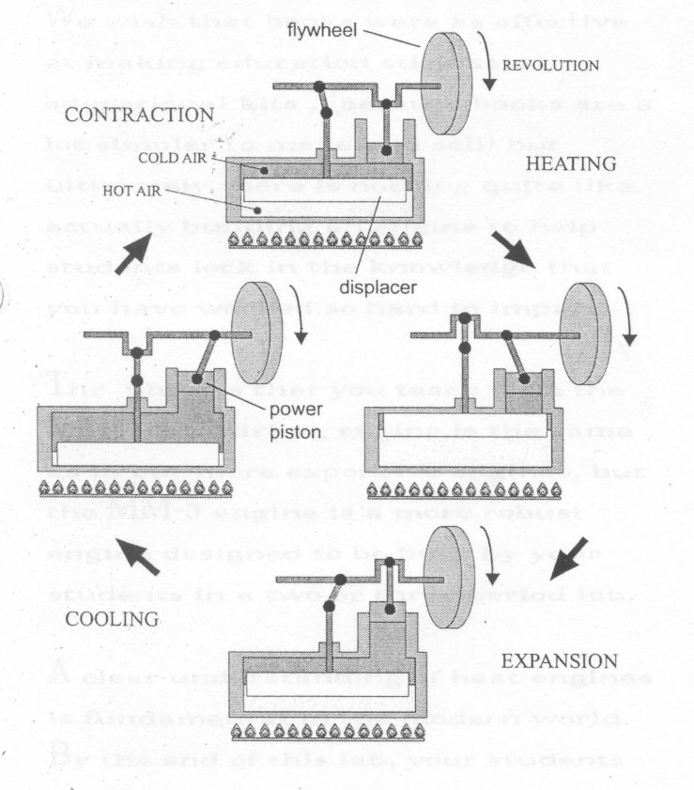

*Figure 5.1: Displacer-Type Stirling Engine Cycle*

It's worthwhile to compare Stirling engines to other more familiar engines and note their similarities as well as their differences. Stirling engines are a type of heat engine. They turn heat into mechanical work and in this sense they perform the same function as other well known heat engines such as gasoline, diesel, and steam engines. Like steam engines, Stirling engines are external combustion engines, since the heat is supplied to the engine from a source outside the cylinder instead of being supplied by a fuel burning inside the cylinder. Because the heat in a Stirling engine, comes from outside of the engine, Stirling engines can be designed that will run on any heat source from fossil fuel heat, to geo-thermal heat, to sunshine. Unlike steam engines, Stirling engines do not use a boiler that might explode if not carefully monitored.

When operating on sunshine, or geo-thermal heat, Stirling engines obviously produce no pollution at all, but they can be exceedingly low emissions engines even when burning gasoline, diesel, or home heating oil. Unlike gasoline or diesel engines that have many thousands of start stop cycles of combustion each minute, burners in Stirling engines burn fuel continuously. It’s much easier to make a continuous combustion engine burn very cleanly than one that has to start and stop. An excellent demonstration of this principle is to strike a match, let it burn for a few seconds, and then blow it out. Most of the smoke is produced during the starting and stopping phases of combustion.

Regeneration

Robert Stirling's most important invention was probably a feature of his engines that he called an "economizer." Rev. Stirling realized that heat engines usually get their power from the force of an expanding gas which pushes up on a piston. The steam engines that he observed dumped all of their waste heat into the environment through their exhaust and the heat was lost forever. Stirling engines changed all that. Robert Stirling invented what he called an "economizer" that saved some heat from one cycle and used it again to pre-heat the air for the next cycle.

It worked like this: After the hot air had expanded and pushed the piston as far as the connecting rod would allow, the air still had quite a bit of heat energy left in it. Rev. Stirling's engines stored some of this waste heat by making the air flow through economizer tubes that absorbed some of the heat from the air. This pre-cooled air was then moved to the cold part of the engine where it cooled very quickly and as it cooled it contracted, pulling down on the piston. Next the air was mechanically moved back through the pre-heating economizer tubes to the hot side of the engine where it was heated even further, expanding and pushing up on the piston. This type of heat storage is used in many industrial processes and today is called "regeneration." Stirling engines do not have to have regenerators to work, but well designed engines will run faster and put out more power if they have a regenerator.

Continued Interest

In spite of the fact that the world offers many competing sources of power there are some very good reasons why interest in Stirling engines has remained strong among scientists, engineers, and public policy makers. Stirling engines can be made to run on any heat source. Every imaginable heat source from fossil fuel heat to solar energy heat can and has been used to power a Stirling engine.

Stirling engines also have the maximum theoretical possible efficiency since their power cycle (their theoretical pressure volume diagram) matches the Carnot cycle. The Carnot cycle, first described by the French physicist Sadi Carnot, determines the maximum theoretical efficiency of any heat engine operating between a hot and a cold reservoir. The Carnot efficiency formula *(ηCarnot*) is:

(5.1)



where *Thot* is the temperature on the hot side of the engine and *Tcold* is the temperature on the cold side of the engine. These temperatures must be measured in absolute degrees (Kelvin or Rankine).

Applications

Stirling engines make sense in applications that take advantage of their best features while avoiding their drawbacks. Unfortunately, there have been some extremely dedicated research efforts that apparently overlooked the critical importance of matching the right technology to the right application.

In the 1970s and 1980s a huge amount of research was done on Stirling engines for automobiles by companies such as General Motors, Ford, and Philips Electronics. The difficulty was that Stirling engines have several intrinsic characteristics that make building a good automobile Stirling engine quite difficult. Stirling engines like to run at a constant power setting, which is perfect for pumping water, but are a real challenge for the stop and go driving of an automobile. Automobile engines need to be able to change power levels very quickly as a driver accelerates from a stop to highway speed. It is easy to design a Stirling engine power control mechanism that will change power levels efficiently, by simply turning up or down the burner. But this is a relatively slow method of changing power levels and probably is not a good way to add the power necessary to accelerate across an intersection. It's also easy to design a simple Stirling engine control device that can change power levels quickly but allows the engine to continue to consume fuel at the full power rate even while producing low amounts of power. However it seems to be quite difficult to design a power control mechanism that can change power levels both quickly and efficiently. A few research Stirling engines have done this, but they all used very complex mechanical methods for achieving their goal.

Stirling engines do not develop power immediately after the heat source is turned on. It can take a minute or longer for the hot side of the engine to get up to operating temperature and make full power available. Automobile drivers are used to having full power available almost instantly after they start their engines. In spite of these difficulties, there are some automobile Stirling applications that make sense. Hybrid electric cars which include both batteries and a Stirling engine generator would probably be an extremely effective power system. The batteries would give the car the instant acceleration that drivers are used to, while a silent and clean running Stirling engine would give drivers the freedom to make long trips away from battery charging stations. On long trips, the hybrid car could burn either gasoline or diesel, depending on which fuel was cheaper.

To generate electricity for homes and businesses, research Stirling generators fueled by either solar energy or natural gas have been tested. They run on solar power when the sun is shining and automatically convert to clean burning natural gas at night or when the weather is cloudy.

Since there are no explosions inside Stirling engines they can be designed to be extremely quiet. The Swedish defense contractor Kockums has produced Stirling engine powered submarines for the Swedish navy that are said to be the quietest submarines in the world.

Aircraft engines operate in an environment that gets increasingly colder as the aircraft climbs to altitude, so Stirling aircraft engines, unlike any other type of aircraft engine may derive some performance benefit from climbing to altitude. Additionally, the communities near airports would benefit from the extremely quiet operation that is possible.

In short Stirling engines make sense where these conditions are met.

* There is a premium on quiet.
* There is a very good cooling source available.
* Relatively slow revolutions are desired.
* Multiple fuel capacity is desired.
* The engine can run at a constant power output.
* The engine does not need to change power levels quickly.
* A warm up period of several minutes is acceptable.

Apparatus

The KY-2000 Stirling engine designed by the American Stirling Company and purchased by Concordia University is shown in Figure 5.2

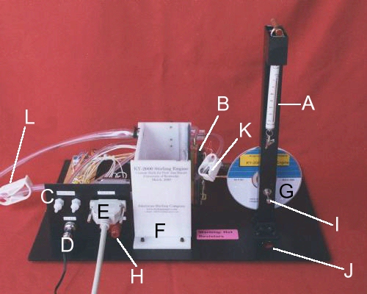

*Figure 5.2: K-Y 2000 Stirling Engine from American Stirling Company*

The engine is electrically heated for accurate power input measurements (this also keeps fumes out of the lab) and is cooled by air or water. It has built-in pressure, temperature, and angular position sensors to allow a PV diagram to be plotted on a PC. It also includes a data acquisition system that ports ASCII data to a PC where it can be analyzed. A variable voltage DC power supply is required.

Components of the KY-2000 Stirling Engine

Refer to Figure 5.2

1. 30 g spring scale used to measure torque and power output
2. Transparent cylinder
3. Helium or other non-flammable gas ports. These ports, which contain integral valves, allow operation of the KY-2000 with working fluids other than air. The valves are automatically closed when the helium filling tubes are not connected.
4. Electrical power for the sensors
5. USB cable to PC (Figure 3.2 shows serial cable to PC).
6. Cold water box
7. Flywheel
8. Variable dc voltage for heaters (0-12 V)
9. Output shaft (0.0625 in radius)
10. Hole that allows power measurement by raising a weight or applying torque to the spinning output shaft.
11. Pinch clamps (2). These clamps are normally left open. Closing these clamps slightly reduces dead space in the system. This reduction in dead space results in a small increase in operating speed. Leave these clamps open when the engine is not in use.
12. Drain clamp. Close this clamp tightly before putting water in the cold water box.
13. Resistors (4). Physical dimensions: 0.75 in (length) x 0.42 in (width) x 0.35 in (height)

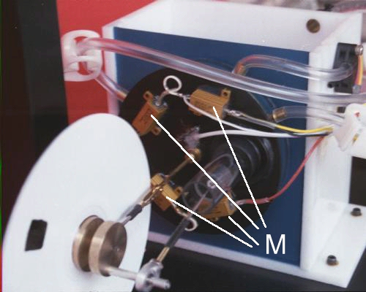

Warning: This engine is electrically heated. The resistors (M) get very hot! The plate to which the resistors are attached also gets very hot. Be careful. Do not touch this part of the engine during operation or for at least ten minutes after the power has been turned off.

**Procedure**

The basic procedure for running the engine and taking data is as follows:

1. Fill the box with an ice bath to within one-inch (2.5 cm) of the top. An ice bath is not required; however, maximum speed is only achieved with an ice bath.
2. Plug in the connectors at D & E.
3. Plug the cable from location E on the engine into the PC’s USB port.
4. Verify that the variable voltage DC power supply is turned off then plug in the banana leads at H. Make sure to maintain the correct polarity (red to red & black to black).
5. Adjust your power supply so it is supplying 12 V at about 3 A. After the power has been turned on, it may take three to five minutes before the engine is hot enough to run, since Stirling engines do not start instantly. When the engine has become hot, gently spin the output shaft (I) clockwise by hand to start the engine. If the engine is hot enough, it will start quickly, and build up speed. If the engine is not hot enough, no amount of spinning will make it start.
6. While exact performance will differ with changing atmospheric conditions and the condition of your engine, the KY-2000 needs a temperature difference of approximately 20°C to run when its working fluid is air, and 10°C if helium is used as the working fluid. Maximum performance is achieved with the hot side at the maximum allowable temperature of 373 K and the cold side at 273 K. This engine spins clockwise when you are looking at it as shown on Figure 3.2. It is worth noting that you cannot harm the engine by spinning it backwards. In fact, if the engine is hot and is spun backwards, it may come to a complete stop, reverse itself, and run in the clockwise direction.
7. Install the LabJack Software on a Windows XP PC and open the Lab Jack Stream program. Set the Scan Rate to 300 and the Number of Scans to 300 as shown in Figure 5.3.
8. Click on Configure Channels. Set the channel names on the left to be Pulse, Pressure, T Hot, and T Cold. Then Set the analog inputs on the right (AI) to be channels 1 to 4 respectively. Channel 1 displays the timing pulse from an infrared LED that is clocked to produce a signal when the piston is at bottom dead center. Channel 2 is a millivolts signal from the pressure sensor. Channel 3 is the temperature of the hot side in units of Kelvin / 100. For example, a temperature of 293 K reads 2.93. Channel 4 is the temperature of the cold side in the same units as channel 4. When you are finished configuring the channels press Save and Exit to return to the previous screen.
9. Record the voltage and amperage from the DC power supply.
10. Click on Change Working Directory to make sure you know where the data file will be stored.
11. Click on the Enable Stream button at the top left of the screen to make sure that the computer is connecting with the engine. No data will be saved to your file until you also click on the Write to File button below the graphical display area of this screen. Usually you don't need more than a few seconds of data so make sure that you don't turn stream on with the Write to File enabled and generate a huge data file.

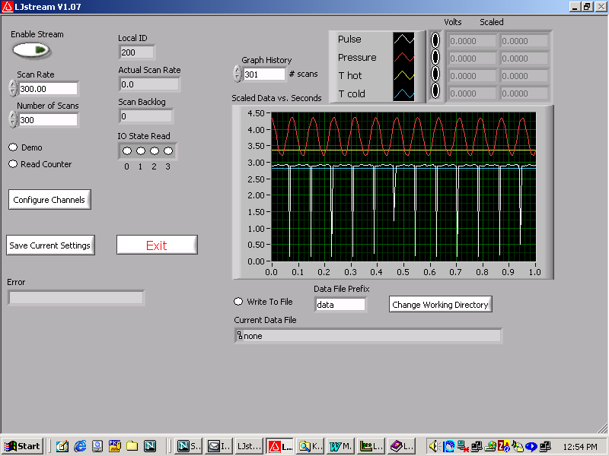

*Figure 5.3: LabJack Software*

1. With the engine running and everything connected, click on “Enable Stream” with the Write to File button pressed for several seconds to collect your data.
2. Open your data file in Excel and convert it to Excel format using the settings for importing a comma-delimited file.
3. Fill the engine with helium; connect both tubes (C) to the engine. Flush helium through the engine by connecting a child’s helium balloon to one of the tubes. Spin the engine through by hand while this process is going on to help purge the air. When the helium has flushed through the engine (and completely filled it), disconnect both of these tubes. Never connect a gas source higher than 1.5 psi to the engine. If you do, you will break something.
4. Record the data by clicking on “Enable Stream” with Write to File enabled. The data file will be automatically saved under another file name.
5. Measure the time it takes to raise several weights ranging from 10 g to 70 g (i.e. 10 data points) from floor level to the bottom of the engine for both air and helium.

Results

1. Calculate the required torque in [N-m] to raise each weight from the floor to the bottom of the engine. Tabulate your results.
2. Calculate the shaft power in [W] to raise each weight from the floor to the bottom of the engine. Tabulate your results.
3. Plot torque versus mass and shaft power versus mass for air and helium displaced engines.
4. Compare the Carnot efficiency for both air and helium displaced Stirling engines with the measured efficiency. Hint: to measure the efficiency of the engine use the area of the resistors and ask your self how much of this area is in contact with the engine?

Data

## Air

Height [cm]: __________________

|  |  |  |  |
| --- | --- | --- | --- |
| Mass [g] | Time [s] | Mass [g] | Time [s] |
|  |  |  |  |
|  |  |  |  |
|  |  |  |  |
|  |  |  |  |
|  |  |  |  |

## Helium

Height [cm]: __________________

|  |  |  |  |
| --- | --- | --- | --- |
| Mass [g] | Time [s] | Mass [g] | Time [s] |
|  |  |  |  |
|  |  |  |  |
|  |  |  |  |
|  |  |  |  |
|  |  |  |  |

Date: ______________________________

Section: _____________

Signature: ______________________________

Lab #

6

**Spark-Ignition Engine Performance Test**

Introduction

The internal combustion engine (IC) is a heat engine that converts chemical energy in a fuel into mechanical energy, usually made available on a rotating output shaft. Chemical energy of the fuel is first converted to thermal energy by means of combustion or oxidation with air inside the engine. This thermal energy raises the temperature and pressure of the gases within the engine, and the high-pressure gas then expands against the mechanical mechanisms of the engine. This expansion is converted by the mechanical linkages of the engine to a rotating crankshaft, which is the output of the engine. The crankshaft, in turn, is connected to a transmission and/or power train to transmit the rotating mechanical energy to the desired final use. For engines this will often be the propulsion of a vehicle (i.e., automobile, truck, locomotive, marine vessel, or airplane). Other applications include stationary engines to drive generators or pumps, and portable engines for things like chain saws and lawn mowers.

Most internal combustion engines are reciprocating engines having pistons that reciprocate back and forth in cylinders internally within the engine. Reciprocating engines can have one cylinder or many, up to 20 or more. The cylinders can be arranged in many different geometric configurations. Sizes range from small model airplane engines with power output on the order of 100 watts to large multi cylinder stationary engines that produce thousands of kilowatts per cylinder. There are so many different engine manufacturers, past, present, and future, that produce and have produced engines which differ in size, geometry, style, and operating characteristics that no absolute limit can be stated for any range of engine characteristics (i.e., size, number of cylinders, strokes in a cycle, etc.).

Engine Classifications

Internal combustion engines can be classified in a number of different ways:

1. Types of Ignition
   1. **Spark Ignition (SI).** An SI engine starts the combustion process in each cycle by use of a spark plug. The spark plug gives a high-voltage electrical discharge between two electrodes which ignites the air-fuel mixture in the combustion chamber surrounding the plug. In early engine development, before the invention of the electric spark plug, many forms of torch holes were used to initiate combustion from an external flame.
   2. **Compression Ignition (CI).** The combustion process in a CI engine starts when the air-fuel mixture self-ignites due to high temperature in the combustion chamber caused by high compression.
2. Engine Cycle
   1. **Four-Stroke Cycle.** A four-stroke cycle experiences four piston movements over two engine revolutions for each cycle.
   2. **Two-Stroke Cycle.** A two-stroke cycle has two piston movements over one revolution for each cycle.
3. Valve Location
   1. **Valve in head (overhead valve)**
   2. **Valve in block (flat head)**
4. Basic Design
   1. **Reciprocating.** Engine has one or more cylinders in which pistons reciprocate back and forth. The combustion chamber is located in the closed end of each cylinder. Power is delivered to a rotating output crankshaft by mechanical linkage with the pistons.
   2. **Rotary.** Engine is made of a block (stat or) built around a large non-concentric rotor and crankshaft. The combustion chambers are built into the non-rotating block.
5. Position and Number of Cylinders of Reciprocating Engines
   1. **Single Cylinder.** Engine has one cylinder and piston connected to the crankshaft.
   2. **In-Line.** Cylinders are positioned in a straight line, one behind the other along the length of the crankshaft. They can consist of 2 to 11 cylinders or possibly more. In-line four-cylinder engines are very common for automobile and other applications. In-line six and eight cylinders are historically common automobile engines. In-line engines are sometimes called straight (e.g., straight six or straight eight).
   3. **V Engine.** Two banks of cylinders at an angle with each other along a single crankshaft. The angle between the banks of cylinders can be anywhere from 15° to 120°, with 60°-90° being common. V engines have even numbers of cylinders from 2 to 20 or more. V6s and V8s are common automobile engines, with V12s and V16s (historic) found in some luxury and high-performance vehicles.
   4. **Opposed Cylinder Engine.** Two banks of cylinders opposite each other on a single crankshaft (a V engine with a 180° V). These are common on small aircraft and some automobiles with an even number of cylinders from two to eight or more. These engines are often called nat engines (e.g., flat four).
   5. **W Engine.** Same as a V engine except with three banks of cylinders on the same crankshaft. Not common, but some have been developed for racing automobiles, both modern and historic. Usually 12 cylinders with about a 60° angle between each bank.
   6. **Opposed Piston Engine.** Two pistons in each cylinder with the combustion chamber in the center between the pistons. A single-combustion process causes two power strokes at the same time, with each piston being pushed away from the center and delivering power to a separate crankshaft at each end of the cylinder. Engine output is either on two rotating crankshafts or on one crankshaft incorporating complex mechanical linkage.
   7. **Radial Engine.** Engine with pistons positioned in a circular plane around the central crankshaft. The connecting rods of the pistons are connected to a master rod which, in turn, is connected to the crankshaft. A bank of cylinders on a radial engine always has an odd number of cylinders ranging from 3 to 13 or more. Operating on a four-stroke cycle, every other cylinder fires and has a power stroke as the crankshaft rotates, giving a smooth operation. Many medium- and large-size propeller-driven aircraft use radial engines. For large aircraft, two or more banks of cylinders are mounted together, one behind the other on a single crankshaft, making one powerful smooth engine. Very large ship engines exist with up to 54 cylinders, six banks of 9 cylinders each.
6. Air Intake Process
   1. **Naturally Aspirated.** No intake air pressure boost system.
   2. **Supercharged.** Intake air pressure increased with the compressor driven off of the engine crankshaft.
   3. **Turbocharged.** Intake air pressure increased with the turbine-compressor driven by the engine exhaust gases.
   4. **Crankcase Compressed.** Two-stroke cycle engine which uses the crankcase as the intake air compressor. Limited development work has also been done on design and construction of four-stroke cycle engines with crankcase compression.
7. Method of Fuel Input for SI Engines
   1. **Carbureted.**
   2. **Multi point Port Fuel Injection.** One or more injectors at each cylinder intake.
   3. **Throttle Body Fuel Injection.** Injectors upstream in intake manifold.
8. Fuel Used
   1. **Gasoline.**
   2. **Diesel Oil or Fuel Oil.**
   3. **Gas, Natural Gas, Methane.**
   4. **LPG.**
   5. **Alcohol--Ethyl, Methyl.**
   6. **Dual Fuel.** There are a number of engines that use a combination of two or more fuels. Some, usually large, CI engines use a combination of methane and diesel fuel. These are attractive in developing third-world countries because of the high cost of diesel fuel. Combined gasoline-alcohol fuels are becoming more common as an alternative to straight gasoline automobile engine fuel.
   7. **Gasohol.** Common fuel consisting of 90% gasoline and 10% alcohol.
9. Application
   1. **Automobile, Truck, Bus.**
   2. **Locomotive.**
   3. **Stationary.**
   4. **Marine.**
   5. **Aircraft.**
   6. **Small Portable, Chain Saw, Model Airplane.**
10. Type of Cooling
    1. **Air Cooled.**
    2. **Liquid Cooled, Water Cooled.**

Several or all of these classifications can be used at the same time to identify a given engine. Thus, a modern engine might be called a turbocharged, reciprocating, spark ignition, four-stroke cycle, overhead valve, water-cooled, gasoline, multi point fuel-injected, V8 automobile engine.

Terminology And Abbreviations

The following terms and abbreviations are commonly used in engine technology literature.

**Internal Combustion (IC).**

**Spark Ignition (SI).** An engine in which the combustion process in each cycle is started by use of a spark plug.

**Compression Ignition (CI).** An engine in which the combustion process starts when the air-fuel mixture self-ignites due to high temperature in the combustion chamber caused by high compression. CI engines are often called diesel engines, especially in the non-technical community.

**Top-Dead-Center (TDC).** Position of the piston when it stops at the furthest point away from the crankshaft. Top because this position is at the top of most engines (not always), and dead because the piston stops at this point. Because in some engines top-dead-center is not at the top of the engine (e.g., horizontally opposed engines, radial engines, etc.), some sources call this position Head-End-Dead-Center (HEDC). Some sources call this position Top-Center (TC). When an occurrence in a cycle happens before TDC, it is often abbreviated bTDC or bTC. When the occurrence happens after TDC, it will be abbreviated aTDC or aTC. When the piston is at TDC, the volume in the cylinder is a minimum called the clearance volume.

**Bottom Dead Center (BDC).** Position of the piston when it stops at the point closest to the crankshaft. Some sources call this Crank-End-Dead-Center (CEDC) because it is not always at the bottom of the engine. Some sources call this point Bottom-Center (BC). During an engine cycle things can happen before bottom-dead-center, bBDC or bBC, and after bottom-dead-center, aBDC or aBC.

**Direct Injection (DI).** Fuel injection into the main combustion chamber of an engine. Engines have either one main combustion chamber (open chamber) or a divided combustion chamber made up of a main chamber and a smaller connected secondary chamber.

**Indirect Injection (IDI).** Fuel injection into the secondary chamber of an engine with a divided combustion chamber.

**Bore.** Diameter of the cylinder or diameter of the piston face, which is the same minus a very small clearance.

**Stroke.** Movement distance of the piston from one extreme position to the other: TDC to BDC or BDC to TDC.

**Clearance Volume.** Minimum volume in the combustion chamber with piston at TDC.

**Displacement or Displacement Volume.** Volume displaced by the piston as it travels through one stroke. Displacement can be given for one cylinder or for the entire engine.

**Smart Engine.** Engine with computer controls that regulate operating characteristics such as air-fuel ratio, ignition timing valve timing exhaust control, intake tuning, etc. Computer inputs come from electronic, mechanical, thermal and chemical sensors located throughout the engine. Computers in some automobiles are even programmed to adjust engine operation for things like valve wear and combustion chamber deposit buildup as the engine ages. In automobiles the same computers are used to make smart cars by controlling the steering, brakes, exhaust system, suspension, seats, anti-theft systems, sound-entertainment systems, shifting, doors, repair analysis, navigation, noise suppression, environment, comfort, etc. On some systems engine speed is adjusted at the instant when the transmission shifts gears, resulting in a smoother shifting process. At least one automobile model even adjusts this process for transmission fluid temperature to assure smooth shifting at cold startup.

**Engine Management System (EMS).** Computer and electronics used to control smart engines.

**Wide-Open Throttle (WOT).** Engine operated with throttle valve fully open when maximum power and/or speed is desired.

**Ignition Delay (ID).**  Time interval between ignition initiation and the actual start of combustion.

**Air-Fuel Ratio (AF).**  Ratio of mass of air to mass of fuel input into engine.

**Fuel-Air Ratio (FA).**  Ratio of mass of fuel to mass of air input into engine.

**Brake Maximum Torque (BMT).** Speed at which maximum torque occurs.

**Overhead Valve (OHV).** Valves mounted in engine head.

**Overhead Cam (OHC).** Camshaft mounted in engine head, giving more direct control of valves which are also mounted in engine head.

**Fuel Injected (FI).**

Engine Components

The following is a list of major components found in most reciprocating internal combustion engines.

**Block.** Body of engine containing the cylinders, made of cast iron or aluminum. In many older engines, the valves and valve ports were contained in the block. The block of water-cooled engines includes a water jacket cast around the cylinders. On air-cooled engines, the exterior surface of the block has cooling fins.

**Camshaft.** Rotating shaft used to push open valves at the proper time in the engine cycle, either directly or through mechanical or hydraulic linkage (push rods, rocker arms, tappets). Most modern automobile engines have one or more camshafts mounted in the engine head (overhead cam). Most older engines had camshafts in the crankcase. Camshafts are generally made of forged steel or cast iron and are driven off the crankshaft by means of a belt or chain (timing chain). To reduce weight, some cams are made from a hollow shaft with the cam lobes press-fit on. In four-stroke cycle engines, the camshaft rotates at half engine speed.

**Carburetor.** Venturi flow device which meters the proper amount of fuel into the airflow by means of a pressure differential. For many decades it was the basic fuel metering system on all automobile (and other) engines. It is still used on low cost small engines like lawn mowers, but is uncommon on new automobiles.

**Catalytic Converter.**  Chamber mounted in exhaust flow containing catalytic material that promotes reduction of emissions by chemical reaction.

**Combustion Chamber.** The end of the cylinder between the head and the piston face where combustion occurs. The size of the combustion chamber continuously changes from a minimum volume when the piston is at TDC to a maximum when the piston is at BDC. The term "cylinder" is sometimes synonymous with "combustion chamber" (e.g., "the engine was firing on all cylinders"). Some engines have open combustion chambers which consist of one chamber for each cylinder. Other engines have divided chambers which consist of dual chambers on each cylinder connected by an orifice passage.

**Connecting Rod.** Rod connecting the piston with the rotating crankshaft, usually made of steel or alloy forging in most engines but may be aluminum in some small engines.

**Connecting Rod Bearing.** Bearing where connecting rod fastens to crankshaft.

**Cooling Fins.** Metal fins on the outside surfaces of cylinders and head of an air-cooled engine. These extended surfaces cool the cylinders by conduction and convection.

**Crankcase.**  Part of the engine block surrounding the rotating crankshaft. In many engines, the oil pan makes up part of the crankcase housing.

**Crankshaft.** Rotating shaft through which engine work output is supplied to external systems. The crankshaft is connected to the engine block with the main bearings. It is rotated by the reciprocating pistons through connecting rods connected to the crankshaft, offset from the axis of rotation. This offset is sometimes called crank throw or crank radius. Most crankshafts are made of forged steel, while some are made of cast iron.

**Cylinders.**  The circular cylinders in the engine block in which the pistons reciprocate back and forth. The walls of the cylinder have highly polished hard surfaces. Cylinders may be machined directly in the engine block, or a hard metal (drawn steel) sleeve may be pressed into the softer metal block. Sleeves may be dry sleeves, which do not contact the liquid in the water jacket, or wet sleeves, which form part of the water jacket. In a few engines, the cylinder walls are given a knurled surface to help hold a lubricant film on the walls. In some very rare cases, the cross section of the cylinder is not round.

**Exhaust Manifold.**  Piping system which carries exhaust gases away from the engine cylinders, usually made of cast iron.

**Exhaust System.**  Flow system for removing exhaust gases from the cylinders, treating them, and exhausting them to the surroundings. It consists of an exhaust manifold which carries the exhaust gases away from the engine, a thermal or catalytic converter to reduce emissions, a muffler to reduce engine noise, and a tailpipe to carry the exhaust gases away from the passenger compartment.

**Fan.**  Most engines have an engine-driven fan to increase air flow through the radiator and through the engine compartment, which increases waste heat removal from the engine. Fans can be driven mechanically or electrically, and can run continuously or be used only when needed.

**Flywheel.**  Rotating mass with a large moment of inertia connected to the crankshaft of the engine. The purpose of the flywheel is to store energy and furnish a large angular momentum that keeps the engine rotating between power strokes and smooths out engine operation. On some aircraft engines the propeller serves as the flywheel, as does the rotating blade on many lawn mowers.

**Fuel Injector.** A pressurized nozzle that sprays fuel into the incoming air on SI engines or into the cylinder on CI engines. On SI engines, fuel injectors are located at the intake valve ports on multi point port injector systems and upstream at the intake manifold inlet on throttle body injector systems. In a few SI engines, injectors spray directly into the combustion chamber.

**Fuel Pump.**  Electrically or mechanically driven pump to supply fuel from the fuel tank (reservoir) to the engine. Many modern automobiles have an electric fuel pump mounted submerged in the fuel tank. Some small engines and early automobiles had no fuel pump, relying on gravity feed.

**Glow Plug.**  Small electrical resistance heater mounted inside the combustion chamber of many CI engines, used to preheat the chamber enough so that combustion will occur when first starting a cold engine. The glow plug is turned off after the engine is started.

**Head.** The piece which closes the end of the cylinders, usually containing part of the clearance volume of the combustion chamber. The head is usually cast iron or aluminum, and bolts to the engine block. In some less common engines, the head is one piece with the block. The head contains the spark plugs in SI engines and the fuel injectors in CI engines and some SI engines. Most modern engines have the valves in the head, and many have the camshaft(s) positioned there also (overhead valves and overhead cam).

**Head Gasket.**  Gasket which serves as a sealant between the engine block and head where they bolt together. They are usually made in sandwich construction of metal and composite materials. Some engines use liquid head gaskets.

**Intake Manifold.** Piping system which delivers incoming air to the cylinders, usually made of cast metal, plastic, or composite material. In most SI engines, fuel is added to the air in the intake manifold system either by fuel injectors or with a carburetor. Some intake manifolds are heated to enhance fuel evaporation. The individual pipe to a single cylinder is called a runner.

**Main Bearing.** The bearings connected to the engine block in which the crankshaft rotates. The maximum number of main bearings would be equal to the number of pistons plus one, or one between each set of pistons plus the two ends. On some less powerful engines, the number of main bearings is less than this maximum.

**Oil Pan.** Oil reservoir usually bolted to the bottom of the engine block, making up part of the crankcase. Acts as the oil Bump for most engines.

**Oil Pump.** Pump used to distribute oil from the oil Bump to required lubrication points. The oil pump can be electrically driven, but is most commonly mechanically driven by the engine. Some small engines do not have an oil pump and are lubricated by splash distribution.

**Oil Sump.** Reservoir for the oil system of the engine, commonly part of the crankcase. Some engines (aircraft) have a separate closed reservoir called a dry sump.

**Piston.** The cylindrical-shaped mass that reciprocates back and forth in the cylinder, transmitting the pressure forces in the combustion chamber to the rotating crankshaft. The top of the piston is called the crown and the sides are called the skirt. The face on the crown makes up one wall of the combustion chamber and may be a flat or highly contoured surface. Some pistons contain an indented bowl in the crown, which makes up a large percent of the clearance volume. Pistons are made of cast iron, steel, or aluminum. Iron and steel pistons can have sharper corners because of their higher strength. They also have lower thermal expansion, which allows for tighter tolerances and less crevice volume. Aluminum pistons are lighter and have less mass inertia. Sometimes synthetic or composite materials are used for the body of the piston, with only the crown made of metal. Some pistons have a ceramic coating on the face.

**Piston Rings.** Metal rings that fit into circumferential grooves around the piston and form a sliding surface against the cylinder walls. Near the top of the piston are usually two or more compression rings made of highly polished hard chrome steel. The purpose of these is to form a seal between the piston and cylinder walls and to restrict the high-pressure gases in the combustion chamber from leaking past the piston into the crankcase (blow by). Below the compression rings on the piston is at least one oil ring, which assists in lubricating the cylinder walls and scrapes away excess oil to reduce oil consumption.

**Push Rods.** Mechanical linkage between the camshaft and valves on overhead valve engines with the camshaft in the crankcase. Many push rods have oil passages through their length as part of a pressurized lubrication system.

**Radiator.** Liquid-to-air heat exchanger of honeycomb construction used to remove heat from the engine coolant after the engine has been cooled. The radiator is usually mounted in front of the engine in the flow of air as the automobile moves forward. An engine-driven fan is often used to increase air flow through the radiator.

**Spark Plug.** Electrical device used to initiate combustion in an SI engine by creating a high-voltage discharge across an electrode gap. Spark plugs are usually made of metal surrounded with ceramic insulation. Some modern spark plugs have built-in pressure sensors which supply one of the inputs into engine control.

**Speed Control Cruise Control.** Automatic electric-mechanical control system that keeps the automobile operating at a constant speed by controlling engine speed.

**Starter.** Several methods are used to start IC engines. Most are started by use of an electric motor (starter) geared to the engine flywheel. Energy is supplied from an electric battery.

**Supercharger.**  Mechanical compressor powered off of the crankshaft, used to compress incoming air of the engine.

**Throttle.** Butterfly valve mounted at the upstream end of the intake system, used to control the amount of air flow into an SI engine. Some small engines and stationary constant-speed engines have no throttle.

**Turbocharger.** Turbine-compressor used to compress incoming air into the engine. The turbine is powered by the exhaust flow of the engine and thus takes very little useful work from the engine.

**Valves.**  Used to allow flow into and out of the cylinder at the proper time in the cycle. Most engines use poppet valves, which are spring loaded closed and pushed open by camshaft action. Valves are mostly made of forged steel. Surfaces against which valves close are called valve seats and are made of hardened steel or ceramic. Rotary valves and sleeve valves are sometimes used, but are much less common. Many two-stroke cycle engines have ports (slots) in the side of the cylinder walls instead of mechanical valves.

**Water Jacket.** System of liquid flow passages surrounding the cylinders, usually constructed as part of the engine block and head. Engine coolant flows through the water jacket and keeps the cylinder walls from overheating. The coolant is usually a water-ethylene glycol mixture.

**Water Pump.** Pump used to circulate engine coolant through the engine and radiator. It is usually mechanically run off of the engine.

**Wrist Pin.** Pin fastening the connecting rod to the piston (also called the piston pin).

Basic Engine Cycles

Most internal combustion engines, both spark ignition and compression ignition, operate in either a four-stroke cycle or a two-stroke cycle. These basic cycles are fairly standard for all engines, with only slight variations found in individual designs. The four-stroke SI engine cycle will be discussed.

Four-Stroke Sl Engine Cycle

1. **First Stroke: Intake Stroke or Induction.** The piston travels from TDC to BDC with the intake valve open and exhaust valve closed. This creates an increasing volume in the combustion chamber, which in turn creates a vacuum. The resulting pressure differential through the intake system from atmospheric pressure on the outside to the vacuum on the inside causes air to be pushed into the cylinder. As the air passes through the intake system, fuel is added to it in the desired amount by means of fuel injectors or a carburetor.
2. **Second Stroke: Compression Stroke.** When the piston reaches BDC, the intake valve closes and the piston travels back to TDC with all valves closed. This compresses the air-fuel mixture, raising both the pressure and temperature in the cylinder. The finite time required to close the intake valve means that actual compression doesn't start until sometime aBDC. Near the end of the compression stroke, the spark plug is fired and combustion is initiated.
3. **Combustion.** Combustion of the air-fuel mixture occurs in a very short but finite length of time with the piston near TDC (i.e., nearly constant-volume combustion). It starts near the end of the compression stroke slightly bTDC and lasts into the power stroke slightly aTDC. Combustion changes the composition of the gas mixture to that of exhaust products and increases the temperature in the cylinder to a very high peak value. This, in turn, raises the pressure in the cylinder to a very high peak value.
4. **Third Stroke: Expansion Stroke or Power Stroke.**  With all valves closed, the high pressure created by the combustion process pushes the piston away from TDC. This is the stroke which produces the work output of the engine cycle. As the piston travels from TDC to BDC, cylinder volume is increased, causing pressure and temperature to drop.
5. **Exhaust Blowdown.** Late in the power stroke, the exhaust valve is opened and exhaust blow down occurs. Pressure and temperature in the cylinder are still high relative to the surroundings at this point, and a pressure differential is created through the exhaust system which is open to atmospheric pressure. This pressure differential causes much of the hot exhaust gas to be pushed out of the cylinder and through the exhaust system when the piston is near BDC. This exhaust gas carries away a high amount of enthalpy, which lowers the cycle thermal efficiency. Opening the exhaust valve before BDC reduces the work obtained during the power stroke but is required because of the finite time needed for exhaust blow down.
6. **Fourth Stroke: Exhaust Stroke.** By the time the piston reaches BDC, exhaust blow down is complete, but the cylinder is still full of exhaust gases at approximately atmospheric pressure. With the exhaust valve remaining open, the piston now travels from BDC to TDC in the exhaust stroke. This pushes most of the remaining exhaust gases out of the cylinder into the exhaust system at about atmospheric pressure, leaving only that trapped in the clearance volume when the piston reaches TDC. Near the end of the exhaust stroke bTDC, the intake valve starts to open, so that it is fully open by TDC when the new intake stroke starts the next cycle. Near TDC the exhaust valve starts to close and finally is fully closed sometime aTDC. This period when both the intake valve and exhaust valve are open is called valve overlap.

Spark Advance Position

To better understand the different processes taking place during each of the four strokes, a diagram is presented in Figure 6.1. For each operating condition (e.g., speed, temperature, etc.), there is an optimal spark advance position which provides the highest power output. This position does not necessarily coincide with the one that results in the highest pressure, since increases in pressure before TDC work against the piston.

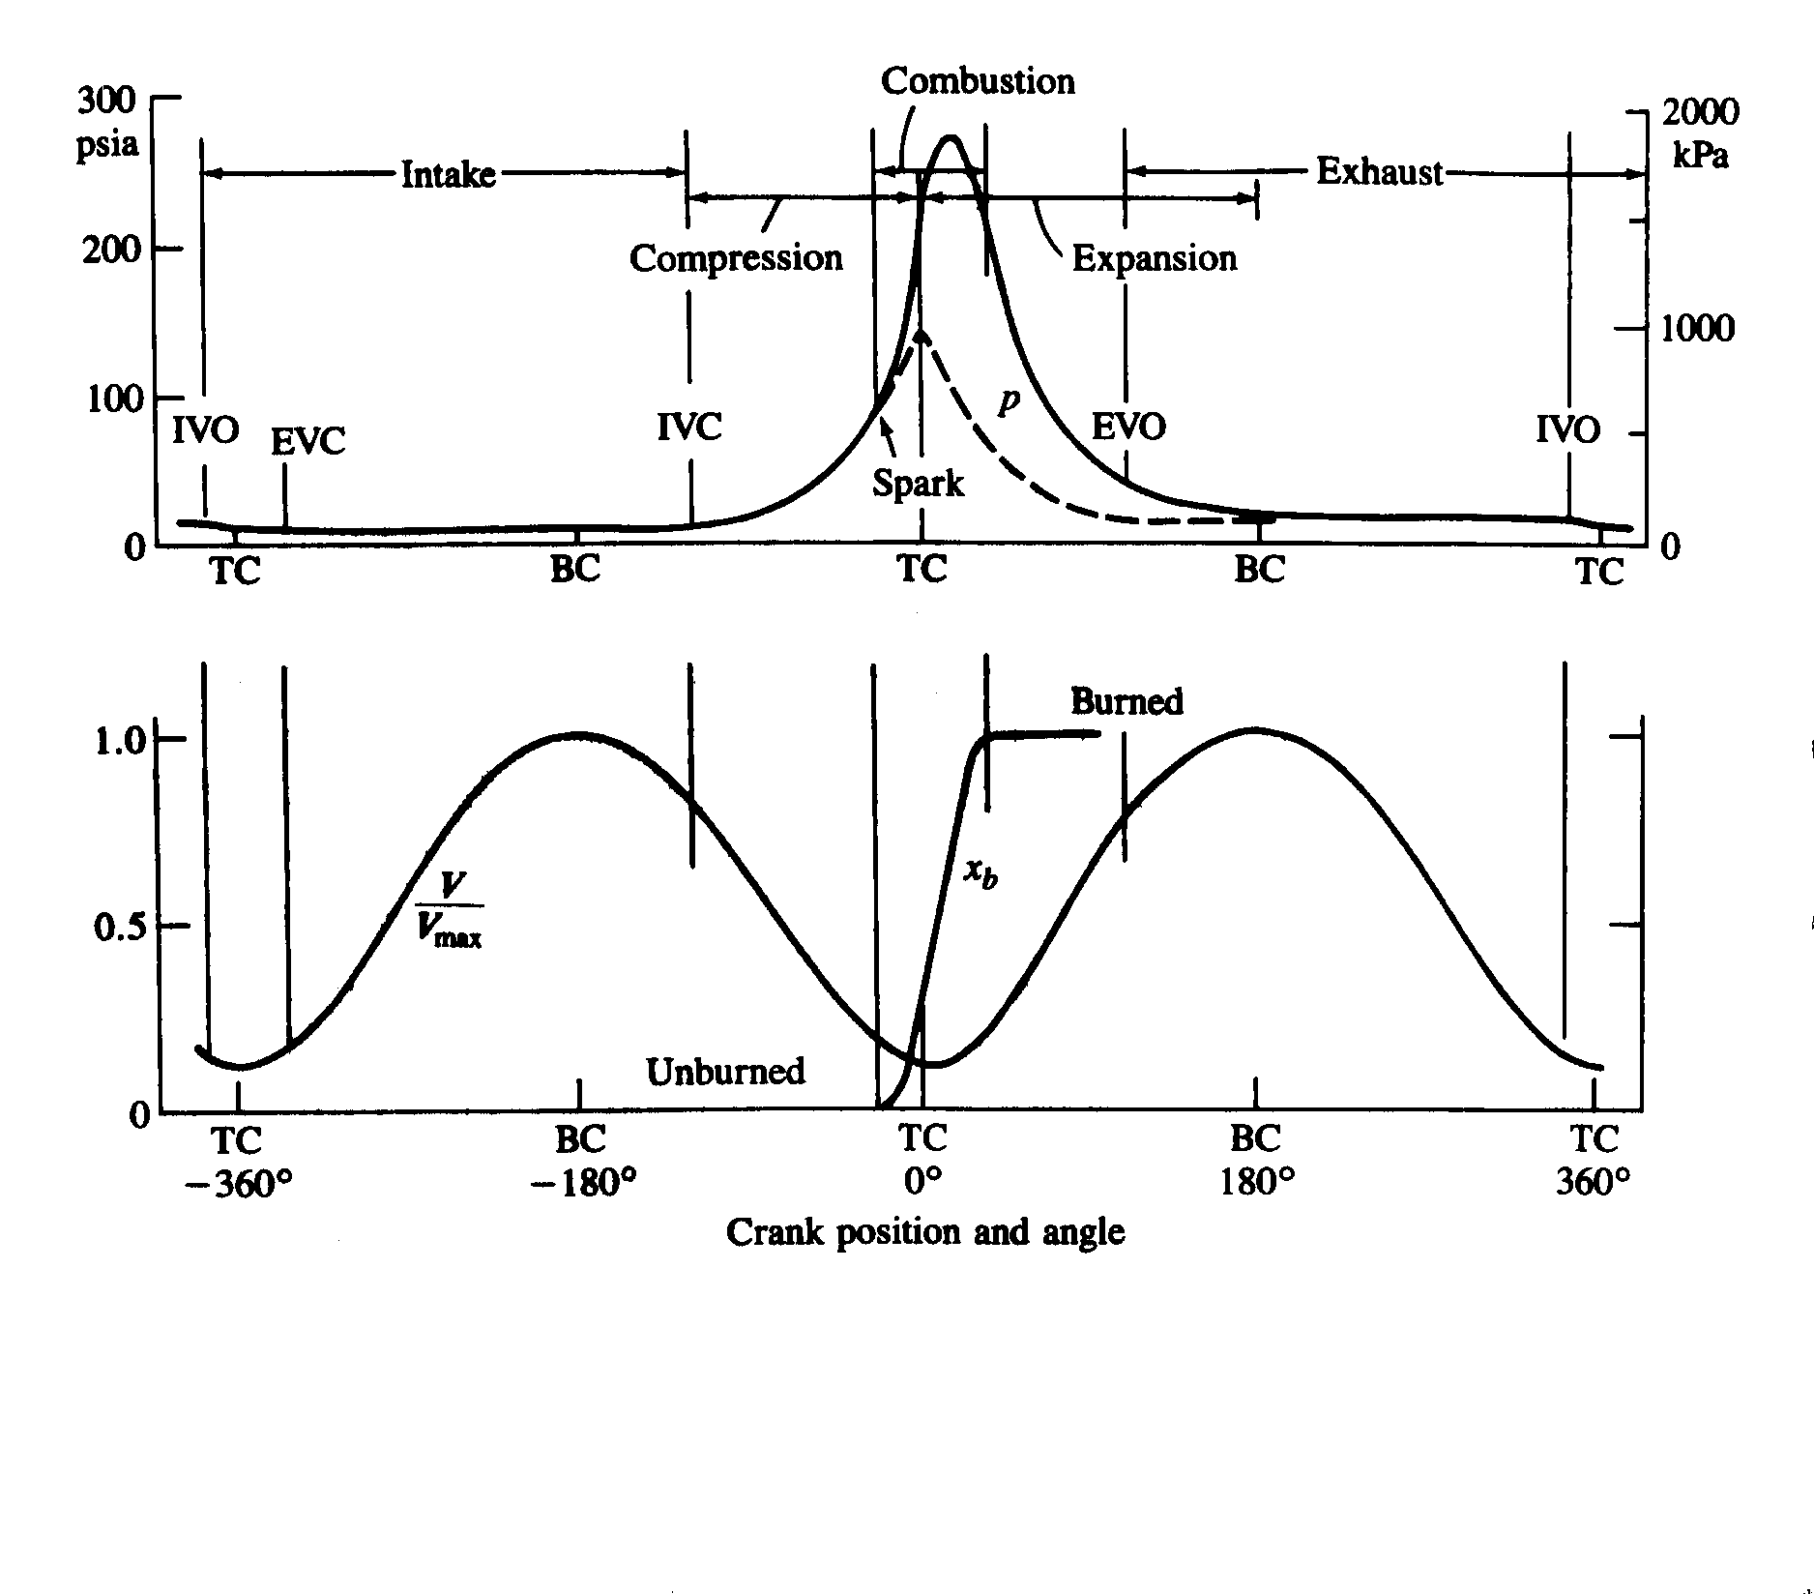

*Figure 6.1: Sequence of Events in Four-Stroke Spark Ignition Engine Operating Cycle.*

Under starting conditions, when the engine is influenced by factors such as engine block temperature, engine speed, and ignition delay, the engine spark advance position varies substantially. At higher engine speeds, or under normal operating conditions, the spark advance position is less influenced by the engine speed. The approximate values of the spark advance position for best performance range from 30 to 50 before TDC, where the maximum cylinder pressure is recorded between 10 to 20 after TDC. The best positions are dictated by the fuel octane number and the fuel/air ratio. When ignition occurs before the spark discharge signal, it is referred to as either auto ignition or detonation. Consequences can range from a drastic loss in power accompanied with unpleasant noise, to melting of the piston and permanent damage to the engine. Auto ignition and eventually detonation, is a result of several ignition source points appearing because of excessive temperature. This phenomenon may eventually provoke the appearance of shock waves in the cylinder. In turn, the presence of shock waves causes a rapid increase in temperature, and causes the pressure to oscillate drastically in the cylinder. As a result, the excessive temperature increases can damage the piston or the cylinder permanently.

The other factor which influences the selection of an operating point for spark advance is pollutant emission. The use of internal combustion engines is subjected to very stringent environmental constraints on car pollution; thereby, forcing car manufacturers to produce engines with low and ultra low pollution emissions. The pollutant component which should be minimized is the NOx emissions. The formation of NOx is not only caused by the high temperatures obtained during the combustion process but increases with higher combustion temperatures. Therefore it is evident that choosing a spark advance position solely based on performance results, is not a wise choice. Pollutant emissions (NO, CO, CO2… etc.) should be carefully analysed before a final selection is made.

Engine Control Module

The method used to control the spark advance needs to be addressed. To begin with, several sensors are used to read the vital signals from the engine, and deliver the required amount of fuel. Upon detection of an analog signal, the information from the sensor is relayed to the Engine Control Module (ECM) which processes the data and sends out control signals to devices such as the fuel delivery, spark advance, and anti-pollution systems.

The spark advance system is the component of interest in this experiment. A few years ago, spark advance control was achieved with mechanical systems. Although they have been quite reliable, pollution control forced car manufacturers to develop an efficient scheme for spark advance control systems. Today, most cars use computer controlled spark advance, where a look up table stores the spark timing position in the computer memory bank (EPROM chip). Based on speed, load, atmospheric pressure, coolant temperature, throttle position, oxygen content in the exhaust, the ECM outputs a control signal to the Electronic Spark Timing (EST) module which is responsible for triggering the ignition coil; thus, causing a spark to occur at the spark plug. As opposed to the old spark advance system where only one open control loop based on manifold pressure was possible, the new electronic system operates in a closed loop based on an oxygen sensor. The only time this system operates in an open loop is when the coolant temperature sensor indicates that the engine has not yet attained its operating temperature. Therefore, in order to use a different EPROM configuration the engine has to operate in an open loop fashion. By telling the ECM that the engine has not yet reached its operating temperature, different EPROM's can be used.

Engine Emissions And Air Pollution

The exhaust of automobiles is one of the major contributors to the world's air pollution problem. Recent research and development has made major reductions in engine emissions, but a growing population and a greater number of automobiles means that the problem will exist for many years to come.

During the first half of the 1900s, automobile emissions were not recognized as a problem, mainly due to the lower number of vehicles. As the number of automobiles grew along with more power plants, home furnaces, and population in general, air pollution became an ever-increasing problem. During the 1940s, the problem was first seen in the Los Angeles area due to the high density of people and automobiles, as well as unique weather conditions. By the 1970s, air pollution was recognized as a major problem in most cities of the United States as well as in many large urban areas around the world.

Laws were passed in the United States and in other industrialized countries which limit the amount of various exhaust emissions that are allowed. This put a major restriction on automobile engine development during the 1980s and 1990s. Although harmful emissions produced by engines have been reduced by over 90% since the 1940s, they are still a major environmental problem.

Four major emissions produced by internal combustion engines are hydrocarbons (HC), carbon monoxide (CO), oxides of nitrogen (NOx), and solid particulates. Hydrocarbons are fuel molecules which did not get burned and smaller non equilibrium particles of partially burned fuel. Carbon monoxide occurs when not enough oxygen is present to fully react all carbon to CO2 or when incomplete air-fuel mixing occurs due to the very short engine cycle time. Oxides of nitrogen are created in an engine when high combustion temperatures cause some normally stable N2 to dissociate into monatomic nitrogen N, which then combines with reacting oxygen. Solid particulates are formed in compression ignition engines and are seen as black smoke in the exhaust of these engines. Other emissions found in the exhaust of engines include aldehydes, sulfur, lead, and phosphorus.

Two methods are being used to reduce harmful engine emissions. One is to improve the technology of engines and fuels so that better combustion occurs and fewer emissions are generated. The second method is after treatment of the exhaust gases. This is done by using thermal converters or catalytic converters that promote chemical reactions in the exhaust flow. These chemical reactions convert the harmful emissions to acceptable CO2, H2O, and N2.

Theory

For an engine with bore *B* (see Figure 6.2), crank offset *a*, stroke length *S*, turning at an engine speed of *N*:

 (6.1)

Average piston speed is:

 (6.2)

*N* is generally given in RPM (revolutions per minute), in m/sec (ft/sec), and *B*, *a*, and *S* in m or cm (ft or in). Average piston speed for all engines will normally be in the range of 5 to 15 m/sec (15 to 50 ft/sec), with large diesel engines on the low end and high-performance automobile engines on the high end. There are two reasons why engines operate in this range. First, this is about the safe limit which can be tolerated by material strength of the engine components. For each revolution of the engine, each piston is twice accelerated from stop to a maximum speed and back to stop. At a typical engine speed of 3000 RPM, each revolution lasts 0.02 s (0.005 s at 12000 RPM). If engines operated at higher speeds, there would be a danger of material failure in the pistons and connecting rods as the piston is accelerated and decelerated during each stroke. From Equation 3.2 it can be seen that this range of acceptable piston speeds places a range on acceptable engine speeds also, depending on engine size. There is a strong inverse correlation between engine size and operating speed. Very large engines with bore sizes on the order of 0.5 m (1.6 ft) typically operate in the 200 to 400 RPM range, while the very smallest engines (model airplane) with bores on the order of 1 cm (0.4 in) operate at speeds of 12000 RPM and higher. Automobile engines usually operate in a speed range of 500 to 5000 RPM, with cruising at about 2000 RPM. Under certain conditions using special materials and design, high-performance experimental engines have been operated with average piston speeds up to 25 m/sec.

The second reason why maximum average piston speed is limited is because of the gas flow into and out of the cylinders. Piston speed determines the instantaneous flow rate of air-fuel into the cylinder during intake and exhaust flow out of the cylinder during the exhaust stroke. Higher piston speeds would require larger valves to allow for higher flow rates. In most engines, valves are at a maximum size with no room for enlargement.

Bore sizes of engines range from 0.5 m down to 0.5 cm (20 in to 0.2 in). The ratio of bore to stroke, *B / S*, for small engines is usually from 0.8 to 1.2. An engine with *B = S* is often called a square engine. If stroke length is longer than bore diameter the engine is under square, and if stroke length is less than bore diameter the engine is over square. Very large engines are always under square, with stroke lengths up to four times bore diameter.

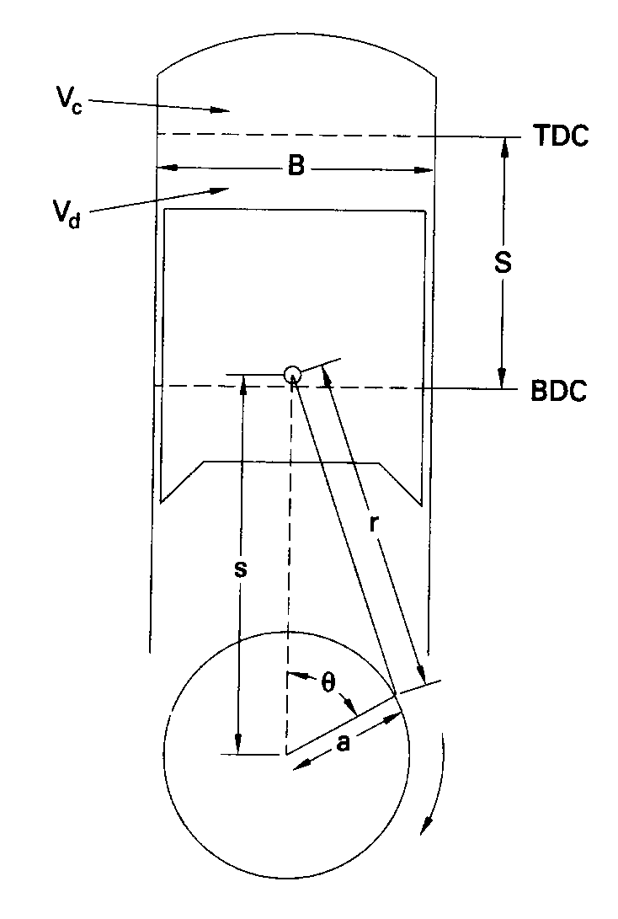

*Figure 6.2: Piston and cylinder geometry of reciprocating engine.*

The distance *s* between crank axis and wrist pin axis is given by

 (6.3)

where: *a* = crankshaft offset

*r* = connecting rod length

*θ* = crank angle, which is measured from the cylinder centerline and is

zero when the piston is at TDC

When *s* is differentiated with respect to time, the instantaneous piston speed *Up* is obtained:

 (6.4)

The ratio of instantaneous piston speed divided by the average piston speed can then be written as

 (6.5)

where

 (6.6)

*R* is the ratio of connecting rod length to crank offset and usually has values of 3 to 4 for small engines, increasing to 5 to 10 for the largest engines. Displacement, or displacement volume *Vd*, is the volume displaced by the piston as it travels from BDC to TDC:

 (6.7)

Displacement can be given for one cylinder or for the entire engine. For one cylinder:

 (6.8)

For an engine with *Nc* cylinders:

 (6.9)

where: *B* = cylinder bore

*S* = stroke

*Nc* = number of engine cylinders

Engine displacements can be given in m3, cm3, in3, and, most commonly, in liters (L).

1 L = 10-3 m3 = 103 cm3 ≈ 61 in3

Typical values for engine displacement range from 0.1 cm3 (0.0061 in3) for small model airplanes to about 8 L (490 in3) for large automobiles to much larger numbers for large ship engines. The displacement of a modern average automobile engine is about two to three liters.

For a given displacement volume, a longer stroke allows for a smaller bore (under square), resulting in less surface area in the combustion chamber and correspondingly less heat loss. This increases thermal efficiency within the combustion chamber. However, the longer stroke results in higher piston speed and higher friction losses that reduce the output power which can be obtained off the crankshaft. If the stroke is shortened, the bore must be increased and the engine will be over square. This decreases friction losses but increases heat transfer losses. Most modern automobile engines are near square, with some slightly over square and some slightly under square. This is dictated by design compromises and the technical philosophy of the manufacturer. Very large engines have long strokes with stroke-to-bore ratios as high as 4:1.

Minimum cylinder volume occurs when the piston is at TDC and is called the clearance volume *Vc*.

 (6.10)

 (6.11)

The compression ratio of an engine is defined as:

 (6.12)

Modern spark ignition (SI) engines have compression ratios of 8 to 11, while compression ignition (CI) engines have compression ratios in the range 12 to 24. Engines with superchargers or turbochargers usually have lower compression ratios than naturally aspirated engines. Because of limitations in engine materials, technology, and fuel quality, very early engines had low compression ratios, on the order of 2 to 3. This limit of 8 to 11 is imposed mainly by gasoline fuel properties and force limitations allowable in smaller high-speed engines.

Various attempts have been made to develop engines with a variable compression ratio. One such system uses a split piston that expands due to changing hydraulic pressure caused by engine speed and load. Some two-stroke cycle engines have been built which have a sleeve-type valve that changes the slot opening on the exhaust port. The position where the exhaust port is fully closed can be adjusted by several degrees of engine rotation. This changes the effective compression ratio of the engine.

The cylinder volume *V* at any crank angle is:

 (6.13)

where: *Vc* = clearance volume

*B* = bore

*r* = connecting rod length

*a* = crank offset

*s* = piston position shown in Figure

This can also be written in a non-dimensional form by dividing by *Vc*, substituting for *r*, *a*, and *s*, and employing the definition of *R*:

 (6.14)

where: *rc* = compression ratio

*R = r / a*

The cross-sectional area of a cylinder and the surface area of a flat-topped piston are each given by:

 (6.15)

The combustion chamber surface area is:

 (6.16)

where *Ach* is the cylinder head surface area, which will be somewhat larger than *Ap*.

Then if the definitions for *r*, *a*, *s*, and *R* are used, Equation 6.16 can be rewritten as:

 (6.17)

Work

Work is the output of any heat engine, and in a reciprocating IC engine this work is generated by the gases in the combustion chamber of the cylinder. Work is the result of force acting through a distance. Force due to gas pressure on the moving piston generates the work in an IC engine cycle.

 (6.18)

where: *P* = pressure in combustion chamber

*Ap* = area against which the pressure acts (i.e., the piston face)

*x* = distance the piston moves

and

 (6.19)

*dV* is the differential volume displaced by the piston, so work done can be written:

 (6.20)

Figure 6.3, which plots the engine cycle on *P-V* coordinates, is often called an indicator diagram. Early indicator diagrams were generated by mechanical plotters linked directly to the engine. Modern *P-V* indicator diagrams are generated on an oscilloscope using a pressure transducer mounted in the combustion chamber and an electronic position sensor mounted on the piston or crankshaft.

Because engines are often multi cylinder, it is convenient to analyze engine cycles per unit mass of gas *m* within the cylinder. To do so, volume *V* is replaced with specific volume *v* and work is replaced with specific work:

 (6.21)

 (6.22)

 (6.23)

Specific work *w* is equal to the area under the process lines on the *P-v* coordinates of Figure 3.3.

If *P* represents the pressure inside the cylinder combustion chamber, then Equation 6.23 and the areas shown in Figure 6.3 give the work inside the combustion chamber. This is called indicated work. Work delivered by the crankshaft is less than indicated work due to mechanical friction and parasitic loads of the engine. Parasitic loads include the oil pump, supercharger, air conditioner compressor, alternator, etc. Actual work available at the crankshaft is called brake work *wb*. Units of specific work will be kJ/kg or BTU/lbm.

 (6.24)

where: *wi* = indicated specific work generated inside combustion chamber

*wf* = specific work lost due to friction and parasitic loads

The upper loop of the engine cycle in Figure 6.3 consists of the compression and power strokes where output work is generated and is called the gross indicated work (areas A and C in Figure 6.3). The lower loop, which includes the intake and exhaust strokes, is called pump work and absorbs work from the engine (areas B and C). Net indicated work is:

 (6.25)

Pump work *wpump* is negative for engines without superchargers:

 (6.26)

Engines with superchargers or turbochargers can have intake pressure greater than exhaust pressure, giving a positive pump work. When this occurs:

 (6.27)

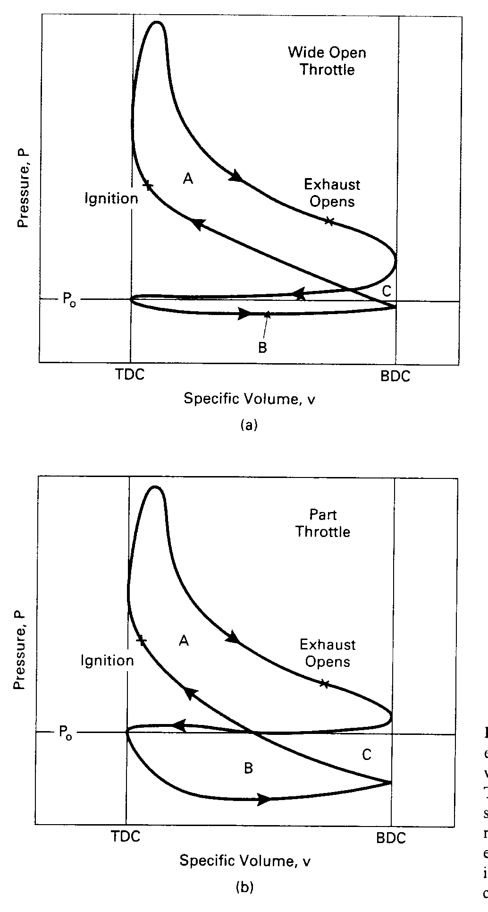

*Figure 6.3: Four-stroke cycle of typical SI engine plotted on P-v coordinates at (a) wide open throttle and (b) part throttle.*

Superchargers increase net indicated work but add to the friction work of the engine since they are driven by the crankshaft.

The ratio of brake work at the crankshaft to indicated work in the combustion chamber defines the mechanical efficiency of an engine:

 (6.28)

Mechanical efficiency will be on the order of 75% to 95%, at high speed for modern automobile engines operating at wide-open throttle. It then decreases with decreasing engine speed to zero at idle conditions, when no work is taken off the crankshaft.

Care should be taken when using the terms "gross work" and "net work". In some older literature and textbooks, net work (or net power) meant the output of an engine with all components, while gross work (or gross power) meant the output of the engine with fan and exhaust system removed.

Mean Effective Pressure

From Figure 3.3 it can be seen that pressure in the cylinder of an engine is continuously changing during the cycle. An average or mean effective pressure (mep) is defined by:

 (6.29)

or

 (6.30)

 (6.31)

where: *W* = work of one cycle

*w* = specific work of one cycle

*Vd* = displacement volume

Mean effective pressure is a good parameter to compare engines for design or output because it is independent of engine size and/or speed. If torque is used for engine comparison, a larger engine will always look better. If power is used as the comparison, speed becomes very important.

Various mean effective pressures can be defined by using different work terms in Equation 6.30. If brake work is used, brake mean effective pressure is obtained:

 (6.32)

Indicated work gives indicated mean effective pressure:

 (6.33)

The imep can further be divided into gross indicated mean effective pressure and net indicated mean effective pressure:

 (6.34)

 (6.35)

Pump mean effective pressure (which can have negative values):

 (6.36)

Friction mean elective pressure:

 (6.37)

Typical maximum values of bmep for naturally aspirated SI engines are in the range of 850 to 1050 kPa (120 to 150 psi). For CI engines, typical maximum values are 700 to 900 kPa (100 to 130 psi) for naturally aspirated engines and 1000 to 1200 kPa (145 to 175 psi) for turbocharged engines.

Torque And Power

Torque is a good indicator of an engine's ability to do work. It is defined as force acting at a moment distance and has units of N-m or lbf-ft. Torque *τ* is related to work by:

 (6.38)

where: *Wb* = brake work of one revolution

*Vd* = displacement volume

*n* = number of revolutions per cycle

For a two-stroke cycle engine with one cycle for each revolution:

 (6.39)

 Two-stroke cycle (6.40)

For a four-stroke cycle engine which takes two revolutions per cycle:

 Four-stroke cycle (6.41)

In these equations, bmep and brake work *Wb* are used because torque is measured off the output crankshaft.

Many modern automobile engines have maximum torque in the 200 to 300 N-m range at engine speeds usually around 4000 to 6000 RPM. The point of maximum torque is called maximum brake torque speed (MBT). A major goal in the design of a modern automobile engine is to flatten the torque-versus-speed curve as shown in Figure 6.4, and to have high torque at both high and low speed. CI engines generally have greater torque than SI engines. Large engines often have very high torque values with MBT at relatively low speed.

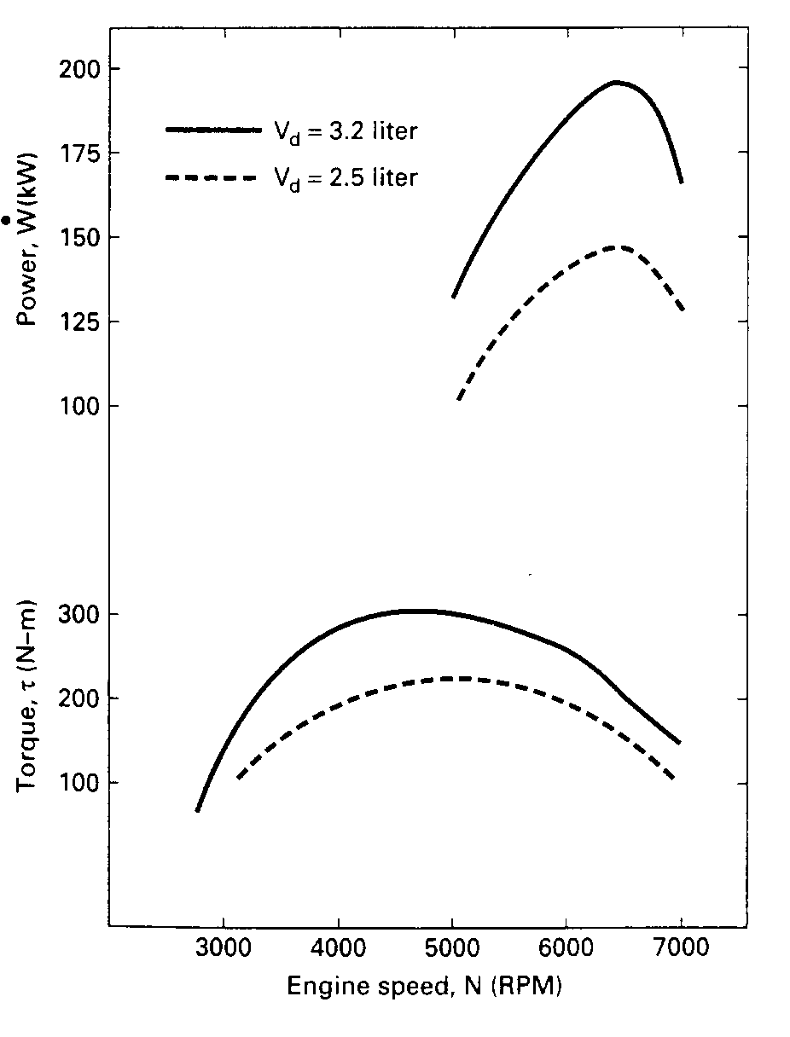

*Figure 6.4: Brake power and torque of typical automobile reciprocating engine as a function of engine speed*

Power is defined as the rate of work of the engine. If *n* = number of revolutions per cycle, and *N* = engine speed, then:

 (6.42)

 (6.43)

 (6.44)

 Four-stroke cycle (6.45)

 Two-stroke cycle (6.46)

where: *W* = work per cycle

*Ap* = piston face area of all pistons

 = average piston speed

Depending upon which definition of work or mep is used in Equations 6.42 – 6.46, power can be defined as brake power, net indicated power, gross indicated power, pumping power, and even friction power. Also:

 (6.47)

 (6.48)

 (6.49)

where *ηm* is the mechanical efficiency of the engine.

Power is normally measured in kW, but horsepower (hp) is still common.

1 hp = 0.7457 kW = 2545 BTU/hr = 550 ft-lbf/sec

1 kW = 1.341 hp

Engine power can range from a few watts in small model airplane engines to thousands of kW per cylinder in large multiple-cylinder stationary and ship engines. There is a large commercial market for engines in the 1.5 to 5 kW (2-7 hp) range for lawn mowers, chain saws, snowblowers, etc. Power for outboard motors (engines) for small boats typically ranges from 2 to 40 kW (3-50 hp), with much larger ones available. Modern automobile engines range mostly from 40 to 220 kW (50-300 hp). It is interesting to note that a modern midsize aerodynamic automobile only requires about 5 to 6 kW (7-8 hp) to cruise at 55 mph on level roadway.

Both torque and power are functions of engine speed. At low speed, torque increases as engine speed increases. As engine speed increases further, torque reaches a maximum and then decreases as shown in Figure 6.4. Torque decreases because the engine is unable to ingest a full charge of air at higher speeds. Indicated power increases with speed, while brake power increases to a maximum and then decreases at higher speeds. This is because friction losses increase with speed and become the dominant factor at very high speeds. For many automobile engines, maximum brake power occurs at about 6000 to 7000 RPM, about one and a half times the speed of maximum torque.

Greater power can be generated by increasing displacement, mep, and/or speed. Increased displacement increases engine mass and take up space, both of which are contrary to automobile design trends. For this reason, most modern engines are smaller but run at higher speeds, and are often turbocharged or supercharged to increase mep.

Other ways which are sometimes used to classify engines are shown in Equations 6.50 - 6.53.

Specific Power  (6.50)

Output Per Displacement  (6.51)

Specific Volume  (6.52)

Specific Weight  (6.53)

where: *Wb* = brake power

*Ap* = piston face area of all pistons

*Vd* = displacement volume

These parameters are important for engines used in transportation vehicles such as boats, automobiles, and especially airplanes, where keeping weight to a minimum is necessary. For large stationary engines, weight is not as important.

Modern automobile engines usually have brake power output per displacement in the range of 40 to 80 kW/L. The Honda eight-valve-per-cylinder V4 motorcycle engine generates about 130 kW/L, an extreme example of a high-performance racing engine. One main reason for continued development to return to two-stroke cycle automobile engines is that they have up to 40% greater power output per unit weight.

Dynamometers

Dynamometers are used to measure torque and power over the engine operating ranges of speed and load. They do this by using various methods to absorb the energy output of the engine, all of which eventually ends up as heat.

Fluid or hydraulic dynamometers absorb engine energy in water or oil pumped through orifices or dissipated with viscous losses in a rotor-stator combination. Large amounts of energy can be absorbed in this manner, making this an attractive type of dynamometer for the largest of engines. Eddy current dynamometers use a disk, driven by the engine being tested, rotating in a magnetic field of controlled strength. The rotating disk acts as an electrical conductor cutting the lines of magnetic flux and producing eddy currents in the disk. With no external circuit, the energy from the induced currents is absorbed in the disk.

One of the best types of dynamometers is the electric dynamometer, which absorbs energy with electrical output from a connected generator. In addition to having an accurate way of measuring the energy absorbed, the load is easily varied by changing the amount of resistance in the circuit connected to the generator output. Many electric dynamometers can also be operated in reverse, with the generator used as a motor to drive (or motor) an unfired engine. This allows the engine to be tested for mechanical friction losses and air pumping losses, quantities that are hard to measure on a running fired engine.

Air-Fuel Ratio And Fuel-Air Ratio

Energy input to an engine *Qin* comes from the combustion of a hydrocarbon fuel. Air is used to supply the oxygen needed for this chemical reaction. For combustion reaction to occur, the proper relative amounts of air (oxygen) and fuel must be present.

Air-fuel ratio (AF) and fuel air ratio (FA) are parameters used to describe the mixture ratio:

 (6.54)

 (6.55)

where: *ma* = mass of air

 = mass flow rate of air

*mf* = mass of fuel

 = mass flow rate of fuel

The ideal or stoichiometric AF for many gasoline-type hydrocarbon fuels is very close to 15:1, with combustion possible for values in the range 6 to 19. AF less than 6 is too rich to sustain combustion and AF greater than 19 is too lean. The fuel input system of an engine, fuel injectors or carburetor, must be able to regulate the proper amount of fuel for any given air flow. Gasoline-fueled engines usually have AF input in the range of 12 to 18 depending on the operating conditions at the time (e.g., accelerating, cruising, starting, etc.).

CI engines typically have AF input in the range of 18 to 70, which appears to be outside the limits where combustion is possible. Combustion occurs because the cylinder of a CI engine, unlike an SI engine, has a very non-homogeneous air-fuel mixture, with reaction only occurring in those regions where a combustible mixture exists, other regions being too rich or too lean.

Equivalence ratio *φ* is defined as the actual ratio of fuel-air to ideal or stoichiometric fuel air:

 (6.56)

Specific Fuel Consumption

Specific fuel consumption is defined by:

 (6.57)

where: = rate of fuel flow into engine

*W* = engine power

Brake power gives brake specific fuel consumption:

 (6.58)

Indicated power gives indicated specific fuel consumption:

 (6.59)

Other examples of specific fuel consumption parameters can be defined as follows:

fsfc = friction specific fuel consumption

igsfc = indicated gross specific fuel consumption

insfc = indicated net specific fuel consumption

psfc = pumping specific fuel consumption

It also follows that:

 (6.60)

where: *ηm* = mechanical efficiency of engine

Brake specific fuel consumption decreases as engine speed increases, reaches a minimum, and then increases at high speeds (Figure 6.5). Fuel consumption increases at high speed because of greater friction losses. At low engine speed, the longer time per cycle allows more heat loss and fuel consumption goes up. Figure 6.5 shows how bsfc also depends on compression ratio and fuel equivalence ratio. It decreases with higher compression ratio due to higher thermal efficiency. It is lowest when combustion occurs in a mixture with a fuel equivalence ratio near one, (*φ* = 1). The further from stoichiometric combustion, rich or lean, the higher will be the fuel consumption.

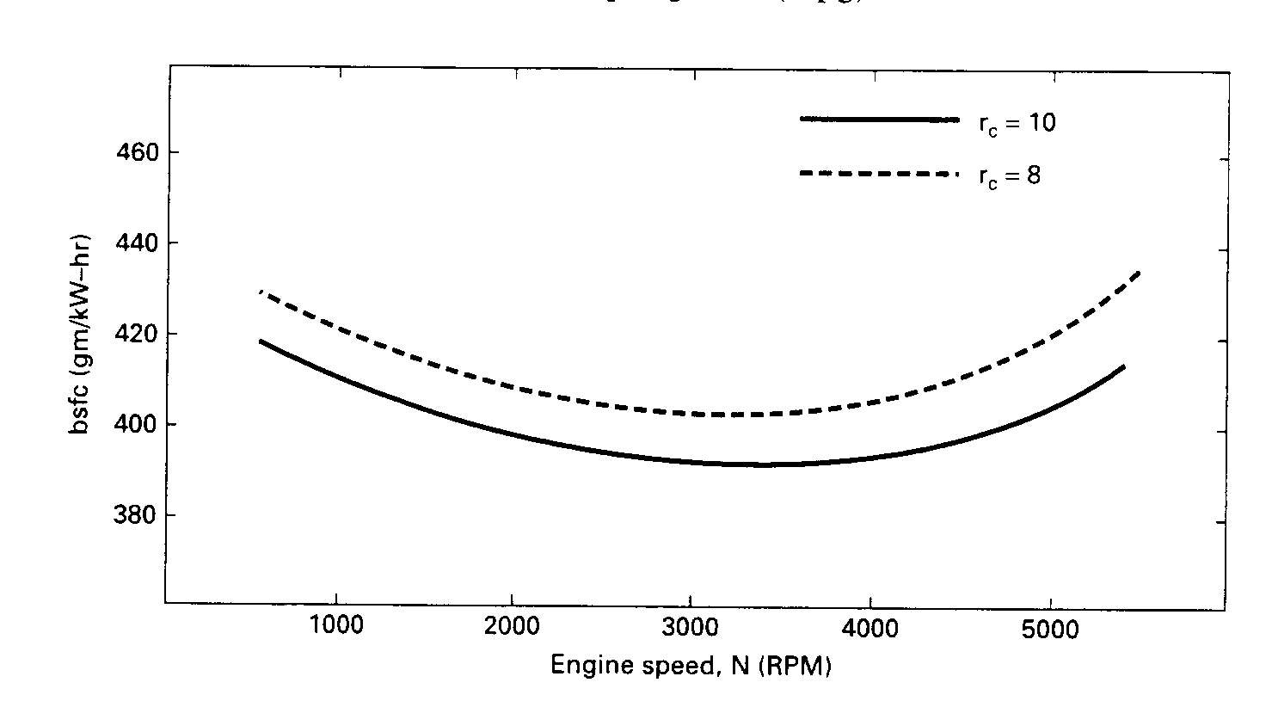

*Figure 6.5: Brake specific fuel consumption as a function of engine speed.*

Brake specific fuel consumption generally decreases with engine size, being best (lowest) for very large engines.

Specific fuel consumption is generally given in units of g/kW-hr or lbm/hp-hr. For transportation vehicles it is common to use fuel economy in terms of distance traveled per unit of fuel, such as miles per gallon (mpg). In SI units it is common to use the inverse of this, with (L/100 km) being a common unit. To decrease air pollution and depletion of fossil fuels, laws have been enacted requiring better vehicle fuel economy. Since the early 1970s, when most automobiles got less than 15 mpg (15.7 L/100 km) using gasoline, great strides have been made in improving fuel economy. Many modern automobiles now get between 30 and 40 mpg (7.8 and 5.9 L/100 km), with some small vehicles as high as 60 mpg (3.9 L/100 km).

Engine Efficiencies

The time available for the combustion process of an engine cycle is very brief, and not all fuel molecules may find an oxygen molecule with which to combine, or the local temperature may not favor a reaction. Consequently, a small fraction of fuel does not react and exits with the exhaust flow. A combustion efficiency *ηc* is defined to account for the fraction of fuel which burns. *ηc* typically has values in the range 0.95 to 0.98 when an engine is operating properly. For one engine cycle in one cylinder, the heat added is:

 (6.61)

For steady state:

 (6.62)

and thermal efficiency is:

 (6.63)

where: *W* = work of one cycle

= power

*mf* = mass of fuel for one cycle

 = mass flow rate of fuel

*QHV* = heating value of fuel

*ηf* = fuel conversion efficiency (see Equation 6.65)

Thermal efficiency can be given as indicated or brake, depending on whether indicated power or brake power is used in Equation 6.63. It follows that engine mechanical efficiency:

 (6.64)

Engines can have indicated thermal efficiencies in the range of 50% to 60%, with brake thermal efficiency usually about 30%. Some large, slow CI engines can have brake thermal efficiencies greater than 50%.

Fuel conversion efficiency is defined as:

 (6.65)

 (6.66)

For a single cycle of one cylinder the thermal efficiency can be written:

 (6.67)

Volumetric Efficiency

One of the most important processes that govern how much power and performance can be obtained from an engine is getting the maximum amount of air into the cylinder during each cycle. More air means more fuel can be burned and more energy can be converted to output power. Getting the relatively small volume of liquid fuel into the cylinder is much easier than getting the large volume of gaseous air needed to react with the fuel. Ideally, a mass of air equal to the density of atmospheric air times the displacement volume of the cylinder should be ingested for each cycle. However, because of the short cycle time available and the flow restrictions presented by the air cleaner, carburetor (if any), intake manifold, and intake valve(s), less than this ideal amount of air enters the cylinder. Volumetric efficiency is defined as:

 (6.68)

 (6.69)

where: *ma* = mass of air into the engine (or cylinder) for one cycle

= steady-state flow of air into the engine

*ρa* = air density evaluated at atmospheric conditions outside the engine

*Vd* = displacement volume

*N* = engine speed

*n* = number of revolutions per cycle

Unless better values are known, standard values of surrounding air pressure and temperature can be used to find density:

*PO* (standard) = 101 kPa = 14.7 psia

*TO* (standard) = 298 K = 25°C = 537°R = 77°F

 (6.70)

where: *Po* = pressure of surrounding air

*To* = temperature of surrounding air

*R* = gas constant for air = 0.287 kJ/kg-K = 53.33 ft-lbf/lbm-°R

At standard conditions, the density of air *ρa* = 1.181 kg/m3 = 0.0739 lbm/ft3. When volumetric efficiency is measured experimentally, corrections can be made for temperature and humidity when other than standard conditions are experienced.

Sometimes (less common) the air density in Equations 2.68 and 2.69 is evaluated at conditions in the intake manifold immediately before it enters the cylinder. The conditions at this point will usually be hotter and at a lower pressure than surrounding atmospheric conditions.

Typical values of volumetric efficiency for an engine at wide-open throttle (WOT) are in the range 75% to 90%, going down to much lower values as the throttle is closed. Restricting air flow into an engine (closing the throttle) is the primary means of power control for a spark ignition engine.

Emissions

The four main engine exhaust emissions which must be controlled are oxides of nitrogen (NOx), carbon monoxide (CO), hydrocarbons (HC), and solid particulates (part). Two common methods of measuring the amounts of these pollutants are specific emissions (SE) and the emissions index (EI). Specific emissions typically have units of g/kW-hr, while the omissions index has units of emissions flow per fuel flow.

Engine

The Twin Dual Cam V6 (see Figure 6.6) from GM is a naturally aspirated, 6 cylinder, 60° V-configuration, 24 valve, double overhead cam engine with a two stage chain and belt cam drive.

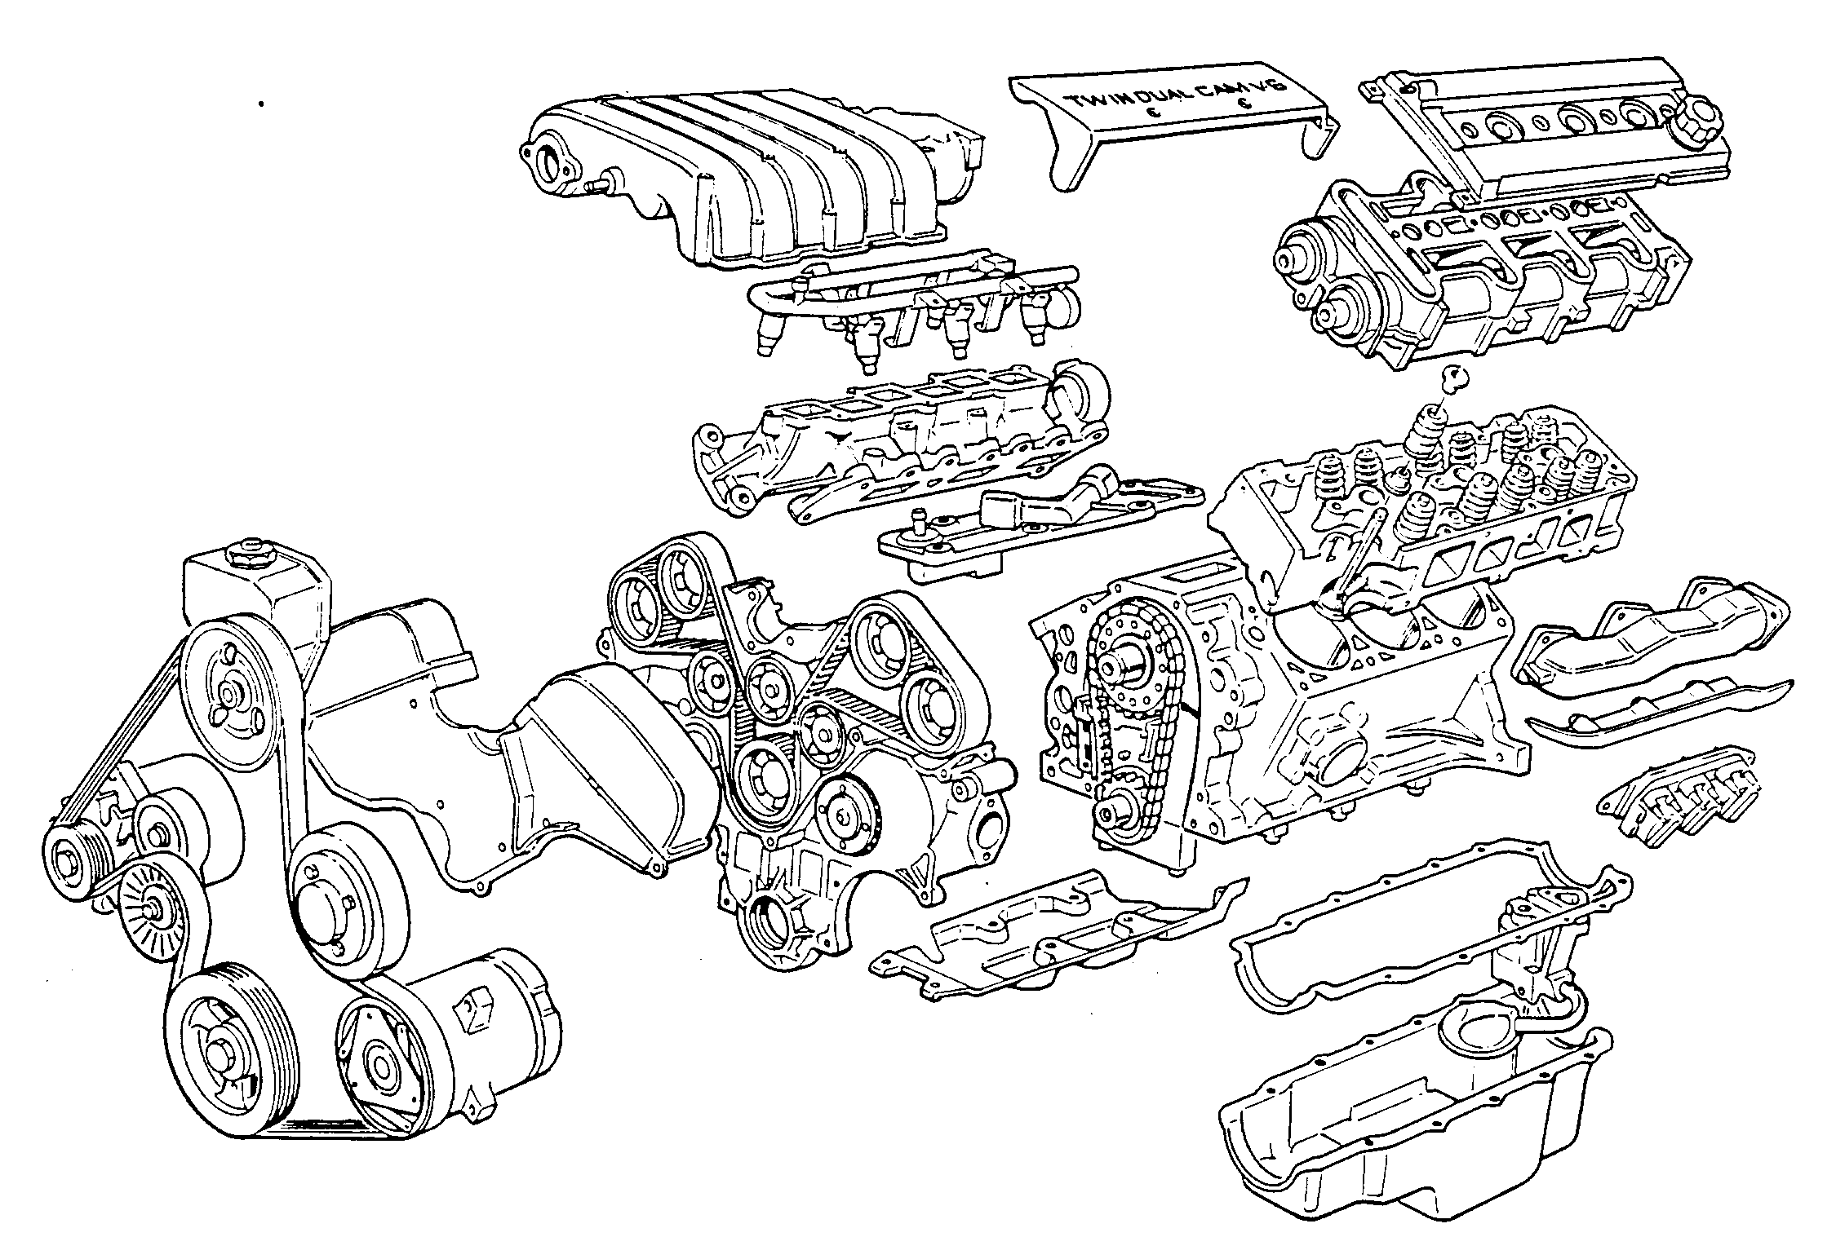

*Figure 6.6: GM 3.4L Twin Dual Cam V6 Components.*

The cylinder block is of cast iron. Cylinder heads, cam carriers, cam covers, intake manifold, upper plenum/runners front cover and several other components are of aluminum. The valve train consists of 12 intake valves, 12 exhaust valves, 24 hydraulic lifters and a pair of direct acting camshafts for each bank. The intake system has tuned individual runners for each cylinder and multi-point electronic fuel injection with the GM speed-density fuel control system. A distributorless direct fire ignition system is used with the spark plug centrally located in the combustion chamber. The high capacity in-sump oil pump is gear driven from the intermediate shaft, which is housed in the cylinder block. The oil distribution system ensures ample supply of oil to the crankshaft bearings. The front cover houses the water pump, coolant supply passages and the cam belt drive system. All accessories are directly mounted to the front cover. Noise isolation and suppression features are used throughout the engine.

Specifications

* **Type**: Naturally aspirated, 60° V6
* **Displacement**: 3.4 L
* **Bore/Stroke**: 92 mm/84 mm
* **Compression Ratio**: 9.25:1
* **Valve Train**: Direct acting dual overhead cams, 4 valves per cylinder, hydraulic valve lifters, 21.5° valve spray angle, 8400 RPM limiting speed
  + **Valves**: 36.5 mm intake, 32.0 mm exhaust, 9.4 mm intake lift at 112° aTDC, 9.4 mm exhaust lift at 111° bTDC
  + **Spring**: Intake and exhaust, 42 mm free length, 35.6 mm installed length, 51 N/mm average rate
* **Cam Drive**: Two-stage, combination chain and belt
* **Ignition System**: Direct Fire; R42LTSM spark plug; Electronic Spark Control; 1-2-3-4-5-6 firing order
* **Fuel Control**: GM Speed Density/Simultaneous Double Fire (Regular Unleaded)
* **Emission Controls**: 3-way catalytic converter; Closed loop A/F control; Digital EGR valve; EVAP charcoal canister with PWM solenoid purge valvc
* **Rated Power**:
  + **Manual**: 210 hp @ 5200 RPM (157 kW)
  + **Automatic**: 200 hp @ 5000 RPM (149 kW)
* **Rated Torque**: 215 ft-lb @ 4000 RPM (291 N-m)
* **Red Line Speed**: 7000 RPM

Dynamometer

A fluid friction dynamometer (water turbine) is used in this experiment, uses fluid friction, as its name implies, for loading the engine and dissipating the removed energy. The advantage of this type of dynamometer is that the water used for cooling is also used for causing a resistive force on the engine, thus the dissipation element does not heat up excessively as it would if dry friction were used. The range of testing of a dynamometer, referred to as its capacity, sets the lower and upper limits of torques and power that can be applied safely on this instrument. The dynamometer used for this experiment, a Super Flow™ dynamometer model SF-901, has a capacity valve which enables it to be set for different ranges (see Figure 6.7).

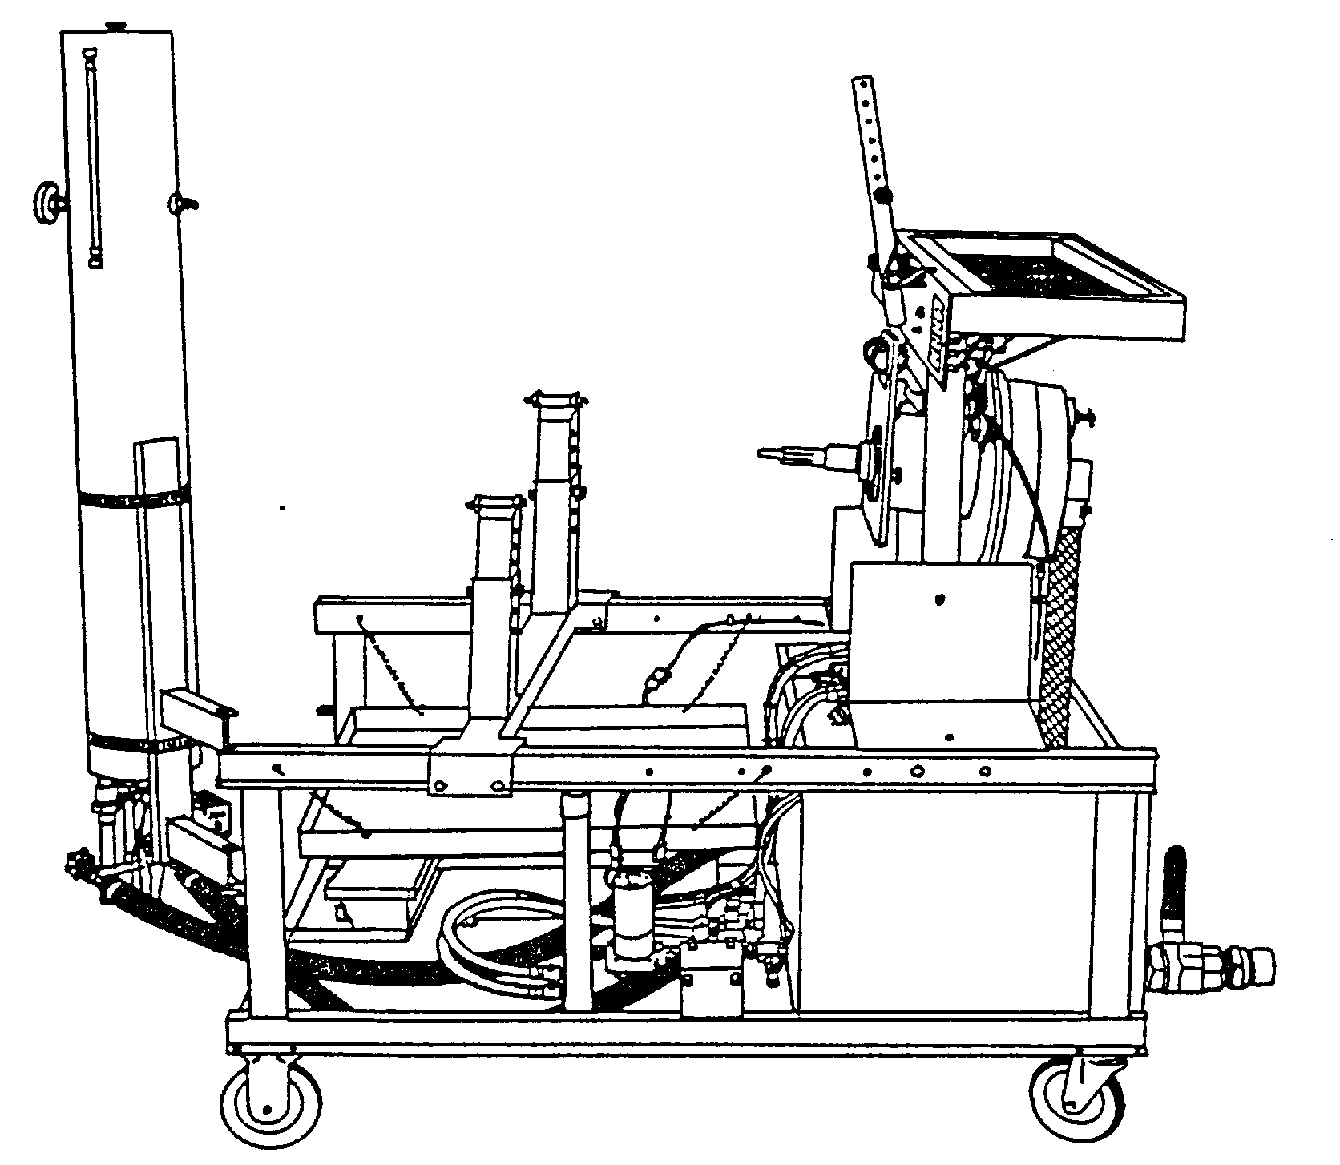

*Figure 6.7: Super Flow™ model SF-901dynamometer schematic.*

The Super Flow™ dynamometer uses a water turbine for loading the engine. However, the torque applied by the engine can be determined from the strain reading given by a strain gauge applied on a torque arm. Since an axial force is applied on a known bar, the force applied is found by recording the strain and using a simple stress calculation. Before the use of digital computers, the operation of a dynamometer required several people for performing a simple experiment and the data obtained was recorded manually. The Super Flow™ model SF-901 dynamometer has a data acquisition system on-board to record the fuel mass flow rate, the temperature readings from thermocouples, and oil pressure sensors. The principal feature of this instrument is that it can control the engine speed. Furthermore, programs can be made to operate the tested engine for acceleration runs.

Procedure

1. Turn on the Super Flow™ dynamometer, run WinDyn™ software, set EPROM setting on ECM to STOCK and start engine without load for initial warm-up.
2. In WinDyn™, load test group, configuration file, calibration file, limits file and select the test file to run the type of test (acceleration & constant speed). The lab instructor will provide details on how to run and get familiar with the software.
3. Before actually running a test, enter the engine specifications at the appropriate area (e.g. bore, stroke, number of cylinders, number of strokes, fuel specific gravity, barometric pressure and water vapor pressure. The water vapor pressure is measured using a wet and dry bulb psychrometer. The lab instructor or technician will explain on how to use a psychrometer.
4. Run the test and observe all the engine parameters on the computer screen.
5. While the engine is running steady state, use the gas analyser to manually record, on the data sheet provided, the gas emissions from the exhaust system before and after the catalytic converter.
6. Once the test is finished, save all engine data on a diskette provided by the student. The diskette contains the data files and an executable program from Super Flow™ to view the data and graphs on any computer running Microsoft Windows 98™ or higher platform. The program can also export the data (*.csv format) to any spreadsheet such as Microsoft Excel™.
7. Repeat constant speed road test by changing the EPROM settings to +3°, +5°, -3° and the LIMPHOME.

Results

1. Tabulate the data in a concise manner (i.e. remove any duplicate columns) for the acceleration test only. Clearly indicate the various parameters, units etc.
2. Plot torque, power and brake specific fuel consumption versus engine speed on separate sheets for the acceleration test.
3. Calculate the following engine parameters using the torque reading at 3000 rpm from the acceleration test and compare where possible with the engine dynamometer data:
   * Average piston speed
   * Clearance volume of one cylinder
   * Piston speed at the end of combustion
   * Distance the piston has travelled from TDC at the end of combustion
   * Volume in the combustion chamber at the end of combustion
   * Brake power
   * Indicated power
   * Brake mean effective pressure
   * Indicated mean effective pressure
   * Friction mean effective pressure
   * Power lost to friction
   * Brake work per unit mass of gas in the cylinder
   * Brake specific power
   * Brake output per displacement
   * Engine specific volume
   * Rate of fuel flow into the engine
   * Brake thermal efficiency
   * Indicated thermal efficiency
   * Volumetric efficiency
   * Brake specific fuel consumption

In your calculations take the length of the connecting rods equal to 15 cm. Assume combustion ends at 20° aTDC, air enters at 85 kPa and 60°C, a fuel heating value of 44,000 kJ/kg, AF = 15 and the mechanical and combustion efficiency to be 85% and 97%, respectively.

1. Does spark advance position affect engine performance and gas emissions during the constant speed tests? Use the data to back up your answer.
2. Explain the differences in gas emissions before and after the catalytic converter. How are the pollutants minimized before exiting to the atmosphere?

**DO NOT SUBMIT THE RAW DYNAMOMETER DATA!!!**

Data

* Data from engine dynamometer to be saved on 3.5” floppy disk (provided by students).

Fuel Emissions (Before Catalytic Converter)

|  |  |  |  |  |  |
| --- | --- | --- | --- | --- | --- |
| Emission Gas  File Name 🡪 | STOCK  ________.sfd | +3°  ________.sfd | +5°  ________.sfd | -3°  ________.sfd | LIMPHOME  ________.sfd |
| % O2 |  |  |  |  |  |
| % CO |  |  |  |  |  |
| % CO2 |  |  |  |  |  |
| HC x 10 [ppm] |  |  |  |  |  |
| NO [ppm] |  |  |  |  |  |
| NO2 [ppm] |  |  |  |  |  |
| NOx [ppm] |  |  |  |  |  |

Fuel Emissions (After Catalytic Converter)

|  |  |  |  |  |  |
| --- | --- | --- | --- | --- | --- |
| Emission Gas  File Name 🡪 | STOCK  ________.sfd | +3°  ________.sfd | +5°  ________.sfd | -3°  ________.sfd | LIMPHOME  ________.sfd |
| % O2 |  |  |  |  |  |
| % CO |  |  |  |  |  |
| % CO2 |  |  |  |  |  |
| HC x 10 [ppm] |  |  |  |  |  |
| NO [ppm] |  |  |  |  |  |
| NO2 [ppm] |  |  |  |  |  |
| NOx [ppm] |  |  |  |  |  |

Date: ____________________

Section: _____________ Signature: ________________________

References

* P.A. Hilton Ltd., Experimental Operating and Maintenance Manual: Steam Turbine Module S210, 1997.
* Eastop, T.D. and McConkey, A., Applied Thermodynamics for Engineering Technologies, Longmans Publishing, 1991.
* Rogers, G.F.C. and Mayhew, Y.R., Enthalpy-Entropy Diagram for Steam, Basil Blackwell Publishing, 1983.
* http://www.qrg.northwestern.edu/thermo/design-library/rankine/rankine.html
* http://www.qrg.northwestern.edu/projects/NSF/cyclepad/cpadwtoc.htm
* Turbine Technologies Ltd, Operator’s Manual: Mini-Lab™
* http://oned.bu.edu/ME304/lab2.pdf
* Senft, J.R., An Introduction to Low Temperature Differential Stirling Engines, River Falls, Wisconsin, Moriya Press, 1996.
* Walker, G., Stirling Engines, Oxford, Oxford University Press, 1980.
* Walker, G., Fauvel, O.R., Reader, G., Bingham, E.R., The Stirling Alternative. Yverdon, Switzerland, Gordon and Breach Science Publishers, 1994.
* West, C., Principles and Applications of Stirling Engines, New York: Van Nostrand Reinhold, 1986.
* http://www.howstuffworks.com/ac.htm
* Kays, W.M. and London, A.L., Compact Heat Exchangers, McGraw-Hill Publishing Co., 1984.
* Van Wylen, G., Sonntag, R. and Borgnakke, C., Fundamentals of Classical Thermodynamics, 4th Edition, John Wiley and Sons, 1994.
* http://www.sporlan.com
* Pulkrabrek, W.W., Engineering Fundamentals of the Internal Combustion Engine, Prentice-Hall Inc., 1997.
* Heywood, J.B., Internal Combustion Engine Fundamentals, McGraw-Hill Publishing Co., 1988.
* Superflow™ SF-901 Operator’s Manual, 1989.
* Subhedar, J.W., Leskiw, P.M., Hahn, C.J. and Langdon, T.P., *General Motors: 3.4L Twin Dual Cam V6 Engine*, SAE Technical Paper Series, No. 910679.