2.49- A university campus has200 classrooms and 400 faculty offices. The classrooms are equipped with 12 fluorescent tubes, each consuming 110W, including the electricity used by the ballasts. The faculty offices, on average, have half as many tubes. The campus is open 240 days a year. The classrooms and faculty offices are not occupied an average of 4 h a day, but the lights are kept on. If the unit cost of electricity is $0.082/kWh, determine how much the campus will save a year if the lights in the classrooms and faculty offices are turned off during unoccupied periods.

4.9- A piston-cylinder device with a set of stops initially contains 0.3 kg of steam at 1.0 Mpa and 400 °C. The location of the stops corresponds to 60percent of the initial volume. Now the steam is cooled. Determine the compression work if the final state is (a) 1.0 Mpa and 250°C and (b) 500kPa. (c) Also determine the temperature at the final state in part (b).
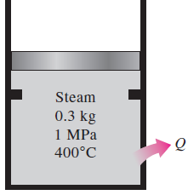
4.41-A 30-L electrical radiator containing heating oil is placed in a 50-m³ room. Both the room and the oil in the radiator are initially at 10°C. The radiator with a rating of 1.8 kW is now turned on. At the same time, heat is lost from the room at an average rate of 0.35 kJ/s. after some time, the average temperature is measured to be 20°C for the air in the room, and 50°C for the oil in the radiator. Taking the density and the specific heat of the oil to be 950 kg/m³ and 2.2 kJ/kg .°C, respectively, determine how long the heater is kept on. Assume the room is well-sealed so that there are no air leaks.
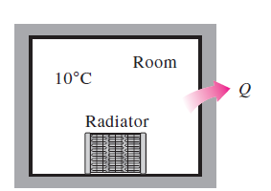
4.70-Argon is compressed in a polytropic process with n= 1.2 from 120 kPa and 30°C to 1200 kPa in a piston-cylinder device. Determine the work produced and heat transferred during this compression process, in kJ/kg.
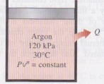

10.16- A simple ideal Rankine cycle with water as the working fluid operates between the pressure limits of 3 MPa in the boiler and 30kPa in the condenser and a turbine inlet temperature of 700°C. The boiler is sized to provide a steam flow of 50kg/s. Determine the power produced by the turbine and consumed by the pump.
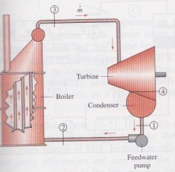
10.20-consider a coal–fired steam power plant that produces 300 MW of electric power. The power plant operates on a simple ideal Rankine cycle with turbine inlet conditions of 5 MPa and 450°C and a condenser pressure of 25 kPa. The coal has a heating value (energy released when the fuel is burned) of 29,300 kJ/kg. Assuming that 75 percent of this energy is transferred to the steam in the boiler and that the electric generator has an efficiency of 96 percent, determine (a) the overall plant efficiency (the ratio of net electric power output to the energy input as fuel) and (b) the required rate of coal supply.

10.35- Consider a steam power plant that operates on the ideal reheat Rankine cycle. The plant maintains the boiler at 4000 kPa, the reheat section at 500 kPa, and the condenser at 10 kPa. The mixture quality at the exit of both turbines is 90 percent. Determine the temperature at the inlet of each turbine and the cycle´s thermal efficiency.
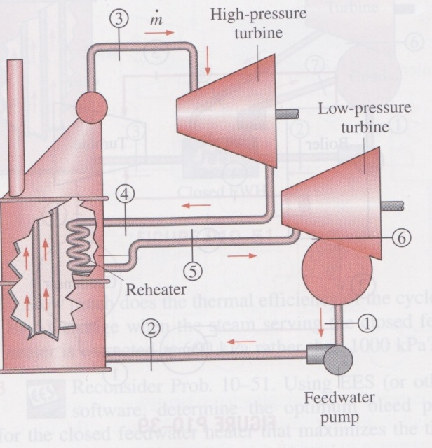
10.49- Consider an ideal steam regenerative Rankine cycle with two feedwater heaters, one closed and one open. Steam enters the turbine at 12.5MPa and 550°C and exhausts to the condenser at 10 kPa. Steam is extracted from the turbine at 0.8 MPa for the closed feedwater heater and at 0.3 MPa for the open one. The feedwater is heated to the condensation temperature of the extracted steam in the closed feedwater heater. The extracted steam leaves the closed feedwter heater as a saturated liquid, which is subsequently throttled to the open feedwater heater. Show the cycle on a T-s diagram with respect to saturation lines, and determine (a) the mass flow rate of steam through the boiler for a net power output of 250 MW and (b) the thermal efficiency of the cycle.
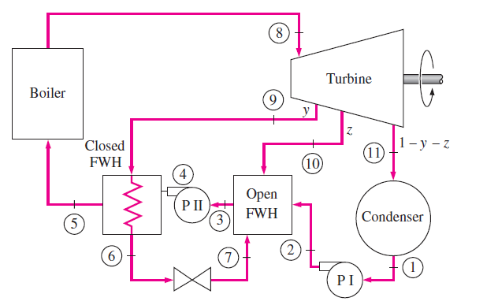
9.35-The compression ratio of an air-standard Otto cycle is 9.5. Prior to the isentropic compression process, the air is at 100 kPa, 35°C, and 600 cm³. The temperature at the end of the isentropic expansion process is 800 K. using specific heat values at room temperature, determine (a) the highest temperature and pressure in the cycle; (b) the amount of heat transferred in, in kJ; (c) the thermal efficiency; and (d) the mean effective pressure.

9.39-A four-cylinder, four-stroke, 2.2-L gasoline engine operates on the Otto cycle with a compression ratio of 10. The air is at 100 kPa and 60°C at the beginning of the compression process, and the maximum pressure in the cycle is 8 Mpa. The compression and expansion processes may be modeled as polytropic with a polytropic constant of 1.3. Using constant specific heats at 850 K, determine (a) the temperature at the end of the expansion process, (b) the net work output and the thermal efficiency, (c) the mean effective pressure, (d) the engine speed for a net power output of 70 kW, and (e) the specific fuel consumption, in g/kWh, defined as the ratio of the mass of the fuel consumed to the net work produced. The air-fuel ratio, defined as the amount of air divided by the amount of fuel intake, is 16.

9.54- An ideal Diesel cycle has a maximum cycle temperature of 2000°C and a cutoff ratio of 1.2. The state of the air at the beginning of the compression is P₁=95 kPa and T₁=15°C. this cycle is executed in a four-stroke, eight-cylinder engine with a cylinder bore of 10 cm and a piston stroke of 12 cm. the minimum volume enclosed in the cylinder is 5 percent of the maximum cylinder volume. Determine the power produced by this engine when it is operated at 1600 rpm. Use constant specific heats at room temperature.

9.93- A stationary gas-turbine power plant operates on a simple ideal Brayton cycle with air as the working fluid. The air enters the compressor at 95 kPa and 290 k and the turbine at 760 kPa and 1100 K. Heat is transferred to air at a rate of 35,000 kJ/s. determine the power delivered by this plant (a) assuming constant specific heats at room temperature and (b) accounting for the variation of specific heats with temperature.

11.11- A commercial refrigerator with refrigerant-134a as the working fluid is used to keep the refrigerated space at -30°C by rejecting its waste heat to cooling water that enters the condenser at 18°c at the rate of 0.25 kg/s and leaves at 26°C. The refrigerant enters the condenser at 1.2 MPa and 65°C and leaves at 42°C. The inlet state of the compressor is 60 kPa and -34°C and the compressor is estimated to gain a net heat of 450 W from the surroundings. Determine (a) the quality of the refrigerant at the evaporator inlet, (b) the refrigeration load, (c) the COP of the refrigerator, and (d) the theoretical maximum refrigeration load for the same power input to the compressor.
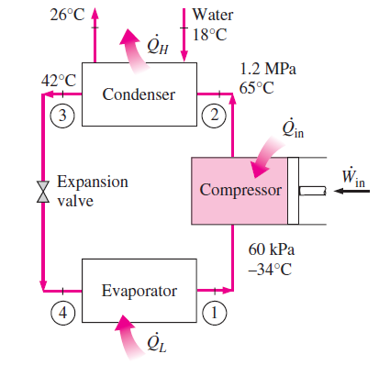
11.17- Refrigerant-134a enters the compressor of a refrigerator as superheated vapor at 0.14 MPa and -10°C at a rate of 0.12kg/s, and it leaves at 0.7 MPa and 50°C. The refrigerant is cooled in the condenser to 24°C and 0.65 MPa, and it is throttled to 0.15 MPa. Disregarding any heat transfer and pressure drops in the connecting lines between the components, show the cycle on a T-s diagram with respect to saturation lines, and determine (a) the rate of heat removal from the refrigerated space and the power input to the compressor, (b) the isentropic efficiency of the compressor, and (c) the COP of the refrigerator.

11.23- A refrigerator uses refrigerant-134a as the working fluid and operates on the ideal vapor-compression refrigeration cycle. The refrigerant enters the evaporator at 120 kPawith a quality of 30 percent and leaves the compressor at 60°C. If the compressor consumes 450 W of power, determine (a) the mass flow rate of the refrigerant, (b) the condenser pressure, and (c) the COP of the refrigerator.
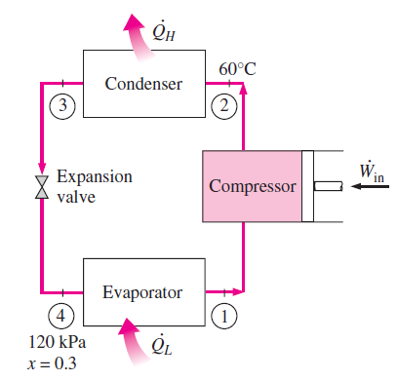
13.55- An insulated rigid tank is divided into two compartments by a partition. One compartment contains 2.5 kmol of CO₂ at 27°C and 200 kpa, and the other compartment contains 7.5 kmol of H₂ gas at 40°C and 400 kPa. Now the partition is removed, and the two gases are allowed to mix. Determine (a) the mixture temperature and (b) the mixture pressure after equilibrium has been established. Assume constant specific heats at room temperature for both gases.
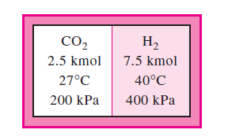

13.71- A piston-cylinder device contains 6 kg of H₂ and 21 kg of N₂ at 160 K and 5 MPa. Heat is now transferred to the device, and the mixture expands at constant pressure until the temperature rises to 200 K. Determine the heat transfer during this process by treating the mixture (a) as an ideal gas and (b) as a nonideal gas and using Amagatˊs law.
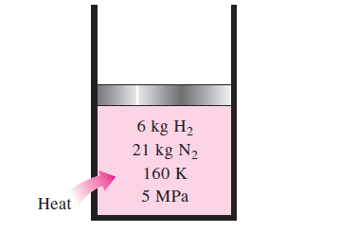
13.73- Air, which may be considered as a mixture of 79 percent N₂ and 21 percent O₂ by mole numbers, is compressed isothermally at 200K from 4 to 8 MPa in a steady-flow device. The compression process is internally reversible, and the mass flow rate of air is 2.9 kg/s. Determine the power input to the compressor and the rate of heat rejection by treating the mixture (a) as an ideal gas and (b) as a nonideal gas and using Amagatˊs law.
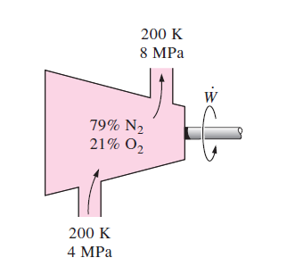

14.40- A room contains air at 1 atm, 26°C, and 70 percent relative humidity. Using the psychrometric chart, determine (a) the specific humidity, (b) the enthalpy, in kJ/kg dry air, (c) the wet-bulb temperature, (d) the dew-point temperature, and (e) the specific volume of the air, in m³/kg dry air.

14.69- Air enters a 40-cm-diameter cooling section at 1 atm, 32°C, and 30 percent relative humidity at 18 m/s. Heat is removed from the air at a rate of 1200 kJ/min. Determine (a) the exit temperature, (b) the exit relative humidity of the air, and (c) the exit velocity.
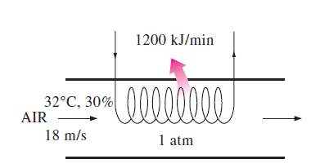
14.91-Air from a workspace enters an air conditioner unit at 30°C dry bulb and 25°C wet bulb. The air leaves the air conditioner and returns to the space at 25°C dry-bulb and 6.5°C dew-point temperature. If there is any, the condensate leaves the air conditioner at the temperature of the air leaving the cooling coils. The volume flow rate of the air returned to the workspace is 1000 m³/min. Atmospheric pressure is 98kPa. Determine the heat transfer rate from the air, in kW, and the mass flow rate of condensate water, if any, in kg/h.

15.58- n-Octane gas (C₈H₁₈) is burned with 100 percent excess air in a constant pressure burner. The air and fuel enter this burner steadily at standard conditions and the products of combustion leave at 257⁰C. Calculate the heat transfer, in kJ/kg fuel, during this combustion.
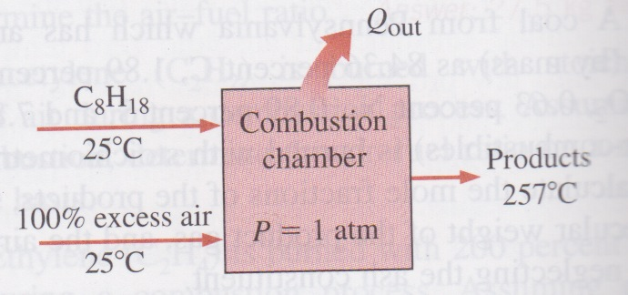

15.70- One kmol of methane (CH₄) undergoes complete combustion with stoichiometric amount of air in a rigid container. Initially, the air and methane are at 100 kPa and 25⁰C. The products of combustion are at 447⁰C. How much heat is rejected from the container, in kJ/kmol fuel?
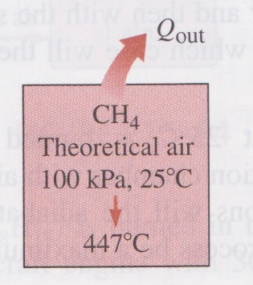
15.79-Liquid octane (C₈H₁₈) is burned in the constant pressure, adiabatic combustor of an aircraft engine with 40 percent excess air. The air enters this combustor at 600 kPa and 307⁰C, and the fuel is injected into the combustor at 25⁰C. Estimate the temperature at which the products of combustion leave the combustor.

