

**Blunt Traumatic Aortic Rupture**

**course Project Report**

**Written by:**

**Ali Shegaf**

**Supervised by:**

**Dr. Lyes Kadem**

**Concordia University**

**Start Date: February 21, 2011**

**End Date: April 04, 2011**

**Blunt Traumatic Aortic Rupture**

**Summary**

Blunt Traumatic Aortic Rupture is the second most common cause of death in traffic accident (more than 7500 deaths/year in North America). Due to aortic rupture and exsanguinations into the chest, up to 90% of the victims die at the scene of the trauma. The principle mechanism leading to BTAR remains uncertain, however, several theories exist describing the possible mechanisms leading to this injury. Three main proposed cause of BTAR are discussed, which are, sudden rise in blood pressure, sudden stretching of the aorta, and the osseous pinching mechanism. Better understanding of the mechanism of BTAR should improve the car safety system and provide early diagnosis and treatment.

______________________________________________________________________________

1. **introduction**

Blunt Traumatic Aortic Rupture (BTAR) refers to transverse tearing of the wall of the aorta. A lethal chest injury that mostly (95%) occurs during severs automotive accidents. It may be (5%) caused by other impacts such as in falling victims, air craft, or any chest trauma. With an overall survival of only 2%, BTAR is the second most frequent cause of death in vehicle related trauma, exceeded only by head injury. Annually, 7500-8000 people die as result of BTAR in North America and about 650 people in UK that represents 20% of motoring fatalities [1]. Most patients (80%-90%) who sustain BTAR die at the site of the trauma due to circumferential disruption and exsanguinations into the chest. Only (10%-20%) survive long enough to be taken to the hospital; however, the majority dies within four months of the accident.

Even though, BTAR has been the subject of investigation for 150 years, the fundamental mechanism responsible for this injury is still uncertain. While some early investigators proposed that BTAR is caused by single factor such as sudden rise in blood pressure [2,3] or sudden stretching of the aorta[4], others went to believe that its much more complicated issue and combination of (torsion, shearing, bending) stresses along with water hummer effects contribute in producing the injury[5]. In spite of the widespread agreement on characterizing of the lesion as a deceleration injury [6, 7, 5], many cases of BTAR were reported where the patients didn’t experience any kind of deceleration [8, 9, 10, 11]. These cases bring up the question of whether the rapid deceleration is the main factor in producing BTAR or the impact by the vehicle’s interiors parts such as steering wheel and the seat belt is sufficient.

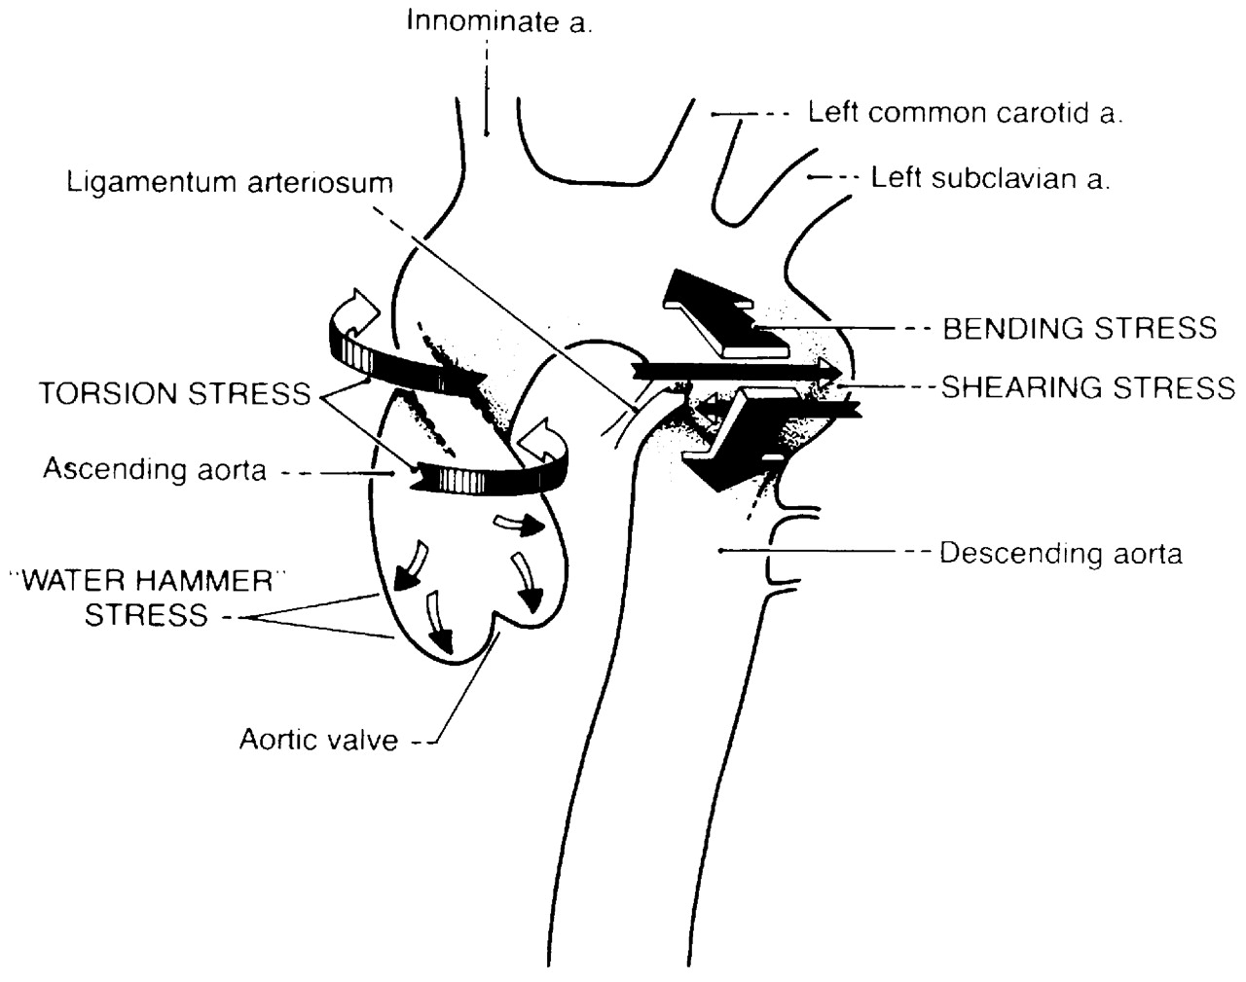

Figure 1: Putative forces acting on the aorta during blunt traumatic injury (from ref. [7])

BTAR can range from partial to complete rupture, single or multiple depending on the amount and the direction of the force implemented on the chest. Most of the cases experience single tear in the beginning of the descending aorta the area so-called isthmus but rupture in other locations along the aorta occurs.

Thus, a better understanding of the mechanism leading to BTAR is necessary to provide useful data for the design of the automobile’s safety system and provides early diagnostic to patients suffering of this injury. In addition, finding the safety requirements for limiting or maybe prevention of BTAR would contribute to reducing the severity of other thoracic and abdominal injuries.

1. **The Aorta**

The aorta is the largest artery in human body. It carries oxygenated blood to the cells and tissue of the body. Its internal diameter is about 2.5 cm and the wall thickness is about 1 mm [6]. The aorta is an elastic artery, and expands when blood is forced through it from the heart. This stretching gives the potential energy that will help maintain blood pressure during its later contraction.

* 1. **Aorta structure**

Ascending aorta- the aorta starts at the aortic root, the conjunction with the left ventricle, and becoming a littlie wider in diameter, it gives rise to tow coronary arteries and ends at the beginning of the aortic arch. it runs upward for about 5 cm then it suddenly takes a sharp curvature at the aortic arch where it gives three branches to supply blood to the upper part of the body before it continue downward.

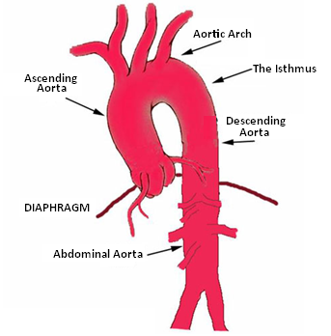

Figure 2: aortic structure from: http://www.slrctsurgery.com/Thoracic%20aortic%20aneurysms.htm

Descending aorta- this section starts as the aorta bends down till it reaches the diaphragm. It contains arteries that feed the spinal cord. Unlike the ascending aorta, this part is a littlie fixed to the spine.

Abdominal aorta- the aorta continues below and supply blood the kidneys before it divides into tow iliac arteries.

* 1. **Anatomy of the aorta and sites of BTAR**

The aortic wall consists of three layers: tunica intima, tunica media, and tunica adventitia as it show in figure 2. The extent of blunt aortic injuries vary from limited laceration of the intima to complete transaction of the aorta depending on the morphological structure of the arterial wall and the amount of the energy transmitted by the trauma. Parmly et al [12] classified BTAR as follows: intimal hemorrhage, intimal hemorrhage with laceration, medial laceration, complete laceration, false aneurysm, and per aortic hemorrhage. Interestingly, this classification proves that this injury starts in the inside of the aorta and continues outward. The majority of the BTAR are transverse tears with relatively smooth margins. Typically, the aorta ruptures at the isthmus due to its narrowed cross section and sharp curvature; however, there are other regions where the rupture has been documented [1]:

1. The isthmus; the proximal descending aorta where 88.8% of the cases occur.
2. The aortic root 3.2%
3. The arch 1.6%
4. The descending aorta 0.8%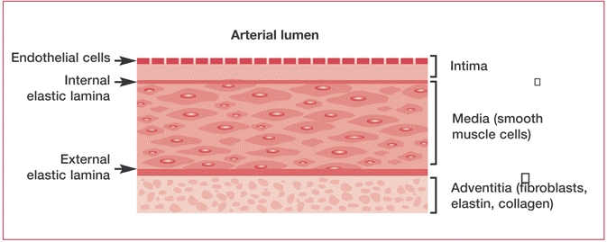

Figure 2: Artery Wall from: http://www.ncbi.nlm.nih.gov/books/NBK2210/)

1. **Mechanisms of injury**

The mechanism responsible for traumatic rupture of the aorta has been debated for many years, and many theories have been put forward to explain why the aorta is subject to this type of injury. Previous studies suggested a number of possible causes which could involve in producing BTAR individually or combined. These possible mechanisms include:

* 1. **Sudden rise in blood pressure**

Some early studies linked the occurrence of BTAR to sudden rise in blood pressure in the aorta [2, 3]. Suggesting that during the trauma a sudden spike in blood pressure occurs as a result of the water hummer effect and that causes wall tension and rupture of the aorta at its weakest point ‘the isthmus’. Water hammer theory is based on the assumption of that during a car accident an occlusion could happens in the abdominal aorta at the level of the diaphragm; as result of the abdomen being compressed, which leads to high pressure waves being reflected back along the vessel wall. Others think that as the organs in the thorax are displaced a cause to the rapid deceleration; the heart is squeezed between the sternum and the spine forcing the blood from the left ventricle into the aorta causing significant high blood pressure[7]. However, in the experiment on open-chest dog, preformed by khir &Parker 2004 [13], they examined the effect of an arterial occlusion in four different locations on the pressure, velocity, and the reflected waves along the ascending aorta. Interestingly, there was a significant change in the pressure during the “thoracic and diaphragm” occlusion by 46% and 23% respectively. Since the work was not preformed to study BTAR, it can be improved if added the factor of rapid deceleration which is believed to play an important role in increasing the internal pressure. Also the location they studied, it’s better to study the effect of arterial occlusion in the descending aorta at the isthmus where 88% of the BTAR cases take place. Notably, this is a region of high curvature witch thought to take a part in increasing the internal pressure as well.

* 1. **Stretching the aorta**

The primary mechanism of chest injury is compression of the chest at high rates of loading. This causes deformation and stretching of the internal organs and vessels. If the aorta is stretched beyond its tensile strength which is $3*{10}^{5} Nm^{-2}$ [6], the tissue will tear. Motion of heart during chest compression stretches the aorta along its axis from point of tethering in the body. This tension generally leads to transverse laceration at the point that is thought to be weaker, the isthmus. Not forgetting that the isthmus of the aorta lies at the junction between the relatively and the fixed parts of the aorta. Experiments preformed on pigs by Sevitt 1977[14]showed that the heart could move as far as 5 cm during extreme body acceleration, which would put the aorta under sufficient tension to cause BTAR. However, many studies have shown experimentally that the tensile strength of the aorta is much larger than the forces generated during the trauma [8] further more, this mechanism will come into play only during an extreme acceleration which doesn’t explain the cases of BTAR happing due to low speed accident or non-acceleration impacts.

* 1. **Osseous pinch mechanism**

The osseous pinch mechanism was first mentioned in 1990 by Crass et al [15] suggested that; as a result of massive force applied to the chest, the thoracic aorta ruptures as it trapped between the spine and the anterior osseous structure. The theory neatly provides an explanation as to why thoracic aortic disruption nearly always occurs in the same place “the isthmus” as this is the point that has been shown radio logically to experience the pinch. Although this mechanism explains why non-deceleration trauma “vehicles hitting pedestrians or crushing chest injury” cause aortic rupture, but it failed to explain the injury in other locations of the aorta. Furthermore, according to this mechanism, the aorta is subjected to bending stress leading to laceration that starts at the tunica adventitia layer. However, the laceration always starts at the tunica intimia and never reaches the tunica adventitia unless it becomes a complete rupture as it classified by Parmly et al [12]. Also, the deep location of the isthmus would seem to protect it from damaged by a direct force, and if the chest to be subjected to enough force to cause rupture of the aorta, other chest injuries such as rib fractures are to be associated.



Figure3, the mechanism of the osseous pinch (from ref. [18])

1. **Conclusion**

During a vehicle collision, forces acting on the body cause two responses: compression of the compliant structures of the torso and acceleration of body masses. The mechanism of compression causes the aorta to occlude at the level of thoracic and/or diaphragm which leads to an increase in blood pressure at the isthmus. An increase in vascular pressure dilates the vessel and produces biaxial strain that is larger in the transverse than axial direction. If pressure rise beyond the vessel’s limit, it will burst. For sever impacts, intra aortic pressure exceeds 500 to 1000 mmHg [16], which is a significant, no physiologic level but is tolerable for short duration. Moreover, the isthmus of the aorta is located between the down fixed part of the aorta and the relatively free part, as result to rapid deceleration, the movement of the upper moveable section of the aorta and the heart would put the isthmus under tension leading ultimately to rupture. It’s clear that neither the increase of the internal blood pressure nor the stretching of the aorta mechanism is sufficient alone to produce BTAR, therefore its thought that the combined effect of stretch and internal pressure contribute to injury. Also the velocity of body deformation is an important factor in impact injury. For example, when an artery inflated slowly, energy can be absorbed by tissue deformation without damage. When inflated rapidly, the vessel can’t deform fast enough and it may burst without significant change in the shape, even though the load might be lower than for the slow loading condition.

As we have discussed, the older proposed theories explaining BTAR include; sudden rise in blood pressure, sudden stretching of the aorta, and the osseous pinch mechanism, however, no experimental model exist to prove and validate those proposed mechanisms of injury. Therefore, the future work to be done, is experimentally investigating the mechanism of combination of higher blood pressure along with stretching the aorta in causing this deadly injury BTAR. Indeed, for those who survive long enough to reach the hospital, delay in diagnosis and treatment would have a fatal outcome. Therefore, knowing the mechanism accounts for this injury not only will improve the car safety systems it also will help to decrease the cases are suspected for BTAR and provide prompt and accurate diagnosis and treatment.

**References:**

[1] Richens D, Field M, Hashim S, Neale M, Oakley C. A finite element model of blunt traumatic aortic rupture. Eur J Cardiothorac Surg 25(2004) 1039-1047

[2] Klotz O, Simpson W. Spontaneous Rupture of the aorta. Am J Med Sci 1932; 184:455-473.

[3] Schleyer F. On adventitial hemorrhages of the thoracic blood vessels. J Forensic Med 1963; 10:3-5.

[4] Moar JJ. Traumatic rupture of the thoracic aorta. An autopsy and histopathological study. S afr Med J 1985: 67(10):383-385

[5] Hardy S, Dittmar B, Hendrik von T-K, Jens-R. Acute Traumatic Aortic tear: open versus stent-graft repair. Semin vasc Surg 19;48-59 @ 2006.

[6] S. J. Chapman, T. J. Pedley, P. D. Howell, D. S. Riley, O. E. Jensen, F. T. Smith, J. R. King, M. J. Tindall. Blunt Traumatic Aortic Injury. Report on problem studied at the UK Mathematics in Medicine Study Group Nottingham 2000.

[7] Richens D, Field M, Neale M, Oakley C. Them mechanism of injury in blunt traumatic rupture of the aorta. Eur J Cardiothorac Surg 21 (2002) 288-293

[8] Geoffrey A. Answini, Mark L. Sturdevant, Ronald F. Sing, David G. Jacobs. Blunt traumatic rupture of the thoracic aorta: A report of an unusual mechanism of injury. American journal of emergency medicine; 2001

[9] Hossein Javadpour, FRCSI, Jhon J. O’Toole, FRCS, J. Niall McEniff, FRCR, David A. Luke, FRCSI, Vincent K. Young, FRCS. Traumatic aortic transaction: Evidence for the osseous pinch mechanism. Ann Thoracic Surg 2002; 73: 951-3

[10] Antonio O, Fabio De G, Sara P, Vincenzo L, Arnaldo C. Delayed rupture of thoracic aorta aneurysm following a kick to the abdomen. Legal Medicine 11 (2009) 87-90

[11] Sohtaro M, Yukihito Y, Masaki H, Masayuki N, Masatoshi O, Masato F. A case of aortic dissection caused by blunt chest trauma. Forensic Science International 132 (2003) 5-8

[12] Parmley LE, Mattingly TW, Manion WC, Jahnke EJ Jr. nonpenetrating traumatic injury of the aorta. Circulation 1958; 17: 1086-1101

[13] A. W. Khir, K. H. Parker. Wave Intensity in the ascending aorta: effects of arterial occlusion. Journal of Biomechanics 38 (2005) 647-655

[14] S. Sevitt, the mechanism of traumatic rupture of the thoracic aorta, Br. J. Surg., 64, 166-173, 1977.

[15] Crass JR, Cohen AM, Motta AO, Tomashefski JF, Wiesen EJ. A proposed new mechanism of traumatic aortic rupture: the osseous pinch. Radiology 1990; 176:645-649.

[16] viano, D. C., King, A. I. “ Biomechanics of chest and abdomen impact.” The Biomechanics Engineering Handbook: second Edition.

[17] Richard P, Nicholas P, Richard H, Sharul H, Mark F, David R, Donal M. Regional wall mechanics and blunt traumatic rupture at the isthmus. Eur J of cardio surg 34 (2008) 616-622

[18] john D. Creasy, Caroline Chiles, Williams D. Routh, Raymond B. Dyer. Overview of traumatic injury of the thoracic aorta. radioGraphics 1997; 17:27-45