Course Number Section

Electronics II ELEC 312/4 W
Examination Date Time # of pages

Final April 19, 2010 3 hours 6
Instructor(s)

Dr.R. Raut
Students are allowed to use ENCS faculty approved calculators

Special Instructions:
Answer Q.1 (compulsory), and any four questions from Q.2-Q.8. Do not forget to indicate the answers to the question numbers that you want to be graded by the instructor. Fill in the table given below.

Do remember to fill in the table before you submit your work at the end of the examination period

If you do not fill in the table, only the first four questions (among Q.2-Q.8) as encountered by turning the pages of the answer book, will be graded.

Show all steps clearly in neat and legible handwriting.

Students are required to return the question paper together with exam booklet(s).

Table

Answers to be marked | Q.1 (compulsory)
Marks

Compulsory ( soft skill component)

Q.1: The circuit in Fig.1 presents a band-pass filter. Analyze the circuit assuming that the OP-AMP is ideal and show that the voltage transfer function V_{o}(s)/V_{i}(s)= H(s) is given by

Figure 1

$H(s)=H_{o}\frac{s/{ω_{L}}}{(1+s/{ω_{L}})(1+s/{ω_{H}})}$,

Where H_{o}=-R₂/R₁, ω_{L}=1/R₁C₁, and ω_{H} = 1/R₂C₂

Answer any Four questions from Q.2-Q.8

Q.2: Figure 2 shows a differential amplifier using BJT devices. The bias current source I is implemented by a basic current mirror. The transistors Q₁, Q₂ are required to have a g_{m} of 2.5 mA/V each. The β of the transistors is 100 and the Early voltage is V_{An}= 70 V for the NPN and V_{Ap} =100 V for the PNP transistor. The supply voltages are ±5 Volts.
(a) Show detail circuit of the bias current source. Do not design the circuit.
(b) What will be the differential input resistance R_{id} of this amplifier?
(c) What voltage gain A_{d} $={v_{o}}/(v_{b2}−v_{b1})$will be realized?

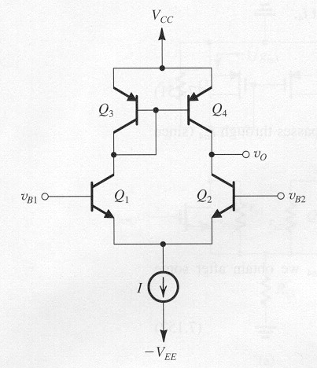
Figure 2

Q.3: In the circuit of Fig.3, assume both transistors operate in saturation and λ ≠ 0. For each transistor you can assume the parasitic capacitances as C_{gsi}, C_{gdi}, (i=1,2).

Figure 3

Draw (i) the ac equivalent circuit, (ii) analyze and (iii) derive the expression for the dominant pole frequency of the voltage transfer function V_{out}/V_{in}.

Q.4: For an amplifier model shown in Fig. 4, you are given:
g_{m} = 5mA/V, R_{sig}=10 kΩ, R_{in}=2.5 kΩ, R_{L}’=10 kΩ, C_{π}=2 pF. The transistor has a transistion frequency f_{T} =360 MHz. The output has a wiring capacitance of 2 pF. Find an estimate for the gain-bandwidth of the amplifier.

Figure 4

Q.5: The shunt-shunt feedback amplifier in the Figure 5 has I = 1 mA and V_{GS} = 0.8 V. The MOSFET has V_{t} = 0.6 V and V_{A} = 30 V. For R_{S} = 10 kΩ, R₁ =1MΩ, and R₂ = 4.7 MΩ, find the voltage gain A_{f}= v_{o}/v_{s}, and the input resistance R_{in} under negative feedback.
Utilize the $A_{f}=A/(1+Aβ)$, where A is the loaded amplifier gain, and β is the feedback factor.

Figure 5

Q.6: An op amp having a low-frequency gain of 10³ and a single-pole transfer function with -3dB frequency of 10⁴ rad/s is connected in a negative feedback loop via a feedback network having a transmission β(s) given by $β(s)=\frac{β_{o}}{(1+s/{{\text{10}}^{4}})^{2}}$. Find the value of β_{o} above which the closed-loop amplifier becomes unstable.

Table: (Negative Feedback related circuits and equations)

Model for feedback network | Equation model | Equivalent circuit model
Hybrid H-
parameters
Hybrid G-
parameters
Z- parameters
Y-parameters

Q.7: A BJT device (Q₁) is used to operate as a class A amplifier into a load of 100 ohms. The required signal power is 0.5 watts. The amplifier is biased by a current-mirror current source circuit. The devices (Q₁ to Q₃) have V_{CE}(sat) of 0.2 volts and an EB junction cut-in voltage of 0.7 volts each. Determine the required supply voltage values that can be used. Based on this supply voltage, provide a design of the current-mirror current source circuit.
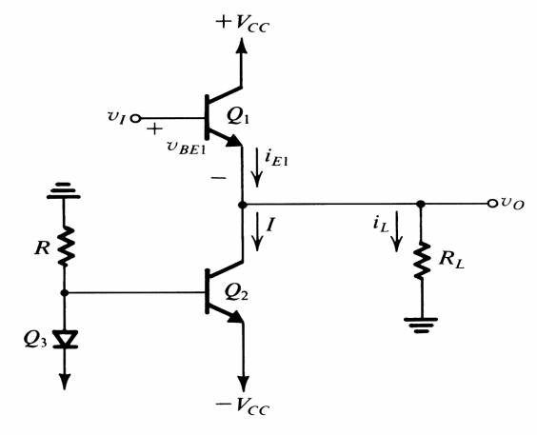
Figure 7

Q.8: Figure 8 below depicts a low frequency oscillator using an ideal operational amplifier (OP-AMP) and several R,C elements.

Figure 8

(i) Derive the expressions for the frequency of oscillation and the condition of oscillation (i.e., gain of the amplifier made from the OP-AMP) for this network.
(ii) If V_{o} is a sine-wave of frequency 10 kHz and the capacitors are 10 µF each, give a design for the resistors R, R₁, and R₂.

