Mid-Term Test#1

Analog/IC Filter Design (ELEC 441/6081)
Electrical and Computer Engineering Department
Concordia University

February 27, 2008

Instructor: Dr. R. Raut Time: 75 minutes

Q.1: The circuit below is a low-pass filter with A_{P} =0.25 dB and ω_{p} =1 rad/sec. Modify the circuit so that
(a) The pass-band becomes 10 kHz.
and (b) The load resistance becomes 75 ohms.
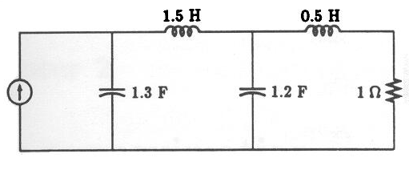
Figure 1

Q.2: Find the transfer function of a high pass filter which has
a) an equiripple pass-band for f> 15kHz with A_{p} = 0.5dB.
and b) a monotonic stop-band for f<7.8 kHz with A_{a}= 35dB.

Q.3: A low-pass filter of order 5 with maximally flat magnitude approximation has a loss of 1 dB at the pass-band edge frequency of 1 kHz.
(a) What will be attenuation produced by this filter at 10 kHz?
(b) What will be the order of the filter if we require a loss of 40 dB at 40 kHz?

Q.4: The following network represents a low-pass filter. Derive the expression for the VTF (i.e., V₂(s)/V₁(s)) of the network. The OA is ideal.
Figure 4

