**Jan.6’10**

**Past tabloid lec (1 & 2- removed)**

**Lecture note (Ch. 1- removed)**

**Lecture note (Ch. 2- removed)**

**Jan.11’10**

**Lecture note (Ch. 3- removed)**

**Past tabloid lec #(3-removed)**

**Feb.2’10**

**Past Tabloid lect (#4-removed)**

**Past tabloid lecture (#5-removed)**

**Lecture note (Ch.4- to be removed by Feb 12, 2010)**

**Feb.10’10**

**Tabloid lecture #6 (past- tobe removed by Feb.19'10)**

**March 3’10**

**Lecture note (Ch5, to be removed by March12'10)**

**Tabloid lecture#8 (to be removed by March 12'10)**

**March 4’10**

**Sol/hints for MT test#1**

**Tabloid lecture#9 (to be removed by March15'10)**

**March 15’10**

**Tabloid lecture (past) #10** **(to be removed by March 25’10)**

**March 16’10**

**Lecture note (Ch.6, to be removed by March 25'10)**

**Lecture note (Ch.7, to be removed by March 29'10)**

**March 23’10**

**Tabloid lecture(past) #11 (to be removed by Apr. 2'10)**

**March 31’10**

**Lecture note (Ch.8, to be removed by Apr.9'10)**

**April 7’10**

**Ch 9 notes & Research directions**

**April 13’09**

**Sol. to MT test#2**

**April 7’09**

**Switch simulations using B2- and P -Spice**

**April 6’09**

Fig.24 on p.147 of chapter 7



**March 27’09**

**Operational Simulation:steps to design**

**Spice experiment for Operational Simulation technique**

**March 25’09**

Hi

This is to confirm that the parameter B is the difference between the two pass-band corners of the band stop filter - as is in my lecture note pack.

The reference book cited by one student is erroneous in this matter. I have checked it in three other books. The sketch in the lecture note pack has been rectified as in the note below. The reason that this student got confused since (probably) he (and may be many of you) are using MATLAB programs for frequency transformations and such work.

As I advised earlier, write your code (they are in my notes) for all numerical simulations. That way you will stay closer to fundamentals.I shall not go to MATLAB to resolve any dispute arising out of incorrect results obtained by you by depending too much on MATLAB.

Similarly do not think of tweaking the given specs. so that the MATLAB output gives a better match that way. One does not make a filter to suit a software program output. A filter is a hardware.

Enjoy your work.

Raut

**(Note from the year 2007)**

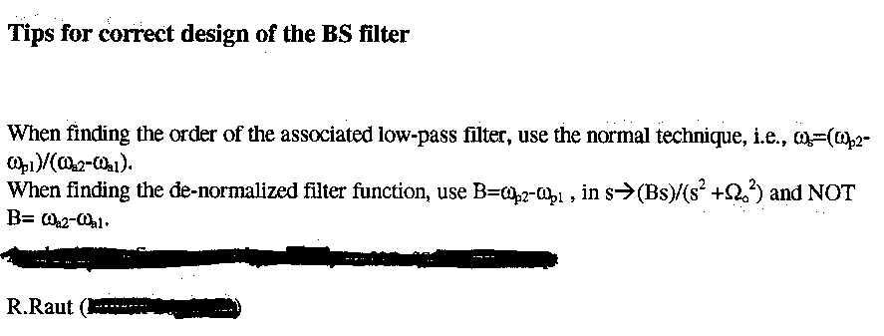

**March 17’09**

**Ch 5 with modified sections**

**March 10’09**

**Lecture note (Ch.7, to be removed by March 31'09)**

**March 6’09**

**MT #1 solution**

**March 2’09**

**Lecture note (Ch.5, to be removed by March18'09)**

**On the project report**

* Sample reports are appended below to serve as guidance (DO NOT *plagiarise* any part from these reports)
* The report should be no more than 30 pages (excluding appendix, codes..)
* You may submit a .pdf version of your report. Please make sure that it is submitted to me (Dr. Raut) by the deadline date and time. You must include your names and ID # on the cover page.

Very poor report

Very good report

Excellent report

**Feb.10’09**

**Example Analysis (State Variable Filter)**

**Feb.4,’09**

More on Table 4.3

**Jan 30’09**

APPENDIX

**Jan.28’09**

Ex 5 ch3 correction

Lec. note (Ch.3 to be removed by Feb.6'09)

Lec. note (Ch.4, to be removed by Feb.13'09)

**Jan 22’09**

MFM order calculations - Clarifications

Example 4 of ch 3

**Jan. 8’09**

Lec note (Ch.1, to be removed by Jan. 23'09)

Lec. note (Ch.2, to be removed by Jan. 23'09)

**OLD MATERIALS!!**

**Mar3, 2008**

(Sol. to MT#1 of Feb.27, 2008)

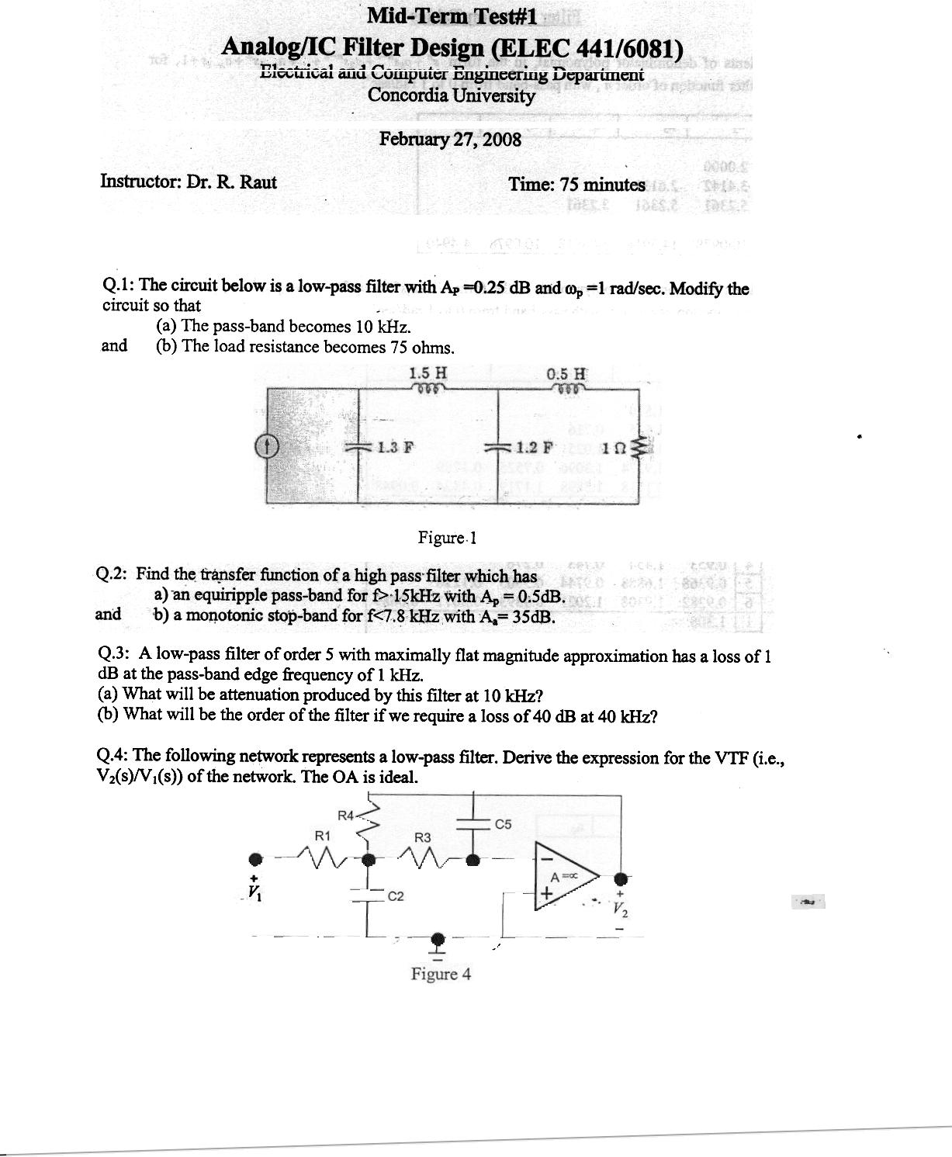

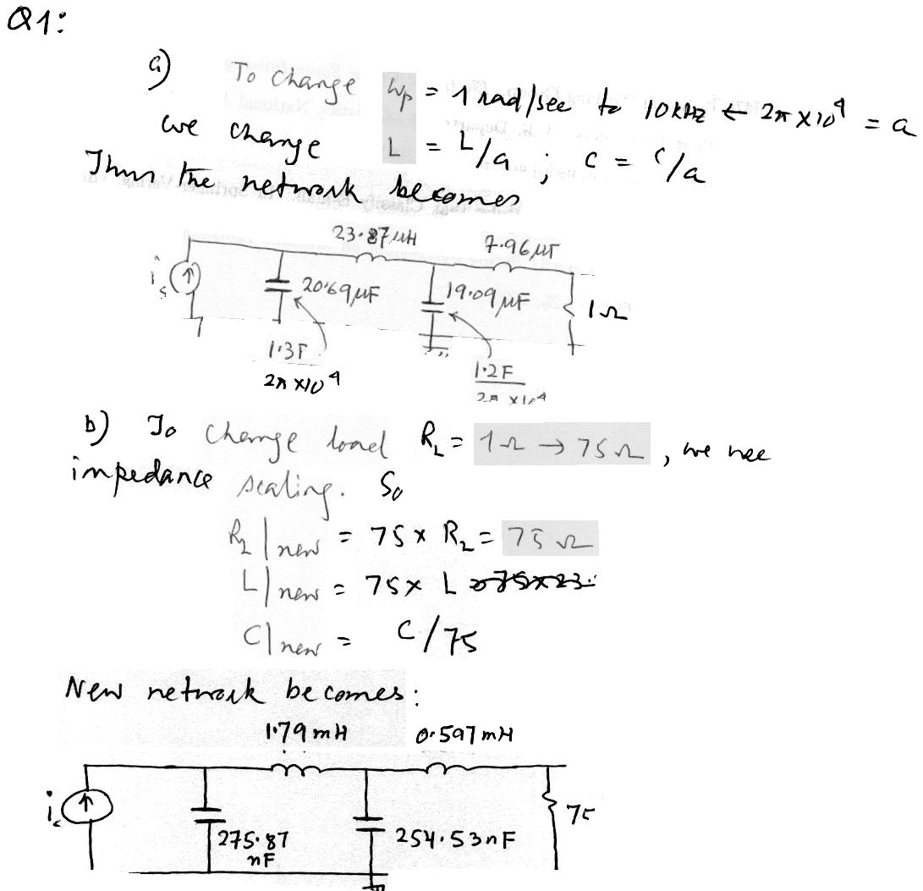

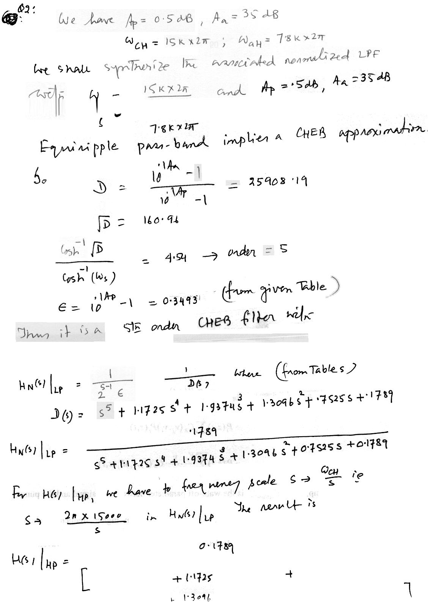

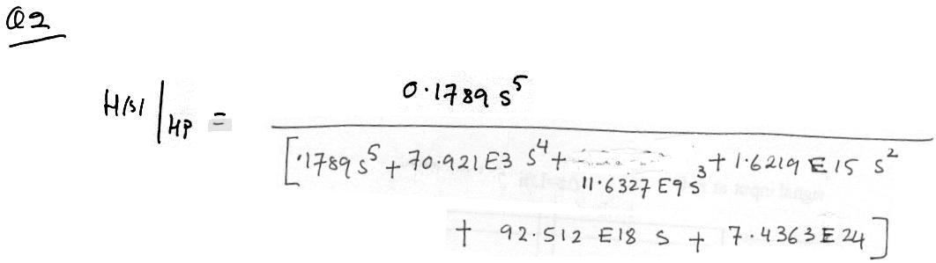

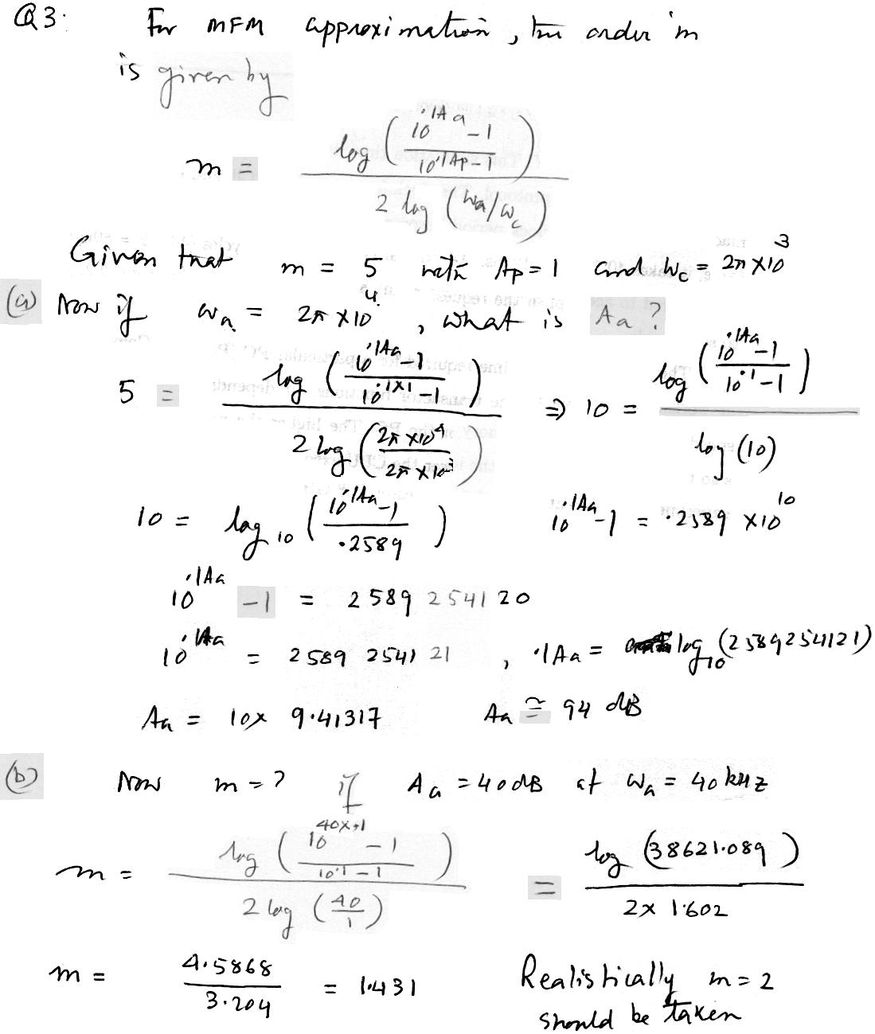

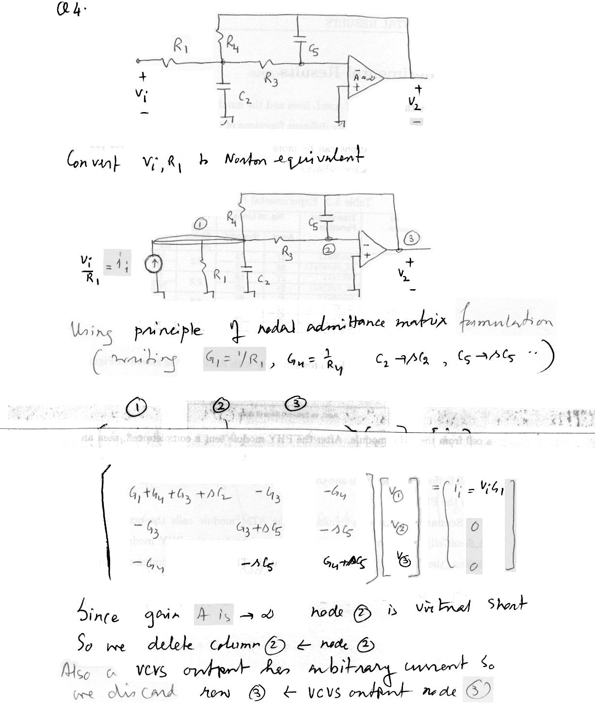

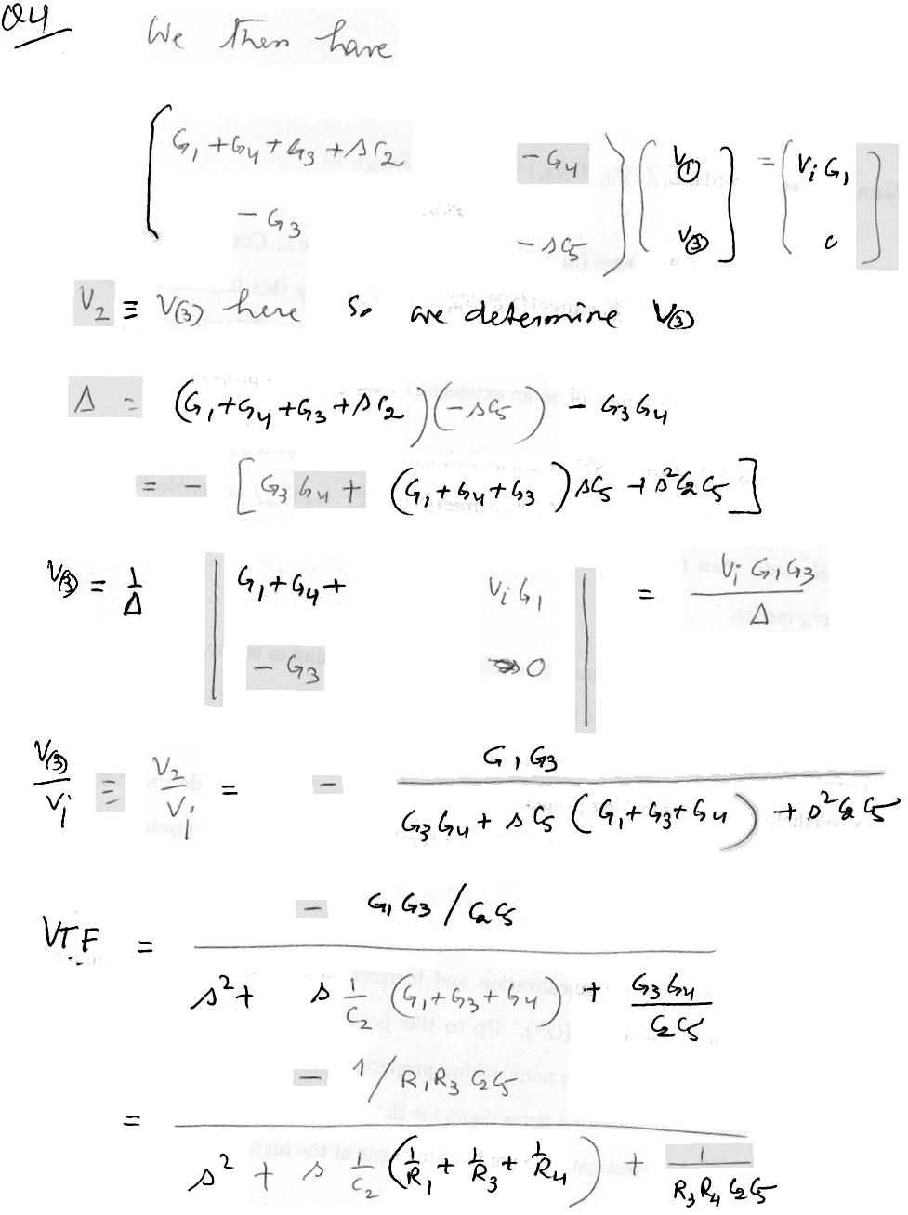

**Feb. 21, 2008**

(*There is an error in the sol. to Q.3 of MT1, 2007. Check the numerical values carefully*)

(Sol./hints for past mid-term tests)

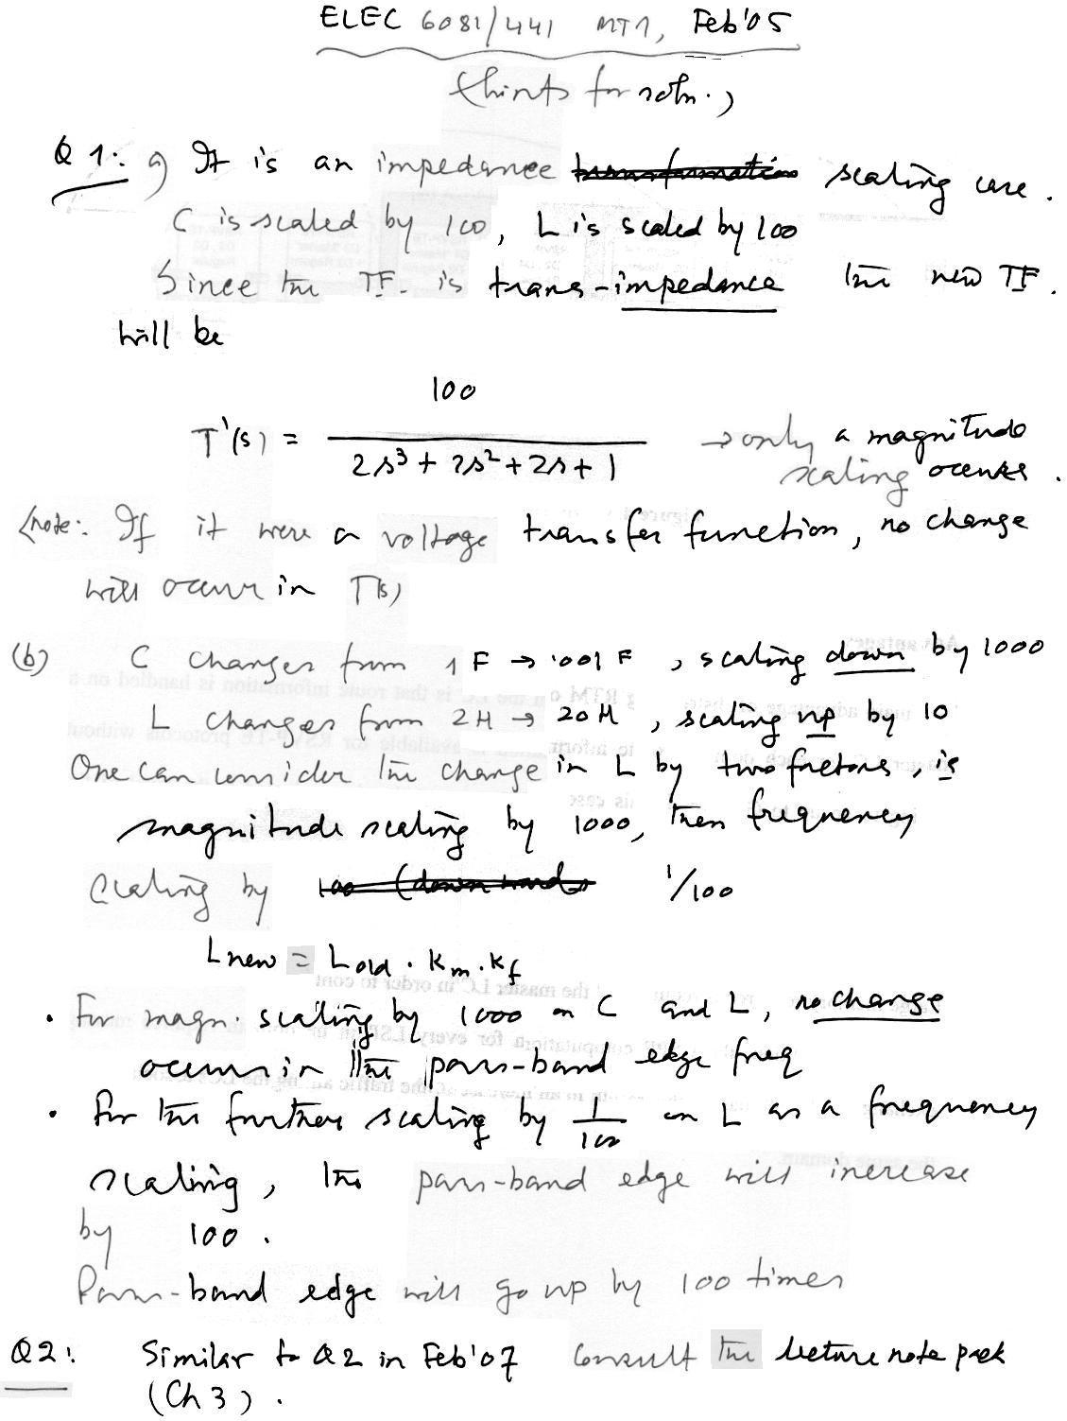

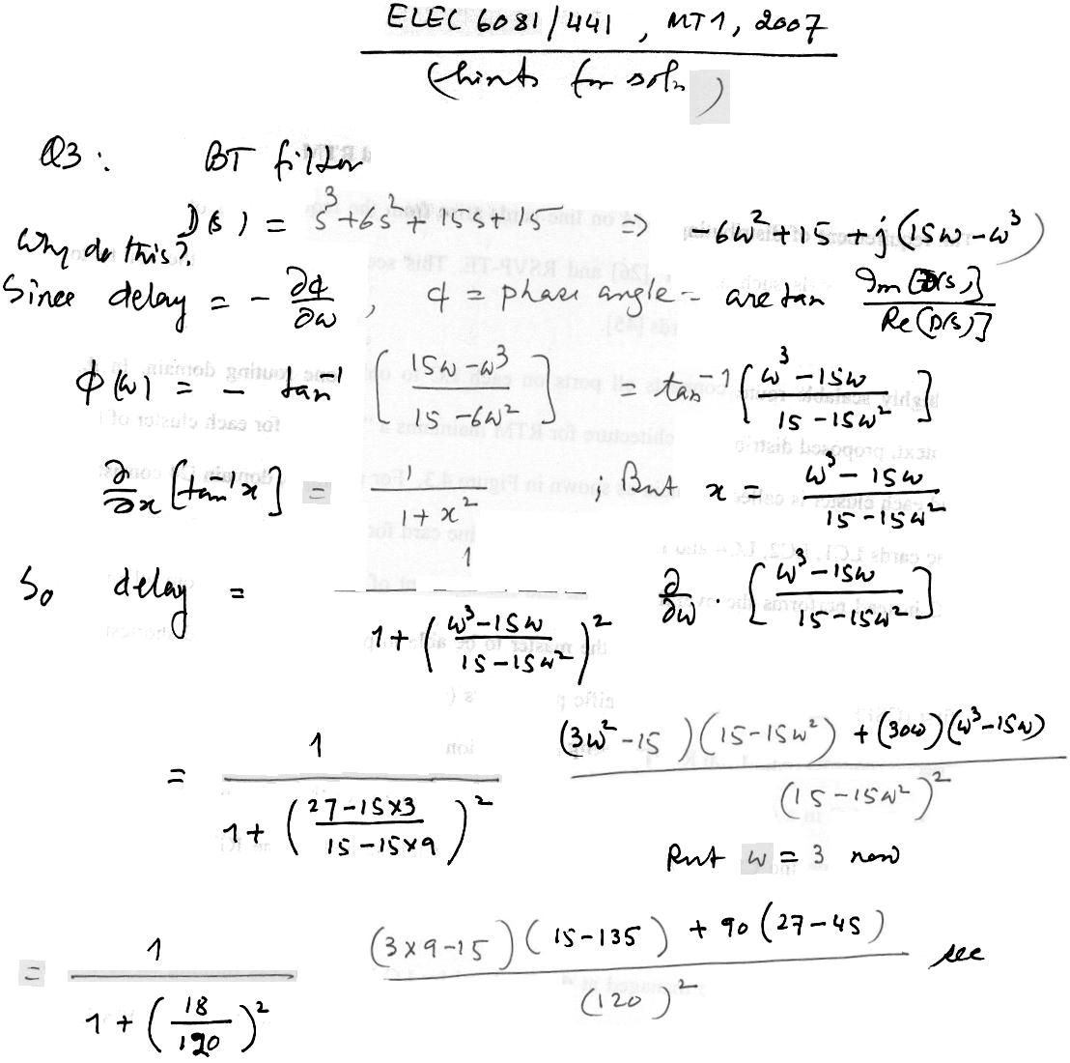

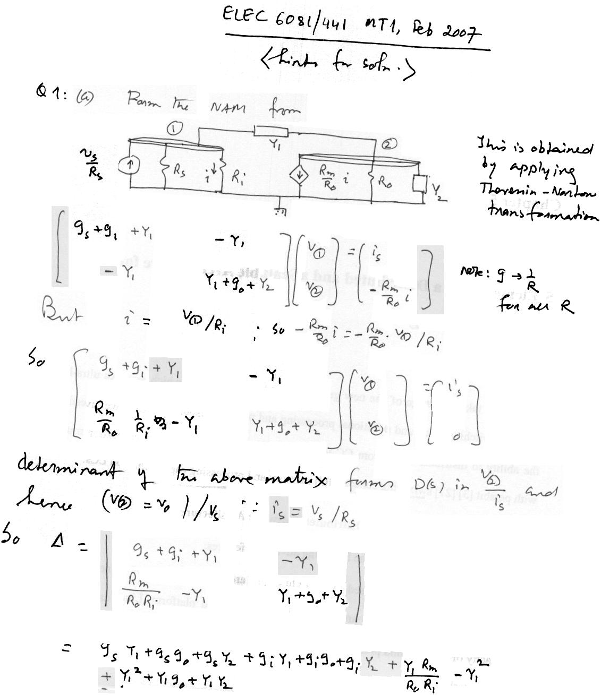

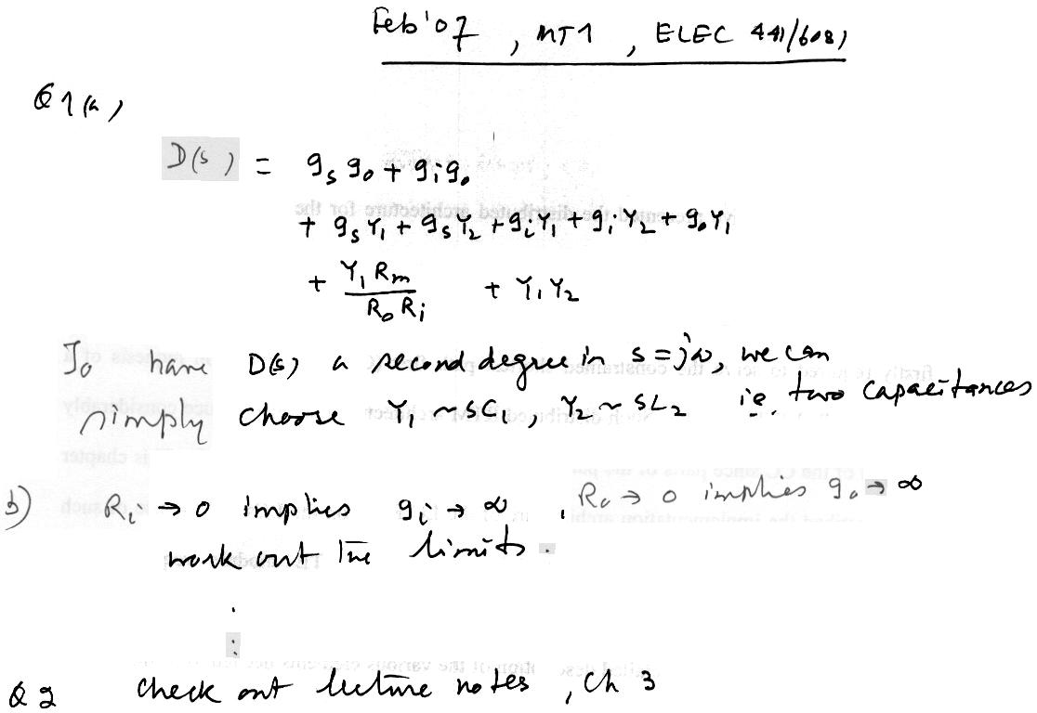

**Feb 18, 2008**

Decomposing higher degree transfer function into product of second degree transfer functions.

(see below)

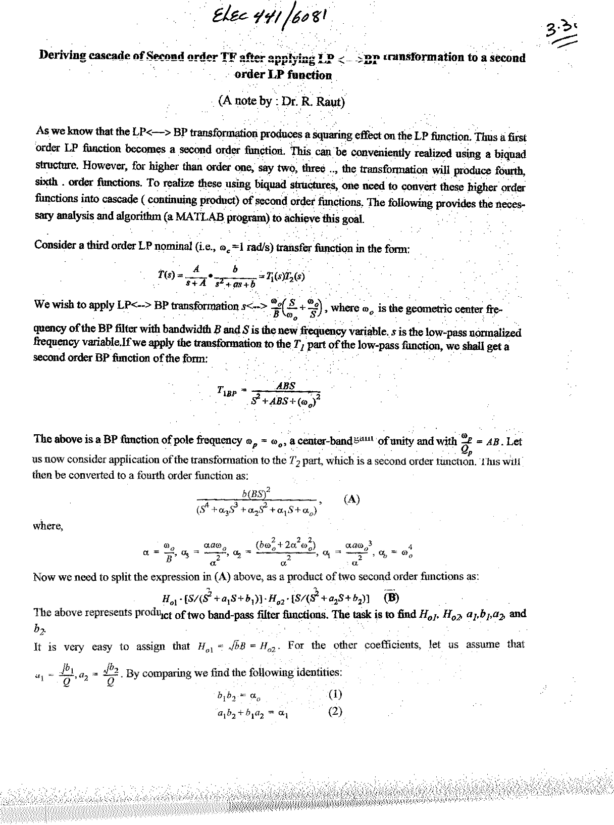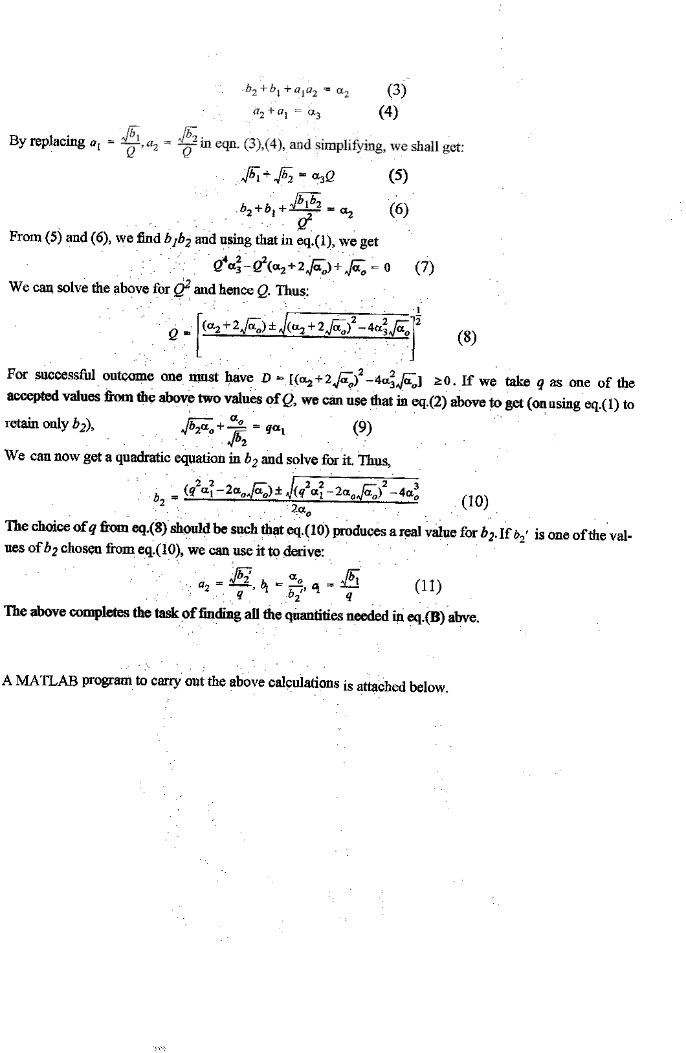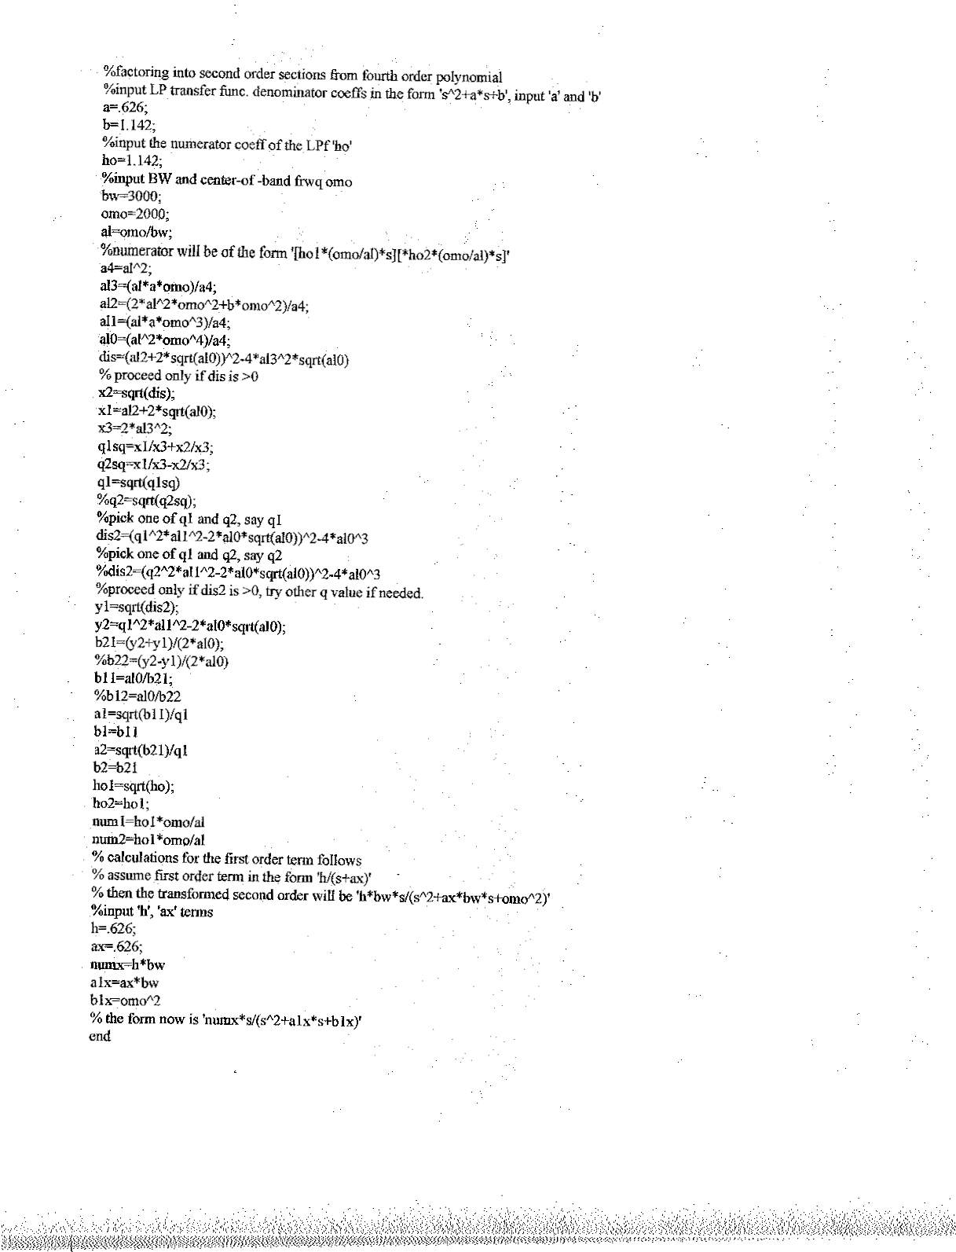

**Feb.27, 2007**

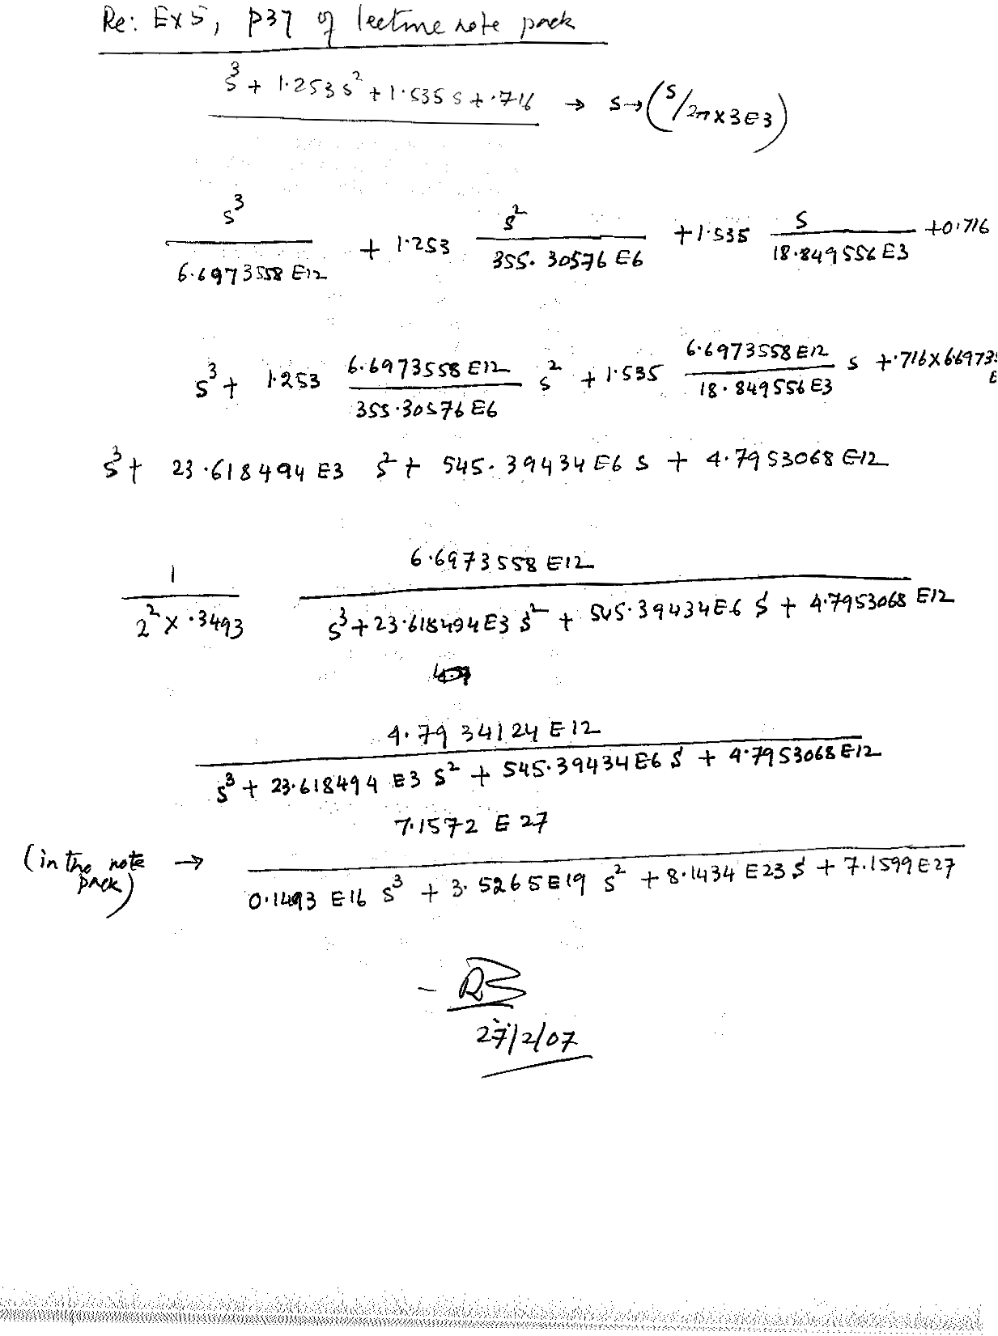

**Feb. 26, 2007**

(Appendices)

## Appendix A

**A.1:** Coefficients of denominator polynomial, in the form , for Butterworth filter function of order *n* , with pass-band from 0 to 1 rad/sec[1]+.

|  |  |  |  |  |  |  |
| --- | --- | --- | --- | --- | --- | --- |
|  |  |  |  |  |  |  |
| 2 | 1.4142 |  |  |  |  |  |
| 3 | 2.0000 | 2.0000 |  |  |  |  |
| 4 | 2.6131 | 3.4142 | 2.6131 |  |  |  |
| 5 | 3.2361 | 5.2361 | 5.2361 | 3.2361 |  |  |
| 6 | 3.8637 | 7.4641 | 9.1416 | 7.4641 | 3.8637 |  |
| 7 | 4.4940 | 10.0978 | 14.5918 | 14.5918 | 10.0978 | 4.4940 |

**A.2:** Coefficients of denominator polynomial, in the form , for Chebyshev filter function of order *n*, with pass-band from 0 to 1 rad/sec+.

|  |  |  |  |  |  |  |  |
| --- | --- | --- | --- | --- | --- | --- | --- |
| Pass-band  ripple *Ap* | *n* | a1 | a2 | a3 | a4 | a5 | a6 |
|  | 1 | 2.863 |  |  |  |  |  |
|  | 2 | 1.425 | 1.516 |  |  |  |  |
| 0.5 dB | 3 | 1.253 | 1.535 | 0.716 |  |  |  |
| ε=0.3493 | 4 | 1.197 | 1.717 | 1.025 | 0.379 |  |  |
|  | 5 | 1.1725 | 1.9374 | 1.3096 | 0.7525 | 0.1789 |  |
|  | 6 | 1.1592 | 2.1718 | 1.5898 | 1.1719 | 0.4324 | 0.0948 |
|  | 1 | 1.965 |  |  |  |  |  |
|  | 2 | 1.098 | 1.103 |  |  |  |  |
| 1.0 dB | 3 | 0.988 | 1.238 | 0.491 |  |  |  |
| ε=0.5089 | 4 | 0.953 | 1.454 | 0.743 | 0.276 |  |  |
|  | 5 | 0.9368 | 1.6888 | 0.9744 | 0.5805 | 0.1228 |  |
|  | 6 | 0.9282 | 1.9308 | 1.2021 | 0.9393 | 0.3071 | 0.0689 |
|  | 1 | 1.308 |  |  |  |  |  |
|  | 2 | 0.804 | 0.637 |  |  |  |  |
| 2.0 dB | 3 | 0.738 | 1.022 | 0.327 |  |  |  |
| ε=0.7648 | 4 | 0.716 | 1.256 | 0.517 | 0.206 |  |  |
|  | 5 | 0.7065 | 1.4995 | 0.6935 | 0.4593 | 0.0817 |  |
|  | 6 | 0.7012 | 1.7459 | 0.8670 | 0.7715 | 0.2103 | 0.0514 |

**A.3:** Coefficients of denominator polynomial, in the form , for Bessel-Thomson filter function of order *n*+.

|  |  |  |  |  |  |  |
| --- | --- | --- | --- | --- | --- | --- |
| *n* | a1 | a2 | a3 | a4 | a5 | a6 |
| 1 | 1 |  |  |  |  |  |
| 2 | 3 | 3 |  |  |  |  |
| 3 | 6 | 15 | 15 |  |  |  |
| 4 | 10 | 45 | 105 | 105 |  |  |
| 5 | 15 | 105 | 420 | 945 | 945 |  |
| 6 | 21 | 210 | 1260 | 4725 | 10395 | 10395 |

### Appendix B

**B.1:** Element interconnections and values for *all-pole* low-pass single-resistance-terminated lossless ladder. Figures B.1(a)-(b) are the structures for voltage source driven with even and odd order filters respectively. Figures B.1(c)-(d) are for current source driven with even and odd order filters respectively.[2]! The element values for several orders are given in **TABLE B.1**.



Figure B.1:

#### TABLE B.1

|  |  |  |  |  |  |  |  |
| --- | --- | --- | --- | --- | --- | --- | --- |
| n | C1 | L2 | C3 | L4 | C5 | L6 | C7 |
| 2 | .7071 | 1.4142 | Butterworth | (1 rad/s bandwidth) |  |  |  |
| 3 | .5000 | 1.3333 | 1.5000 |  |  |  |  |
| 4 | .3827 | 1.0824 | 1.5772 | 1.5307 |  |  |  |
| 5 | .3090 | .8944 | 1.3820 | 1.6944 | 1.5451 |  |  |
| 2 | .7014 | .9403 | **0.5 dB ripple** | **Chebyshev** |  |  |  |
| 3 | .7981 | 1.3001 | 1.3465 | (1 rad/s bandwidth) |  |  |  |
| 4 | .8352 | 1.3916 | 1.7279 | 1.3138 |  |  |  |
| 5 | .8529 | 1.4291 | 1.8142 | 1.6426 | 1.5388 |  |  |
| 2 | .9110 | .9957 | **1 dB ripple** | **Chebyshev** |  |  |  |
| 3 | 1.0118 | 1.3332 | 1.5088 | (1 rad/s bandwidth) |  |  |  |
| 4 | 1.0495 | 1.4126 | 1.9093 | 1.2817 |  |  |  |
| 5 | 1.0674 | 1.4441 | 1.9938 | 1.5908 | 1.6652 |  |  |
| 2 | .3333 | 1.0000 |  | Bessel-Thomson |  |  |  |
| 3 | .1667 | .4800 | .8333 | (1 s delay at DC) |  |  |  |
| 4 | .1000 | .2899 | .4627 | .7101 |  |  |  |
| 5 | .0667 | .1948 | .3103 | .4215 | .6231 |  |  |
| 6 | .0476 | .1400 | .2246 | .3005 | .3821 | .5595 |  |
| 7 | .0357 | .1055 | .1704 | .2288 | .2827 | .3487 | .5111 |
| n | L1’ | C2’ | L3’ | C4’ | L5’ | C6’ | L7’ |

**B.2:** Element interconnections and values for *all-pole* low-pass double-resistance-terminated lossless ladder. Figures B.2(a)-(b) are the structures for even and odd order filters respectively. Figures B.2(c)-(d) are alternate structures for even and odd order filters respectively.[3]! The element values for several orders are given in **TABLE B.2**.



Figure B.2:

#### TABLE B.2

|  |  |  |  |  |  |  |  |
| --- | --- | --- | --- | --- | --- | --- | --- |
| n | C1 | L2 | C3 | L4 | C5 | L6 | C7 |
| 2 | 1.4142 | 1.4142 | Butterworth | (1 rad/s bandwidth) |  |  |  |
| 3 | 1.0000 | 2.0000 | 1.0000 |  |  |  |  |
| 4 | .7654 | 1.8478 | 1.8478 | .7654 |  |  |  |
| 5 | .6180 | 1.6180 | 2.0000 | 1.6180 | .6180 |  |  |
| 3 | 1.5963 | 1.0967 | 1.5963 | **0.5 dB ripple** | **Chebyshev** | (1 rad/s bandwidth) |  |
| 5 | 1.7058 | 1.2296 | 2.5408 | 1.2296 | 1.7058 |  |  |
| 7 | 1.7373 | 1.2582 | 2.6383 | 1.3443 | 2.6383 | 1.2582 | 1.7373 |
| 3 | 2.0236 | .9941 | 2.0236 | **1 dB ripple** | **Chebyshev** | (1 rad/s bandwidth) |  |
| 5 | 2.1349 | 1.0911 | 3.0009 | 1.0911 | 2.1349 |  |  |
| 7 | 2.1666 | 1.1115 | 3.0936 | 1.1735 | 3.0936 | 1.1115 | 2.1666 |
| 2 | 1.5774 | .4226 |  | Bessel-Thomson |  |  |  |
| 3 | 1.2550 | .5528 | .1922 | (1 s delay at DC) |  |  |  |
| 4 | 1.0598 | .5116 | .3181 | .1104 |  |  |  |
| 5 | .9303 | .4577 | .3312 | .2090 | .0718 |  |  |
| 6 | .8377 | .4116 | .3158 | .2364 | .1480 | .0505 |  |
| 7 | .7677 | .3744 | .2944 | .2378 | .1778 | .1104 | .0375 |
| n | L1’ | C2’ | L3’ | C4’ | L5’ | C6’ | L7’ |

**B.3:** Element values for *elliptic* low-pass double-resistance-terminated lossless ladder. Figures in B.3(a) show the structures for even and odd order filters respectively. Figures in B.3(b) are alternate structures for even and odd order filters respectively.[4]!



Figure B.3:

**TABLE B.3A** provide element values for odd orders of several values and also for several even order values for the case when the response at infinite frequency is forced to zero by adopting a modified expression for the transfer function. In this transfer function the denominator is of degree *n* while the numerator degree is forced to be *n-2*. The expression has the form:

 … (B.3.1)

In this case the load and source resistances are equal with a value of 1Ω each. **TABLE B.3B** provide alternate set of element values for several even orders, where the modified elliptic transfer function has the same form as in Eq. B.3.1 above, but the values of the Ωi are slightly different. As a result the transition band slope becomes different. The nature of difference for order n=4 may be appreciated by considering figures B.4(a)-(b). The difference lies in the magnitude of the transfer function at DC (zero frequency). This is similar to the case of even and odd order Chebyshev approximation functions. The source and load resistances for this alternate case, are unequal with Rs= 1 Ω. In each of these tables only two values have been used for Ap, i.e., .1 dB and 1.0 dB.



Figure B.4:

#### TABLE B.3A

|  |
| --- |
| *n*  *ωs Aa L1 C2 L2 L3 C4 L4 L5 (see Fig. B.3(a))* |





|  |
| --- |
| *n*  *ωs Aa C1’ L2’ C2’ C3’ L4’ C4’ C5’ (see Fig.B.3(b))* |

#### TABLE B.3B

|  |
| --- |
| *n*  *ωs Aa L1 C2 L2 L3 C4 L4 L5 C6 (see Fig. B.3(a))* |

4 1.05 4.485 .15780 .18091 4.73822 1.20743 .82637

1.10 8.308 .33411 .33438 2.28333 1.26881 .84827

1.20 14.387 .53773 *.55478 1.12558* 1.36980 .85261

1.50 26.320 .79962 .88310 .43628 1.53672 .84068 0.1-dB passband **r**ipple

2.00 38.697 .95051 1.08631 .19517 1.64684 .83004 *RL=0.73781 Ω*

6 1.05 20.307 .57153 *.65752* 1.01346 .92972 .32584 2.72744 1.03524 .88809

1.10 27.889 .70783 .81703 .67992 1.10484 .51890 1.54640 1.19779 .88523

1.20 37.827 .84244 .98082 .43111 1.32791 .75659 .88144 1.37708 .87992

1.50 55.966 .99836 1.17887 .20248 1.64500 1.08849 .38623 1.61158 .87198

2.00 74.548 1.08280 1.28970 .09690 1.84134 1.29301 .18123 1.75160 .86710

-----------------------------------------------------------------------------------------------------------------------------------------------------------------

4 1.05 13.243 .951 l 1 .26779 3.20104 1.90749 .80699

1.10 18.140 1.16239 .39958 1.91077 2.05228 .80907

1.20 24.700 1.40135 *.56068* 1.11374 2.23453 .80633 1.0-dB passband ripple

1.50 36.771 1.71483 .78307 .49201 2.49368 .79924 RL=0.37598 *Ω*

2.00 49.156 1.90048 .91820 .23091 2.65459 .79441

6 1.05 30.730 1.40432 .58067 1.14761 1.37588 .31837 2.79144 1.79883 .82259

1.10 38.342 1.56906 .69149 .80335 1.66832 .45609 1.75937 1.99786 .82076

1.20 48.285 1.73631 .80659 .52424 2.01190 .62218 1.07185 2.22816 .81822

1.50 66.425 1.93461 .94611 .25229 2.47740 .85305 .49283 2.53990 .81461

2.00 85.008 2.04359 1.02402 .12205 2.75884 .99547 .23540 2.72966 .81243

|  |
| --- |
| *C1’ L2’ C2’ C3’ L4’ C4’ C5’ L6’ (see Fig. B.3(b))* |

**Jan.31, 2007**



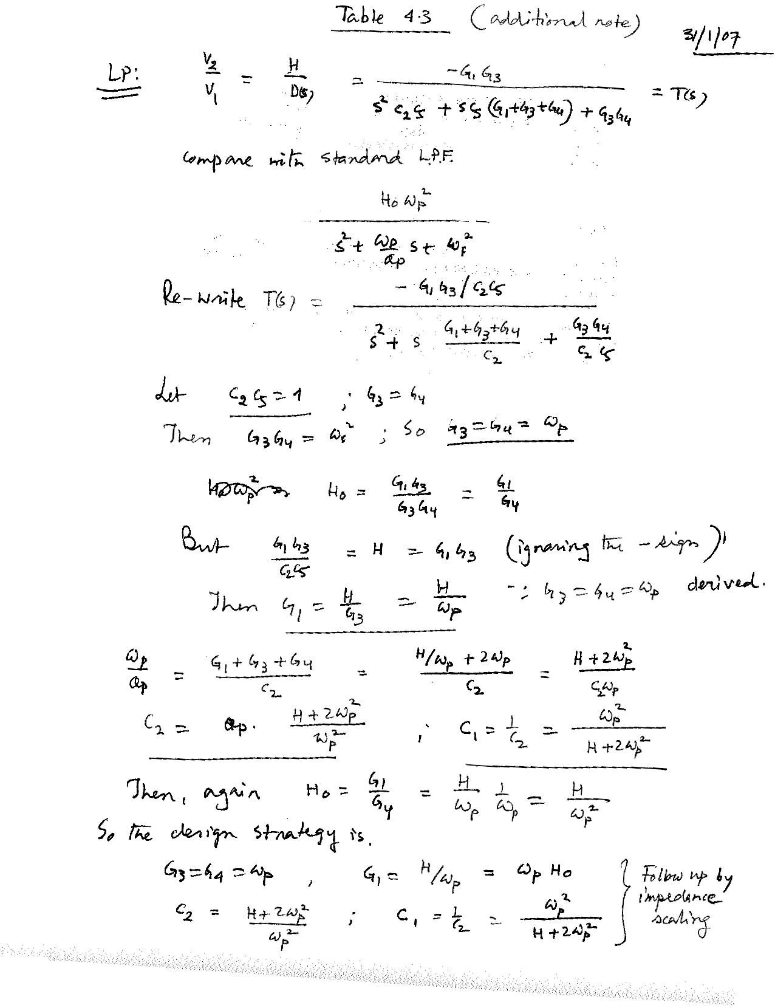

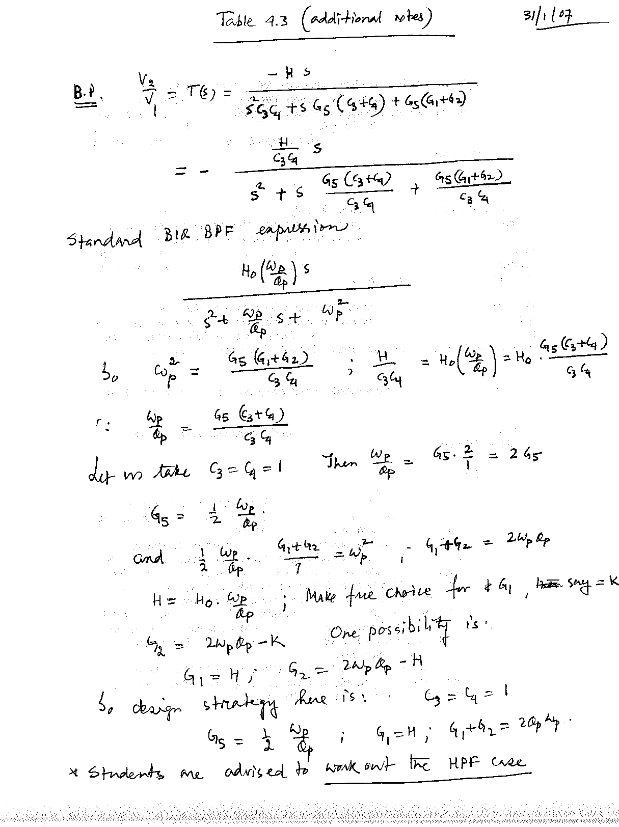

1. + R. Schaumann et al, “Design of Analog Filters- Passive, Active RC, and Switched Capacitor”, Prentice-Hall Inc., © 1990

  
2. ! L.P.Huelsman, “Active and Passive Analog Filter Design – An Introduction”, McGraw-Hill, Inc., ©1993.
3. ! L.P.Huelsman, “Active and Passive Analog Filter Design – An Introduction”, McGraw-Hill, Inc., ©1993.
4. ! L.P.Huelsman, “Active and Passive Analog Filter Design – An Introduction”, McGraw-Hill, Inc., ©1993.