Experiment 4

OTA - Based Filter Design and ANALYSIS (Experimental)

I. **OBJECTIVES** - To introduce the Operational Transconductance Amplifier (OTA) as an alternative to the conventional Op_Amp for implementing filters.

II. INTRODUCTION AND THEORY

Transconductance term, () is used to characterize any semiconductor device that uses its input voltage to control the output current. Other semiconductor devices can be characterized as a trans-resistance type (the input current controls the output voltages). The OTA is a transconductance type device, which means that the input voltage controls the output current by means of the device transconductance. This classifies the OTA as a voltage-controlled current source (VCCS). In contrast to the OTA, the conventional Op-Amp is characterized as a voltage-controlled voltage source (VCVS). One can draw an immediate conclusion about the difference between VCCS and VCVS that lie in the output stage of the amplifier. The output stage in the VCCS is a current source, which means that the output resistance is very high. On the contrary, the VCVS has a very low output resistance. The most important feature in OTA is that the transconductance parameter  can be controlled by an external current called the amplifier bias current,. The symbol and the equivalent circuit of a commercial OTA are shown in figure 1.



The transconductance (it is a *small signal* parameter!)  can be written as: 

 (1)

The transconductance  is assumed to be linearly dependent on the bias current  in all circuit configurations operating in linear region. Thus,

  (2)

The proportionality constant is dependent upon temperature, device geometry and the process.

1. **An application of OTA (First order LPF)**

The circuit shown in Figure 2 is a first order low-pass filter (LPF). Here the dc voltage Vc is used to supply the dc biasing current IABC which in turn determines gm. The analysis of this circuit is simple provided you recognize that the Darlington pair attached at the output of OTA is just a buffer. The input and the output voltages of the Darlington pair are same and that is Vo. The purpose of using a Darlington pair at the output of OTA is to convert the OTA output io into a voltage Vo. The Darlington pair offers very large input resistance and a very small output resistanc.



If you analyze this circuit in figure 2, you would find that the transfer function is given as follows.

$\frac{Vo}{Vin}=\frac{1}{1+{sc}/{Kg_{m}}}$ (3)

Where $K=\frac{R1}{R1+R}$

Therefore the cut-off frequency $f_{c }= \frac{R1g_{m}}{\left(R1+R\right)2πC}$ (4)

The variable *s* shown in equation (3) is the Laplace parameter. Physically it is the complex frequency *jw.*

Two points need be noted for the analysis of the circuit in figure 2 (LPF).

1. The inputs of the OTA take no current as they have very large input impedance.
2. The output of OTA io passes through the capacitor C and no part of it goes into the Darlington pair. The reason is that the Darlington pair offers very large input impedance.
3. **Voltage Controlled 2-Pole (i.e., second order) Butterworth LPF**

The following example illustrates the use of OTA to build a second order LPF.



The analysis of this circuit can be done on the same lines as first order LPF. It can be shown that the voltage transfer function is given by the expression

$\frac{Vo}{Vin}=\frac{1}{1+\frac{sc2}{Kg_{m}}+{c1c2(\frac{s}{Kg_{m}})}^{2}}$ (5)

Where $K=\frac{R1}{R1+R}$

The pole-frequency of the transfer function is

$ω_{p}=\frac{Kg_{m}}{\sqrt{c1c2}}$ (6a)

and, the cut-off frequency . (6b)

The pole-Q is obtained from $\frac{ω_{p}}{Q}=\frac{Kg_{m}}{c1}$, i.e., $Q=\sqrt{\frac{c1}{c2}}$. (6c)

Notice that the transconductance  is considered as the independent variable in all equations above. The frequency response could be altered or adjusted by simply setting the value of the transconductance. Since is proportional to the bias current  the cut-off frequencywillvary according to the value of the bias current.

Note that gm is same for both OTAs because the same voltage Vc is applicable in both cases. The bias current (IABC) can be changed by varying VC or R0 (See figs. 2 and 3) and hence the gm. Now after this brief introduction about OTA we will focus on a specific OTA chip LM13700 from national semiconductor. This chip has two identical OTAs and two buffer circuits (Darlington pair).

Pre-Lab

1. Derive equation (3) and (4) and verify that the circuit shown in figure (2) is indeed a LPF. What is the maximum gain for this filter?
2. Analyze the circuit in figure 3 and derive equations (5) and (6).

.

**III. Experimental Procedure**

The purpose of this experiment is to use OTAs for filtering. Both the examples described above have been taken from the application notes appended to the data-sheet for LM13700. This data-sheet is included in your lab manual as an appendix at the end. More examples of OTA-based filters are given in this data-sheet. The pin-out for this chip is given in the connection diagram below.

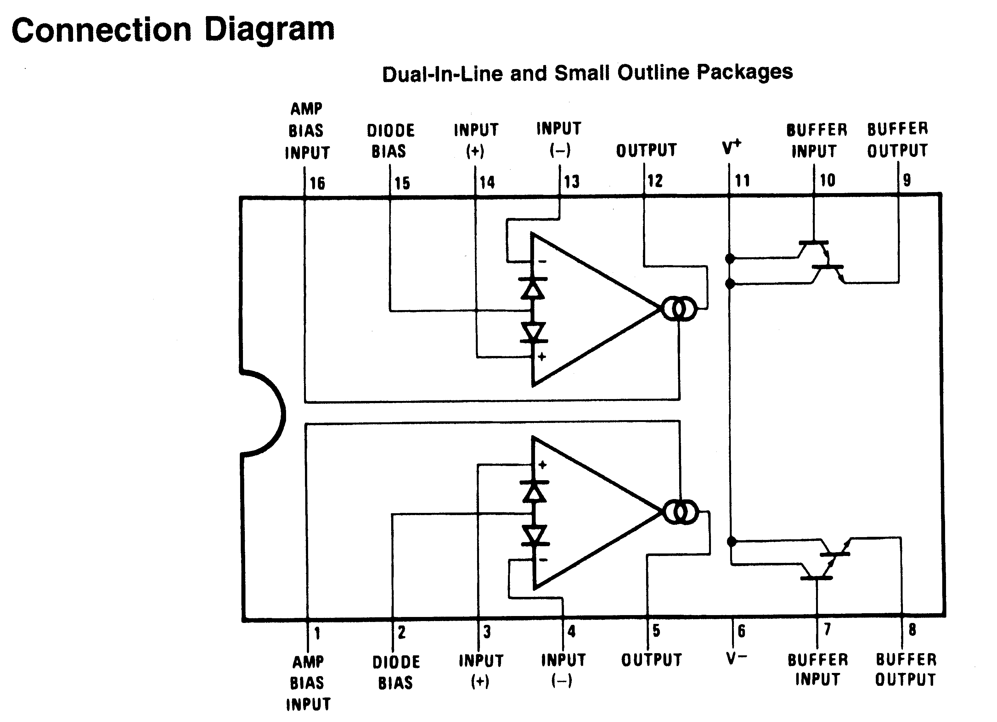

Figure 1 (Top-view)

Note the following points about this chip when you use it to assemble figure 2 and 3.

1. The two OTAs share a common supplies (pin 11 and pin 6) but otherwise operate independently. Pin 11 should be connected to +15V and pin 6 should be connected to -15V for this experiment.
2. The voltage supplies for the two Darlington pairs are internally connected to pin 11.
3. If you carefully inspect figures 2 and 3, you would notice that the output of an OTA is always connected to the input of the Darlington pair. For example in figure 2 you would need to connect pin 5 to pin 7.
4. In figures 2 and 3, a node with an open circle corresponds to a pin for the chip LM13700. Note that the dark circles are not a pin of the chip.
5. You will never use the pins (2 and 15) meant for Diode bias.

* Implementation of first order LPF (Figure 2)

1. Assemble the circuit shown in figure 2 with the following parameters.

|  |  |  |  |  |  |
| --- | --- | --- | --- | --- | --- |
| Vin | R | R1 | R0 | C | Vc |
| 2V p-p | 100K | 1K | 30K | 1nF | 15V |

Measure the output Vo for the frequency range 1-50KHz. Determine the cut-off frequency.

1. Now change Vc to 5V and sweep in the frequency range of 1-50 KHz to determine the cut-off frequency. Plot Gain (dB) vs. frequency in both cases.

* **Implementation of 2nd order LPF (figure 3)**

1. Assemble the circuit shown in figure 3 with the following parameters.

|  |  |  |  |  |  |
| --- | --- | --- | --- | --- | --- |
| Vin | R | R1 | R0 | C1=C2=C | Vc |
| 2V p-p | 100K | 1K | 30K | 1nF | 15V |

Measure the output Vo for the frequency range 1-50KHz. Determine the cut-off frequency.

1. Now change R0 to 5.1 KΩ. Measure the output Vo for the frequency range 1-50KHz. Determine the cut-off frequency. Plot Gain (dB) vs. frequency in both cases.
2. Adjust the capacitances to different values. Say C1=1.5nF and C2=1nF. What values of ωp and Q you can get now?

Questions

1. What are the applications of OTAs other than making filters? Hint – See the data-sheet.
2. LM 741 is also used for building filters. Experiment 2 and 3 are the examples. Name an advantage that an OTA-based filters has over the filters made from LM-741 (i.e., an OP-AMP).
3. While measuring the frequency response of first-order LPF, Vc was reduced to 5V (step-2). In this case the cut-off frequency decreased. Why is that?
4. In step-2 of 2nd order LPF, R0 was reduced to 5.1K. It was found that the cut-off frequency increased. Explain why?

.

