Experiment 5
Objective – Filter design and testing with Current Conveyor chip (Experimental)
- Introduction
An operational amplifier such as LM 741 is a voltage mode analog circuit. Here the analog functions such as amplification, mathematical operation, filtering etc. are implemented with the voltages as inputs. The output obtained is also in the form of voltages. In experiment 2 we used LM 741 to assemble a filter circuit.
In contrast, a current conveyor (CC) is a current mode analog circuit. In other words, all the inputs and output are current. A CC circuit offers some advantages such as higher bandwidth, higher dynamic range, and lower power supply voltages.
AD 844 chip is similar to LM 741 but it can also work as a CC chip. In fact it can provide the functionality of CCII (pronounced as Current Conveyor 2). Figure 1 shows a block representation for CCII.
Fig. 1
Iy
Z
Y
X
CCII
Iz
Ix
The behavior of CCII is defined by the following three relationships.
- The terminal X is a low input impedance node. The terminal Y has an infinite impedance and therefore, Iy = 0 (1)
- The voltage at the terminals X (Vx) and Y (Vy) are same, therefore Vx=Vy (2)
- The high impedance output node Z has the same current as Ix and therefore Iz = ±Ix (3)
- Theory – All-pass/notch and band-pass filters using CCII
Figure 2 shows a general form of filter circuit that is capable of providing all-pass, notch, and band-pass filters.

Figure 2
The general current transfer function is given by the relation: $\frac{Io}{Iin}=\frac{s^{2}G1C4C5+s\left(G1G5C4+G1G2C5-G2G6C4\right)+G1G2G5}{\left(G1+G6\right)[s^{2}C4C5+s\left(G5C4+G2C5\right)+G2G5]}$ (4)
Here G is defined as 1/R. Band-pass configuration is obtained when G1 = 0 or R1 = ∞ (5)
The notch filter realization is possible with $G6=\frac{G1G5C4+G1G2C5}{G2C4}$ (6)
The all-pass realization is possible with G6 = $\frac{2(C4G5G1+C5G1G2)}{C4G2}$ (7)
The pole-frequency is ω_{p} = $\sqrt{\frac{G2G5}{C4C5}}$ , and the pole Q is = (8)
- BP realization in the laboratory: - In equation (4) the input and the output are currents because the circuit in figure (2) is a current-mode circuit. In out laboratory we don’t have an ac current source. We also can’t measure the current output (Io). Therefore we pass input voltage (Vin) through a 100 kΩ resistor to mimic a current source.
The following band-pass filter needs to be implemented in the laboratory. It is shown in figure 3. Note that the components within the dotted area constitute the band-pass filter. The components situated outside the dotted area are placed to facilitate the measurement.

Figure -3
The pin-out for AD 844 is shown below in Figure 4. Note that the pin numbers used are shown in Fig. 3. We have used pins 2 and 3 for the input and pin 5 for the output. Pins 7 and 4 are the power supply points. Be aware that the Z terminal of CCII is pin 5 which is marked as TZ. Pin 6 which is marked as output in Figure 4 is meant for different kind of applications of AD844. The capacitor of 47µF is placed at the output to block the dc and the load of 10KΩ is attached to get the output as voltage. Note that pin 5 is a high impedance node (≈3MΩ). Therefore, a load of 10 KΩ wouldn’t alter the output current (Io). Vin is obtained using the Function Generator.
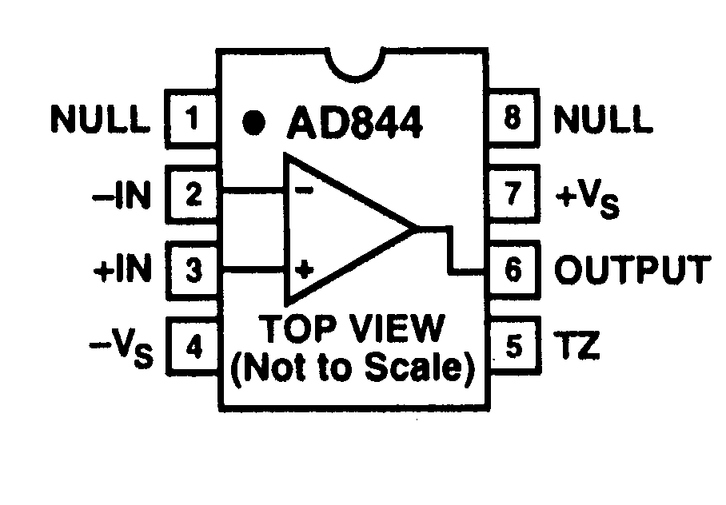
Figure 4
Pin 2 and 3 correspond to X and Y terminals respectively of CCII shown in Figure 2. You may use 10 volt peak-to-peak for the input (Vin). Io is directly proportional to the voltage across RL, and therefore voltage should be measured as a function of frequency. Choose a suitable frequency range that covers 3dB points in both directions. You may start with 1 KHz.
- Determine the pole frequency (ω_{p}).
- Determine the pole Q.
- Determine the bandwidth.
- Plot Io vs. frequency on the semi-log graph.
- Verify the experimental values against the theoretical formulas for , and Q.
4. Notch (Band-reject) realization using CCII.
Modify the circuit in Fig. (3) to obtain a notch filter.
- Draw the appropriate circuit in you notebook.
- Assemble the circuit and plot Io vs. Frequency on a semi-log scale. Once again you may start with 1 KHz. Use the input voltage of 5V peak-to-peak.
- Determine the notch frequency (ω_{z}).
- Verify the experimental value against the theoretical expression for the notch filter. Remember that for a notch filter the numerator function is of the form ().
5. Questions and Analysis
- Derive the transfer function shown in equation (4). For this derivation you would need to use the conditions described in equations 1 – 3.
- For the band-pass filter in figure 3, show that the transfer function is given by the expression I_{o}/I_{in} =$-\frac{sRC}{{(sRC)}^{2}+2sRC+1}$ Here R=10KΩ and C = 1nF. Note that pin 2 and 3 in this figure are same as terminals X and Y of CCII respectively.
- Is it possible to measure ac current using DMM?

