Introduction to PSPICE

PSPICE is a simulation tool to check the functionality of a circuit. You can also obtain the values of various parameters such as current, voltage, etc.

To open the program, go to start -🡪programs-🡪Cadence-🡪Release 16.6-🡪OrCAD Capture🡪OrCAD PCB designer professional w/Pspice. From the center of the screen go to “Getting Started” and select NEW PROJECT.

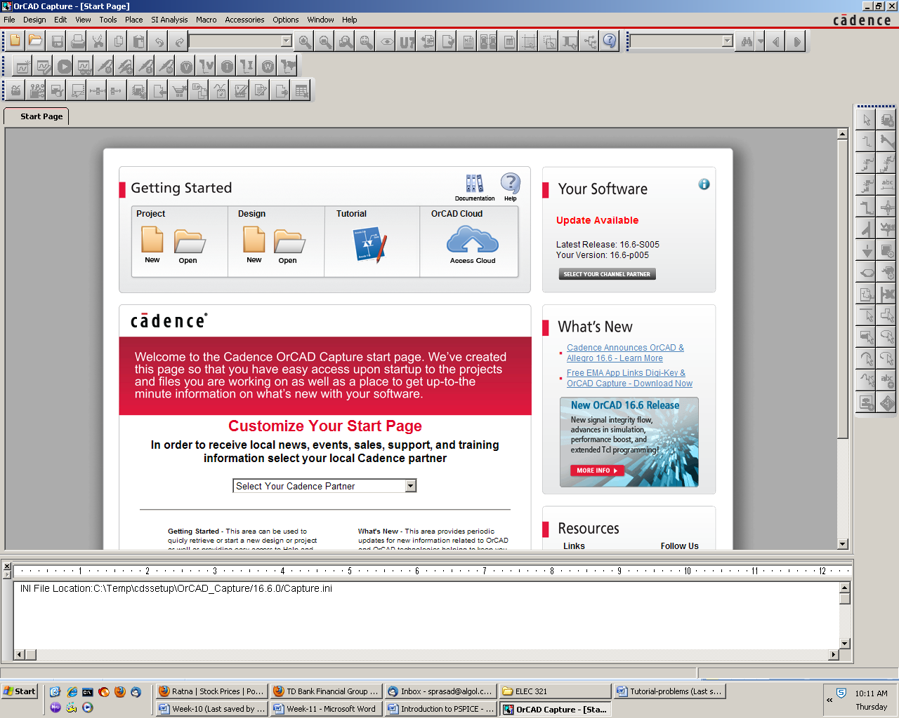

Fig.1

A pop-up window opens as shown in Fig. 2. Select the option “Analog or Mixed A/D”. Also in the “Location” field indicate the folder where you want your files to go. It is important that you don’t put it on your desktop because all these files will get deleted when you log out.

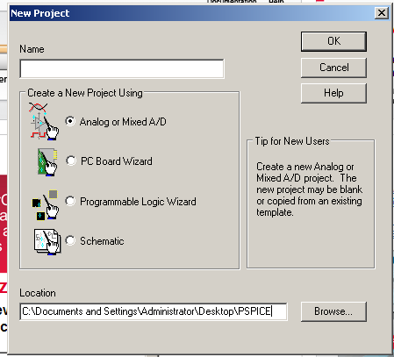

Fig.2 (creating a project)

Another pop-up window opens and is shown in Fig. 3. Select the option “Create a blank project”.

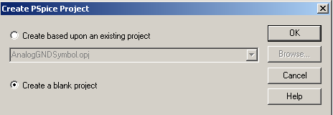

Fig. 3 (Creating Pspice project from a blank screen or an existing project)

Once you click OK a new window would open as shown in Fig. 4. This is the OrCAD capture window where you would place the circuit of the schematic. You need to familiarize yourself with the buttons on this screen. Not all of them are useful at this point.

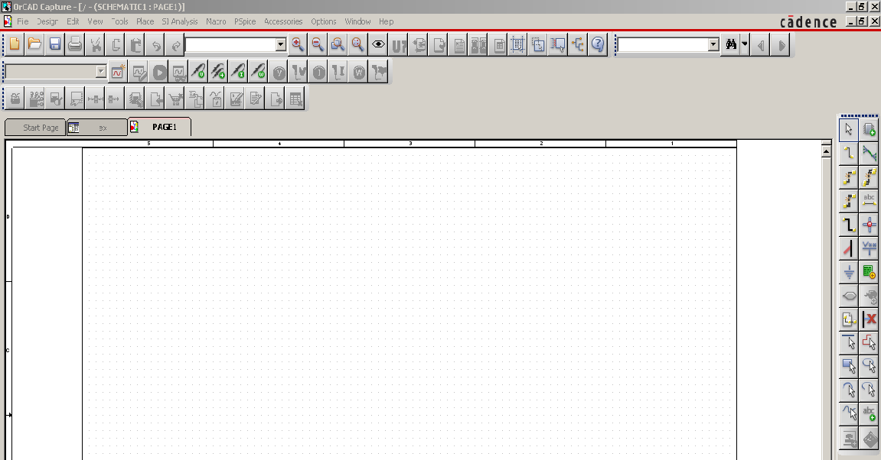

Place wire

Place Part

Fig. 4 (location of the toolbar: top and right)

We need to place various components of the schematic on the drawing board. So click the Place Part button. That opens a new menu box as shown in Fig 5. You need to add library into the system. This is the library of parts such as resistor, capacitor, diode, transistor etc. If you click on “Add Library” button, a folder opens that has dozens of library. You chose ANALOG, EVAL, and SOURCE from the list. Once these libraries are imported, you need to choose various components from these libraries.

The library ANALOG contains passive elements such as resistor, capacitor, and inductor.

The library EVAL contains active elements such as diode, BJT, MOSFET, Opamp etc. The SOURCE library contains various types of voltage and current sources. These are dc, ac, or pulse signals. After loading the library you need to select various components from the list. After selecting the component, click on “Place Part” as shown in Fig. 5. The item on the part’s window can now be placed on the circuit board. Once you have placed the component, right click the mouse and a menu opens. Click the “End Mode”.

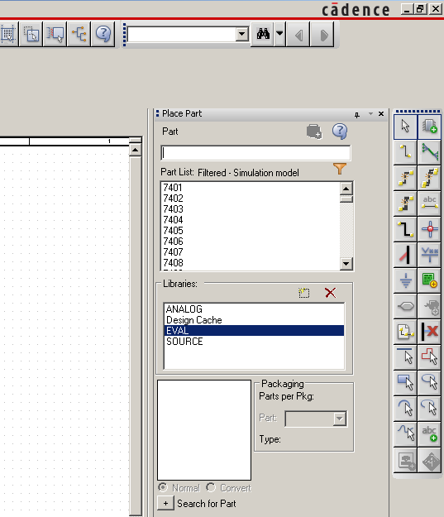

Ground

Place part

Add Library

Fig. 5 (Draw toolbar on the right of the Capture screen)

We need to draw a circuit as shown in Fig. 6. The components R1 and C1 are located in the ANALOG library. You need to rotate C1. You can select the capacitor and then right-click the mouse. A menu opens. Choose ROTATE option. You also need to assign the value of 22u (stands for 22μF). Select the default value and then right-click. From the menu that opens, choose “EDIT PROPERTIES”. In the value field write 22u. From the SOURCE library choose VPULSE and place it on the schematics. You would notice that the parameter values are missing. Once again select each parameter and go to EDIT PROPERTIES and then assign the values shown in Fig. 6. Now connect each component through a wire (shown in Fig. 4). Place ground (shown in Fig. 5).



Fig.6 (Schematic for an R-C circuit)

Attach voltage markers as shown in Fig. 6. The buttons for various markers are shown in Fig. 7

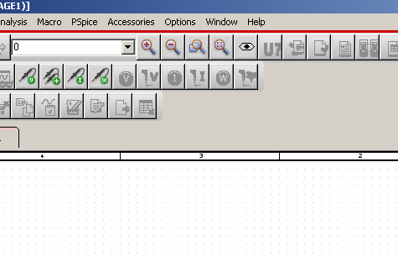

Power dissipation marker

Current Marker

Voltage marker

Fig. 7 (Icon for various markers in the toolbar)

Now you are ready to run the simulation.

**Time Domain analysis:** From the top menu of the screen click on “**Pspice**”. It is visible in Fig. 7. From pull-down menu, click on “**New Simulation Profile”.** A window opens where you write the name of your simulation. Once you click OK after assigning a name, a new dialog box opens as shown in Fig. 8. For ANALYSIS TYPE choose “Time Domain (Transient). In the field for “Run to Time” write 200m. Click OK. Now you are ready to run simulation. Click on **Pspice-🡪Run.** You can also run it from the button with green arrow head in the toolbar. After the simulation is completed an output window opens and is shown in Fig. 9. This completes the simulation. One curve is the input and the other one is the output. These two curves come from the two voltage probes that we placed in the schematic.

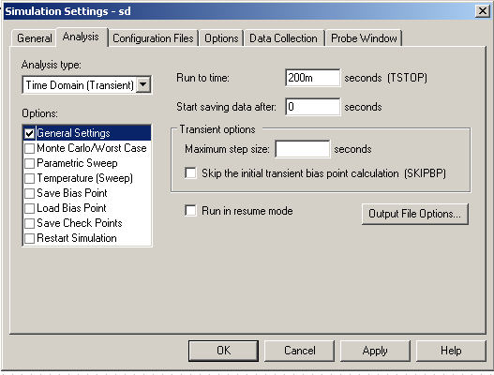

Fig. 8 (Choosing the analysis type)

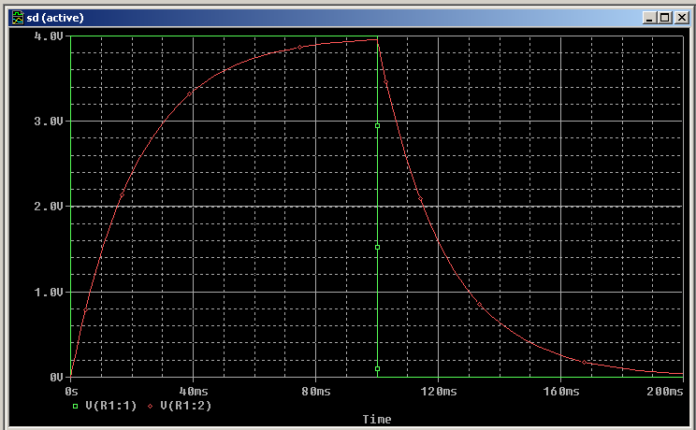

Fig.9 (Output window: result of simulation)

**Frequency Domain Analysis:**

Start a new project. The dialog box shown in Fig. 2 appears. Give it the name LOWPASS. Select **Analog or Mixed A/D.** Then create a blank project. Build the circuit shown in Fig. 10. The instructions to build this circuit follow.



Fig. 10 (Schematic of a low-pass filter)

The Opamp (uA741) can be found in EVAL library. You need to mirror it to get in the configuration as shown. Once again resistors and capacitors are in ANALOG library. The power sources (+15V and -15V) can be obtained from SOURCE library. You choose VDC and then assign the appropriate values by editing its properties. Note that for V3 the polarity of the supply has been flipped using the mirror function. The source V1 is obtained from the SOURCE library by choosing VAC. This is an ac signal with 1 volt amplitude but variable frequency. The pins 7 and 4 of the Opamp are named VCC and –VCC respectively. These are off-page connectors. They are defined on the left side of the circuit. The icon for off-page connector is located on the capture page and shown in Fig. 11.

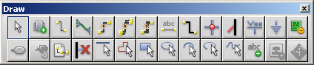

Off-page connector

Fig. 11

Click on the PSPICE icon and create a new simulation profile called “Frequency Response”. In the simulation setting window, select AC Sweep/Noise for Analysis type. Enter start and end frequency, as well as the number of points/decade as shown in Fig. 12.

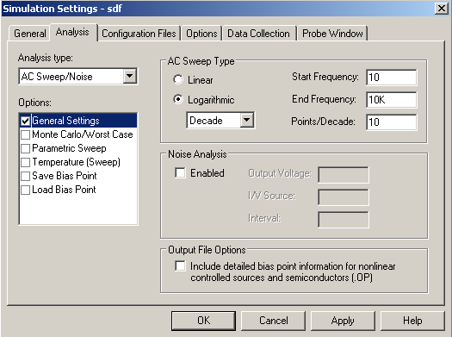

Fig. 12 (Choosing the analysis type)

Once you have defined the simulation parameters it is time to attach the voltage probe to the output of the Opamp. This voltage probe is shown in Fig. 10. This is not the voltage marker shown in the toolbar and the one used in the previous section. This is voltage in dB. To get this click **Pspice🡪Markers-🡪Advanced-🡪dB Magnitude of Voltage.**

Now run the simulation. You will get an output as shown in Fig. 13.

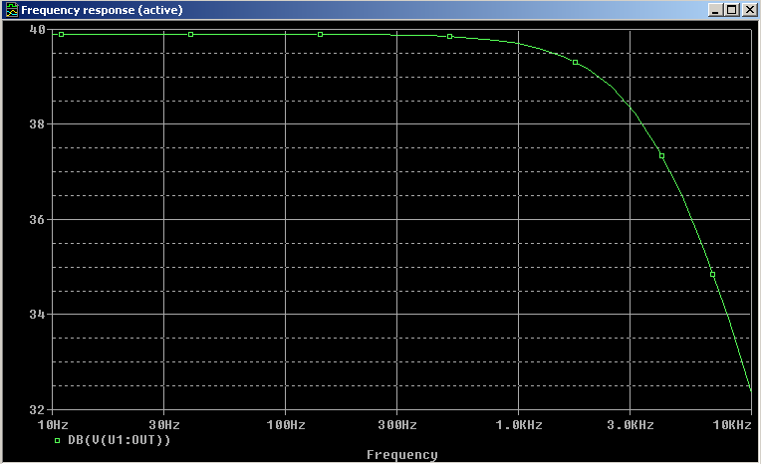

Fig. 13: Frequency response of LOWPASS filter

One can use **Cursors** to extract information from the output curve such as shown in Fig. 13. The output window is again copied in Fig 14. Cursor toggle icon is shown which can be used to activate the cursor option. On the right side of the toggle switch there are several options such as maximum or minimum of the curve. One can simply drag the cursor to a point and read-off the value of that point. On the lower right hand corner of the simulation widow for the output, you would see a box. This box contains the location of the point where the cursor is located. For example, you would want to find out the 3 dB point for this low-pass filter. This box is shown in Fig. 15. This box, for example, will show the frequency at which the 3 dB point is located.

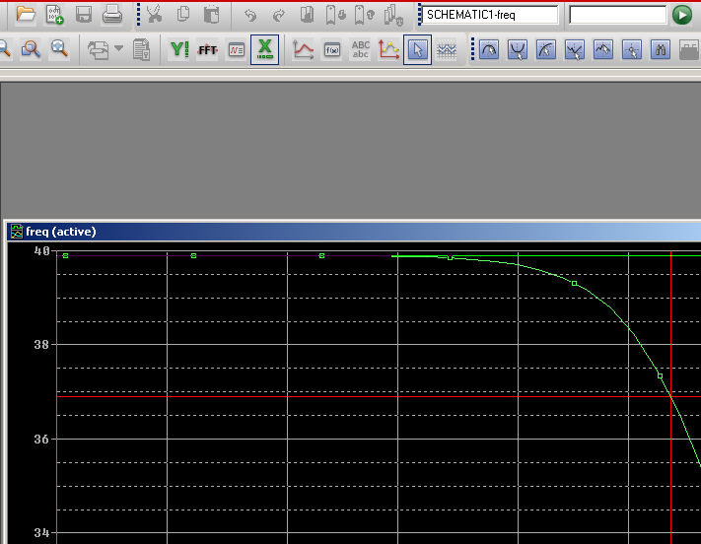

Various options for cursor reading

Cursor Toggle icon

Fig. 14 (Use of cursor)

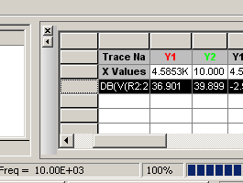

Fig. 15 (Reading the values at cursor location)

**DC Analysis**

Build the circuit shown in Fig. 16 after creating a new project. Call it DCBJT. The BJT Q2N2222 is located in the EVAL library.



Fig. 16 (Circuit for DC analysis)

From Pspice menus choose “New Simulation Profile”. Type the name “DC Analysis”. When the dialog box for simulation settings opens, choose “Bias Point” for Analysis Type. Then click OK. At the top toolbar there are two icons that measure voltage and current at various nodes. These two icons are shown in Fig. 17.

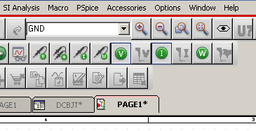

Icon for current measurement

Icon for voltage measurement

Fig. 17 (DC voltage and current measurement)

Enable voltage and current measurement by clicking on these two icons. Then click on the Run button which is green arrow head. You would notice that the schematic of the circuit (Fig. 16) has currents and voltages for each node. The output is shown in Fig. 18.

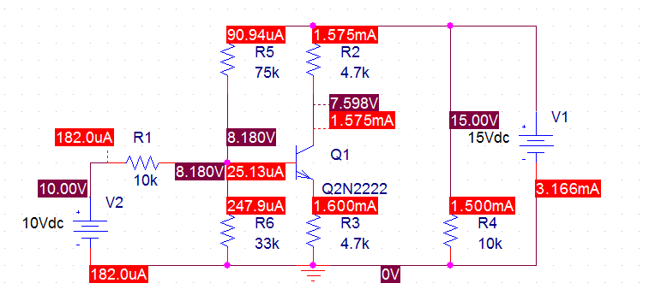

Fig. 18 (Biasing current and voltage at various nodes)

In summary we have seen three types of analysis: 1) Time Domain; 2) AC Sweep; and 3) Bias Point. These are three main types of analyses which give the functionality of a circuit and then help us realize an actual circuit on the bread-board.

**Assigning values to R, C, L**

|  |  |  |  |  |  |  |  |  |  |
| --- | --- | --- | --- | --- | --- | --- | --- | --- | --- |
| Value | 1012 | 109 | 106 | 103 | 10-3 | 10-6 | 10-9 | 10-12 | 10-15 |
| symbol | T or t | G or g | MEG or meg | K or k | M or m | U or u | N or n | P or p | F or f |

If you want to change the value for a component then select the component value. Right click it and then select “Edit Properties”. A dialog box opens. There you write the correct value. For example, the default value for the resistor R is 1K (1000 Ω). To change it to 100 Ω, simply write 100 in the value field.

**What to do when a device is not available in EVAL library:**

Some devices are not present in the EVAL library. One important example is NMOS and PMOS. In this situation we select PLACE from toolbar of the CAPTURE screen. Then select PSPICE COMPONENTS. Then select DISCRETE and then NMOS. The screen below (Fig. 19) shows the details. Note that many of the components that are present in the library are also present here.

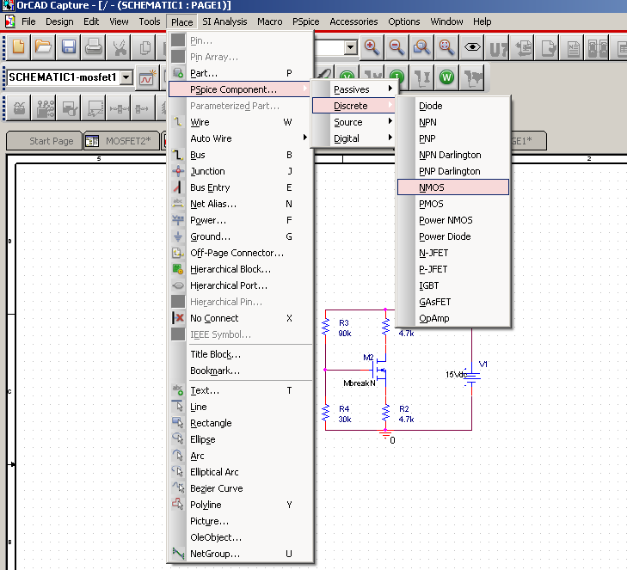

Fig. 19 (Getting components without going into the library).

Now draw the schematic shown in Fig. 20 where the transistor NbreakM is an NMOS. For this circuit do bias-point analysis. The procedure is same as the one described in the DC analysis. Note down various currents and voltages measured.



Fig. 20