Topics covered in this course this session:
Chapter 1, .1,1.2,1.3,1.4,1.6,1.7-BCD Code
Chapter 2 All
Chapter 3 ( except Section 3.9, 3.10)
Chapter 4 ( except Sections 4.12, 4.13, 4.14, 4.15)
Chapter 5 ( except Sections 5.6)
Chapter 6 ( except Sections 6.6)
Chapter 7, pages 321-- to 334 only ( 5th edition)
pages 394---to 414 only (6th edition)

FINAL exam date and location :
Friday Dec 13th 2018 14:00 to 17:00
Rooms : MB3.270 , MB3.430, MB3. 435
--
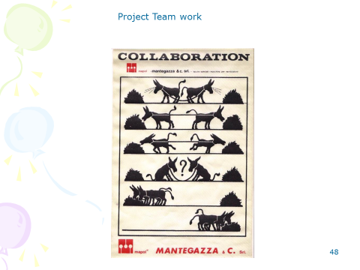

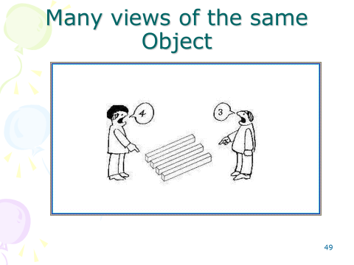
To hear you forget
To see you remember
To do you understand
Chinese proverb

FINAL WORDS

- Thank you for being good students.
- Always See the future, and see where technology is going then adapt to be always “EMPLYABLE”
- Always go to the root of any problem that you are solving, whether engineering or social.
- Be a Good engineer, Never forget your Engineering ethics.
- Always keep your mind open to new ideas and development, and have vision as where the world is heading and try to be there before others.
- Do NOT forget the “ENVIRONMENT”.
- Be a team player.
- Always be a dignified Engineer, respect yourself and other people’s dignity.
- Be just to yourself and give justice to others.
- Always have good intentions with your thinking, actions and speaking.
- THANK YOU

Smile, It makes life sweeter
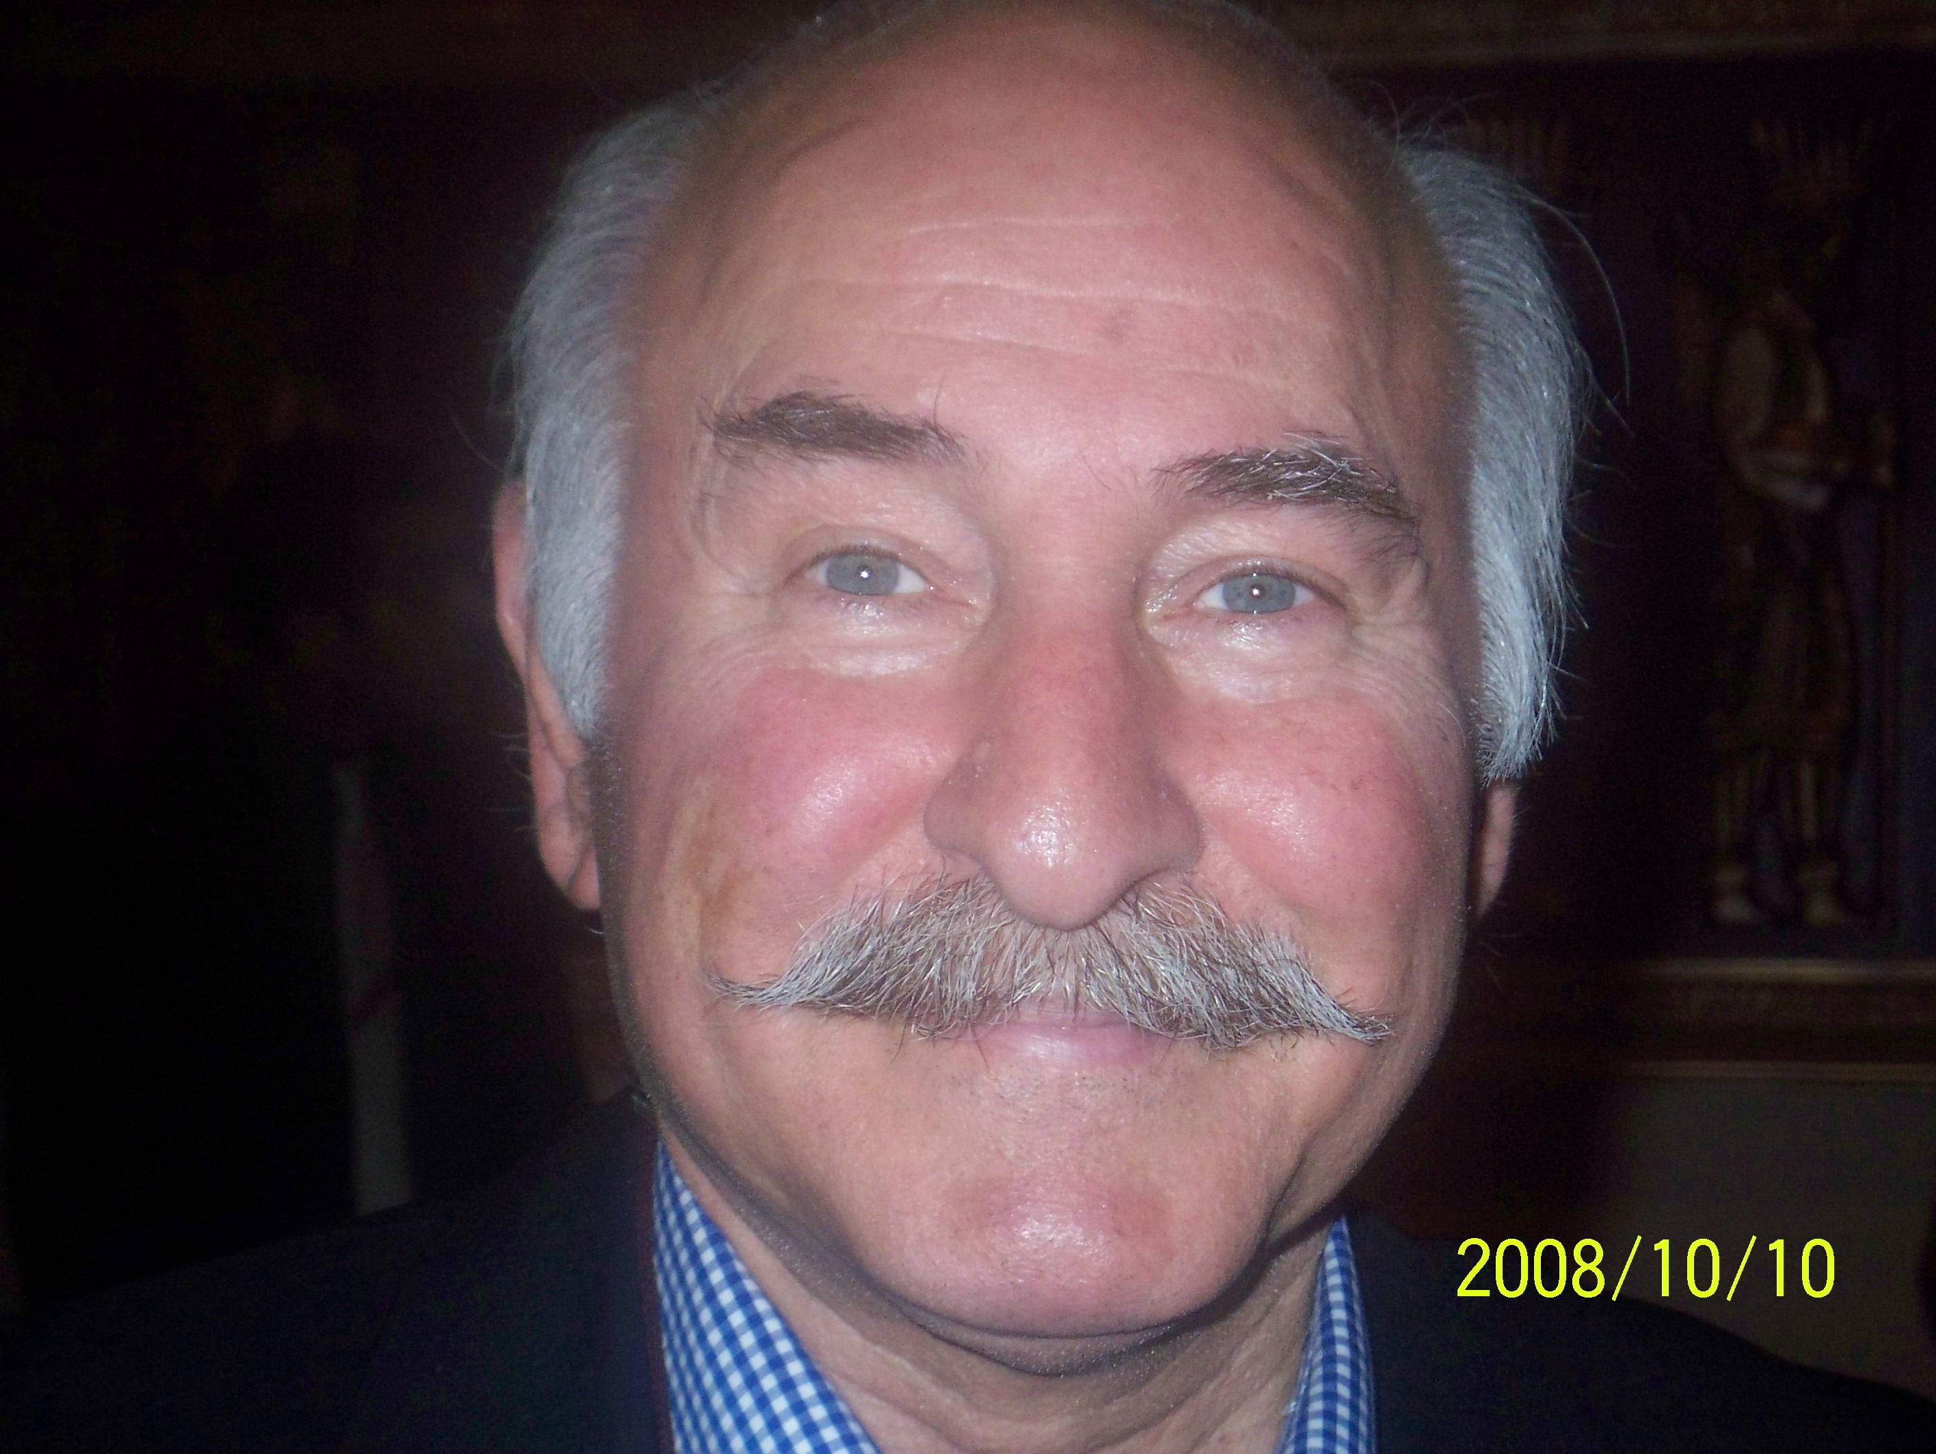
Merci beaucoup pour votre attention, vous étiez très gentils, et admirables.
J’aimerais également vous souhaiter bonne chance à l’examen, un joyeux Noël et une bonne année.
