OBJECTIVES:

- To design for Metal Oxide Semiconductor Field Effect Transistors parameters using theoretical approach.
- To fabricate Metal Oxide Semiconductor Field Effect Transistors.
- To test the fabricated Metal Oxide Semiconductor Field Effect Transistors performance and compare with theory.

THE THEORY:

The diffused planar process remains one of the most important processes available for large-scale IC fabrication. The aim of this lab experiment is the fabrication of Metal Oxide Semiconductor (M.O.S.) transistors using this process.
IC's fabricated using the planar processes have available on their top surfaces the regions on which contacts are to be made. For instance, in our particular case we will be fabricating MOS transistors on (N or P-type) silicon wafers. Figure 1 shows a cross section of these transistors. The Source, Drain and Gate regions are all "accessible" on the top surface of the silicon substrate. Once the source and drain have been formed in the substrate through the diffusion of appropriate impurities, aluminum contacts can be made to these areas on the wafer's surface.

Channel length "L"

P-well
N⁺
N⁺
Source contact
Gate contact
Gate SiO₂
Drain contact
Figure 1. Cross-section of a diffused planar MOS transistor

The planar process is made possible due to the fact that silicon dioxide (SiO₂) may be grown on the silicon substrate and then selectively removed from designated areas through photolithographic and etching techniques. The oxide effectively keeps any doping impurities from diffusing into the areas it covers and permits the formation of P or N regions over well defined areas on the substrate's surface. The oxide also serves to protect the junctions where they reach the surface of the slice from surface contamination and it effectively isolates the three contacts from each other (SiO₂ is an excellent insulator).

Figure 2 shows the process steps required for the formation of an N-channel, enhancement-type MOS transistor. These are the steps that will be followed during the course of this experiment. Keep in mind that the figure shows the formation of simply one transistor but in fact, several such structures will be created over the surface of the substrate. We begin with a P-type substrate on which a layer of silicon dioxide is grown. The slice is then coated with photoresist, which is subsequently exposed through the "PHOSPHORUS DIFFUSION" mask and developed. The SiO₂ is etched away from the source/drain regions and the remaining photoresist is stripped from the surface. Phosphorus is diffused into the open "window" to form the N-type source and drains and then the surface is re-oxidized. We are now ready to grow the high quality gate oxide. However, before this can be done, the "old" oxide over the gate regions must be removed. Removal of this oxide is done once again through the use of photolithography and the "GATE AREA" mask. Contact holes down to the source/drain regions are opened up with the "CONTACT" mask (again we use photolithography) and finally, the "METALLIZATION" mask is used to lay aluminum on the source, drain and gate areas. For this last step, the wafer's surface is re-oxidized and it is then coated with photoresist. The photoresist is exposed through the metallization mask and developed. This time, after the oxide has been etched away from the designated areas, the photoresist is NOT removed from the slice's top surface. Aluminum is evaporated onto the entire surface with the resin still on it and the excess Al, which does not cover any contact areas, is "floated off". This is done chemically with a solution that "swells up" the resin and dislodges the aluminum from the non-contact areas. After this process, aluminum is left only in the source, drain and gate contact regions. The contacts are then alloyed to the Si substrate and device performance is finally tested.
Nevertheless, in the course of carrying out the fabrication process we are going to utilize a lot of integrated circuits fabrication devices. The abilities and performance of those devices will certainly affect the outcome, which is our MOSFET's.

BEGIN WITH P-TYPE SUBSTRATE
GROW A LAYER OF SiO₂
COAT WITH PHOTORESIST (PR)
EXPOSE PR THROUGH MASK #1 & DEVELOP
ETCH SiO₂ AWAY IN THE BASE REGION
REMOVE PR
DIFFUSE (P) N-TYPE BASE
RE-OXIDATION OF SURFACE
REMOVE SiO₂ USING MASK #2
OXIDIZE GATE AREA
USE MASK #3 TO OPEN CONTACT AREA
SPIN PR ON THE SURFACE
USE MASK #4 TO OPEN ALLOYED AREA
METALLIZATION
Figure 2. Process Steps: N-MOS planar transistor fabrication

The Cleaning Process:

Dust, sodium (Na), aluminum (Al), and native oxide, are the most known types of unwanted impurities that a sample may be infected with during storage or fabrication. So, a cleaning process was optimized to rid the sample of those surface impurities. This cleaning process will be done in four steps

WARNING: A facemask and proper gloves should be worn during this operation.
- Mix a 1:1 (75ml: 75ml) H₂So₄:H₂O₂ in a 200-ml glass beaker, then heat it on the hot plate. Let the samples boil for 5 minutes, then rinse them in DI water. (For all impurities except the native oxide)
- Mix a 1:1:5 (25ml: 25ml: 125ml) HCl:H₂O₂:H₂O in a 200-ml glass beaker, then heat it on the hot plate. Let the samples boil for 5 minutes, then rinse them in DI water. (For all impurities except the native oxide).
- Mix a 1:50 (2ml: 100ml) HF:H₂O in a Teflon beaker, then dip the samples for 30-60 seconds in it. Rinse the samples in DI water after that. (For native oxide only)
- Mix 1:1:5 (25ml: 25ml: 125ml) NH₄OH:H₂O₂:H₂O in a 200-ml glass beaker, then heat it on the hot plate for 5 minutes. But this time don’t let it boil, then rinse the samples in DI water. Blow-dry the samples with N₂ gun. (For native oxide only)

Thermal Oxidation:

Silicon dioxide may be grown on the substrates through either "Dry" or "Wet" thermal oxidation:
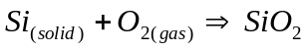 (DRY)
Or
(WET)

The silicon is the sample itself in these reactions and therefore, some of it is used up in the growth of the oxide film. It can be shown from the densities and molecular weight of silicon and silicon dioxide that during the growth of an oxide layer with thickness x, a layer of silicon with thickness 0.45x is consumed. If we assume that a minimum oxide layer of 0.6 μm is required to prevent the formation of a junction in the silicon during diffusion, then the growth of such an oxide layer will consume 0.27 μm of silicon. This can be neglected for our purposes. To determine the oxidation condition for the growth of this oxide layer with the "masking thickness" of x =0.6 μm, the following "parabolic relationship" can be used:

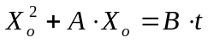 (1)

Where:
X_{o} = oxide layer thickness [μm].
t = oxidation time [hr].

B = parabolic rate constant [(μm)²/hr].
= 0.4 (μm)²/hr @ T = 1000 °C, wet oxidation.
= 0.6 (μm)²/hr @ T = 1100 °C, wet oxidation.
= 0.00402322488839 (μm)²/hr @ T = 900 °C, dry oxidation.
B/A = linear rate constant [μm/hr].
= 0.647 μm/hr @ T = 1000 °C, wet oxidation.
= 2.441 μm/hr @ T = 1100 °C, wet oxidation.
= 0.009524999428304 μm/hr @ T = 900 °C, dry oxidation.

Thus, if we want to grow 0.6 μm of oxide using wet oxidation with T = 1000 °C, we would require an oxidation time equal to:

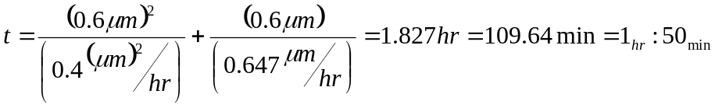

The oxidation is performed using the apparatus shown in figure 3. The samples are loaded on the quartz oxidation boat and placed in the center of the quartz oxidation reactor. The reactor temperature and gas flow should be adjusted before the loaded boat is positioned inside the chamber. For our initial oxidation, the temperature inside the reactor (@ its center) is set to 1000 °C and the oxygen gas O₂ flow rate is set to approximately 4 CFH (1 CFH ~ 2 L/min). The O₂ is passed through a heated (96-100 °C) saturator filled with de-ionized (DI) H₂O and is then piped through to the reactor input tube. Note that the "wrap-around" heater located at the reactor input serves to vaporize any liquid H₂O which is not caught by the condensation trap.

resistance heated furnace
resistance heated furnace
Wet O₂
QUARTZ REACTOR
QUARTZ BOAT
THE SAMPLES
WRAP-AROUND HEATER
CONDENSATION TRAP
Figure 3. Oxidation furnace set-up

The Diffusion Process:

The diffusion process is a microelectronic fabrication process through which we can introduce a certain type of dopant impurities to the sample. The depth and concentration of the dopant can be controlled by the general diffusion equation:

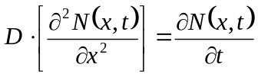 (2)
Where:
N(x,t): (1/cm³) is the impurity concentration at a certain depth (x) and diffusion time (t).
D: (cm²/sec) diffusion coefficient of a given impurity at a given temperature.

The solution to this equation is highly dependable on the boundary condition and process settings. Mainly, there are two kinds of boundary conditions process settings, the Predeposition diffusion process setting, and the Drive-In diffusion process setting. Since mostly every time the Predeposition process comes before the Drive-In diffusion process, we are going to start with it.

The Predeposition Diffusion Process:

Predeposition is a diffusion process by which a certain amount from the total dopant impurity atoms placed at desired region on the sample surface can be inserted into the sample bulk to a specific depth. Thus, by the end of this process we can measure the number of impurity atoms by their surface concentration (1/cm²). The boundary condition for this type of diffusion is set as follows:

- 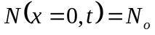= constant (usually the solid solubility or manufacturer specified)
- 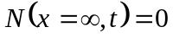
- 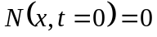
- D = constant
With respect to those conditions, the general diffusion equation will be solved using a numerical method to produce the following solution:

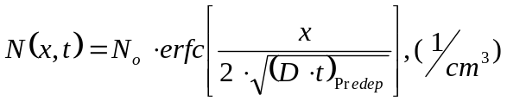 (3)

Where the Complementary Error Function (erfc[x]) is a well known numerical solution which have been rigorously tabulated.
Now for example, if we have an P-type sample and we want to dope it with Phosphorus (to make it N-type), the junction depth will be located at the point in the substrate where the impurity concentration, N(x,t), equals the background concentration, N_{BC}, of the sample. We therefore need the value of the background doping concentration of our samples before we can proceed with the calculation of our diffusion time.
N_{BC} can be calculated by using the value of average resistivity, which is supplied with the wafer. This can be done as follows.

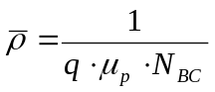 (4)
Where:
q = electronic charge [1.6x10⁻¹⁹ C]
μ_{p} = hole mobility [cm²/V⋅sec]
N_{BC} = substrate background concentration [cm⁻³]
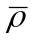= Average resistively [Ω⋅cm]

In order to solve for N_{BC}, the hole mobility must be known. Since Mobility varies with substrate doping, μ_{p} can be determined by means of a form of iterative process, which will give us a "best estimate" for the background concentration. This process will be demonstrated by means of an example.

Let us assume that ρ = 0.4 Ω⋅cm and that our substrate is phosphorus-doped. From figure 4 which plots dopant density (N_{BC}) vs. resistivity (ρ), we get that at ρ ≅ 0.4 Ω⋅cm, N_{BC} ≅ 5×10¹⁶ cm⁻³. Now from figure 5 which plots mobility vs. dopant density (N↔N_{BC}), we get that for N_{BC} ≅ 5×10¹⁶ cm⁻³, μ_{p} ≅ 375 cm²/Vs.
Replacing our value of ρ = 0.4 and μ_{p} = 375 in equation (4), we get that N_{BC} = 4.17x10¹⁶. If we repeat the process once more we find that for N_{BC} =4.17x10¹⁶, μ_{p} ≅ 380 cm²/Vs. Replacing this and ρ = 0.4 in equation (4) again, we get N_{BC} = 4.11x10¹⁶.

Thus, we can conclude that for average resistivity value of 0.4 Ω⋅cm, the substrate background doping concentration is roughly 4.11x10¹⁶ cm⁻³.
Before proceeding with the calculation of diffusion time, we must determine the diffusion coefficient of Phosphorus at T = 1100 °C (ie. our diffusion will be carried out at this temperature). Referring to figure 6 which plots diffusion coefficients for different dopants as a function of temperature, we find that D = 1.43x10⁻¹³ cm²/s (↔0.0514 μm²/hr)

Thus the following parameters may now be used to solve equation (3) for our diffusion time, t_{diff}:
X= Xj = 2.6 μm (this is our design value for the depth of the junction)
N_{o}(T=1100 C, Phosphorus) = 5x10²⁰ cm⁻³ (solid solubility of P in Si @ T=1100 C)
D(T=1100 C, Phosphorus) = 1.43x10⁻¹³ (cm)²/s = 0.05148 (μm)²/hr
N(xj,t) = N_{BC} = 4.11x10¹⁶ cm⁻³
Replacing these values in equation (3) we get:
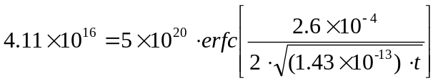
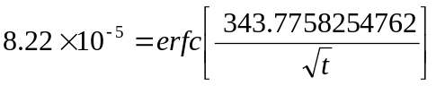
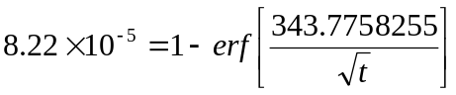
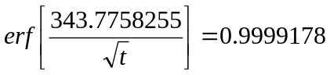

Referring to an error function table, we get that for erf(z) = 0.9999178, z ≅ 2.78

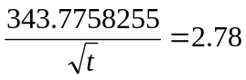
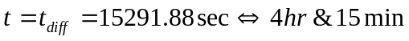

Our Predeposition DIFFUSION conditions are therefore:

Xj = 2.6 um
T_{diff} = 1100 °C
t_{diff} = 4 hr & 15min
Phosphorus source: Phosphorosilica gel
Atmosphere: 80 % N₂, 20 % O₂

The Phosphorosilica gel is applied to the samples with a spinner @ 3000 rpm for 30 sec. The samples are then dried at 110 °C for 1 min in the oven, after which they are ready for diffusion. The manufacturer of the gel claims that the thin coating applied to the surface of the sample will act as a constant source of boron for diffusion depths of up to 10 um. The manufacturer also advises the use of a ~20% O₂, ~80% N₂ atmosphere during the diffusion to prevent the formation of a so-called "brown stain" which has been proven to cause high contact resistance problems after metallization.

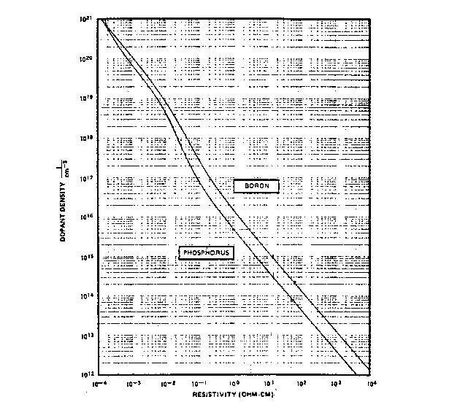
Figure 4. Substrate dopant density (N_{BC}) vs. resistivity (ρ)
Data obtained from class notes for ELEC 624

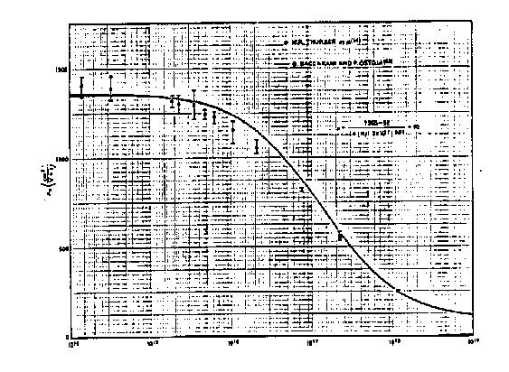
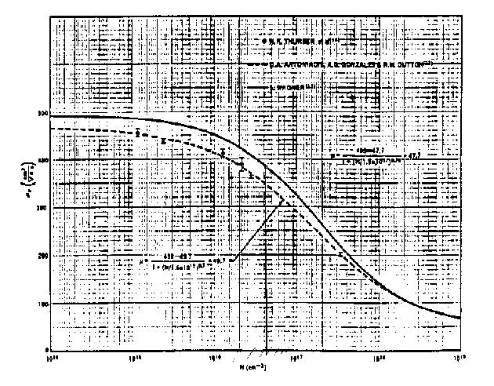
Figure 5. Electron/hole mobility Vs substrate dopant density (N↔N_{BC})
Data obtained from class notes for ELEC 624

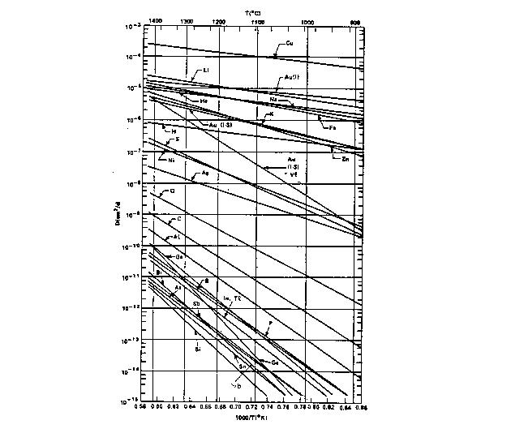
Figure 6. Diffusion coefficient for various dopants Vs temperature
Data obtained from class notes for ELEC 624

The Drive-In Diffusion Process:
As the name suggests, in this process the impurity atoms that were placed at the surface in the predeposition process will be diffused to desirable depth using the Drive-In process. Thus, with these two processes the amount of impurity atoms (concentration) and the depth of their penetration can be controlled. Also, with this process setting we can re-grow the etched oxide on the sample surface. The boundary conditions and the associated assumption of the Drive-In settings are listed as follows:
- 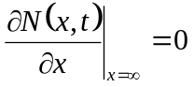, No loss of impurities to the growing oxide layer.
- 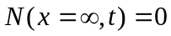, The sample is assumed to be very long (∞ crystal).
- 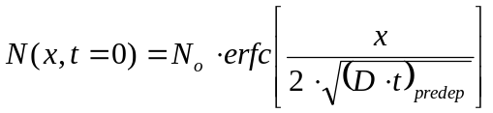.
- 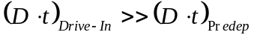, The average depth of Predep is much less then Drive-In.
- Total impurity atoms number is constant during the Drive-In.
- D = constant.
With respect to those conditions, the diffusion equation will have the Gaussian profile as a solution. Thus, the form of the solution will be as follows:

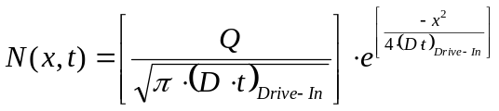 (5)

Where:
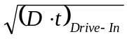: Is the average penetration depth of impurity atoms due to Drive-In (cm).
Q: is the number of impurity atoms inside the substrate per unit area at the end of the Predep process (atoms/cm²).

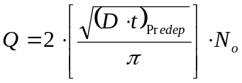 (6)
As can be seen from step 8 in the process steps shown in figure 2, the samples must be re-oxidized after Source/Drain Predep diffusion in preparation for gate oxide photolithography. For our purposes, this will be done by changing the atmosphere in the reactor to wet O₂ at the end of the Predep diffusion time and performing a wet oxidation at 1100 °C for 1/2 hr.
It can be shown that within 5 minutes after the change in ambient, a sufficiently large layer of SiO₂ is grown beneath the Phosphorosilica layer that it can be assumed that N_{o} has been effectively "removed" from the sample's surface. Thus, during the last 30 minutes, the diffusion proceeds via a Gaussian distribution. The fact that the ambient is changed will not prevent the phosphorous from diffusing any further in the substrate and therefore, our diffusion depth will be affected. Let us calculate how much farther x_{j} will be located from our design value of 2.6 μm.
Examining assumption number (d- on the previous page we see that, the average depth of Predep is much less then Drive-In

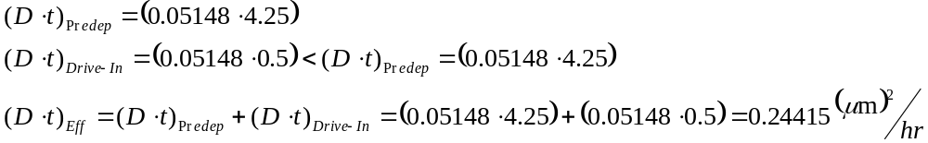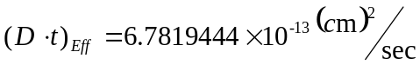
And since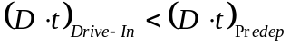, we can’t use equation (5-6) (the Gaussian distribution) to calculate X_{j}; instead we will use equation (3) once again:

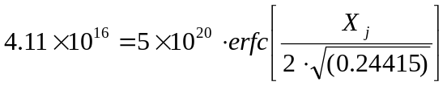
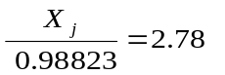
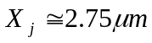

Hence, we can expect our diffusion depth to be about 0.15 μm deeper than expected. However, recall that during the growth of 1 μm of SiO₂, 0.45 μm of Si is consumed. During the last half-hour at T = 1100 °C, about 0.5 μm of SiO₂ is grown and therefore, about 0.25 μm of Si is consumed. Subtracting this from xj = 2.5 μm, we find that our effective junction depth will be located at roughly 2.5 μm even though the oxidation is performed after the diffusion time of 4_{hr} : 15_{min}.

The Photolithography Process:

In microelectronic devices fabrication we sometimes need to selectively be able to subject a certain region of the sample to further fabrication processing but at the same time leaving the other regions virtually not affected. The photolithography process can enable us to do just that by modifying the sample surface using: a polymer substance called Photoresist (PR). The accessories are spinner, certain photo mask, photolithography machine, and PR developer solution. There are two type of photoresists, positive photoresist (PR⁺) and negative photoresist (PR⁻), we are going to use PR⁺. The sample is spin-coated with PR⁺ and then exposed to ultra-violet (UV) light. The photoresist from the area exposed to UV light gets removed when kept in a developer solution
Usually we need to etch a window in SiO₂ to deposit impurities or to make contact holes, and to do that we can use the following procedure:

Procedure:
- Secure the sample on the spinner and turn the vacuum switch ON.
- Blow the sample with N₂ gun, and then turn the spinner switch ON.
- Using the dropper, deposit between 3-5 droops of PR⁺ on the sample, then let it spin for 30 sec.
- To make the PR⁺ sets more firmly on the wafer surface, we “Soft Bake” it using the forced-air convection oven at 110 °C for up to 30 min.
- Expose the wafer to UV light for 10 second under the desired photo mask. This is done with the mask-aligner/expose system located in the “yellow room”. The mask usually contains some dark areas called “opaque”, which will prevent the UV-light from hitting the wafer, and some transparent areas, which will let the UV light hit the sample causing the exposed PR⁺ to become weaker.
- The exposed PR⁺ will be developed and removed by dipping the wafer in Microposit Developer for almost 1.5 min. Then we rinse the wafer in D.I. water for 15 sec and blow it dry with the N₂ gun.
- Using the forced-air convection oven at 110 ⁰C for 30 min we will “Hard Bake” the wafer in preparation for etching.
- Repeat from step 1 to 7 for each sample.

SiO₂ Etching:
Almost every time we do Photolithography, SiO₂ etching comes after it. The procedure that we are going to use this time is as follow:

Preparation:
- Rinse clean two Teflon and two glass beakers.
- Fill the glass beakers with DI water, and put a sample carrier in one of them, which we will use to store the samples after the end of this process.
- Prepare a mix of 1:4 (25ml:100ml) HF:NH₄F in one of the Teflon beakers.
- Prepare a mix of 1:50 (3ml:150ml) HF:H₂O in the second Teflon beaker.

Procedure:
- Dip the sample in the HF:NH₄F Teflon beaker for 1-2 min.
- Dip the sample in the HF:H₂O Teflon beaker and check for hydrophobic surface at the window opining on the sample, if sample still not hydrophobic then repeat from step 1.
- Dip the etched sample in the glass beakers filled with DI water, then rinse it with DI water and store it in the second glass beakers.
- Repeat from step 1 to 3 for each sample.
- Remove the PR⁺ from all the samples by dipping them in Acetone filled beaker (except when the next process is metallization of the sample, in this case we leave the PR⁺ on the samples).
The Metallization Process:
The Metallization is a microelectronic process, by which metal contact to the active parts of the wafer is established. The Metallization process can be carried on in the following manner:

- Clean the samples by rinsing them thoroughly with DI water then drying them with N₂ gun.
- Load the samples in the evaporation chamber as soon as possible. When the chamber has been properly evacuated (i.e. vacuum down to roughly 10⁻⁶ Torr), evaporate the aluminum onto the loaded samples. When the evaporation is completed, the samples may be kept in the vacuum chamber until further processing can be carried out.
- Take out the samples from the evaporator, and prepare a beaker filled with Acetone.
- Remove the excess aluminum (i.e., “Lifted Off’) by soaking the samples in the Acetone filled beaker. The acetone will cause the PR⁺ to swell and thus dislodge or lift-off when placed in an ultrasonic cleaner.

To make an intimate contact between the metal contacts and the Si surface, we will use the Alloying furnace.

- Dry the samples with the N₂ gun. Then load them into the alloying furnace.
- Let N₂ gas flow through the sealed reactor tube for 2 min. While waiting, light the Bunsen burner at the reactor tube exhaust.
- Turn ON the furnace (Variac set to 80) and begin monitoring reactor temperature. When temperature reaches 350 ⁰C ( about 20 min. after), change ambient to nitrogen/hydrogen ... **make sure that the gas begins burning at the exhaust within 2 min. …if not, shut OFF H₂ and determine source of problem**
- When a temperature of 450 ⁰C is attained, begin alloy timing and reduce variac setting to ∼69. Perform the alloying for a total of 30 minutes.
- When the alloying is complete, shut OFF the furnace and allow the system to cool in an H₂ atmosphere until the temperature decreases to 350⁰C. At that point, the ambient may be changed to N₂ and the Bunsen burner may be extinguished.
- The samples may be removed from the reactor when the temperature decreases to below 80 ⁰C. **don't forget to shut OFF the N₂**

THE PROCEDURE:

Session #1:

- Clean the P-type samples using the four-step cleaning process.
- Oxidize the P-type samples @ T = 1100 °C for 1_{hr} using Wet O₂ oxidation process.

Session #2:

- Perform the photolithography of mask #1 on the P-type samples. Mask #1 is shown in figure 7.
- Open the Source and Drain diffusion windows for the P-type samples using the oxide etching process. Clean the sample using only the first two steps of the cleaning process.

Session #3:
- Deposit Phosphorosilica film on the P-type samples and dry it for 1 min @ 110 °C in the air convection oven.
- Diffuse the deposited Phosphorus on the P-type samples @ 1100 °C for 2_{hr}:20_{min}, in an environment consisting of 80 % nitrogen and 20 % oxygen.
- Re oxidize the P-type samples @ 1100 °C for 30_{min}, using the Drive-In diffusion process settings.

Session #4:
- Perform the photolithography of mask #2 on the P-type samples. Mask #2 is shown in figure 8.
- Open the Gate Oxide windows for the P-type samples using the etching process. Clean the sample using only the first two steps of the cleaning process.

Session#5
- Grow the gate oxide for the P-type samples using the Dry O₂ Oxidation process @ T= 900 °C for 2_{hr}:40_{min}.

Session #6:
- Perform the photolithography of mask #3 on the P-type samples. Mask #3 is shown in figure 9.
- Open the Source and Drain contact windows for the P-type samples using the oxide etching process then clean the samples using only the first two steps of the cleaning process.

Session #7:

- Perform the photolithography of mask #4 on the P-type samples. Mask #4 is shown in figure 10.
- Deposit Al on the samples using metal evaporator
- Do lift-off by dipping the samples in acetone and placing the beaker in an ultrasonic cleaner.

Session#8
- Do the alloying at 450 ºC in alloying furnace
- See the characterization of a MOSFET using Semiconductor Parameter Analyzer.

Figure 7. Mask #1 the Source and Drain diffusion

Figure 8. Mask #2 Gate oxidation Windows

Figure 9. Mask #3 Source and Drain windows

Figure 10. Mask #4 Metallization

T1 T2 T3 T4

T5 T6 T7 T8

T9 T10 T11 T12

C1 C2 Com C3 C4
Figure 11. Device Layout
5μm
20μm
40μm
80μm
10μm
20μm
40μm



