**Lab #3**

**Measurement of majority carrier concentration and mobility.**

A. **Introduction:** When a semiconductor sample is subjected to mutually perpendicular electric and magnetic field, Hall voltage develops in a direction that is perpendicular to both the applied fields. This voltage is indicated as VH in Fig. 1. This effect is known as Hall effect. This effect is used to obtain the carrier concentration (n or p) of the semiconductor. Now refer to Fig. 1. It can be shown that

(1)



Here VH is the Hall voltage, I is the current through the sample and B is the strength of the strength of the magnetic field. The parameter d is the thickness of the sample as shown in Fig. 1.

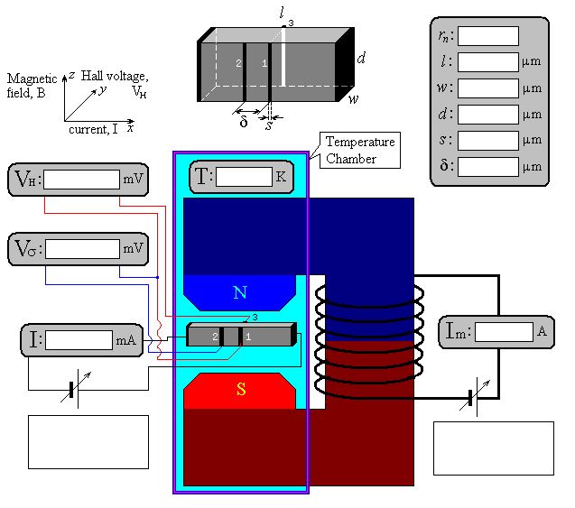

Figure-1

RH is the Hall coefficient and is given by the following expression.

(2)



Here b=μn/μp where μn and μp are electron and hole mobility respectively and e is the elementary charge (=+1.6x 10-19 C). Furthermore, rn is the scattering factor defined by the scattering mechanism that is dominant in the semiconductor. The scattering factor rn can vary between 1.0 (scattering on lattice atom vibrations) and 1.93 (scattering on ionized impurity atoms). For silicon the empirical value of rn is about 1.15 at room temperature (T=300 K). It is easy to show that for n-type material (n/p>>1)

(2a)



Similarly, for p-type material (p/n>>1)

(2b)



The parameter G in equation (1) is called the geometric factor that describes the shape effect of the sample.

(3)



G is close to 1 for the samples that are long (l>>w) and thin (l>>d).

It is shown in Fig. 1 that magnetic field B is produced by applying a current Im through an electromagnet. Due to the edge effects the dependency of B on Im is not linear. B can be calculated using the following relationship

B=0.135(Im-0.025Im2) (4)

Note that Im is in the unit of A and the field produced is in tesla (T).

**B.** **Determination of carrier type and majority carrier concentration**

The Hall effect is widely used for determining a) type of conductivity of a semiconductor (n or p), and b) the majority carrier concentration. As one can see from Eq. (1), the slope of dependency VH vs. B is defined, in particular, by the Hall coefficient RH. This RH carries information about majority electron or hole concentration (Eqs. 2, 2a, 2b) and type of conductivity of semiconductor (sign of RH). Therefore, by measuring the dependency VH vs. B, one can calculate the Hall coefficient RH and thus the concentration n or p. In order to get accurate results, measurement have to be made for different values of current I.

**C. Measurement of majority carrier mobility**

Hall effect measurements are made with contacts 1 and 3 at opposite sides (see Fig. 1). If we add an additional contact 2, then we have a chance to measure the mobility of majority carriers (μn or μp) as well. For this purpose, we need to measure voltage Vσ across contacts 1 and 2 which are usually called “conductance contacts” while 1 and 3 are called “Hall contacts”. Vσ is in essence the voltage drop on a resistor cut by the contacts 1 and 2 from the sample (i. e. with size δ x w x d). It is clear that Vσ=IR where

(5)



Here ρ is the resistivity and σ is the conductivity of the semiconductor. Moreover δ, w, and d are the geometric parameters as shown in Fig. 1. Thus, by calculating R from the plot of Vσ vs. I and using the value of n or p obtained from Hall effect measurements one can find the mobility of majority carriers μn or μp.

**D. Hall effect basic apparatus:**

The Hall effect basic apparatus provides contacts and power supply for the circuit boards with a germanium crystal, also holding them in place in experiments measuring the Hall effect and how it depends on temperature, magnetic field or sample current, as well as experiments on electrical conductivity.

The apparatus contains an adjustable constant current source for the sample current, a measurement amplifier with offset compensation for the Hall voltage. Hall voltage, sample current, and sample voltage can all be read off from the display, which can be switched between these various modes.

The equipment is set up on the U-shaped core of the multi-piece transformer kit. The magnetic field can be measured using a Tesla meter.

**1) Hall effect console**

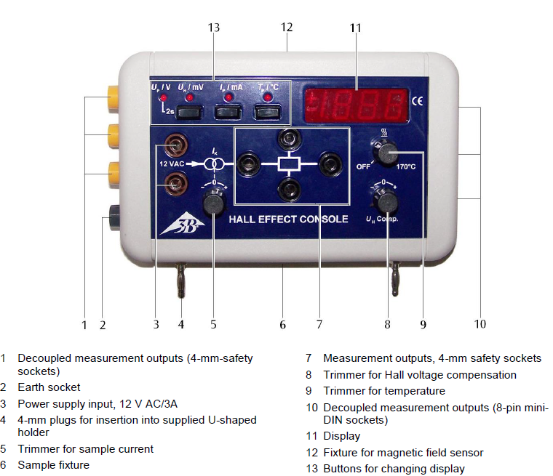

Figure-2. Hall effect console.

**2) Tesla meter**

The TD8620 Handheld Digital TeslaMeter is a field-portable unit that measures DC magnetic fields with direct digital readout in mT or Gs. The unit is designed for wide range, auto-range, high accuracy, and ease of use.

Probe readings are dependent on the angle of the sensor in relation to the magnetic field. The magnetic field should vertical cross the sensor. Maximum output occurs when the flux vector is

perpendicular to the plane of the sensor. The greater the deviation from vertical orientation, the larger error of reading.

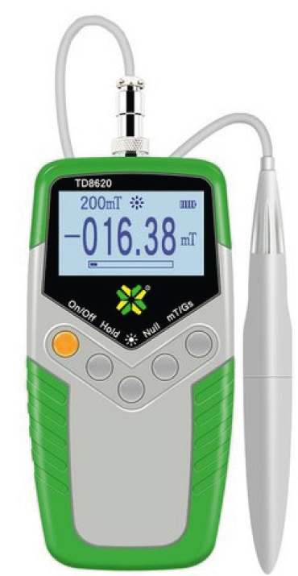

Figure 3. Handheld Digital Teslameter

**3) Transformer with rectifier**

The transformer with rectifier (shown in Fig. 4) provides small voltages, switchable in four voltage steps, with outputs in the form of AC voltages or full-wave rectified DC voltages.

The maximum load for each output is 3 A. Both outputs are protected against short-circuiting.

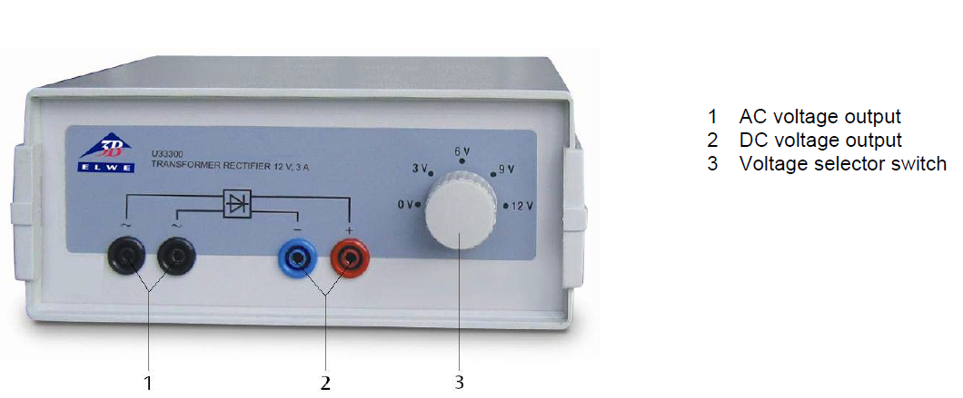

Figure 4. Transformer with rectifier

**4) Coils**

A suitable choice of coil enables all experiments to be performed safely at low voltage. Simple whole-number winding and intermediate tap ratios allow the transformer laws to be derived in clear and understandable fashion.

Coils are made of impact-resistant plastic. Number of turns, maximum current for long-term operation, effective resistance, direction of windings and inductance are specified on the case of the coil. The current may reach approximately double the long-term maximum for short periods (10 seconds).

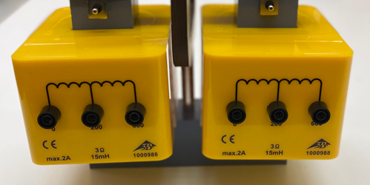

Figure 5. 600 turns coils

**5) N/P-doped germanium on circuit board**

The circuit board is intended for use with the Hall effect basic apparatus in order to measure the conductivity and Hall voltage of n- or p-doped germanium as a function of temperature. In addition, it is also possible to study how the Hall voltage depends on an external magnetic field and the sample current through the crystal. The circuit board has a multi-pin plug with contacts for a sample current, the resistive heating element and the temperature sensor underneath the crystal.

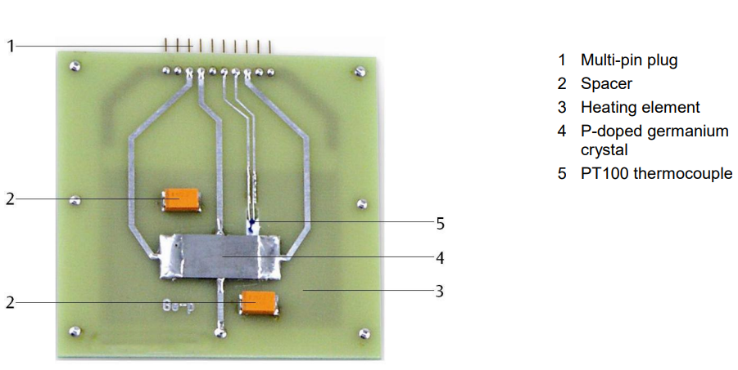

Figure 6. p-doped germanium on circuit board

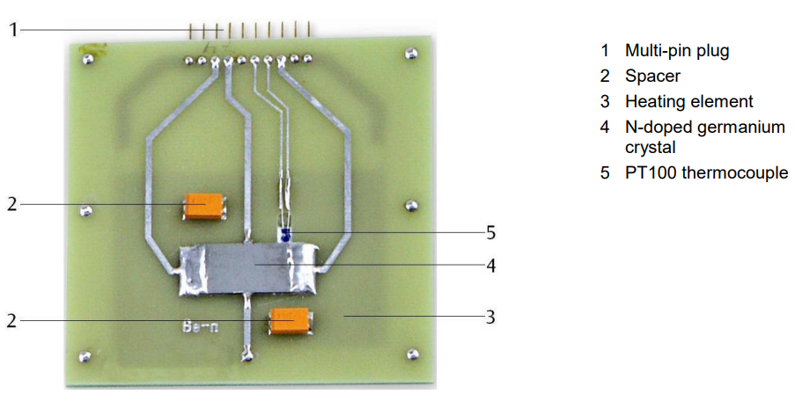

Figure 7. n-doped germanium on circuit board

Dimensions and parameters of crystals:

|  |  |  |  |  |  |  |  |
| --- | --- | --- | --- | --- | --- | --- | --- |
| rn | l(m) | w(m) | d(m) | s(m) | δ(m) | π | e |
| 1.15 | 2.00E-02 | 1.00E-02 | 1.00E-03 | 1.00E-03 | 2.00E-02 | 3.141593 | 1.60E-19 |

**E**. **The Eperiment Procedure:** For each sample go through the following steps:

**1.** Insert the console with the circuit board attached onto the U-shaped holder. Make sure the board is held parallel with the U-shaped core.

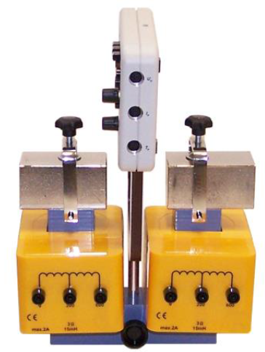

Figure 8. Console inserted onto U-shaped holder

**2.** Connect the AC output of the transformer to the input sockets for the power supply and set an output voltage of 12 V.

**3.** Connect the coils to the DC power supply.

**4.** Select sample current *IP* and set to ‘0’, select the Hall voltage (*V*H) on the console and adjust the zero point for the Hall voltage with the help of the compensation trimmer.

To determine concentration of the majority carriers:

* Set the trimmer of temperature to ‘OFF’ and record the temperature value.
* Turn on the DC power supplier and set it up as a constant current source.
* Enter required sample current (*IP*) in console, e.g. *IP* = 20 mA.
* Vary the magnetic coil current (*Im*) by varying DC power supplier output, from -800mA to 800mA with interval of 100mA and record the corresponding Hall voltage (*V*H) and magnetic filed (*B*).

By measuring the dependency *VH* vs. *B*, we can calculate the Hall coefficient (RH) and thus the concentration n or p.

**5.** To determine the mobility of majority carriers:

It is clear that $V_{P}=I_{P}×R$

where (5)

Here ρ is the resistivity and σ is the conductivity of the semiconductor. Moreover δ, w, and d are the geometric parameters.

* Set constant magnetic coil current to ‘0’ or disconnect DC power supplier.
* Vary the sample current ($I_{P}$) from -25mA to 25mA with interval of 5mA and record the corresponding sample voltage ($V_{P}$).

By calculating R from the plot of $V_{P}$ vs. $I_{P}$ and using the value of n or p obtained from Hall effect measurements we can find the mobility of majority carriers μn or μp.

**6.** Set the trimmer of temperature to 50oC and repeat **step 5**

**7.** Change another type of semiconductor sample and repeat **steps 1 ~ 6**.

Complete hall measurement set-up is shown in Fig. 9.

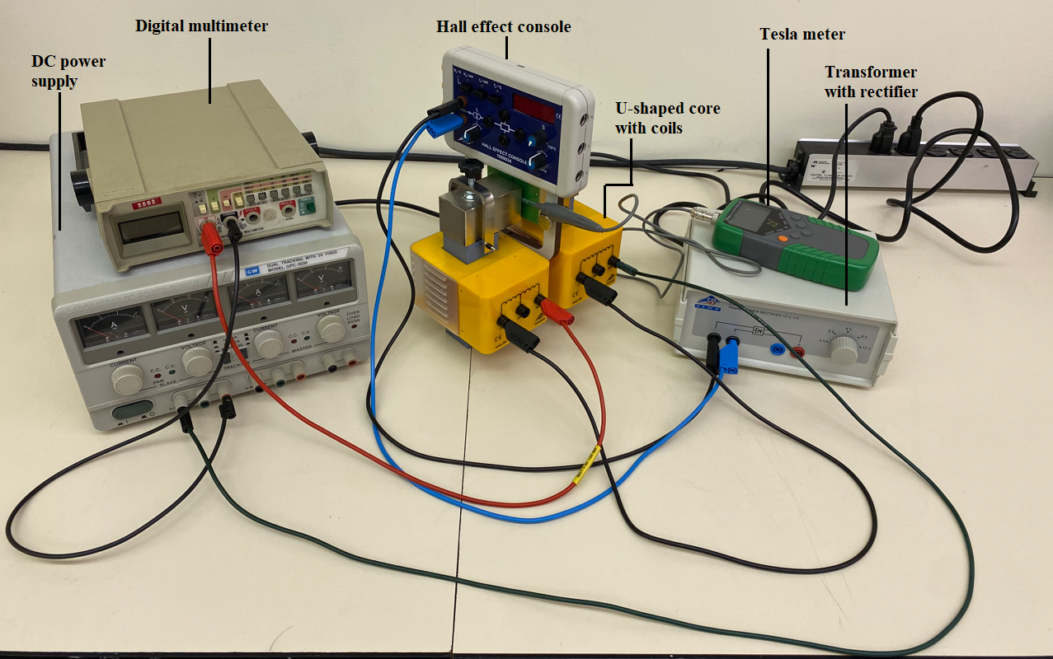

Figure-9. Experiment set-up for investigating the Hall effect.

**Questions:**

1. If the concentration of scattering centers increase in the semiconductor, would it increase or decrease the mobility?
2. How does carrier mobility depend on T?
3. Does orientation of the sample in magnetic field affect the Hall voltage? Explain your answer.